DEAPRTMENT OF COMPUTER ENGINEERING

Workshop on “PHP”

By
TechnoWings IT Solutions,Pune

Date: - 22/10/2018 to 24/10/2018

Academic Year: - 2017-18

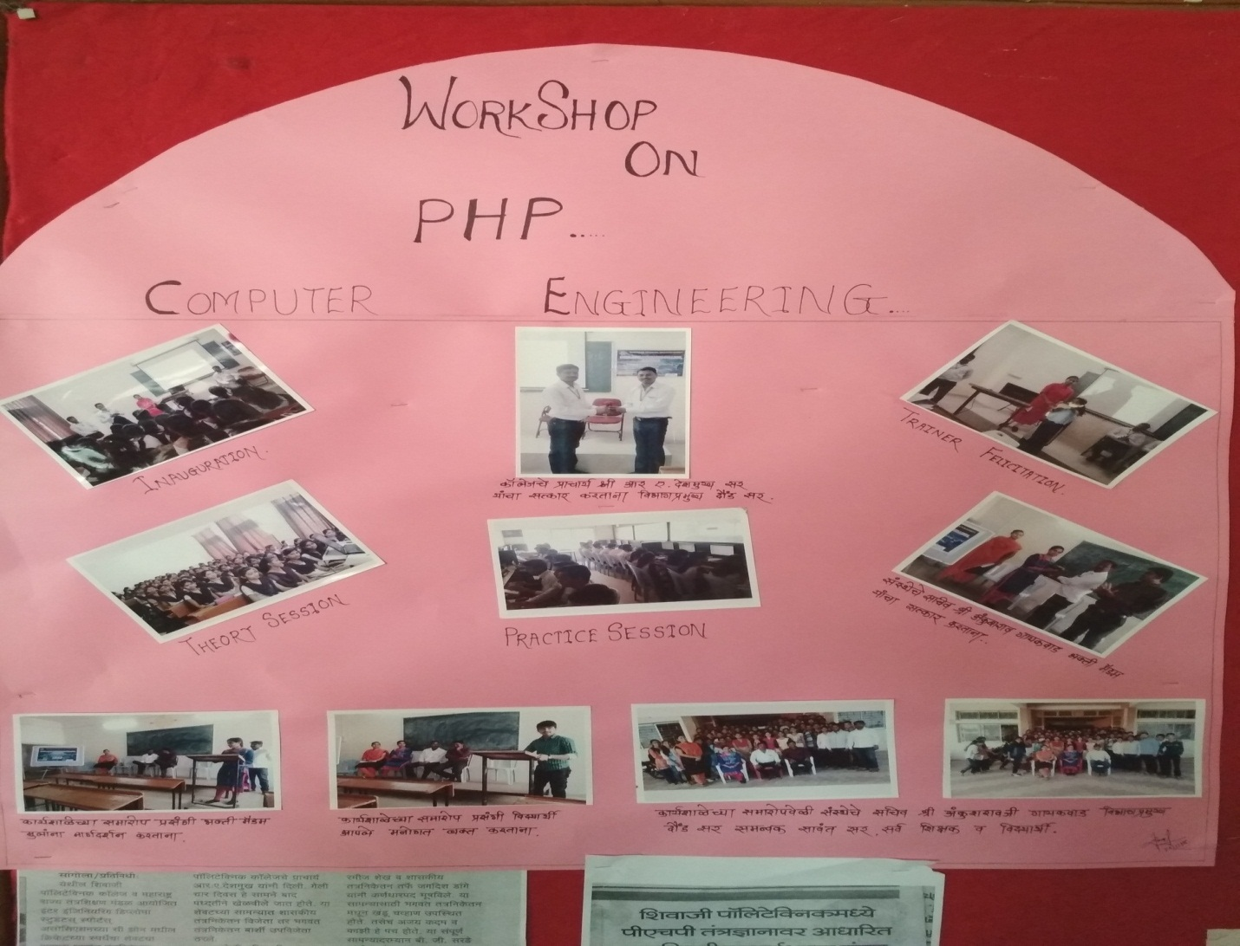

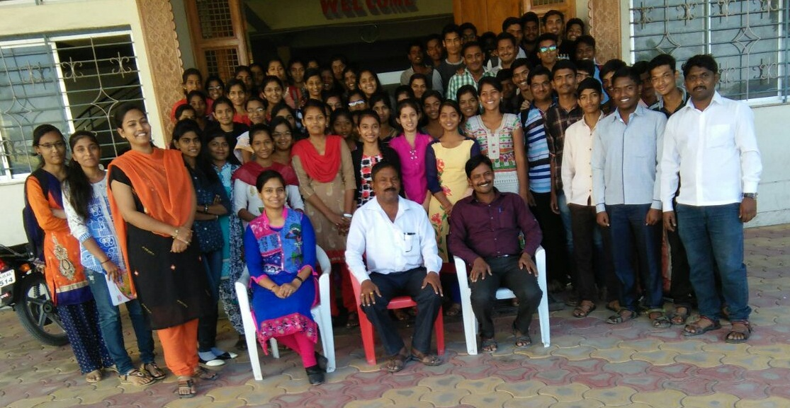
Group photo at the end of PHP Workshop with Hon.Ankushraoji Ramchandra Gaikwad, Secretary of S.P.C,Sangola , Ms.Bhakti Madam, Trainer,Mr.Dound M.S H.O.D of Computer Engineering Dept.Ms.Khatib K.P, Lectuer of Computer Engineering Dept. Mr.Sawant S.M Sir and Students of Third Year and Second Year Computer Engineering Dept.

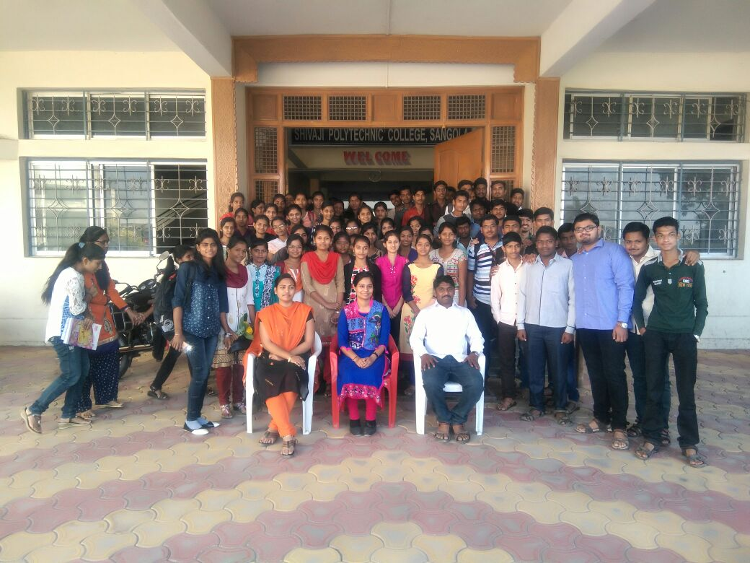
Group photo at the end of PHP Workshop with Ms.Bhakti Madam,Ms.Khatib Madam,Mr.Sawant S.M sir and Students.

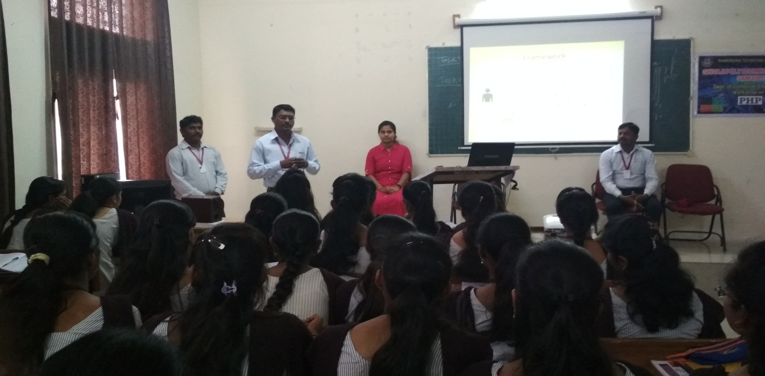

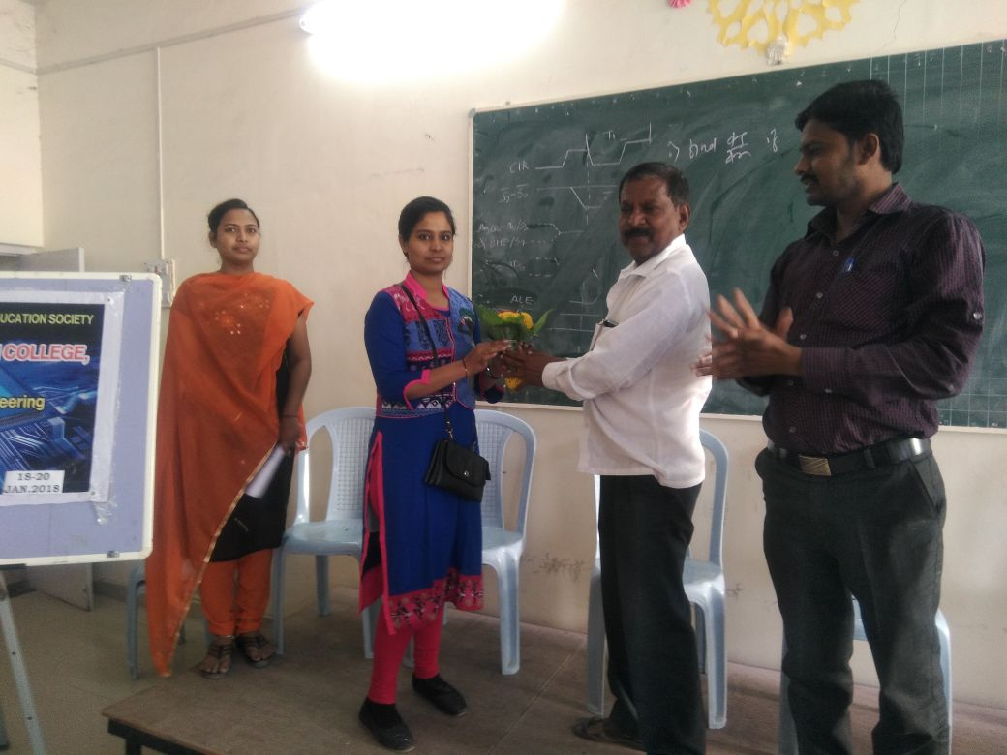

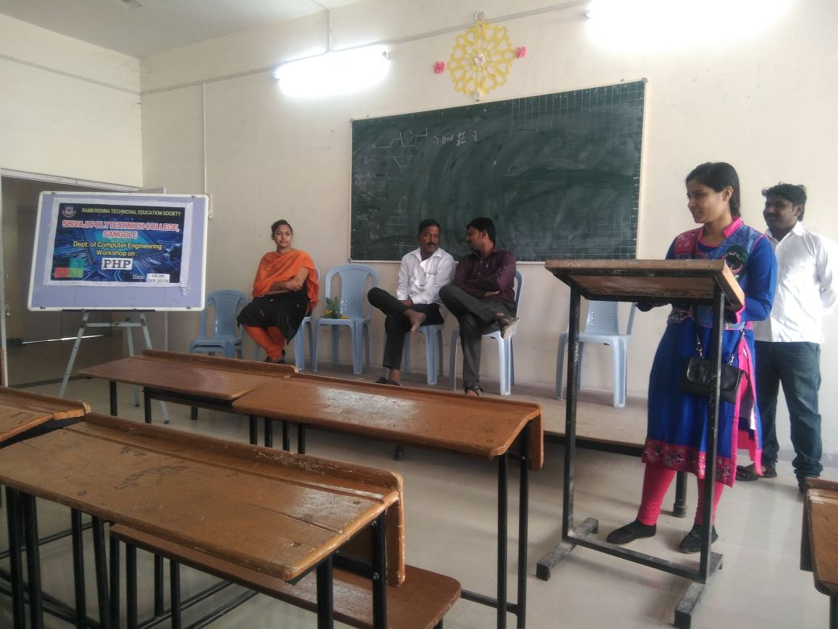

DEAPRTMENT OF COMPUTER ENGINEERING

Workshop on “Android Technology”

By
ISB&M School of Management,Pune

Date: - 06/02/2018 to 07/02/2018

Academic Year: - 2017-18

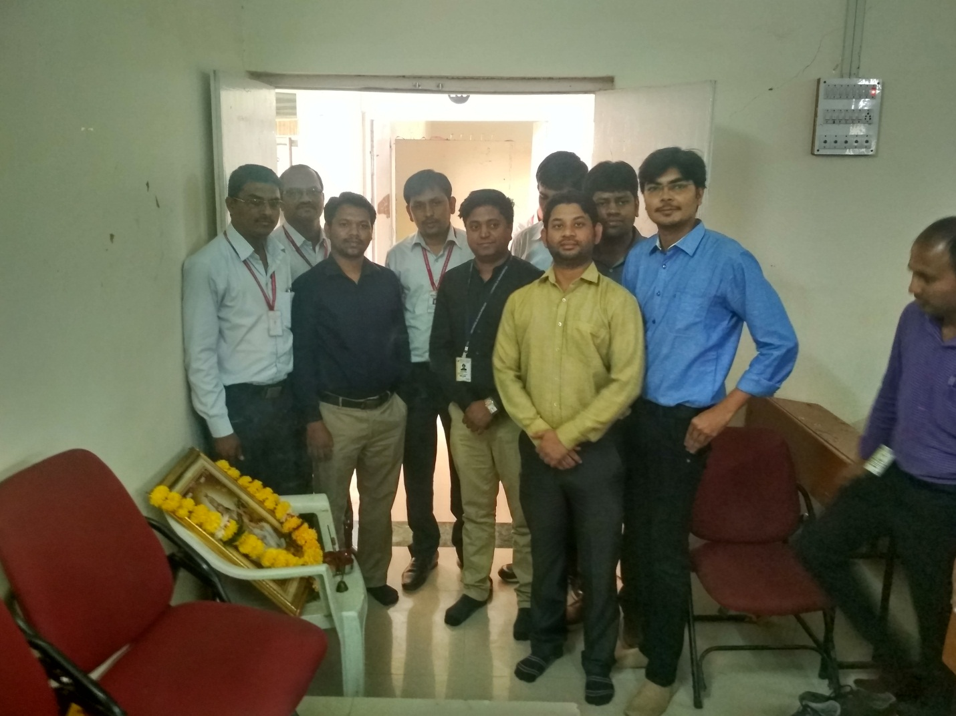
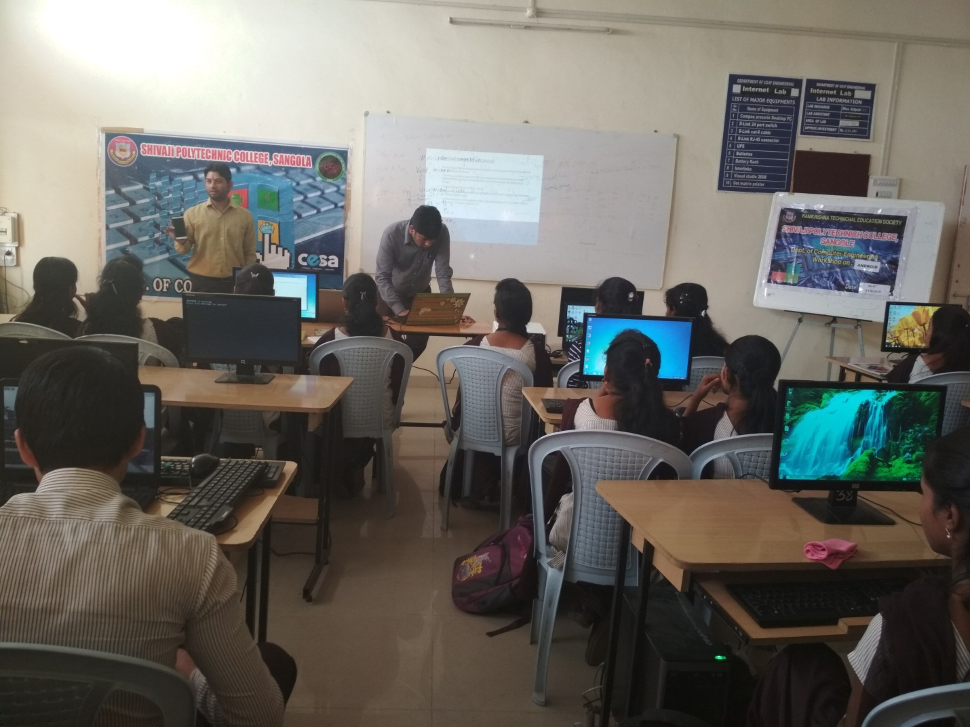

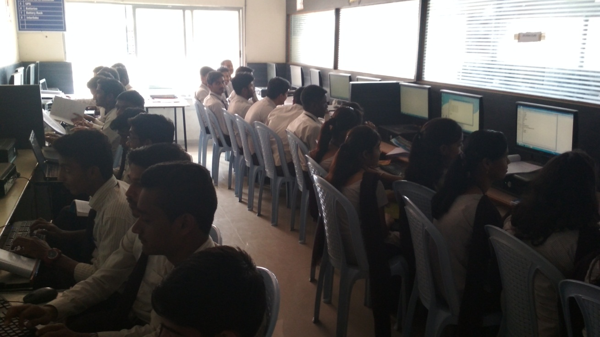

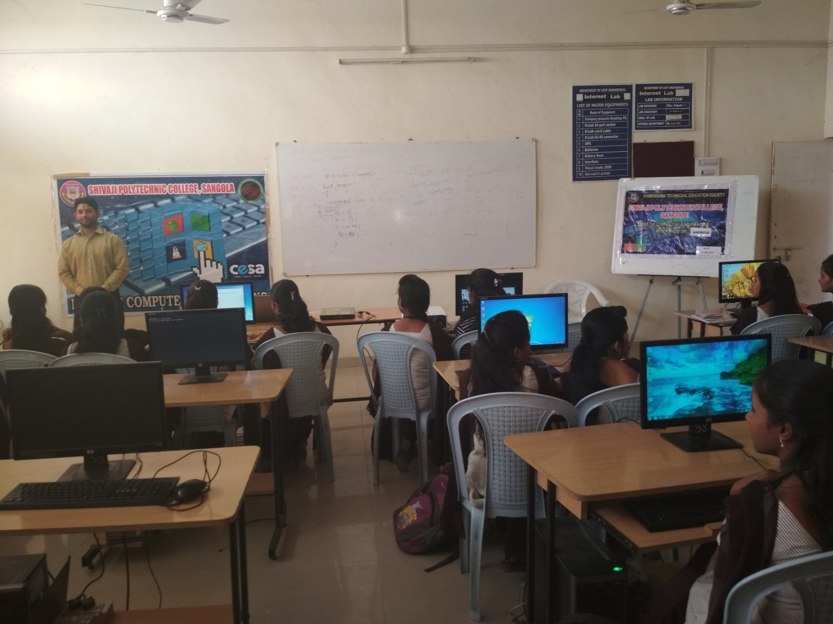

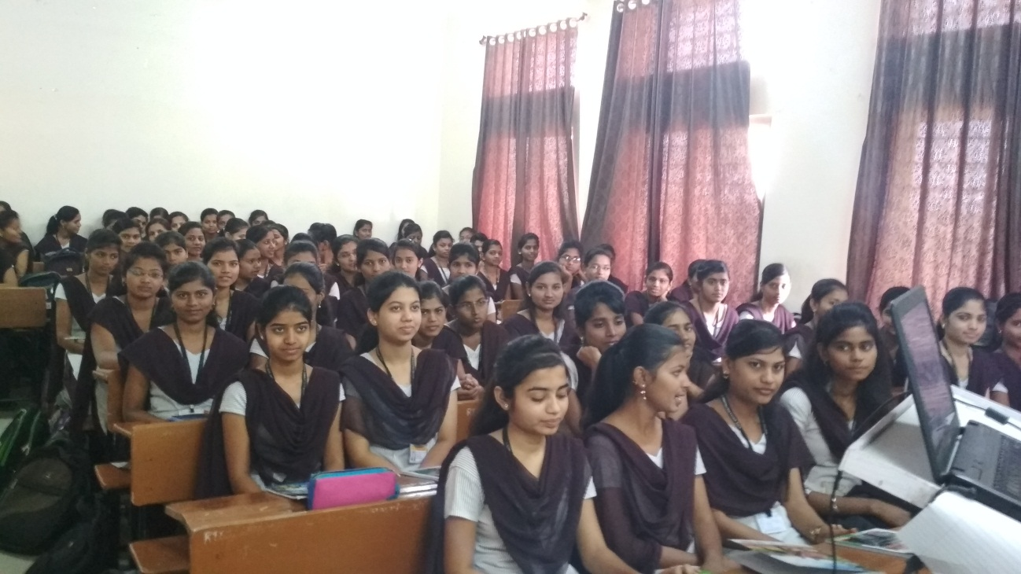

Guest of Lecture of Mr.S.R.Divase (CEO of StanceCode Pvt.Ltd. Pune ) on “Digital Marketting”

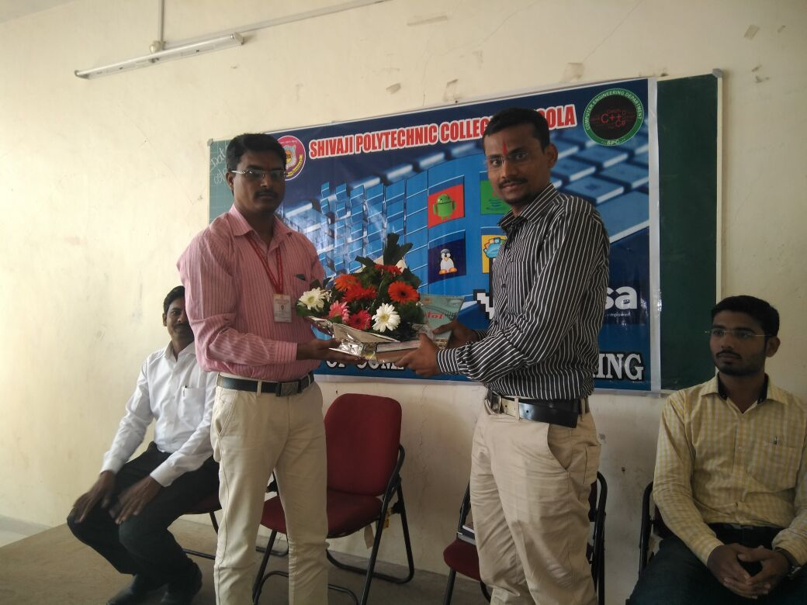

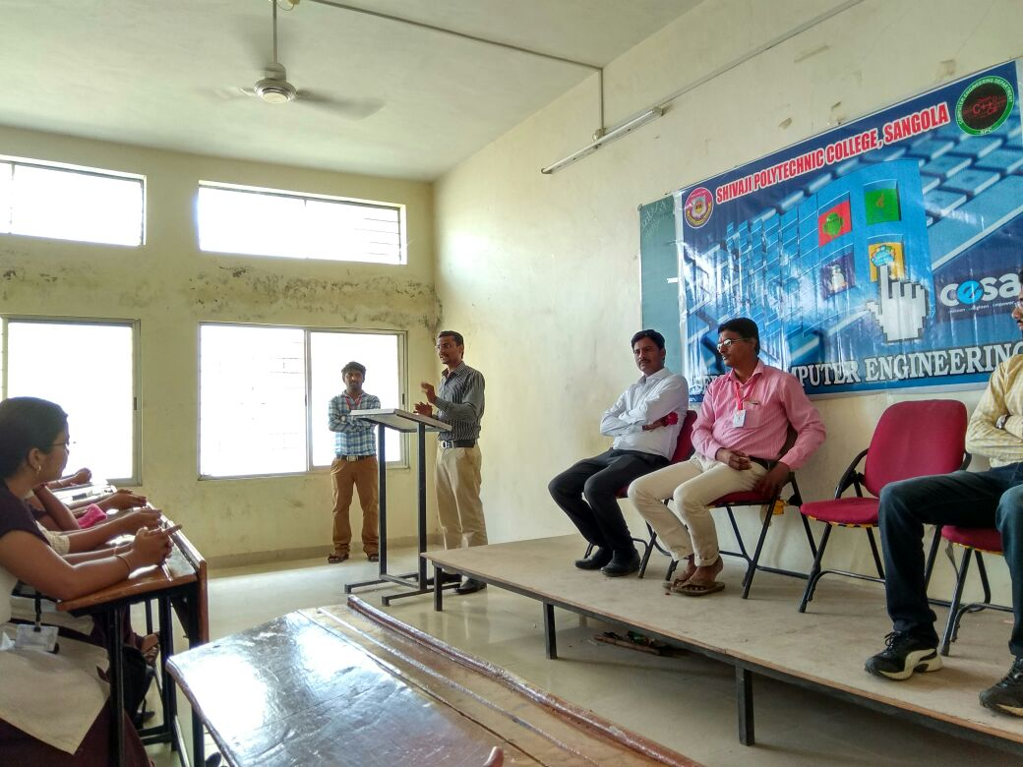

Guest of Lecture of Mr.Bahubali Kandale (CEO of TechnoWings IT Solutions,Solapur ) on Date:- 31/01/2018 “Importance of Online Certification Courses”
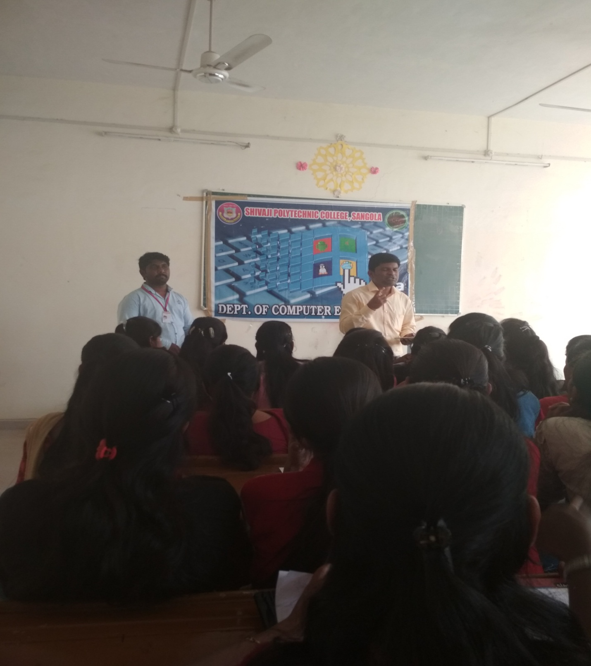

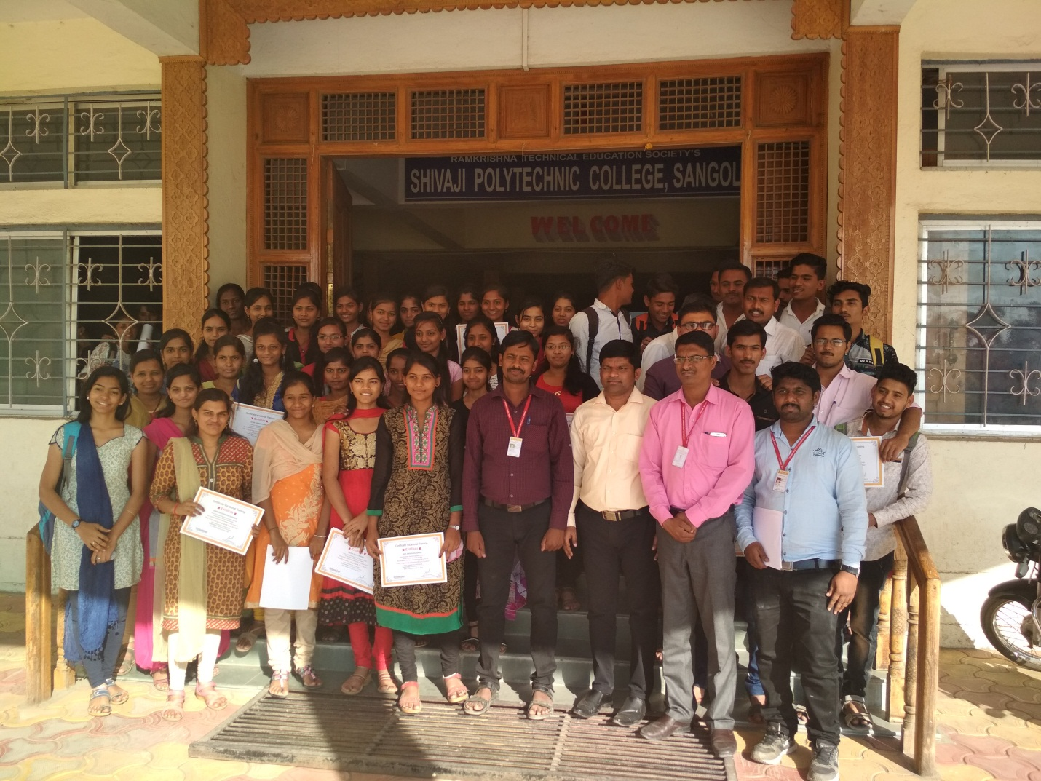

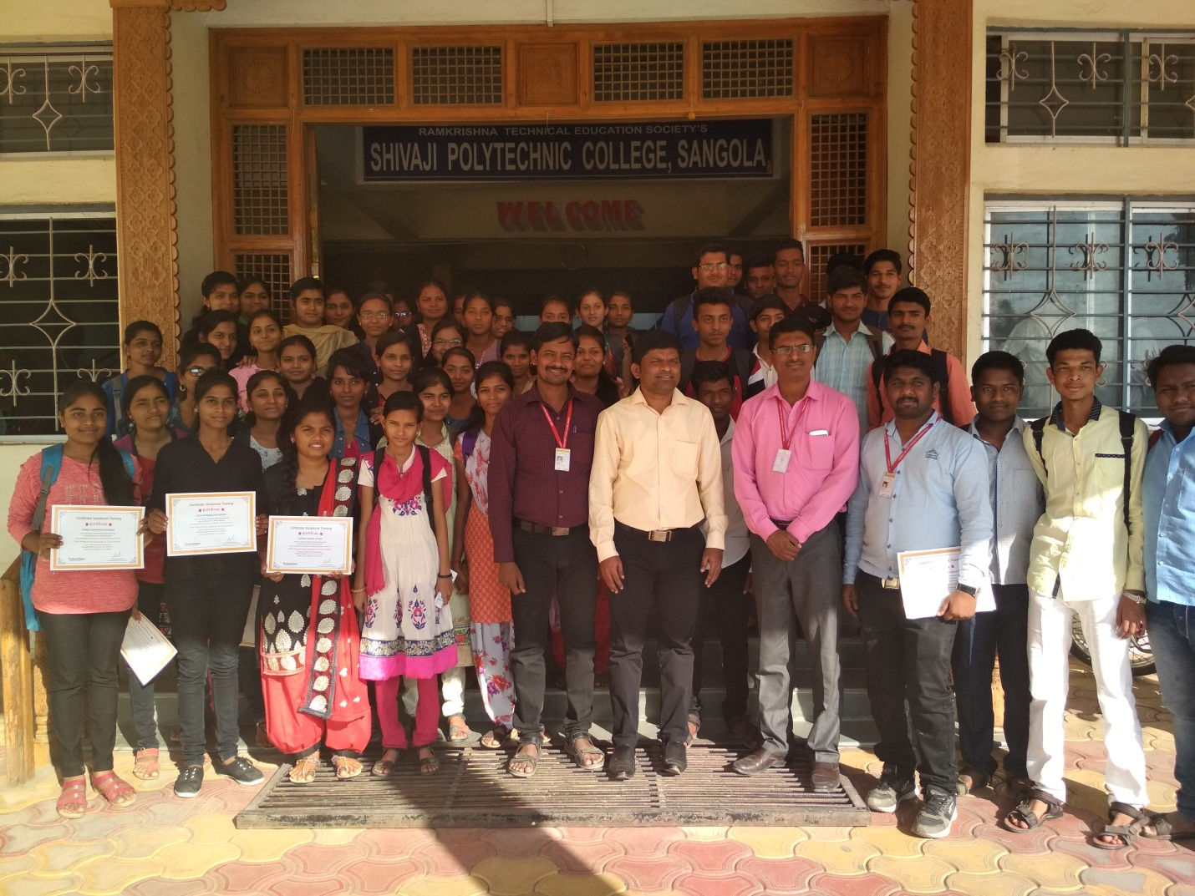

Guest Lecture on “NBA” by Dr.R.T.Vyavahare (Prof. at SKN,Sinhgad College of Engineering, Pandhapur) on Date:- 05/02/2018

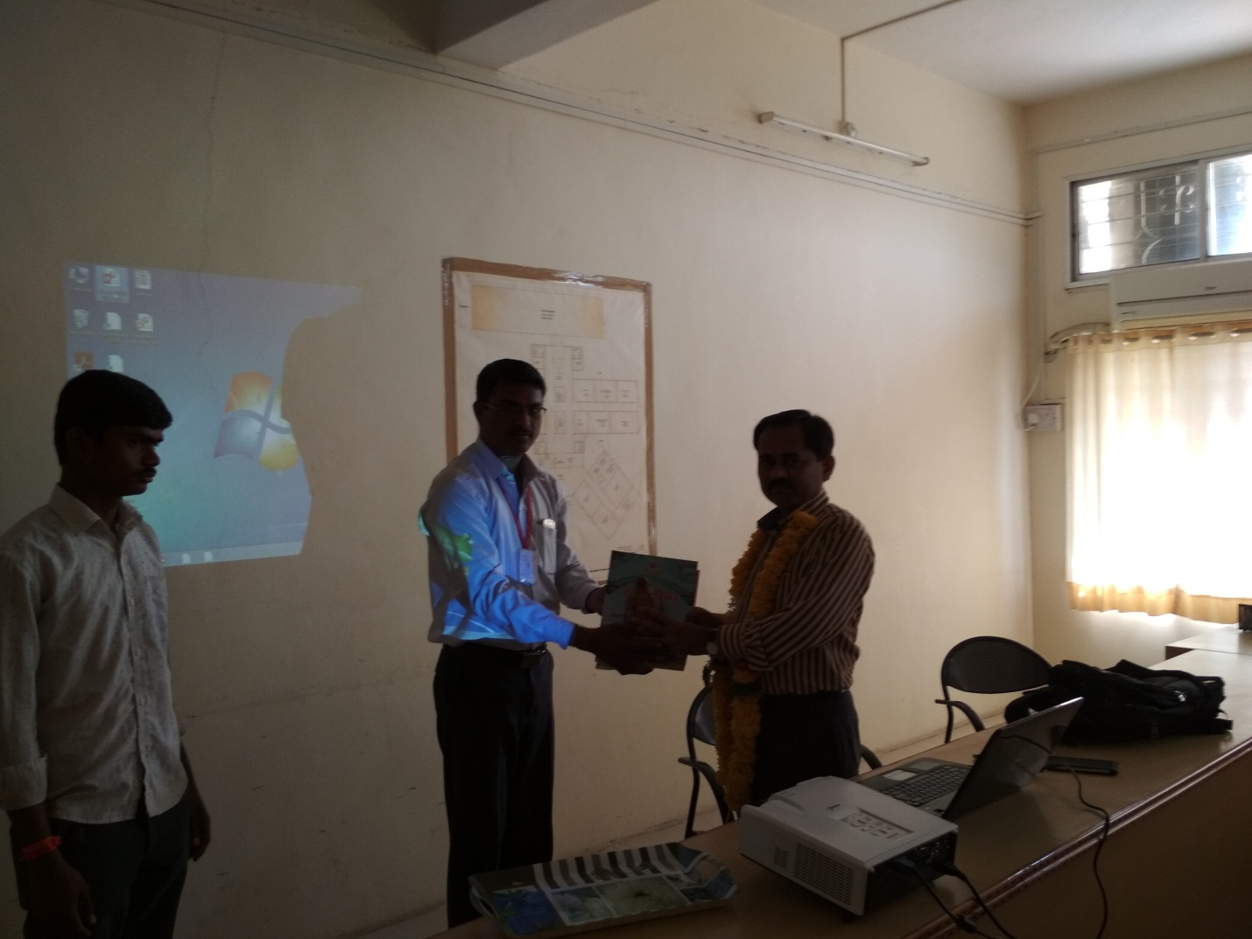
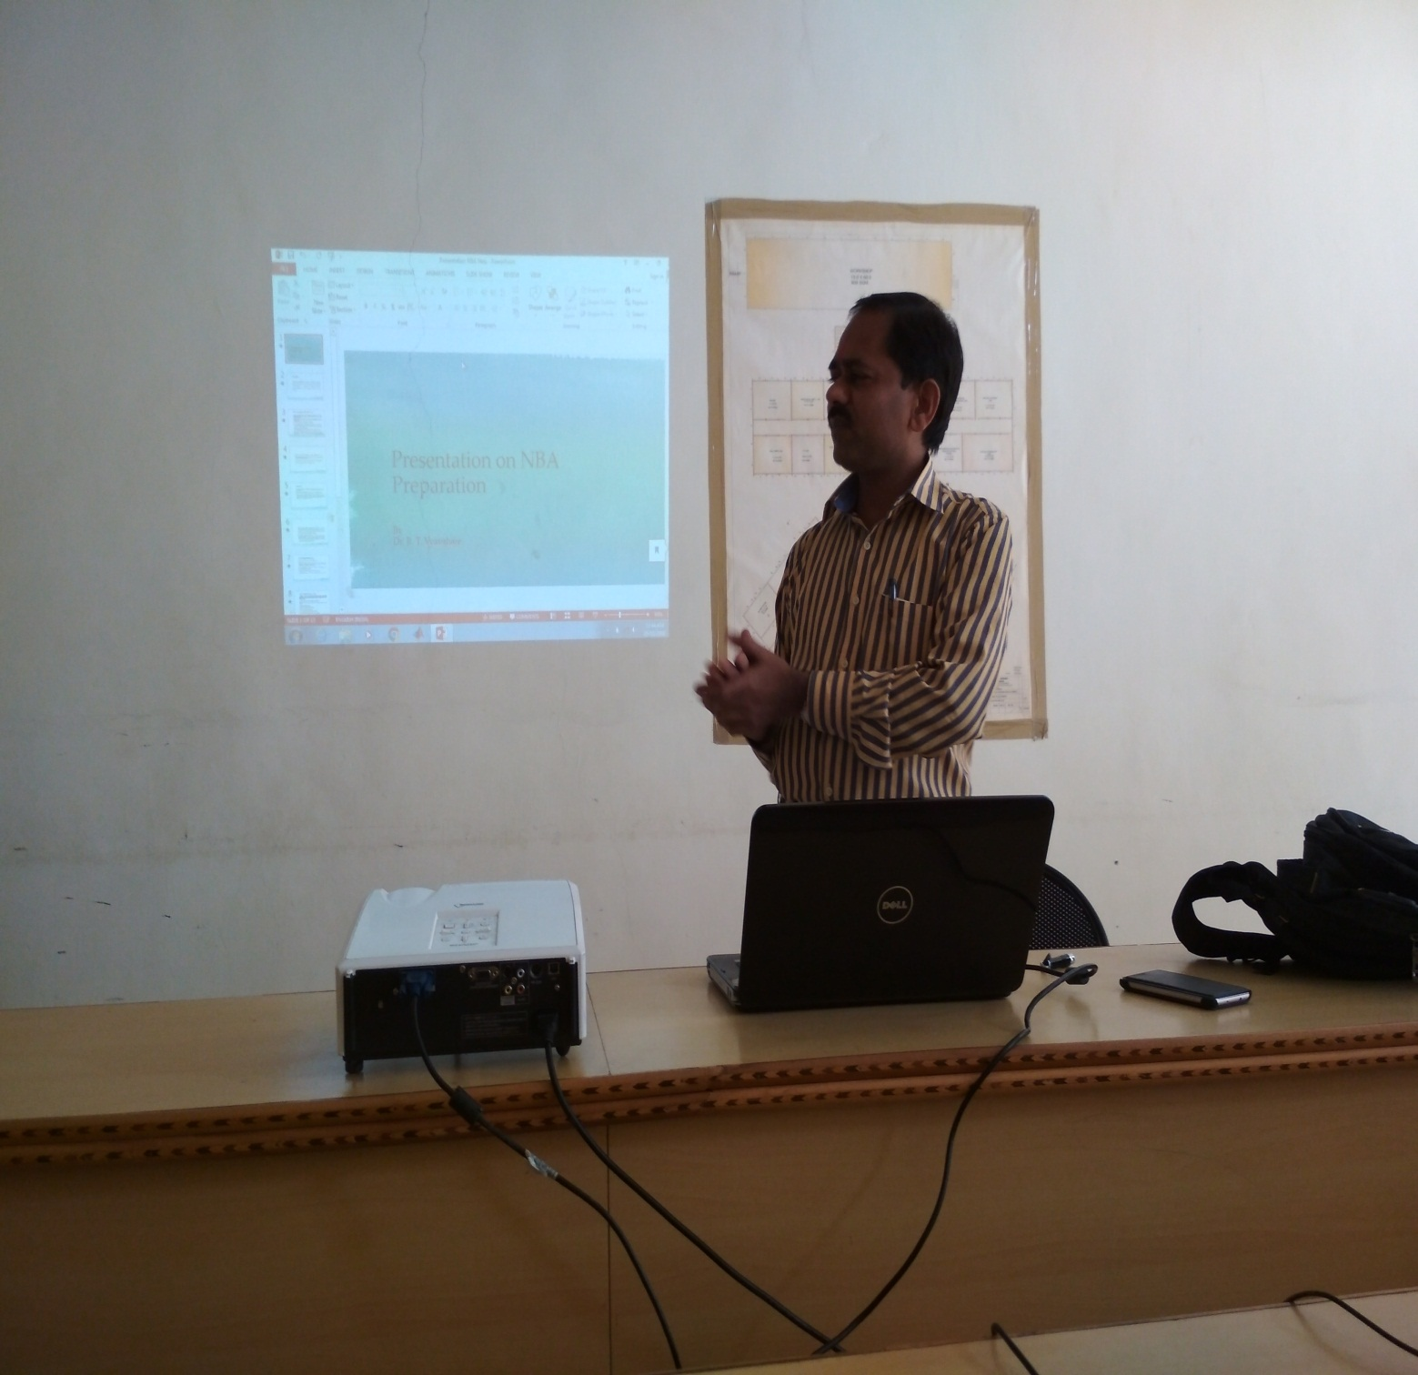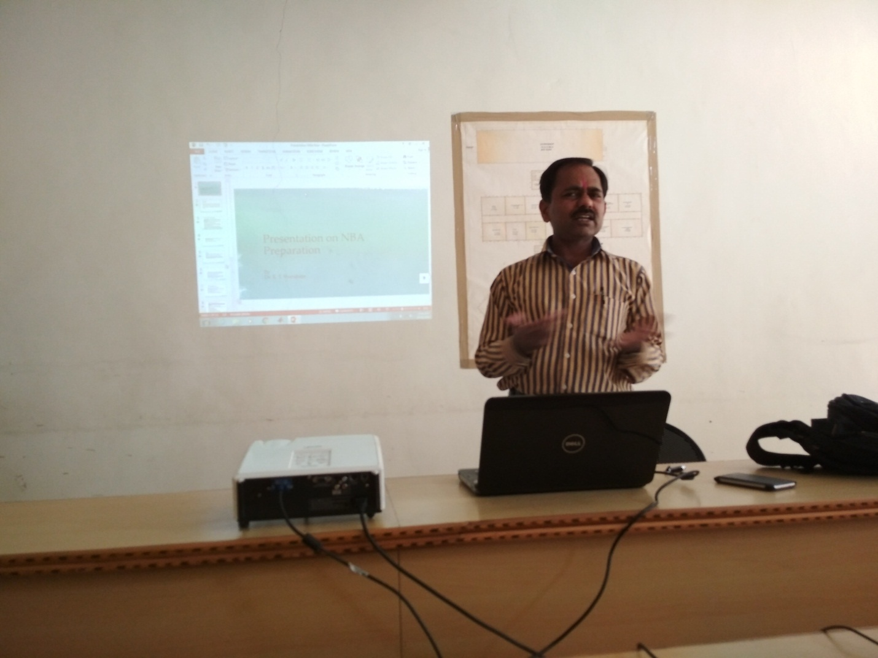
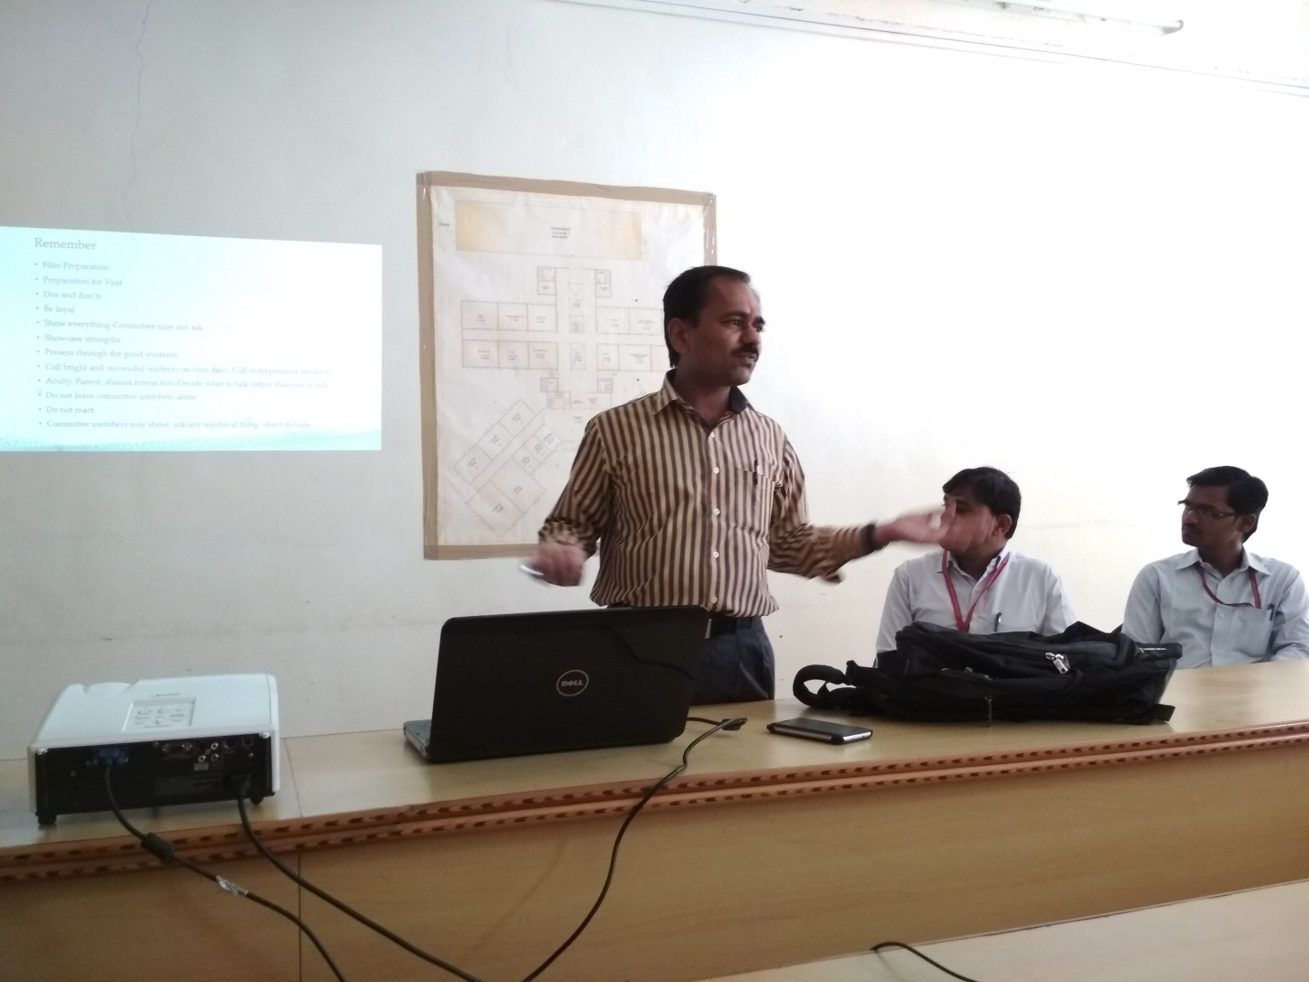

Guest Lecture on “NBA” by Dr.P.S.Kachre (Prof. at SVERI’s College of Engineering,Pandharpur) on Date:- 06/02/2018
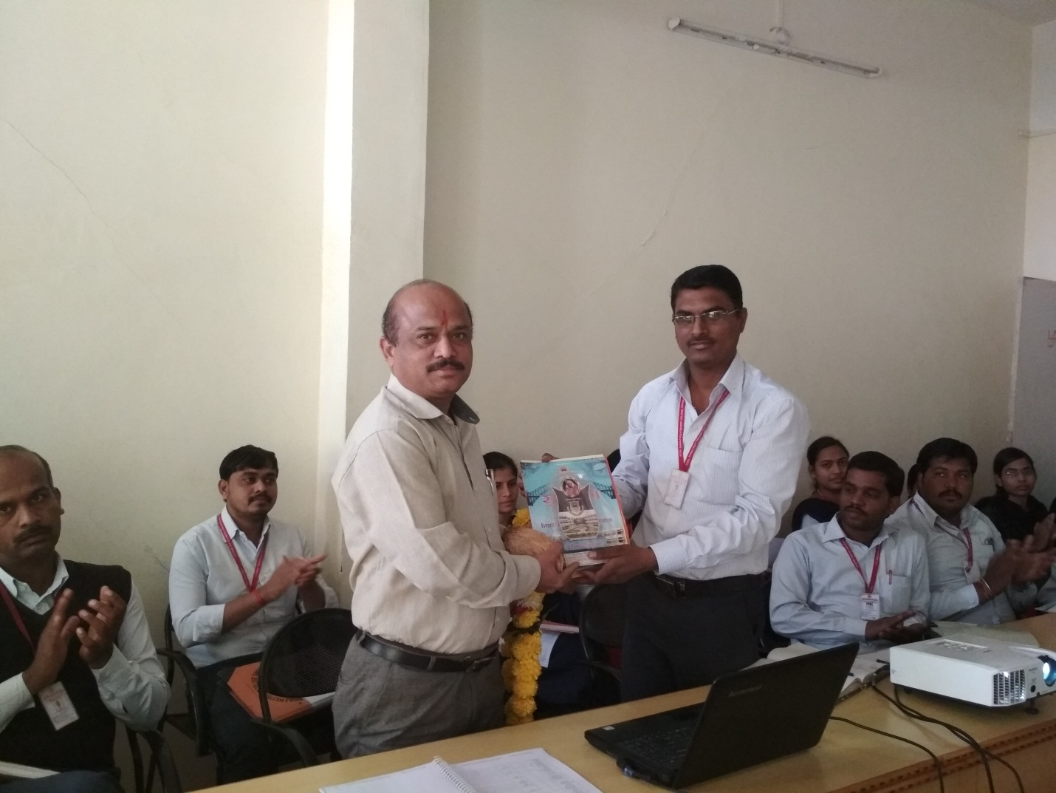

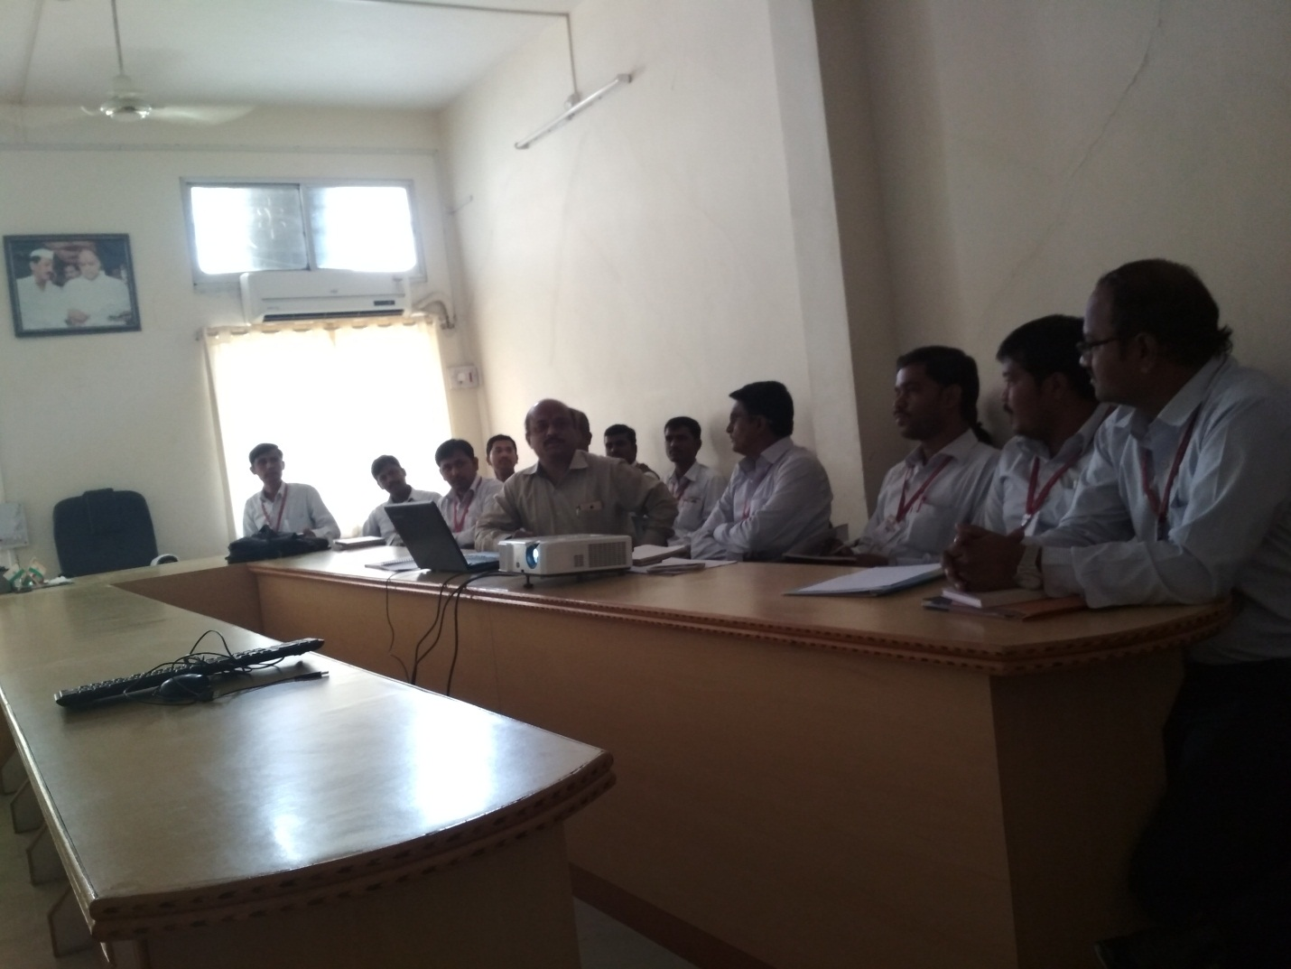

DEAPRTMENT OF COMPUTER ENGINEERING

Workshop on “Android Technology”

By
Stance Code Pvt.Ltd, Pune.
Date:- 09/09/2017 to 10/09/2017

Academic Year: - 2017-18
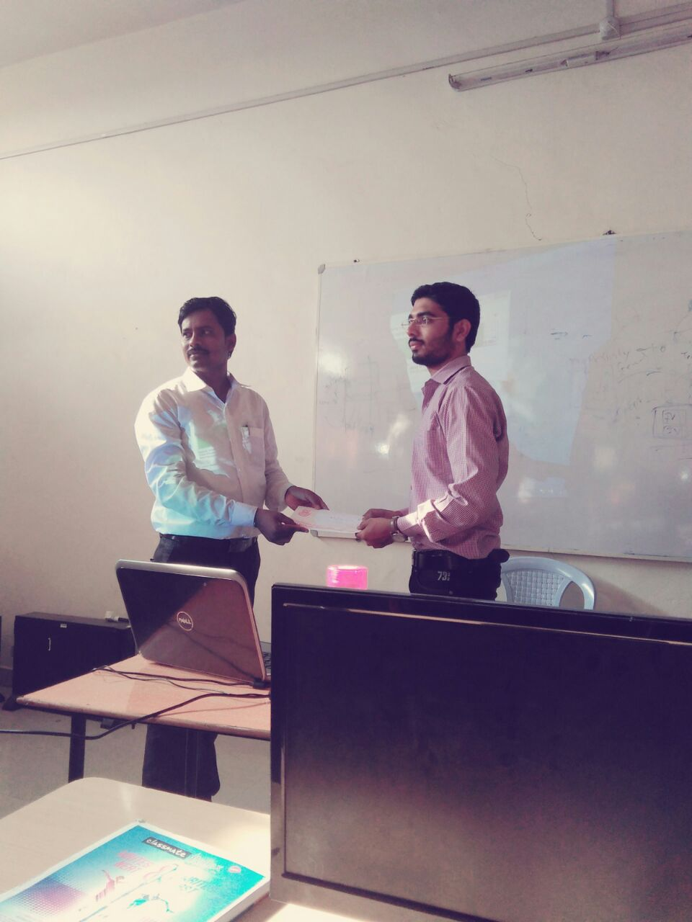
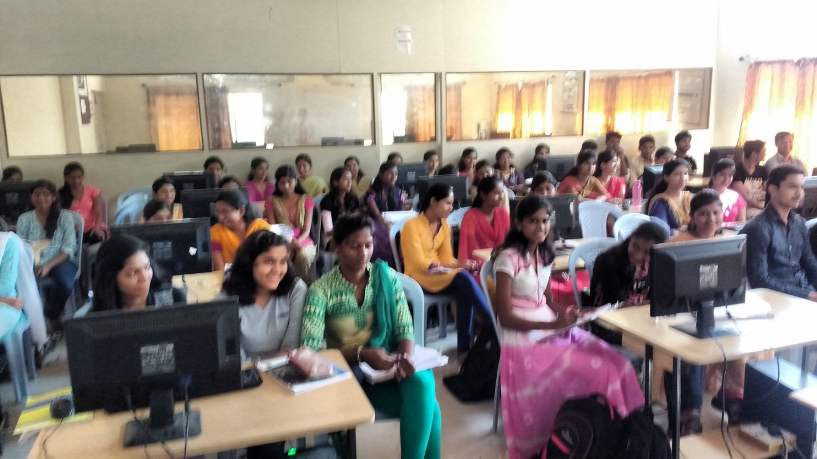

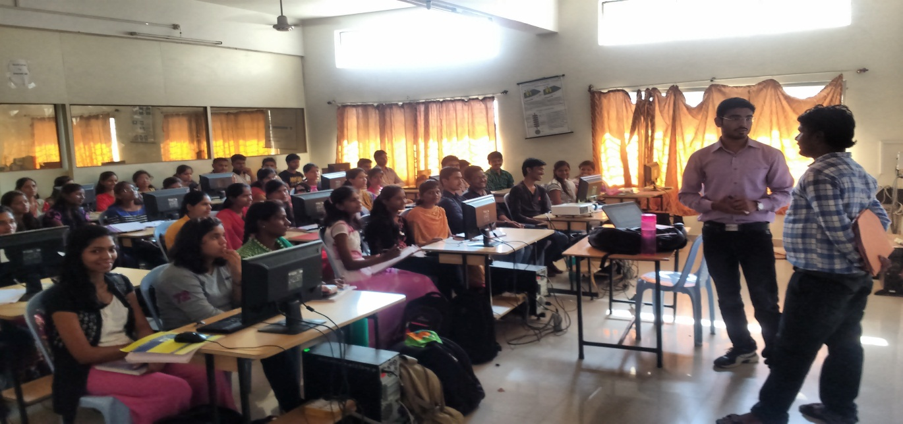

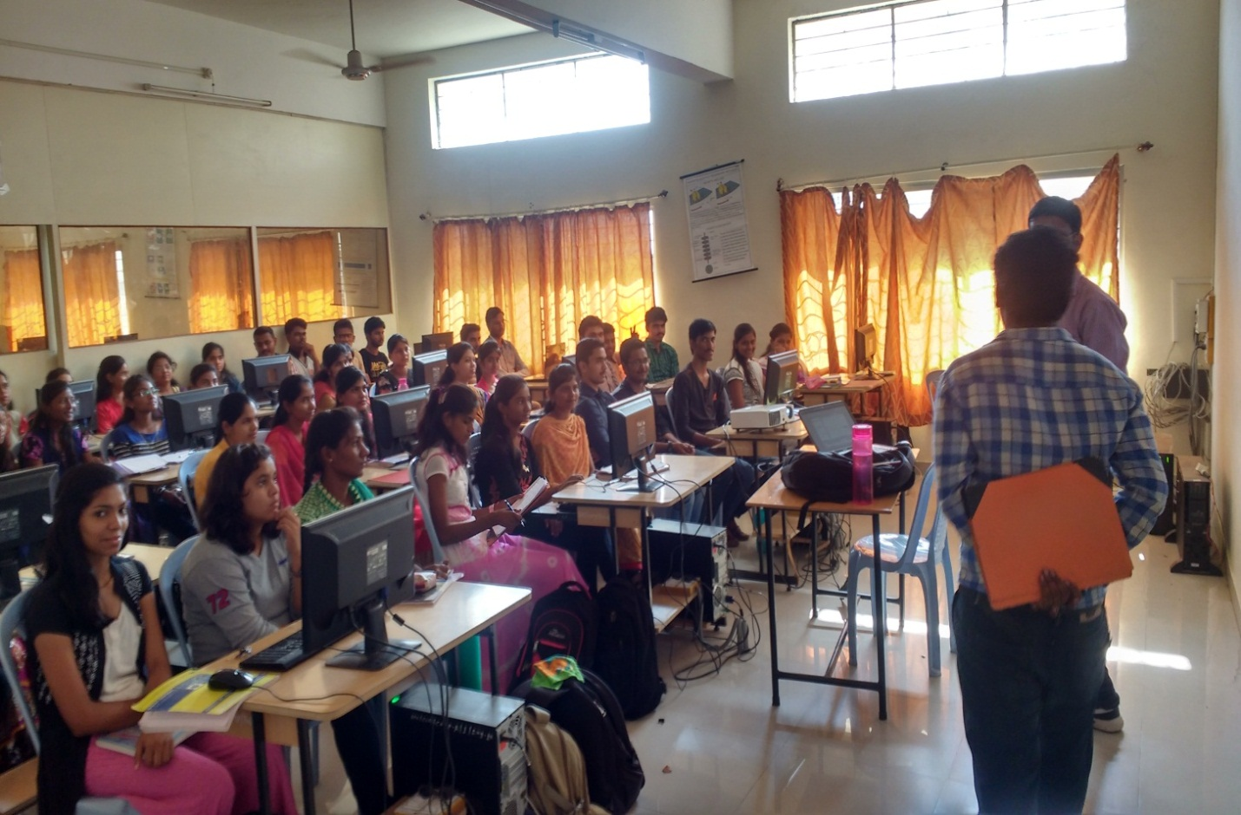
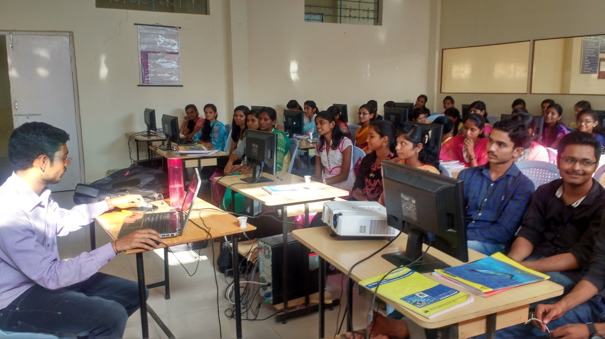
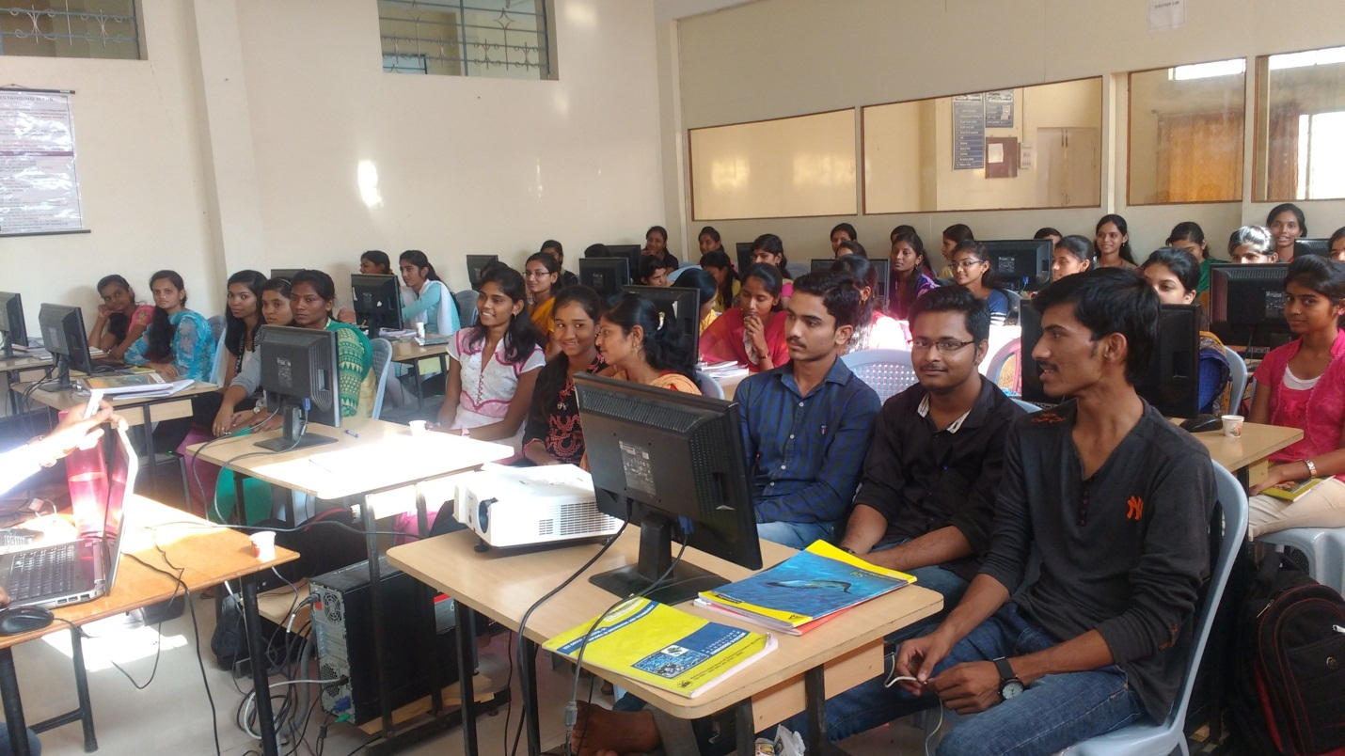

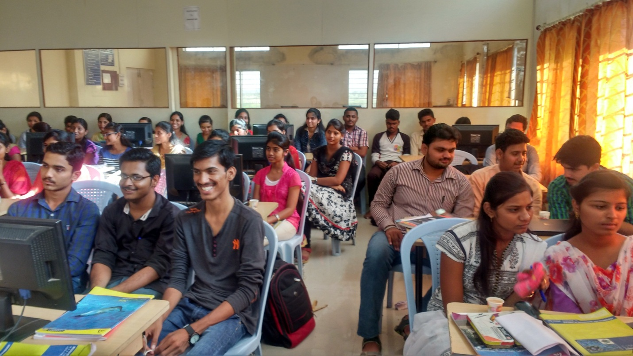
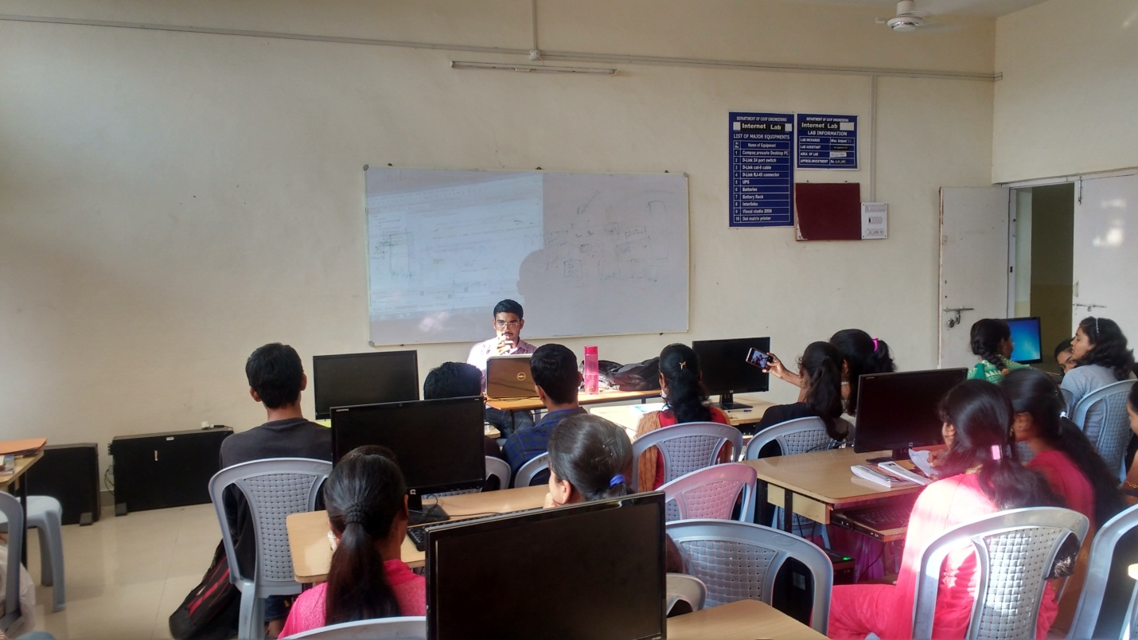
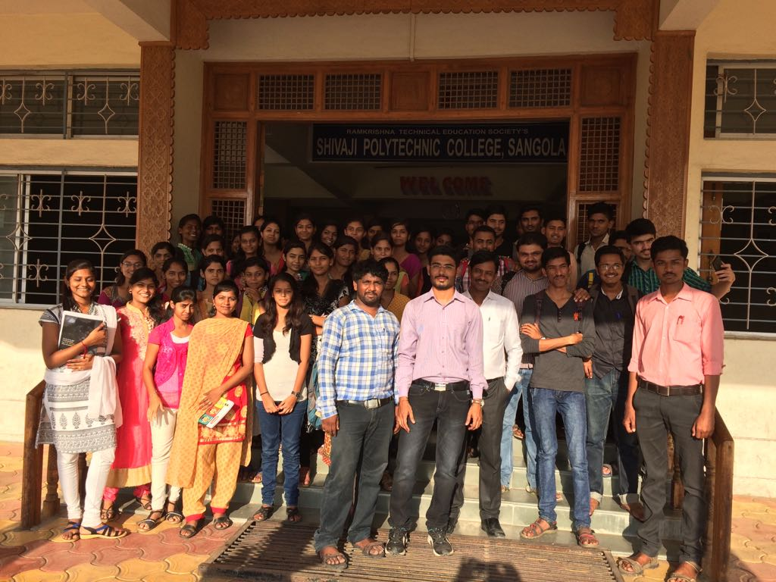
NSS CAMP:-

