Guest Lectures
Academic Year (2017-18)

Sr.  No | Gap | Action Taken | Date | Resource Person with Designation | Mode | No of Students Present
1 | Inplant Training | Inplant Training Programme on CNC cut viewer Lathe Trainer | 11/5/2017 to 28/5/20117 | MSBTE Inplant Training Programme | workshop | TY 30
2 | Inplant Training | Inplant Training Programme on CATIA | 11/5/2017  To  28/5/2017 | MSBTE Inplant Training Programme | workshop | TY 15
3 | Solid Modeling | Arranged workshop for Final Year Students. | 06/02/2018  To  07/02/2018 | Prof.Swapnil Khobragade | workshop | TY 28
1 | Bosh Pump | Understand the pratical maintenance of Bosh pump | 3/1/2018 | Mr. V.H.Magar  ( SKN Lonavala) | Guset lecture | TY
2 | Advanced safety precautions | Guest lecture on Advanced safety precautions | 2/2/2018 | Mr.Sunil Purandare  ( General Manager TATA Motors ) | Guset lecture | TY
3 | Ethical and sociological awareness | Ethical and sociological awareness | 03/12/2017 | Mr.Laulkar Sir  ( Sangola Mahavidyalay ) | Guset lecture | TY
4 | Soft Skills | Soft Skills | 2/11/2017 | Mr. V.H.Magar  ( SKN Lonavala) | Guset lecture | TY

DEAPRTMENT OF MECHANICAL ENGINEERING

Workshop on “Solid Modeling”

By
ISBM School Of Technology,Pune

Date: - 06/02/2018 to 07/02/2018

Academic Year: - 2017-18

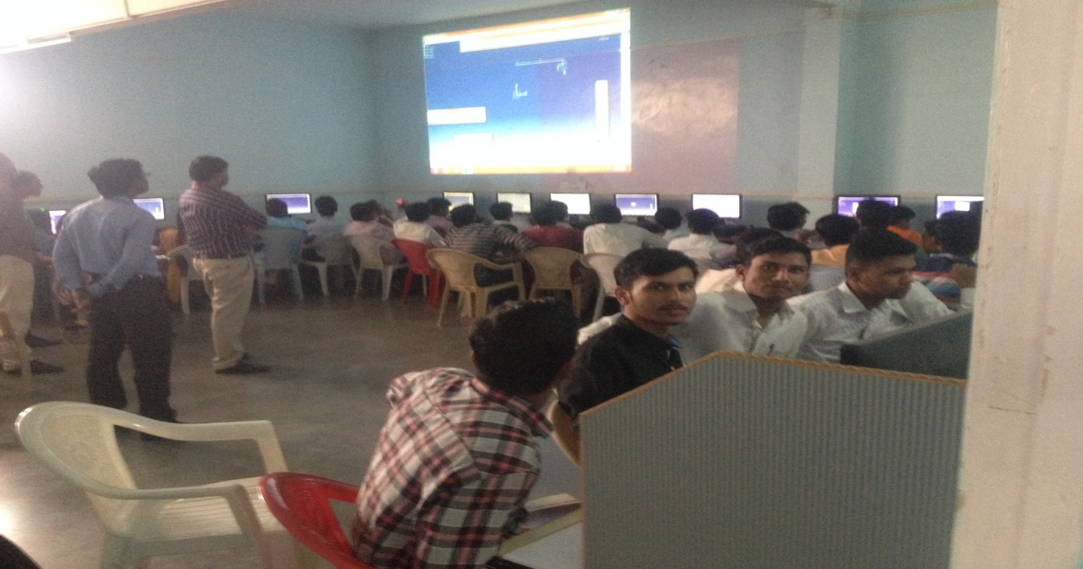
Mr.Swapnil Khobragade explaning about solid modeling software

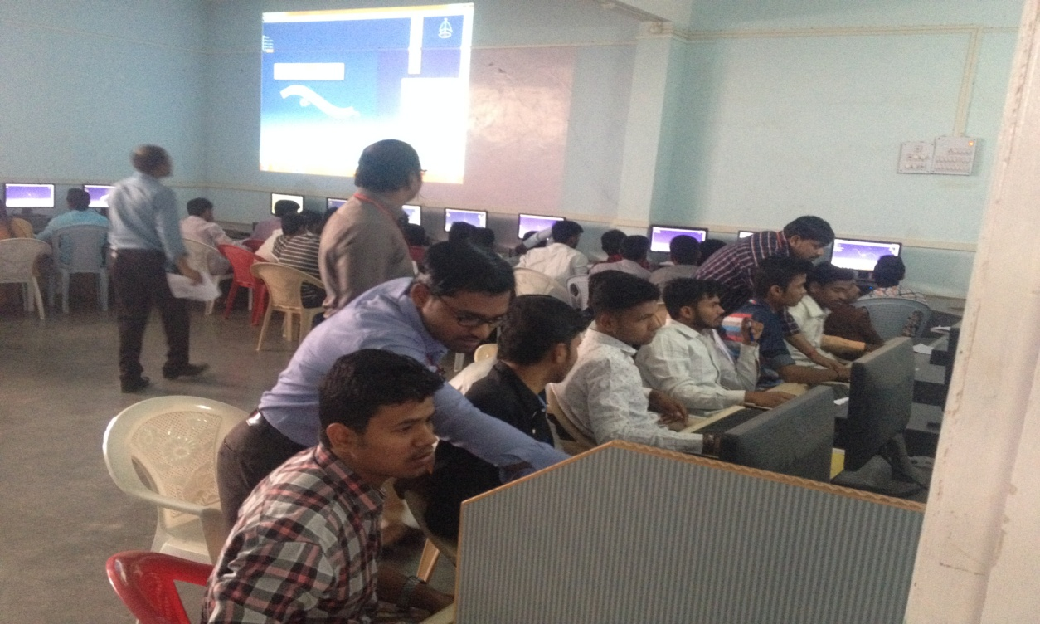
Mr.Bhosale A.B.and Mr. Bavache S.D. is teaching different commands to the students

Guest Lectures for Faculty:-
Guest Lecture on “NBA” by Dr.R.T.Vayvahare (Prof. at SKN College of Engineering,Pandharpur) on Date:- 06/02/2018
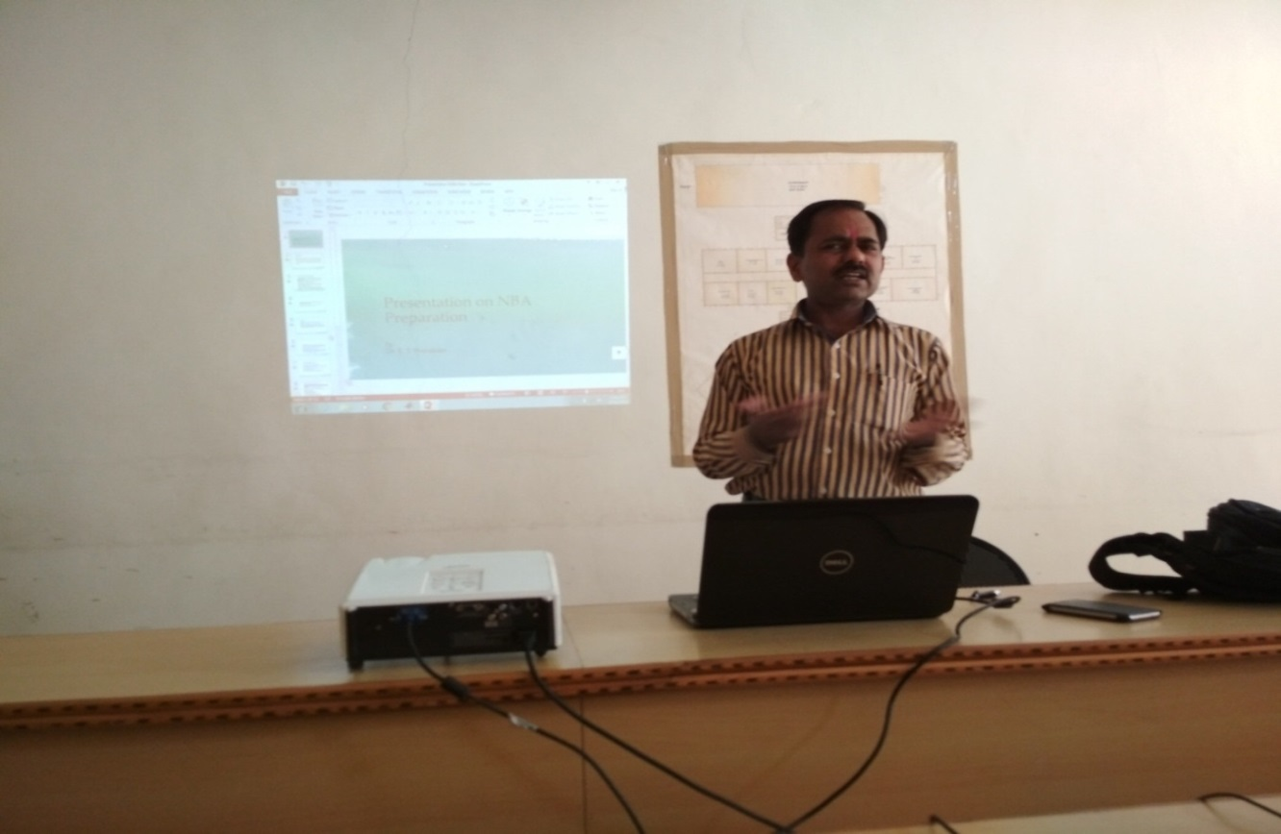
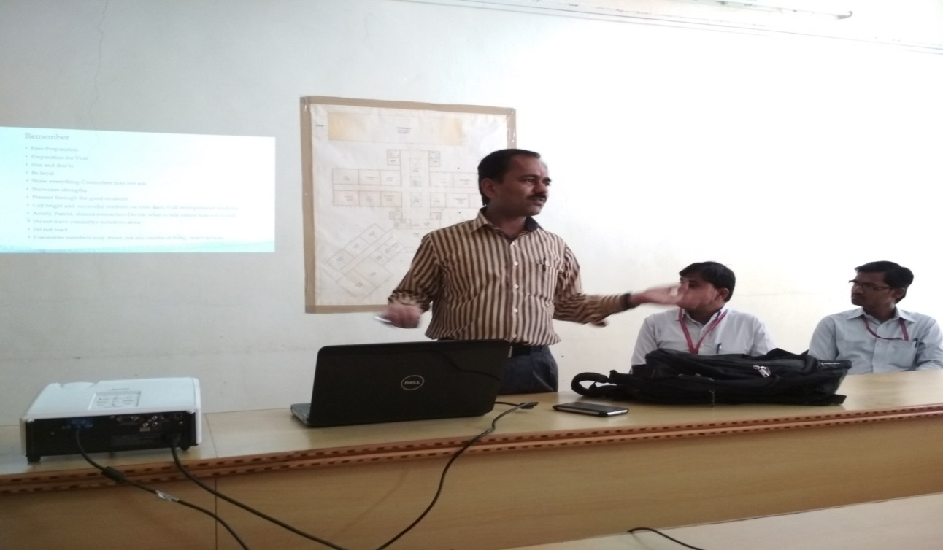
Guest Lecture on “NBA” by Dr.P.S.Kachre (Prof. at SVERI’s College of Engineering,Pandharpur) on Date:- 06/02/2018
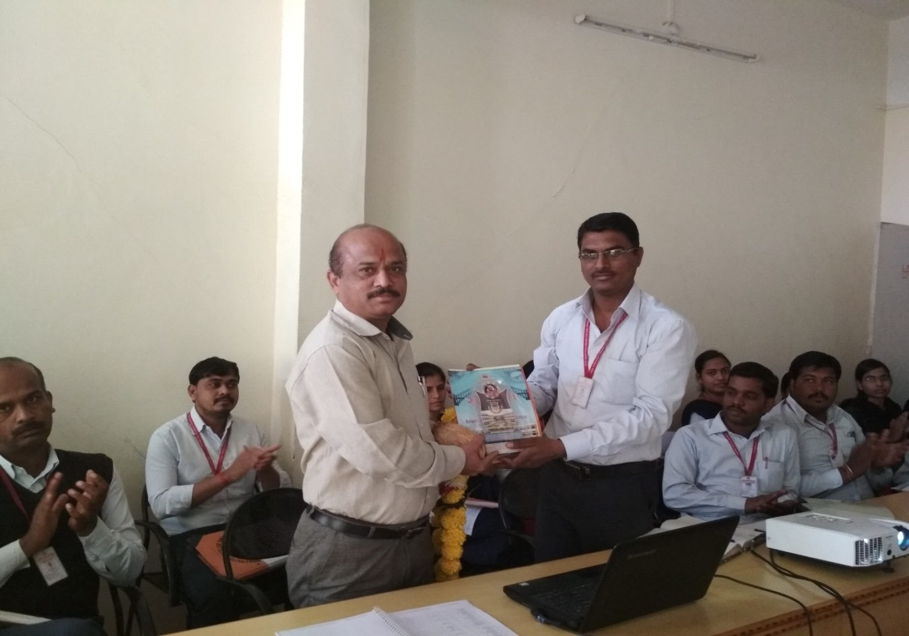

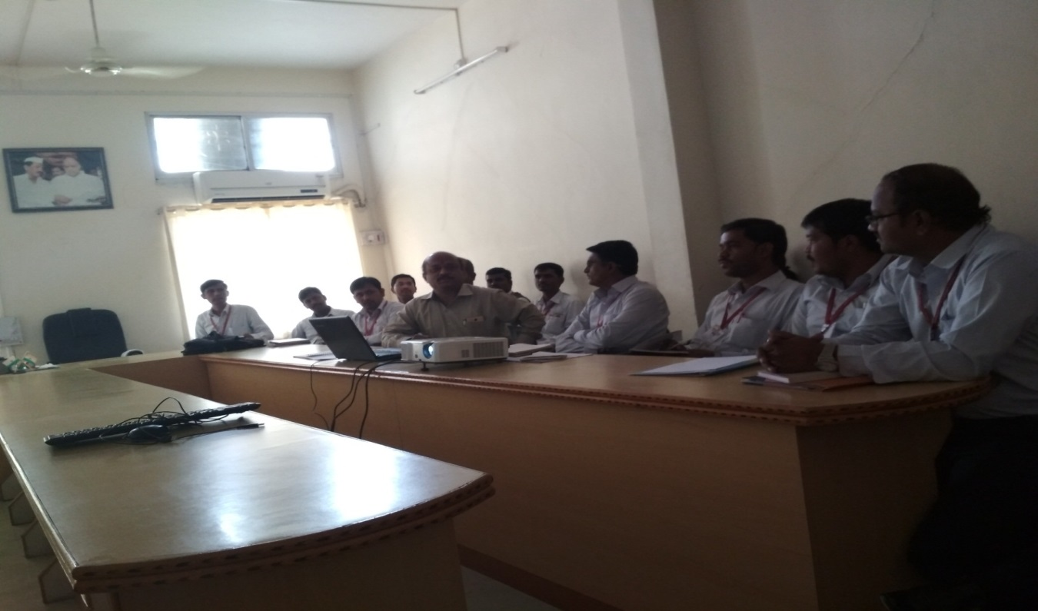
NSS CAMP:-

