Guest Lecture on “NBA” by Dr.R.T.Vyavahare (Prof. at SKN,Sinhgad College of Engineering, Pandhapur) on Date:- 05/02/2018

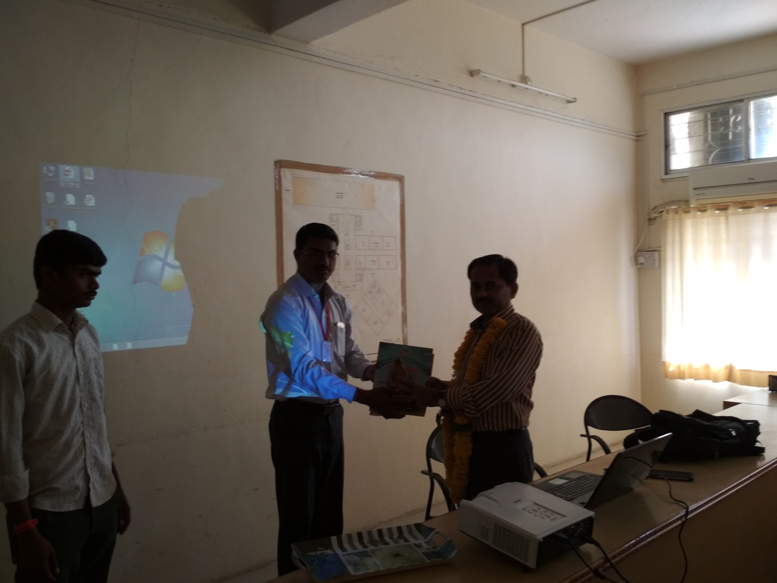
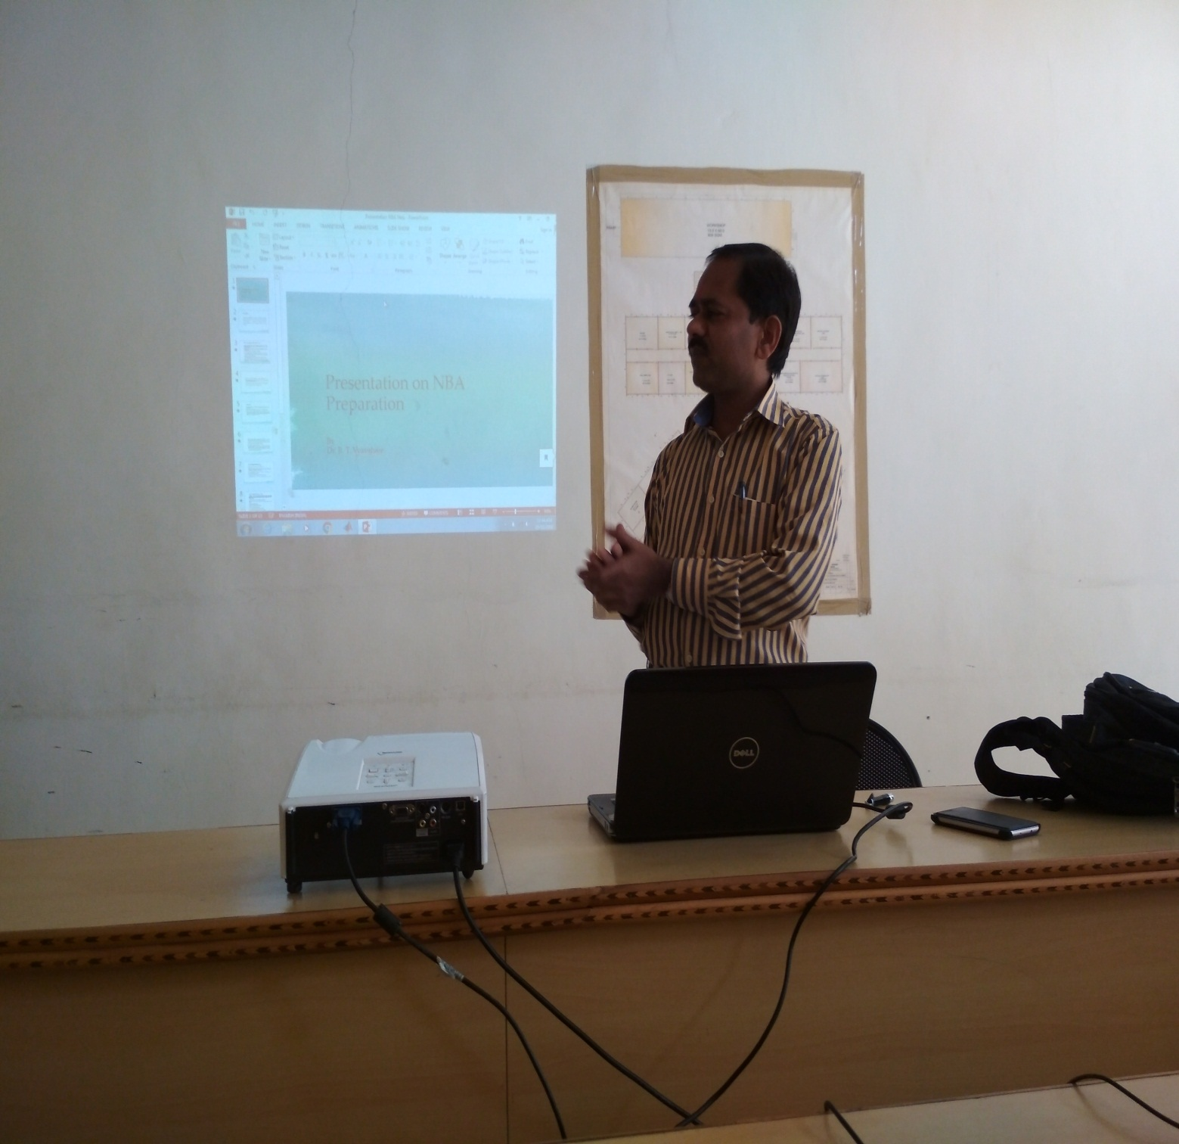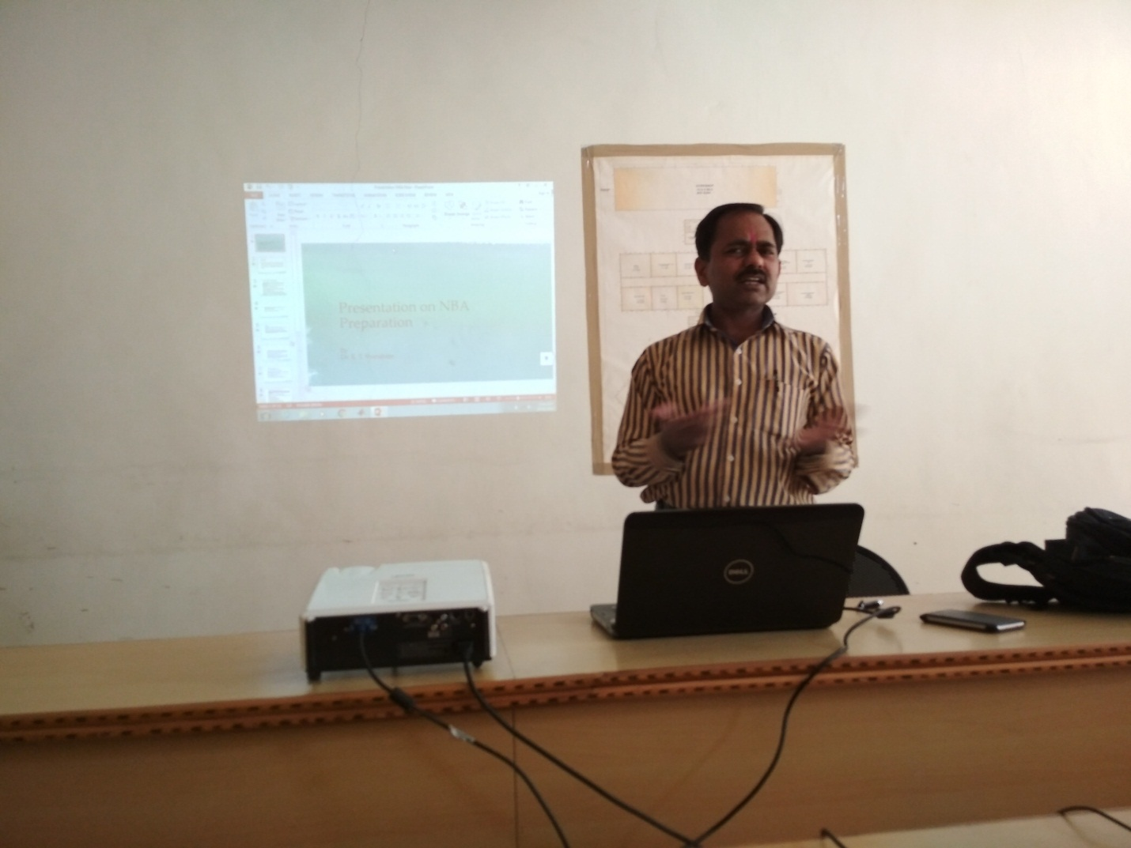
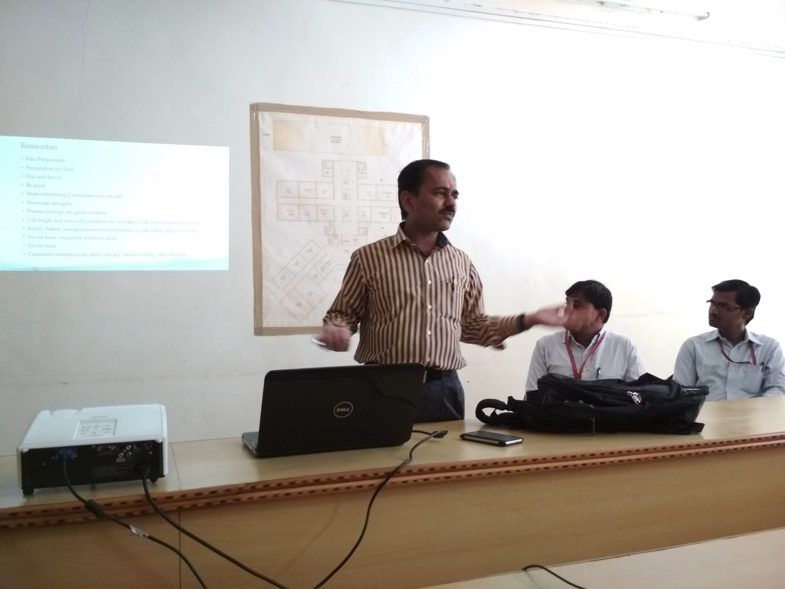

Guest Lecture on “NBA” by Dr.P.S.Kachre (Prof. at SVERI’s College of Engineering,Pandharpur) on Date:- 06/02/2018
