Academic Year (2018-19)

- Workshop:-
Sr.  No | Subject | Date | Resource Person with Designation | Mode | No of Students Present
1 | EDP | 8/3/2019 | Mr.T.R.Pandey  Project Manager  Consumer Guidance Society of India Mumbai | workshop | TY 28
2 | EDP | 14/02/2019 | Mr.M.C.Shaikh | Guest Lecturer | 90

Guest Lectures
Academic Year (2018-19)
Sr.  No | Subject | Action Taken | Date | Resource Person with Designation | Mode | No of Students Present
1 | Nonmetallic Advanced Materials | Arranged Guest for Third Year Students. | 13/10/2018 | Dr.R.S.Dhivare  Assi.Prof.  Sangola Mahavidyalay | Guest Lecturer | 47
2 | SOM | Arranged Guest lecturer fo Second Year students | 06/02/2019 | Prof.S.D.Katekar  SKN Pandharpur | Guest Lecture | SY 45
3 | MPR | Expert lecture on Manufacturing Processes | 13/02/2019 | Mr.R.A.Ashtekar  Assi.Porf.  New Satara Polytechnic  Pandharpur | Guest Lecture | 40
4 | Renewable Energy Sources | Arranged Guest for Third Year Students. | 11/02/2019 | Mr.N.S.Nidasosi  Assi.Prof  Sanjeevan Engg and  Tech Institute Panhala | Guest Lecture | 60
5 | I.C Engine Testing | Arranged Guest for Third Year Students. | 25/08/2018 | Mr.Uday Karvekar  Assi.Prof  Karmyogi Engg and Polytecnic Shelve | Guest Lecture | 90
6 | AUTO-CAD  ( 2D and 3D Drawing ) | Arranged Guest for Third Year Students | 24/08/2018 | Mr.Balaso Suresh Dhumal  Head of Disha Computer Institute Pandharpur | Guest Lecture | 90
7 | Electrical System usedin Automobile | Arranged Guest for Third Year Students | 11/10/2018 | Mr.Y.S.Doifode  New Satara Polytechnic  Pandharpur | Guest Lecture | 90
8 | Refrigeration and Air Conditioning | Arranged Guest for Third Year Students | 26/09/2018 | Mr.V.R.Ranavare  SMSMP Akluj | Guest Lecture | 90

Guest Lectures (Photos)
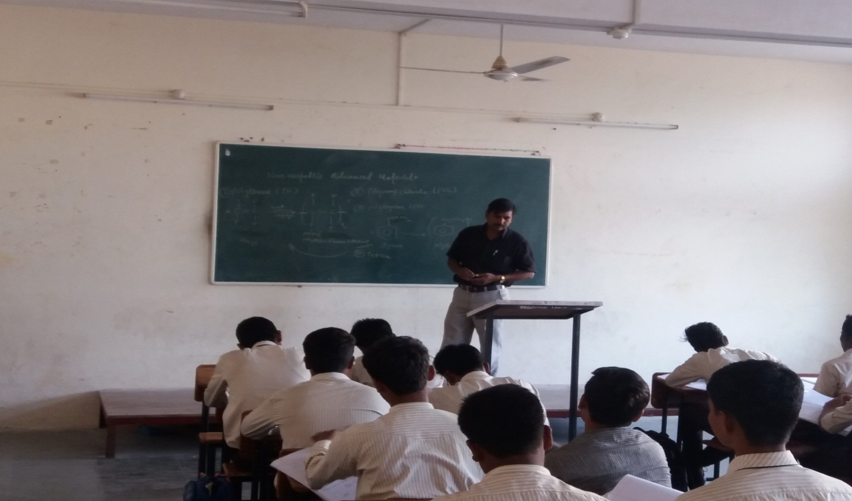
Dr.Dhivare sir is explaining the non -metallic materials to the second year students.
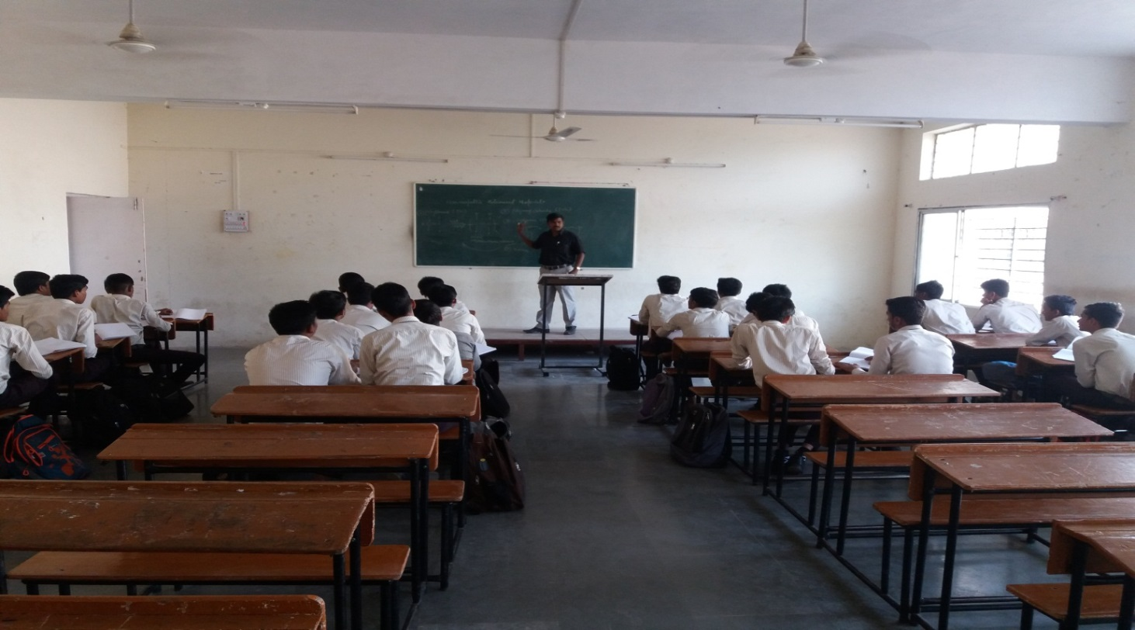
Mr. Dhivare sir is interacting with students.
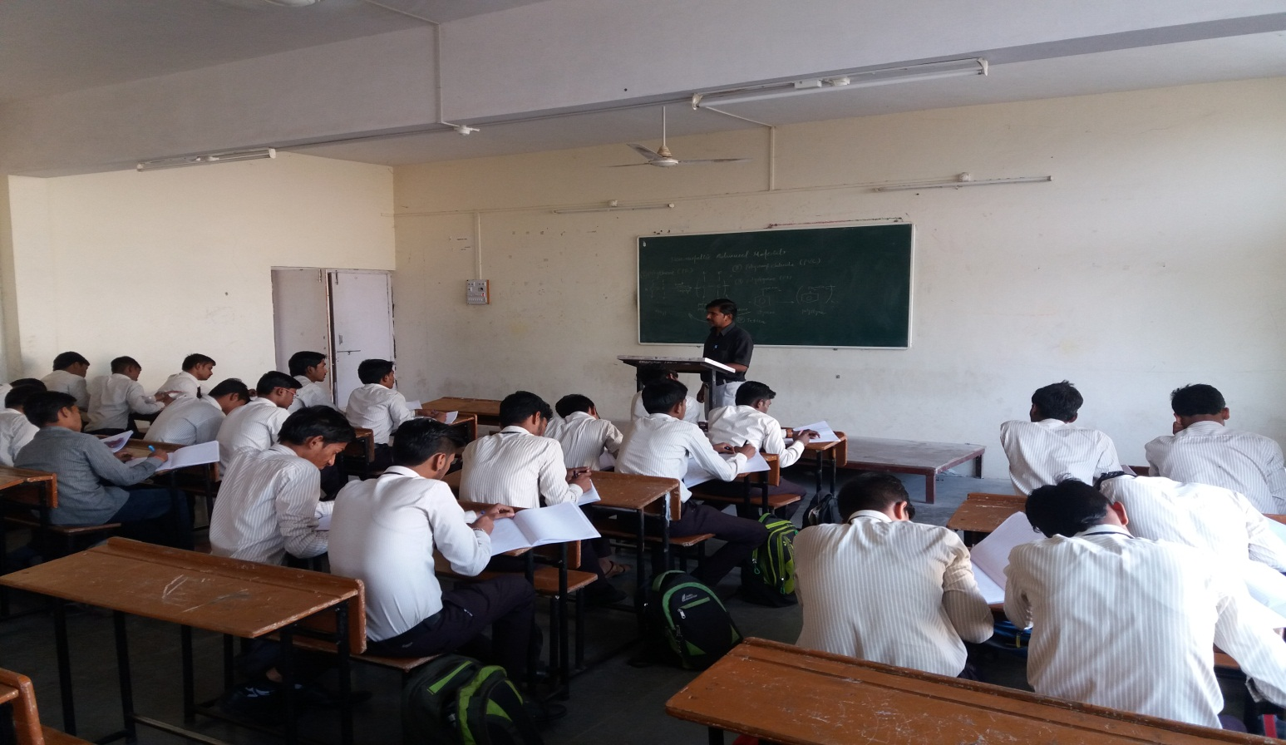
Mr. Dhivare sir is explaining the importance of plastic materials.
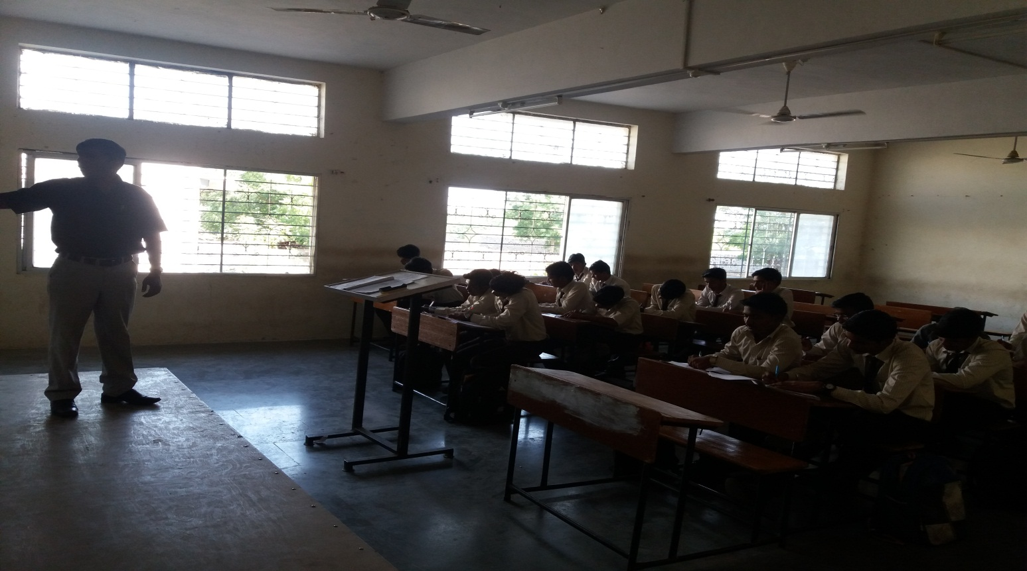
Mr. Dhivare sir is explaining the importance of In-organic materials.

