DEAPRTMENT OF CIVIL ENGINEERING

Workshop on “TOTAL STATION”

By
Gallop infra services Consultancy
Date:- 23/09/2019 to 24/09/2019

Academic Year: - 2019-20
Date: 23/09/2019
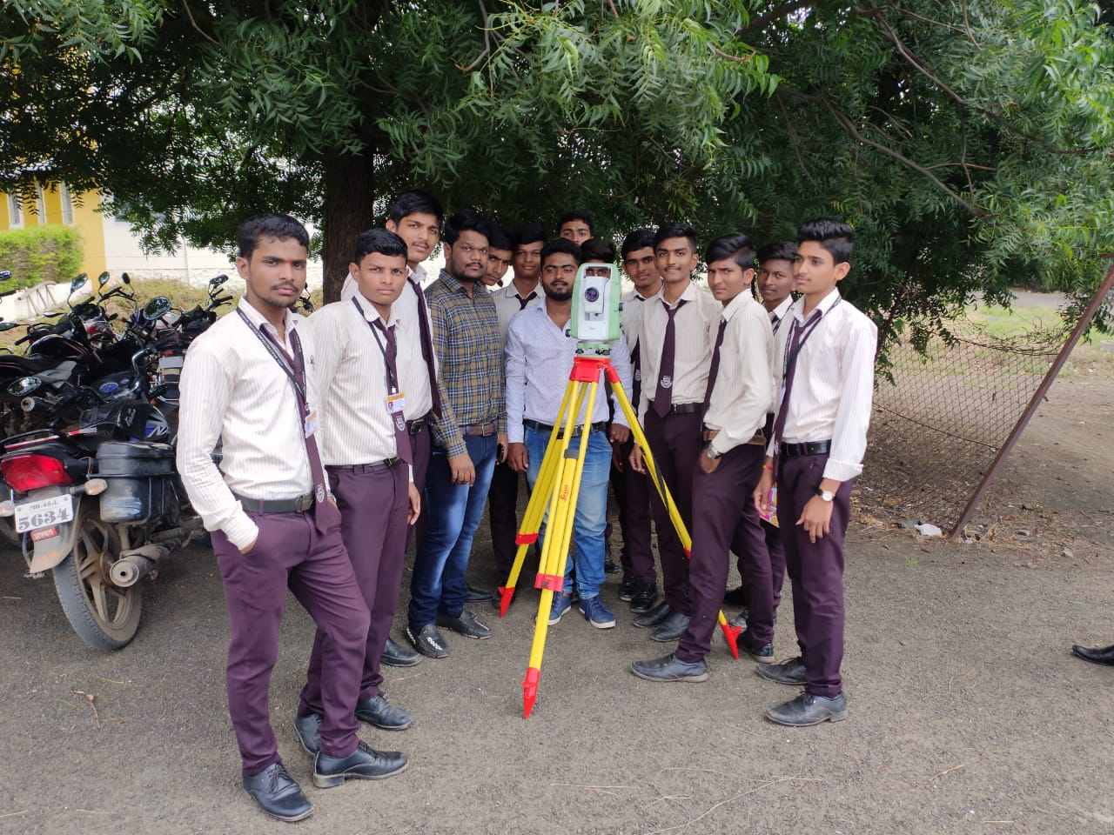

MR. Kalyansingh. Rajput ( Project Manager, Gallop Infra Services Consultancy) CONDUCTING PRACTICAL SESSION OF WORKSHOP OF “TOTAL STATION”
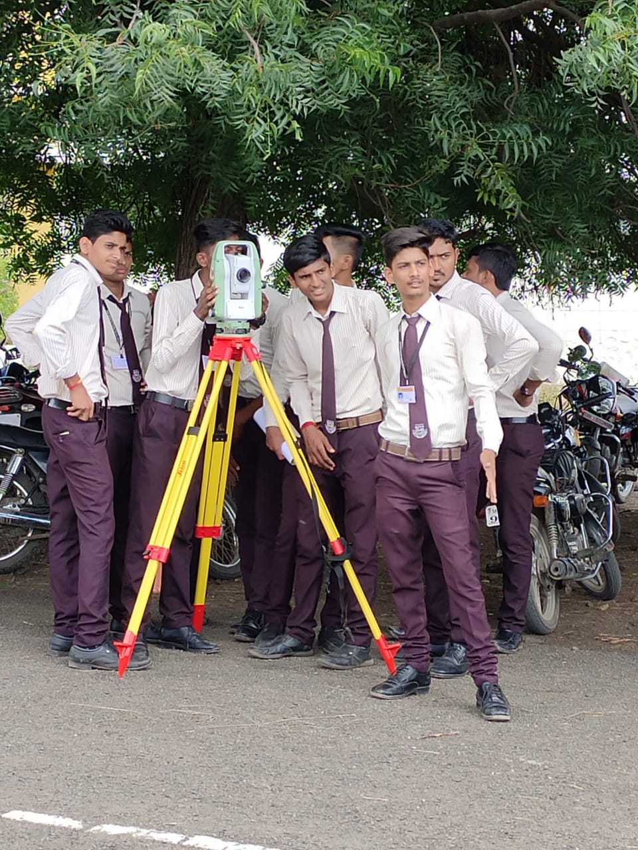
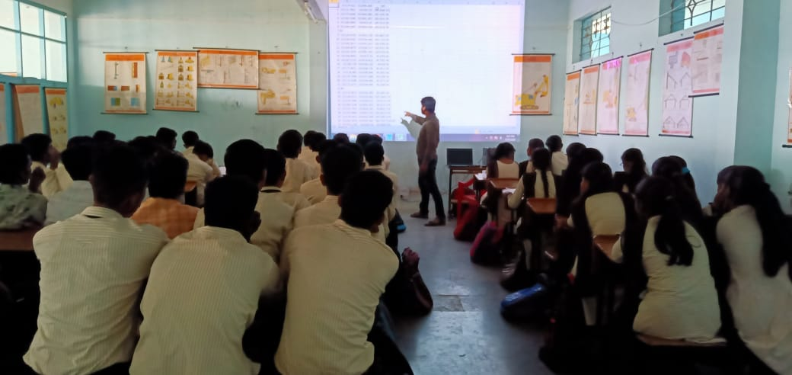
.

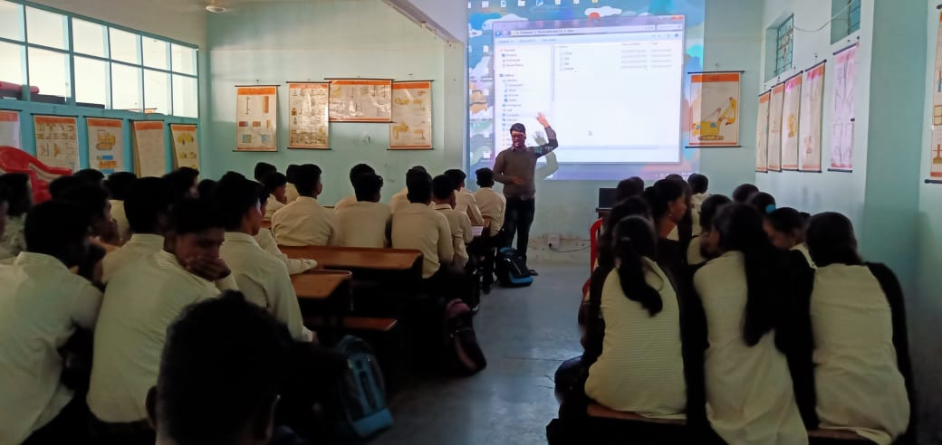

MR. D. Deshmukh ( Surveyor, Gallop Infra Services Consultancy) CONDUCTING CLASS SESSION OF WORKSHOP OF “TOTAL STATION”
GUEST LECTURES BY INDUSTRY PROFESSIONALS
Date: 20/02/2020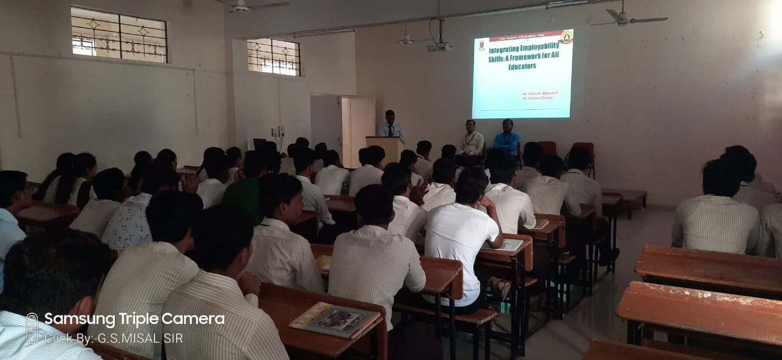

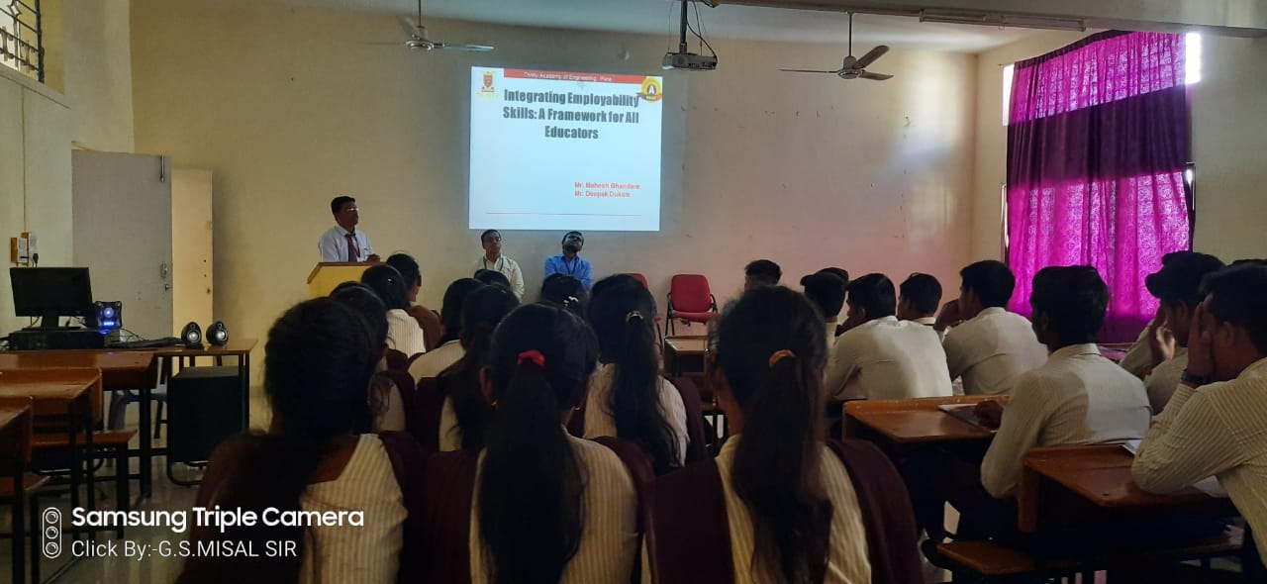
Mr.M.A. Bhandare and Mr D.B.Dukale of Triniyty Academe of engineering , VJTI Mumbai Conducting lecture on Integrating employabling skills(Frame work for all educaters)
DATE:-12/02/2020
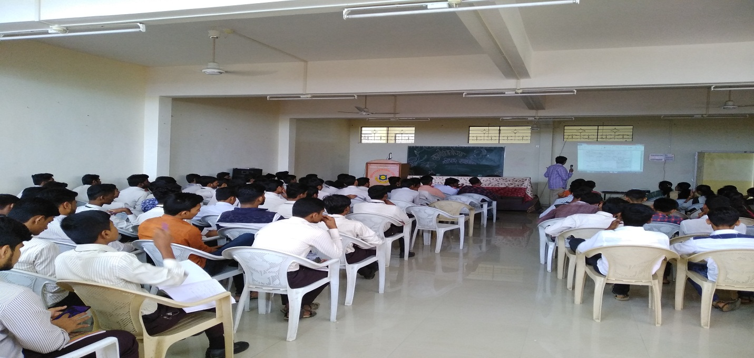
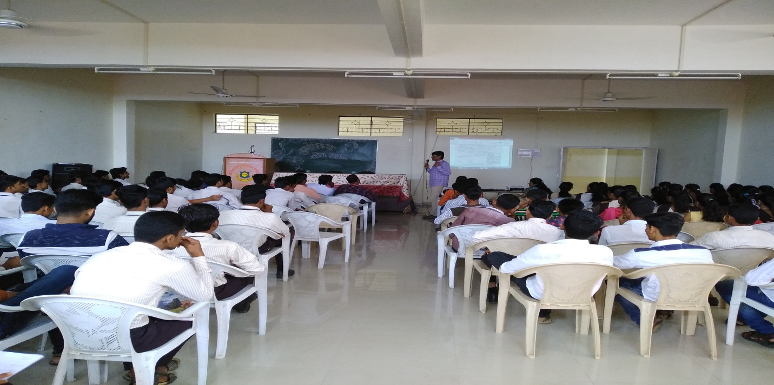

Mr. Ankalgi Sir explaining the management of construction.

DATE:-27/02/2020
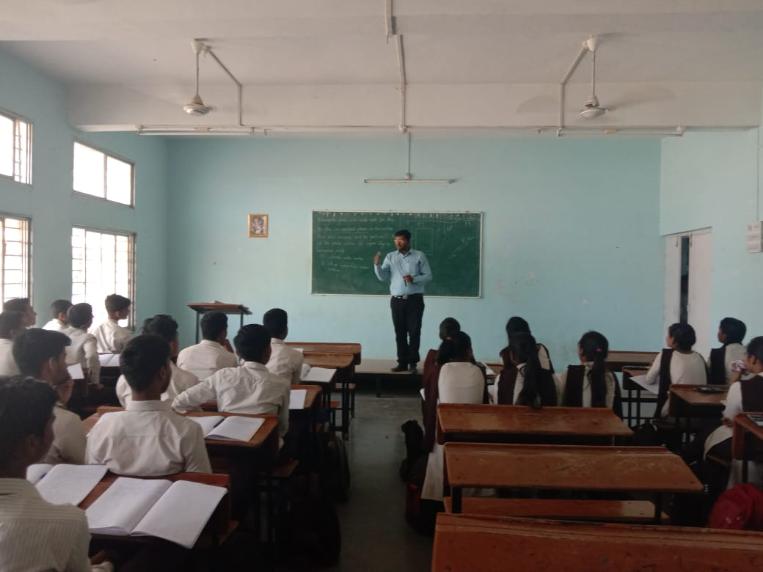
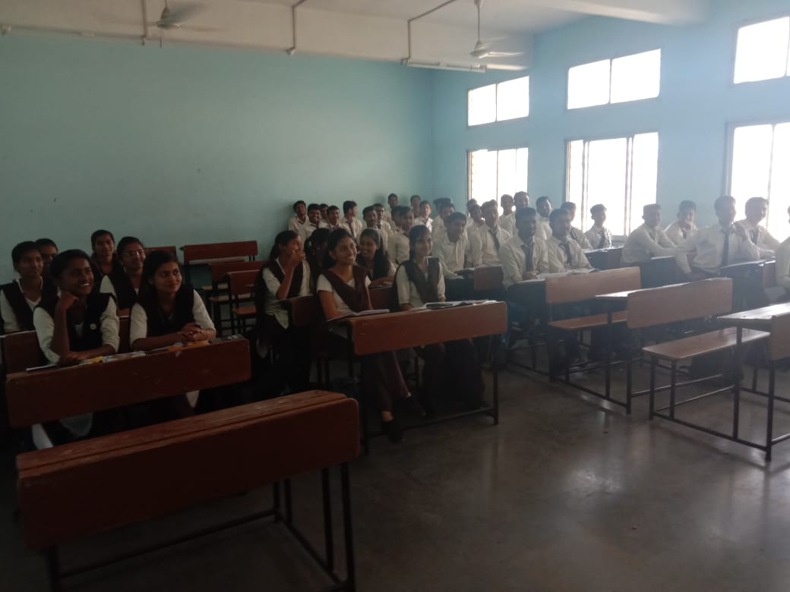
Mr. S.S. Kolekar conducting expert lecture on Hydraulics-Hydrostatitc on second year civil engineering class
DATE:-17/02/2020
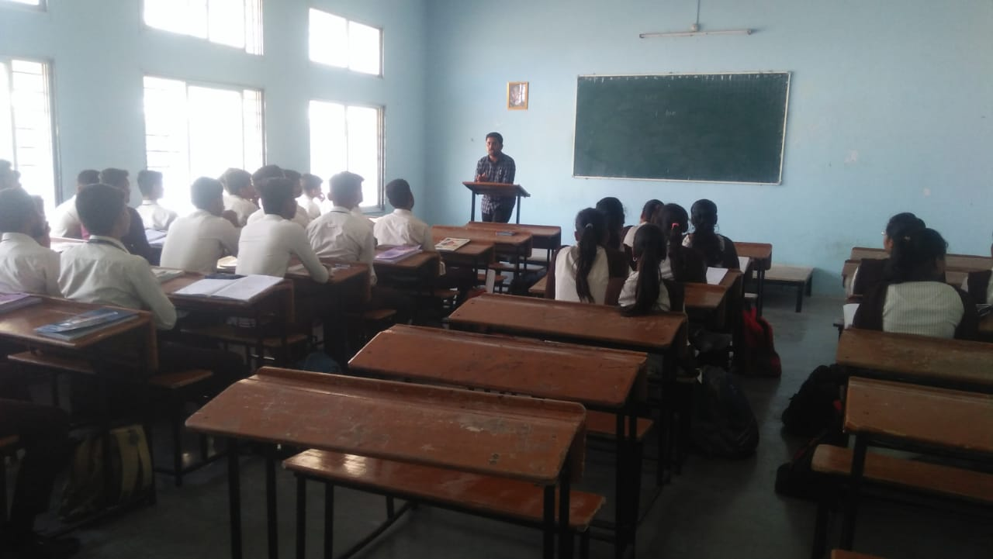

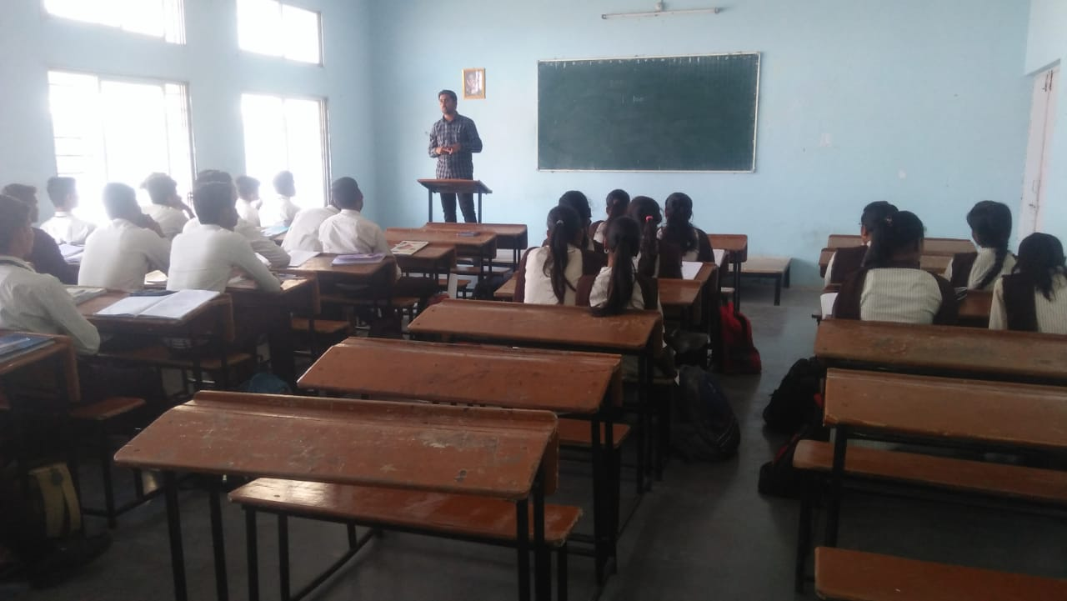

Mr. V.C. Bagal sir conducting a guest lecture on second year civil engineering class on the topic of building planning and design.

NSS CAMP:-

