Workshop & Guest Lecture:-

Academic Year (2019-20)
- Guest Lecture
Sr.  No | Gap |  | Action Taken | Date |  | Resource Person with Designation |  | Mode | No of Students Present | Relevance to  POs &PSOs
1
 | Water Treatment |  |  | 26/2/2020 |  | Mr.P.T.Lokhande |  | Guest Lecture | 47 | Po-1,po-6
3
1
2

DEAPRTMENT OF GENERAL SCIENCE
WORKSHOP ON

MSBTE Video Lectures on Applied Mathematics to
First Year Mechanical and Electronics Engineering Dept.
Date: - 3/2/2020 to 5/2/2020

Academic Year: - 2019-20

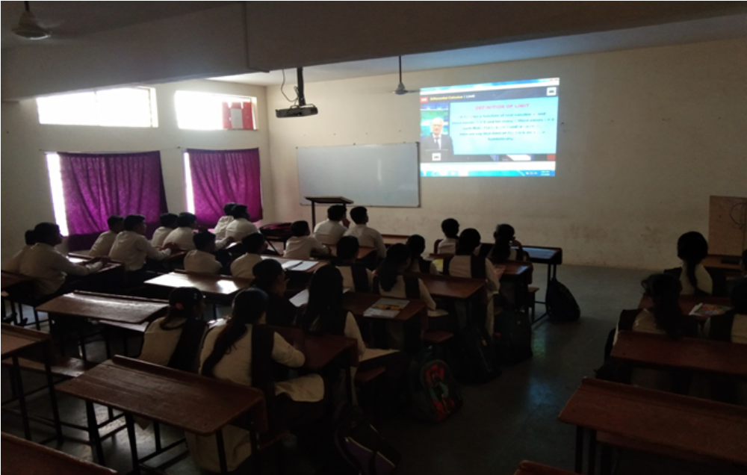

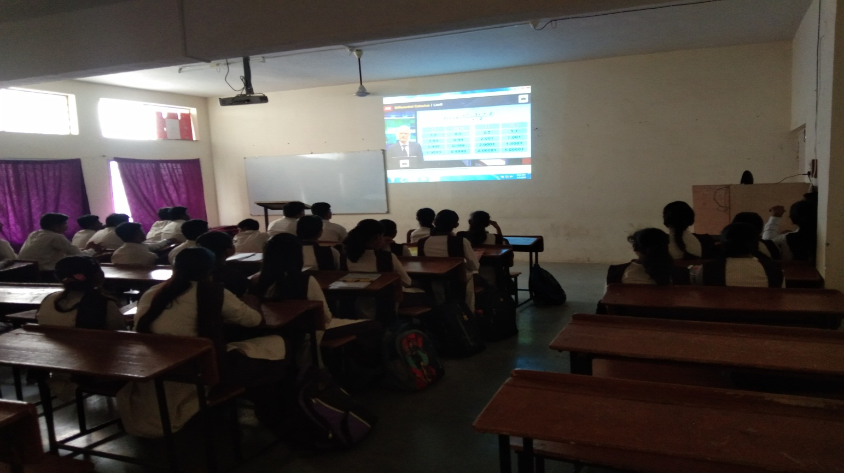

Guest lecture on Water Treatment delivered by
Mr.P.T.Lokhande (SVERI’s College of engg,pandharpur)
Date-26/2/2020 A.Y-2019-20

