Guest Lecture on “Fiber Optics ”
Date :- 20/10/2023
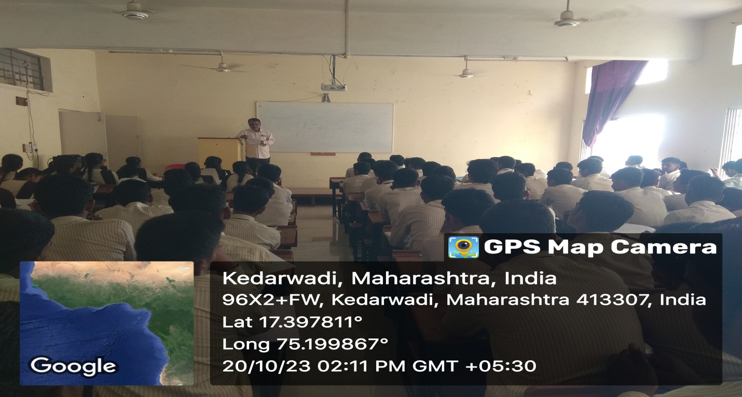

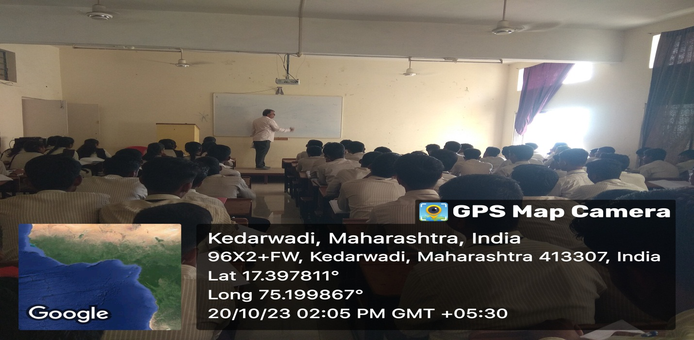
Mr.Dhotre Conducting Guest Lecture on “Fibre Optics” For First Year Student.
Guest Lecture on “Electrochemistry”
Date: 16/10/2023
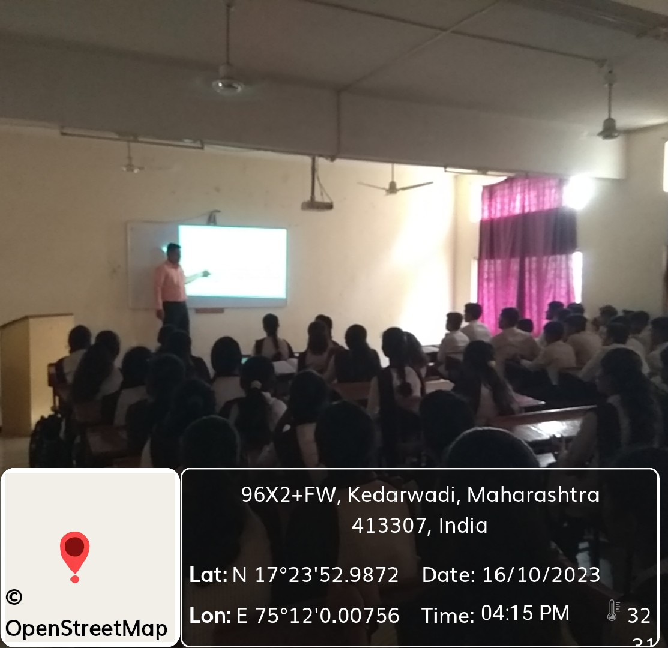

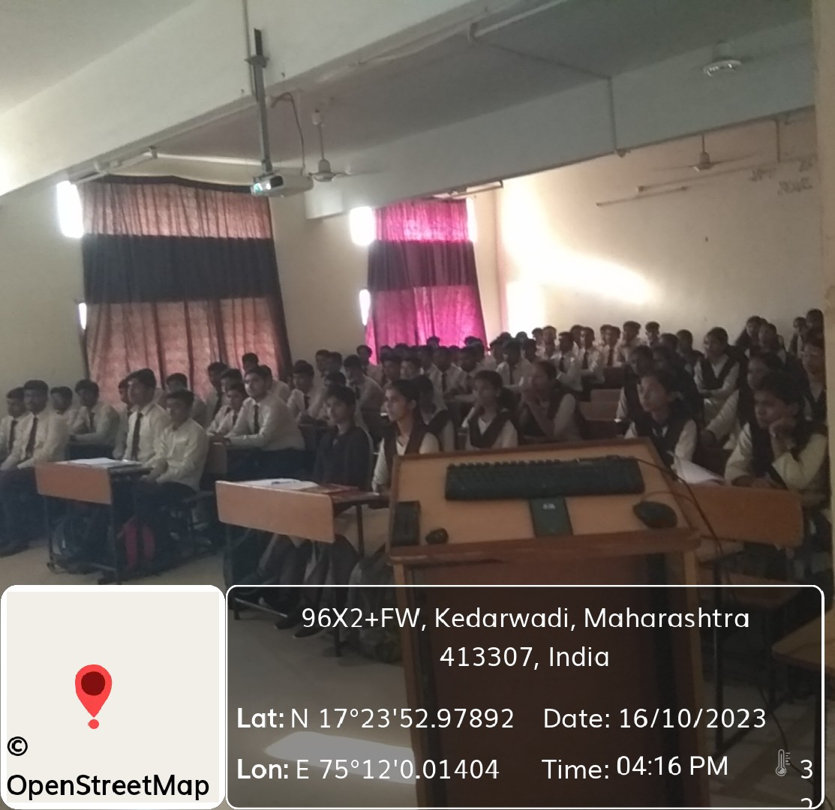
Dr.Bharat Pawar Conducting Guest Lecture On “Electrochemistry”For First Year Student.
Guest Lecture on “LASER” Date :- 08/02/2024
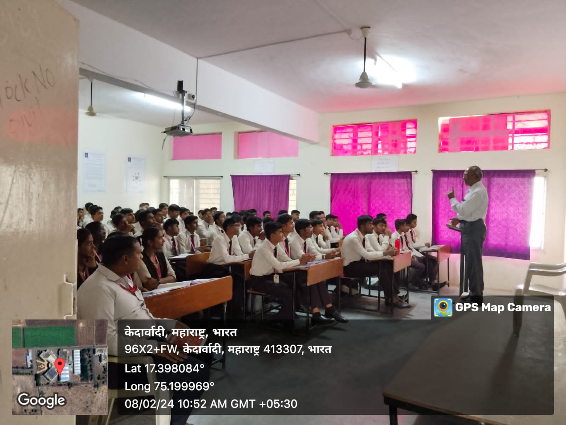
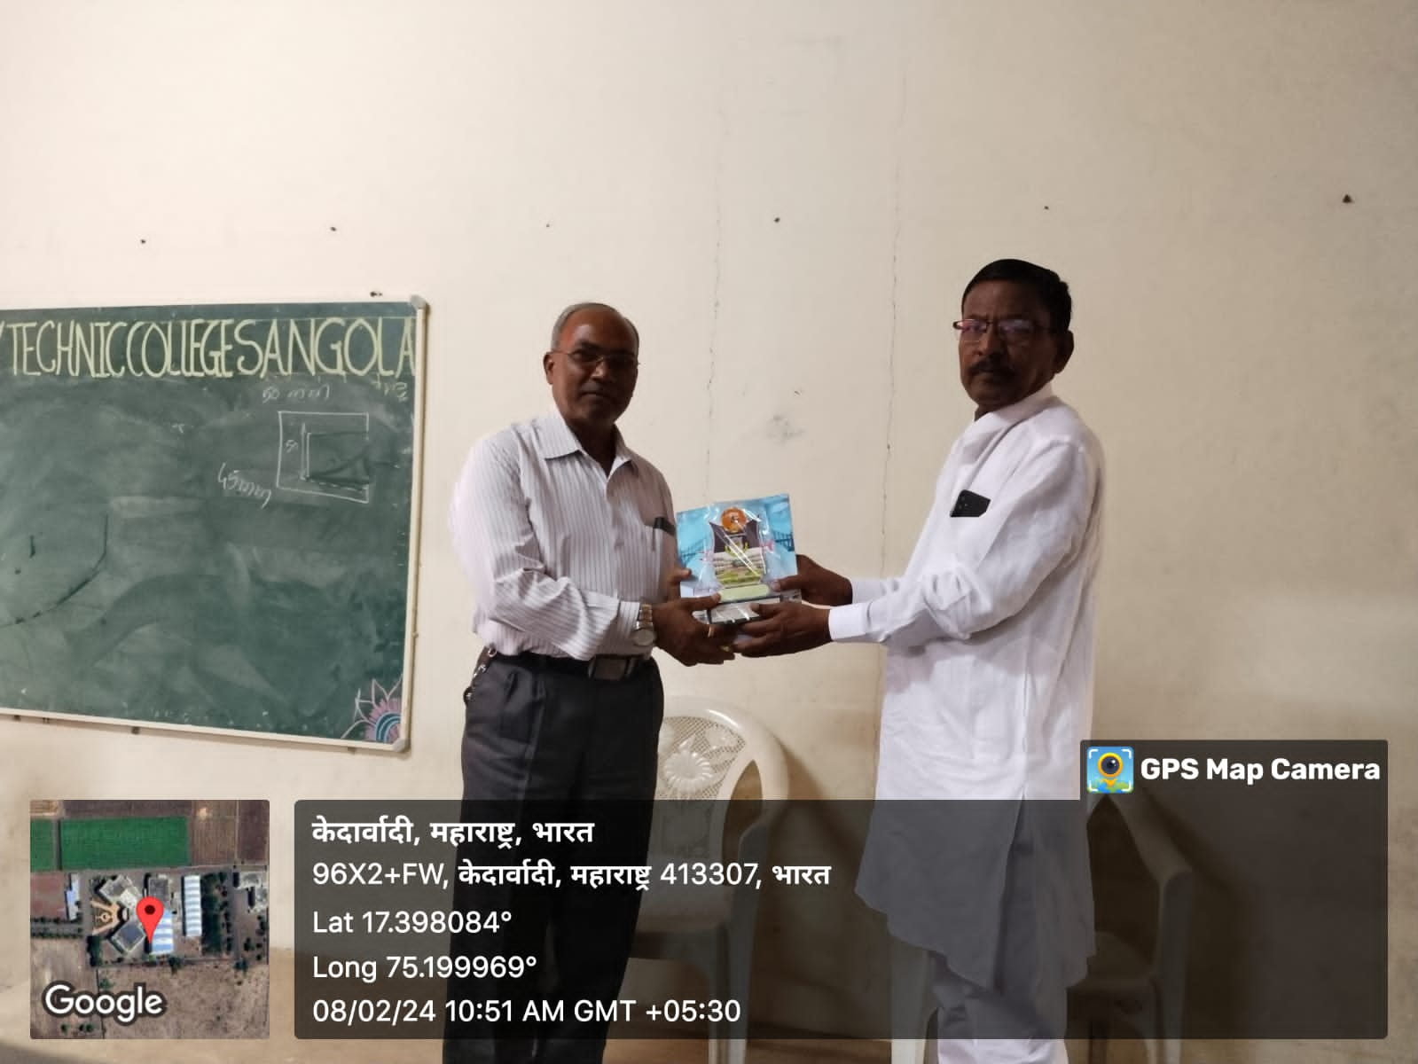
Mr.B.G.Shitole Conducting Guest Lecture On “LASER” For First Year Student.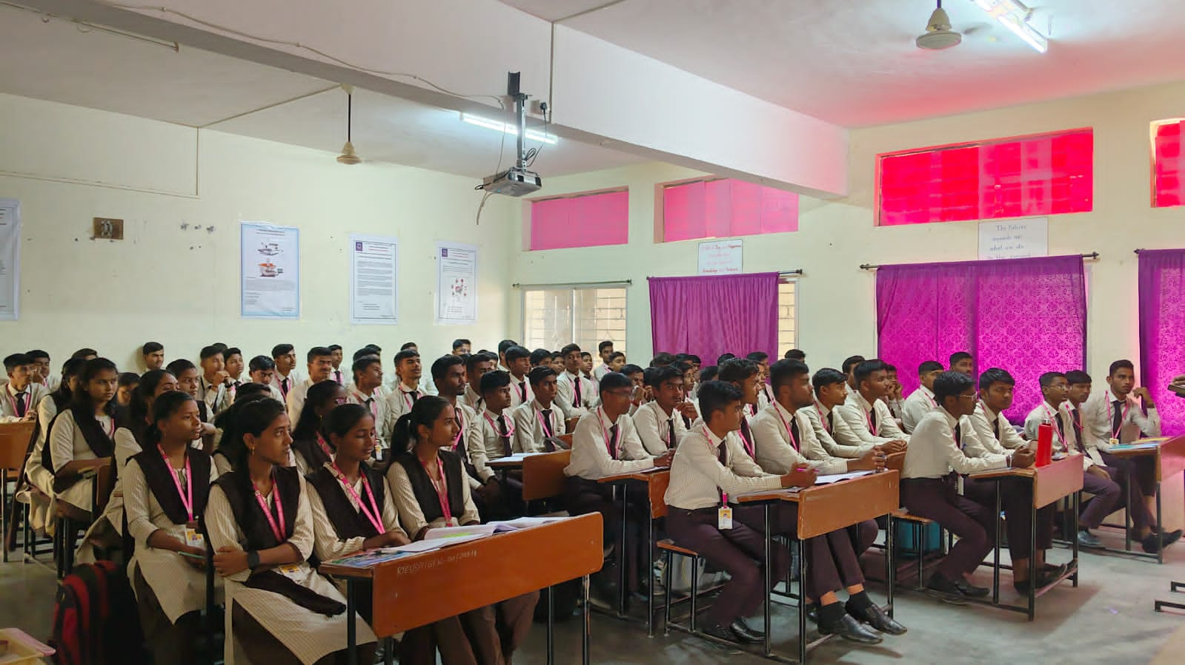

Chief Guest Dr.R.A.Bugad Felicated by Mr.P.G.Pawar General Science HOD , Mr. S.M. Bhosale Civil HOD
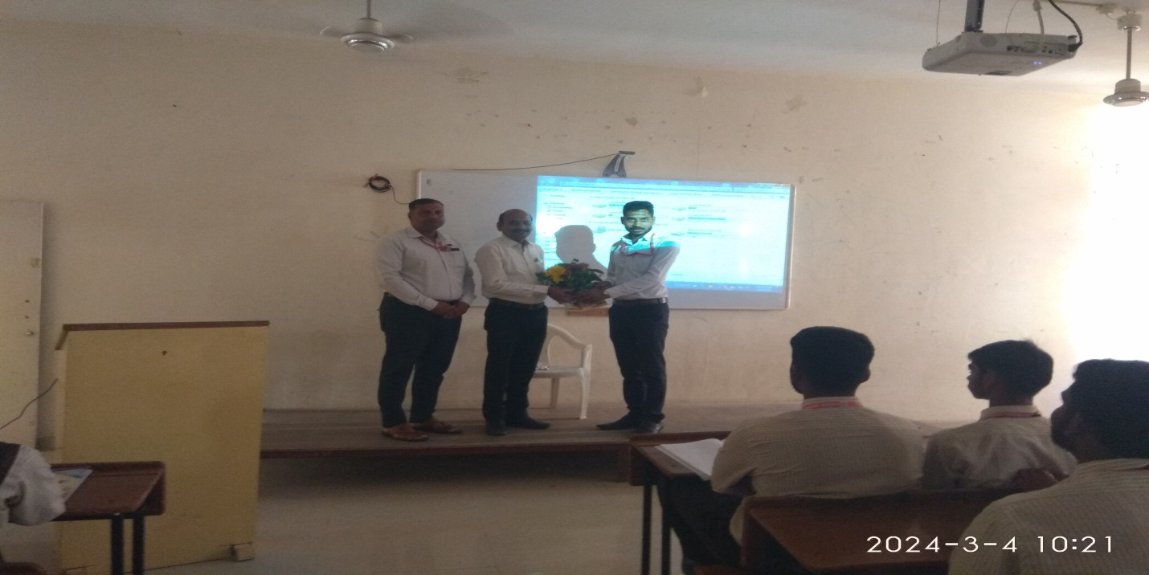

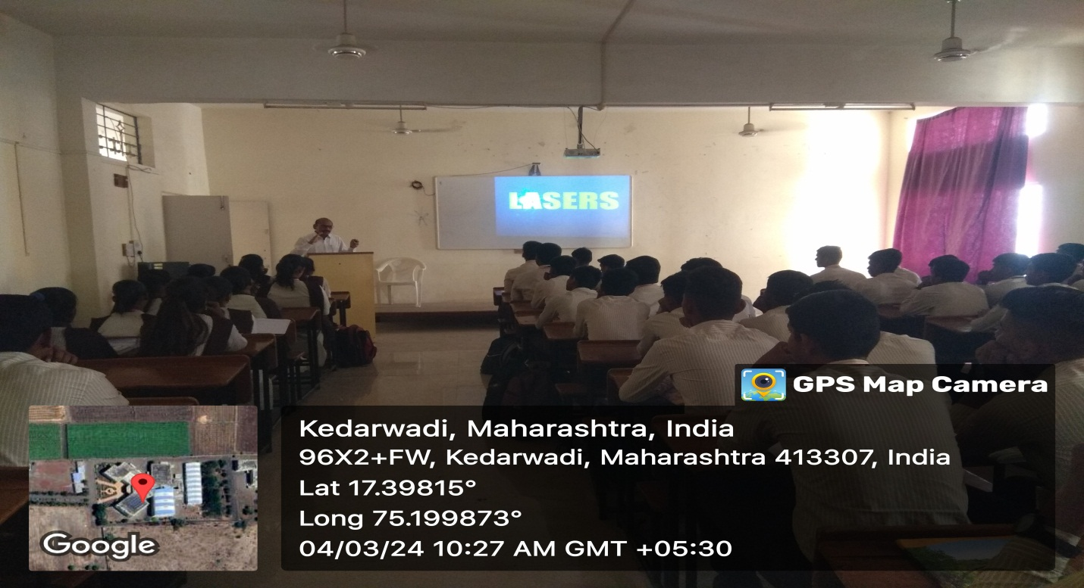
Dr.R.A.Bugad Conducting Guest Lecture on “ LASER ” For First Year Student.

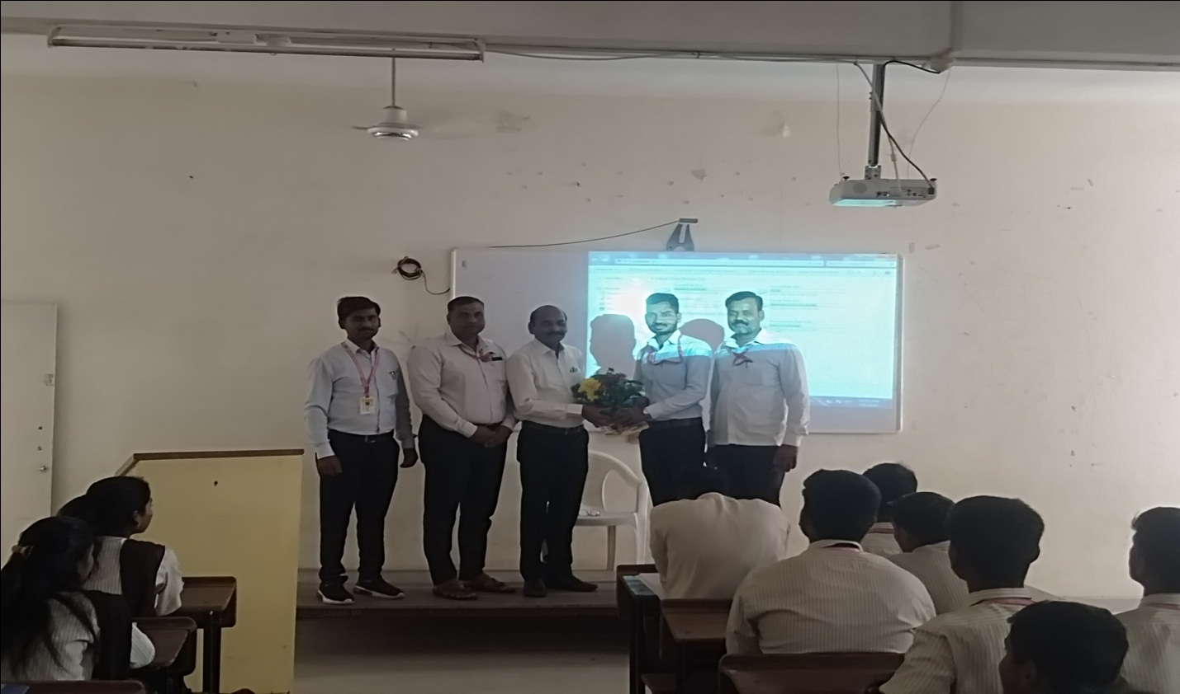

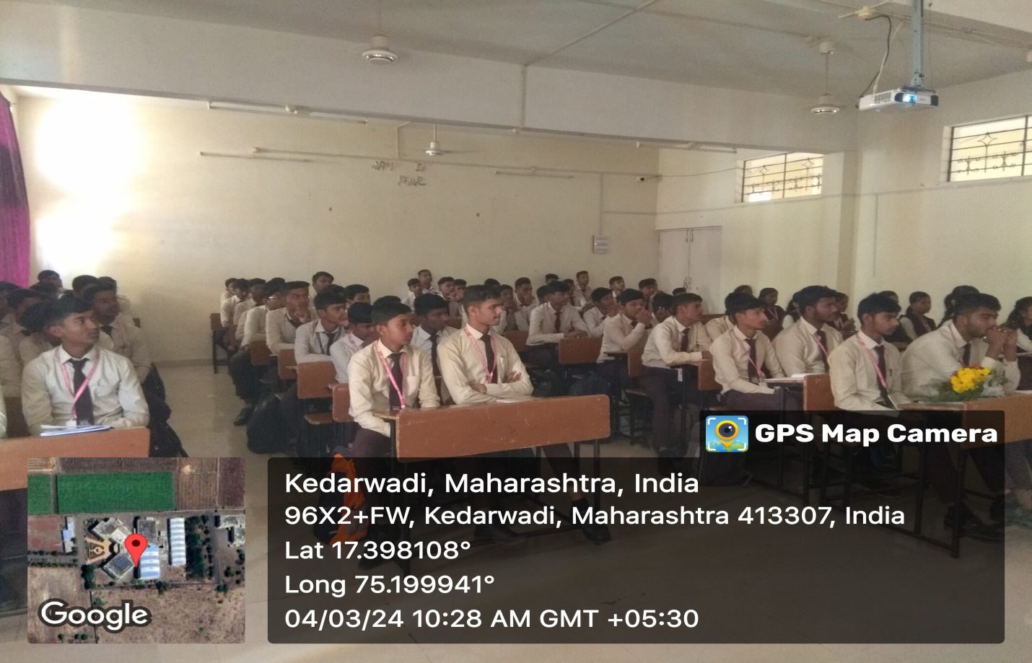
Chief Guest Dr.P.M.Kharade Felicated by Mr.P.G.Pawar General Science HOD and Mr. S.D.Aldar.
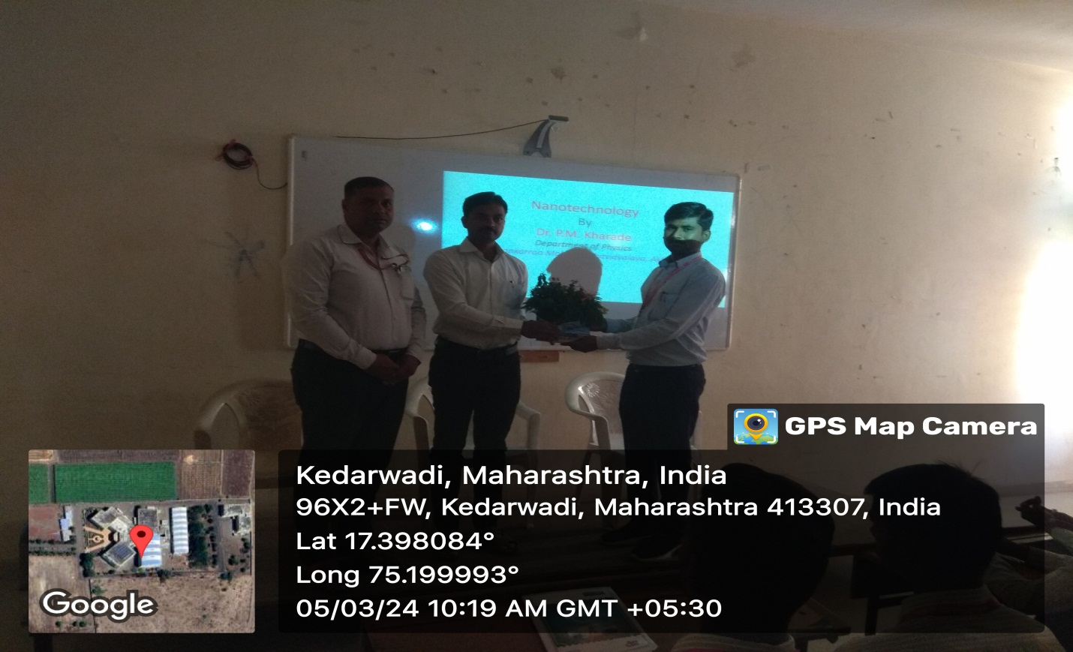
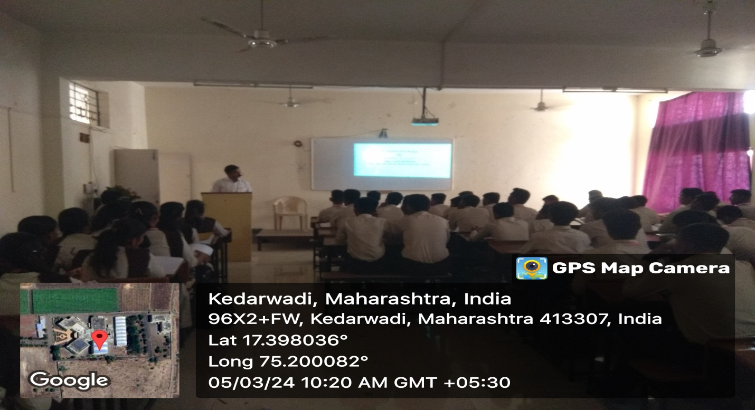Dr.P.M.Kharade Conducting Guest Lecture on Nanotechnology
(Physics) For First Year Student.
Chief Guest Dr.B.G.Pawar Felicated by Mr. S.D.Aldar and Mr.P.B.Gaikwad .
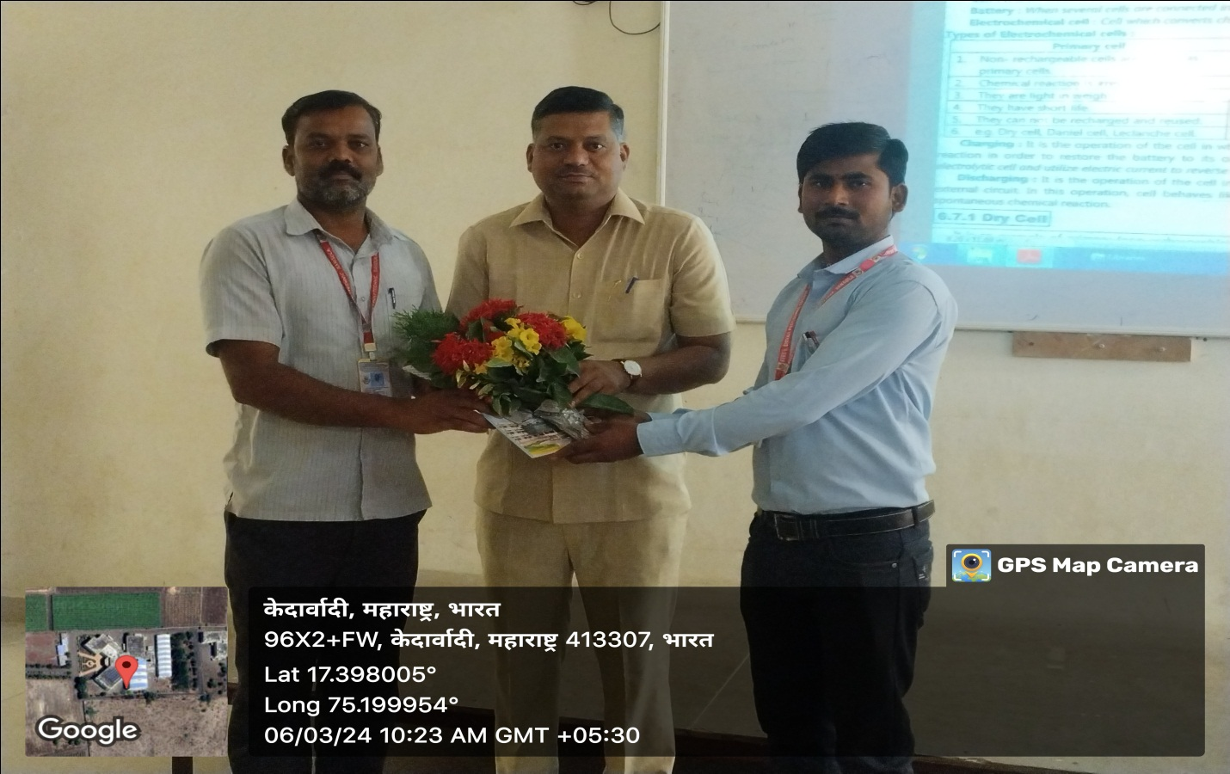
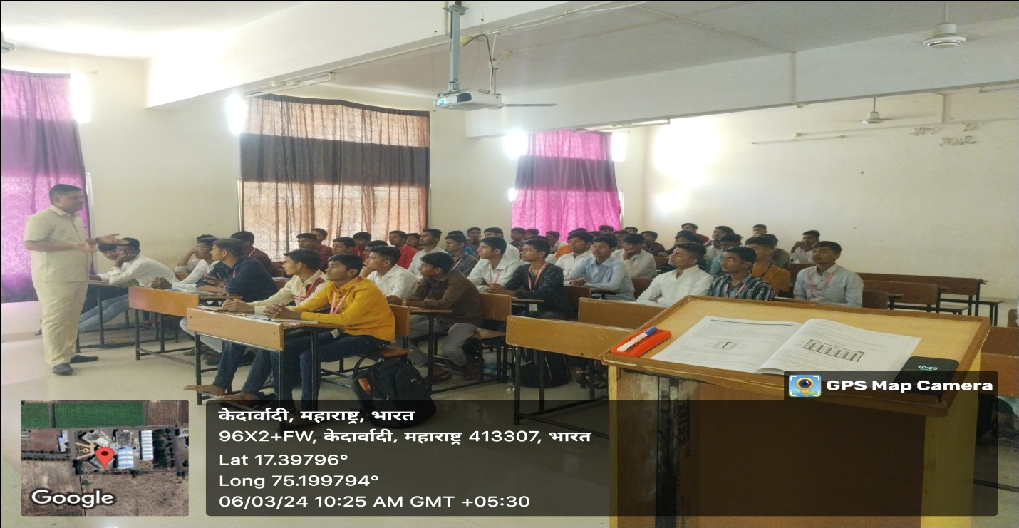Dr.B.G.Pawar Conducted Guest lecture on Electric Conductance , Cell and Batteries For First Year Student.
Chief Guest Mr.B.S.Savase Felicated by Mr.P.C.Chavan and Mr.A.Y.Gaikwad
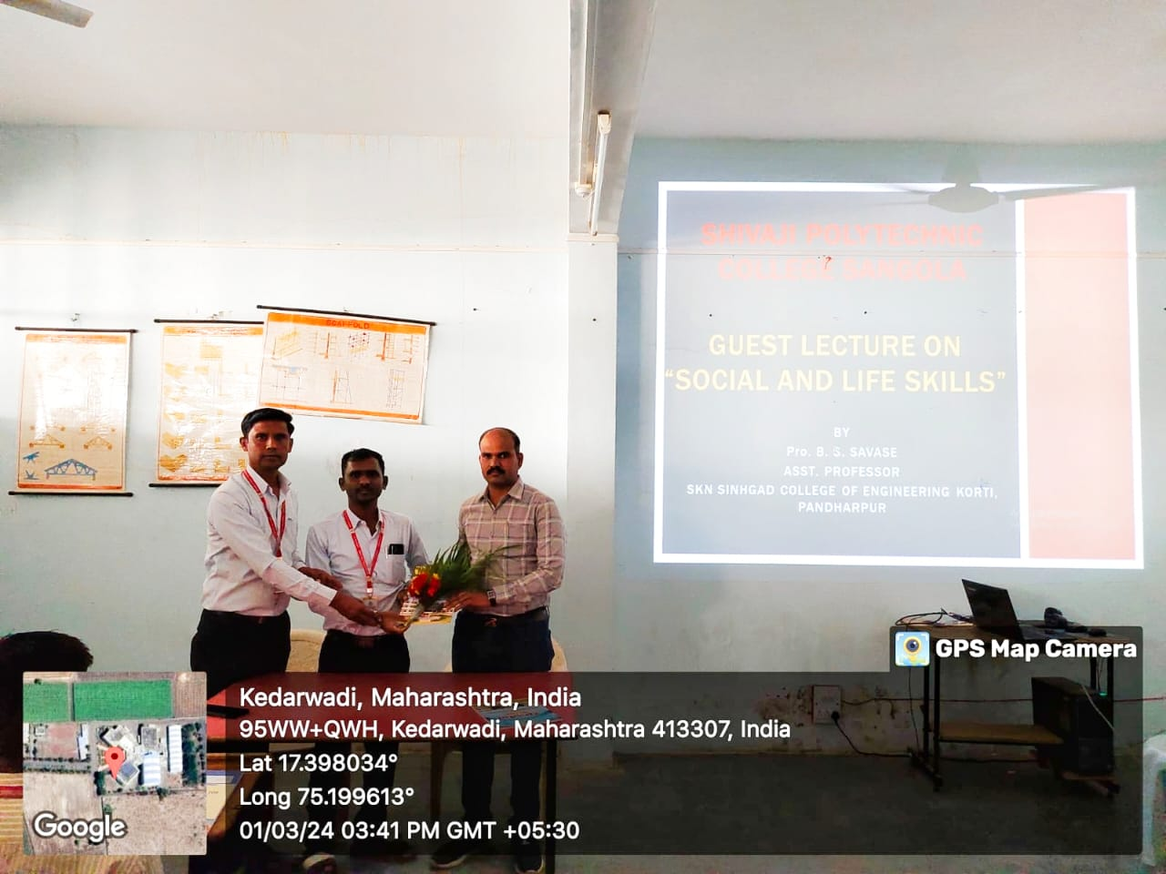
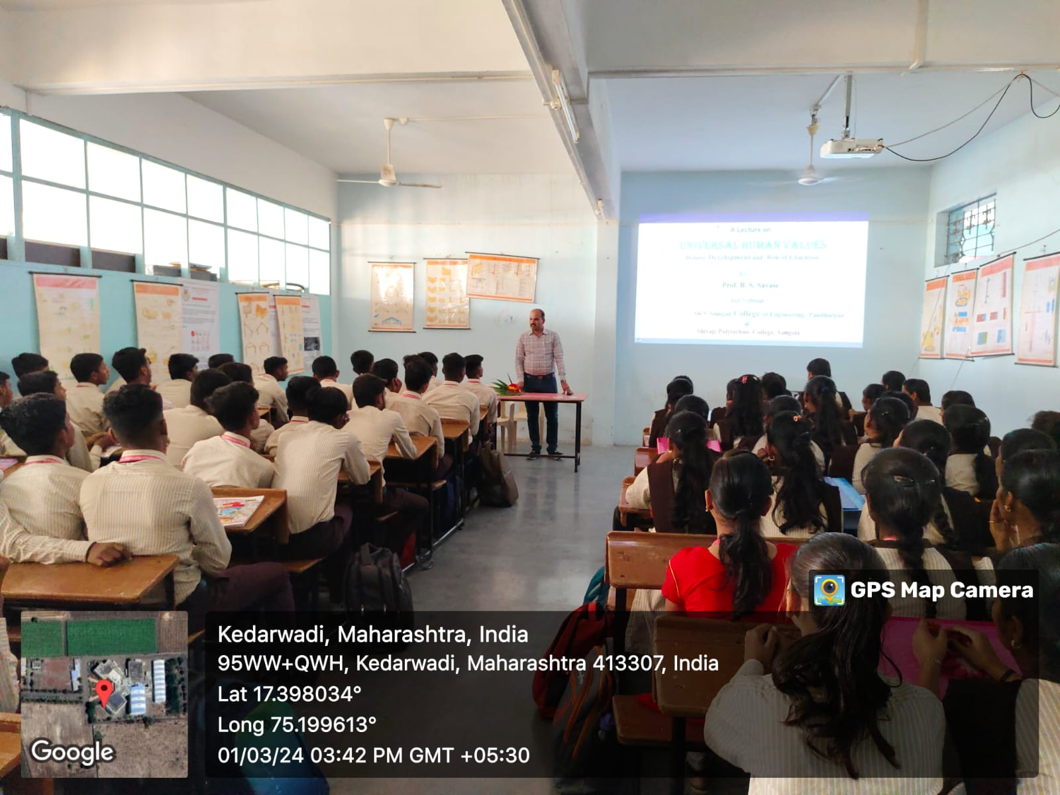
Mr.B.S.Savase Conducted Guest lecture on Personality Development For First Year Student.
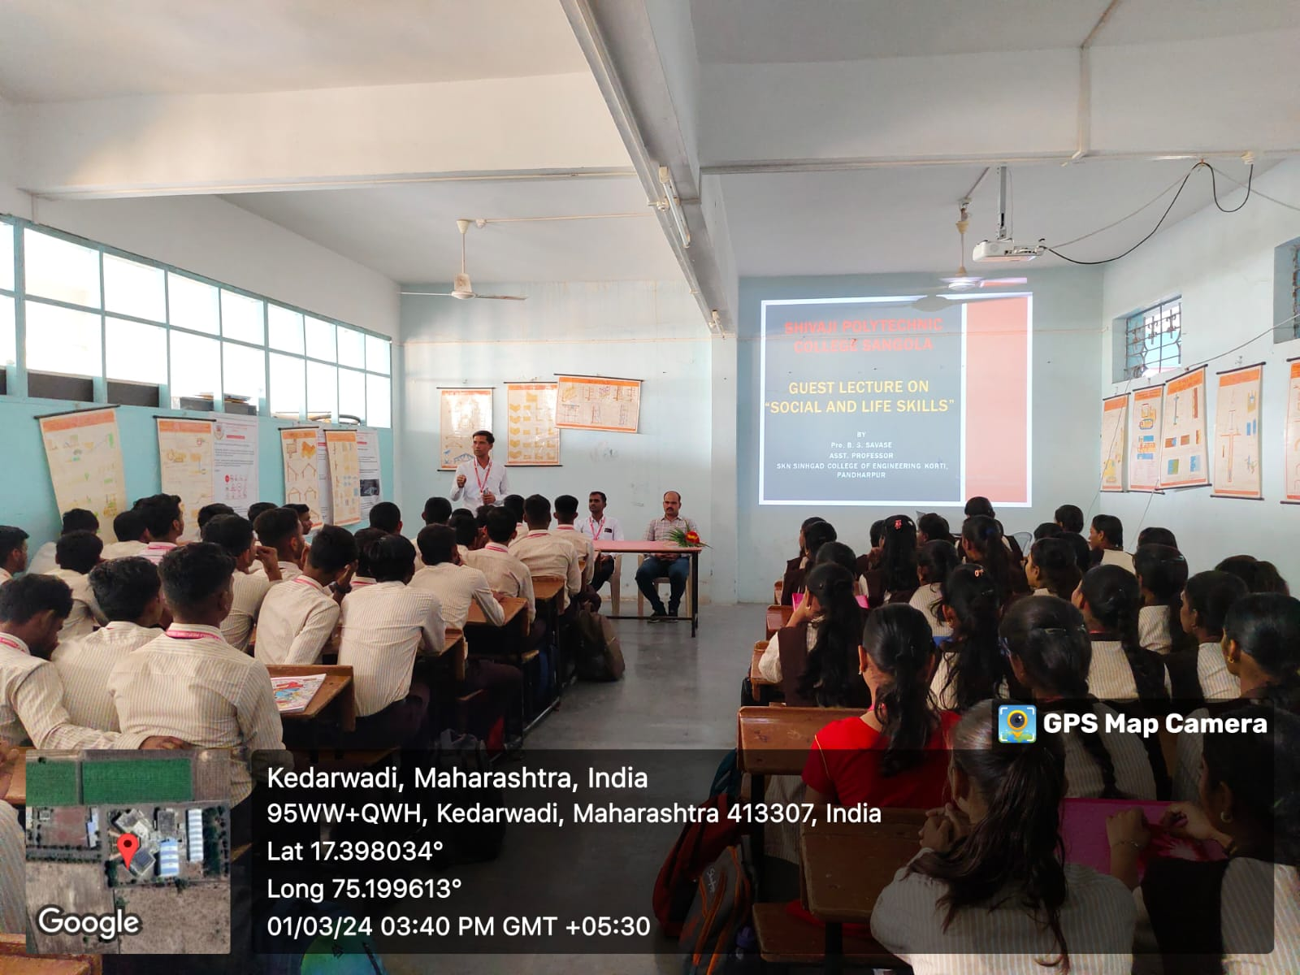
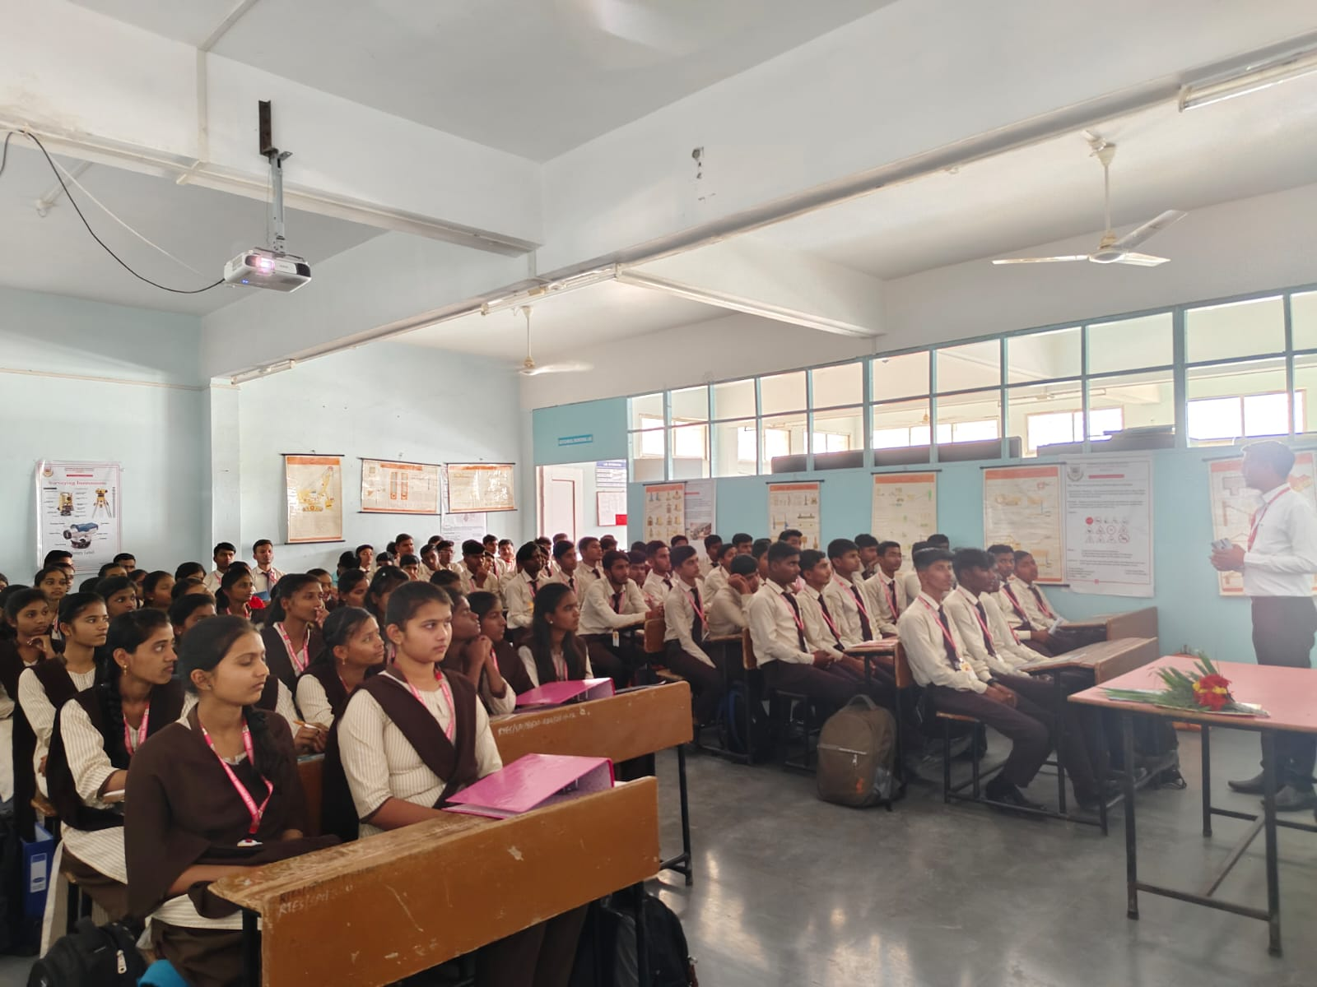
Mr.B.S.Savase Conducting Guest Lecture On Value Education and Universal Human Values ( Social and Life Skills) For First Year Student.

