Industrial Expert Lecture on Industry Engineering and Quality Control
Date – 10/08/2023
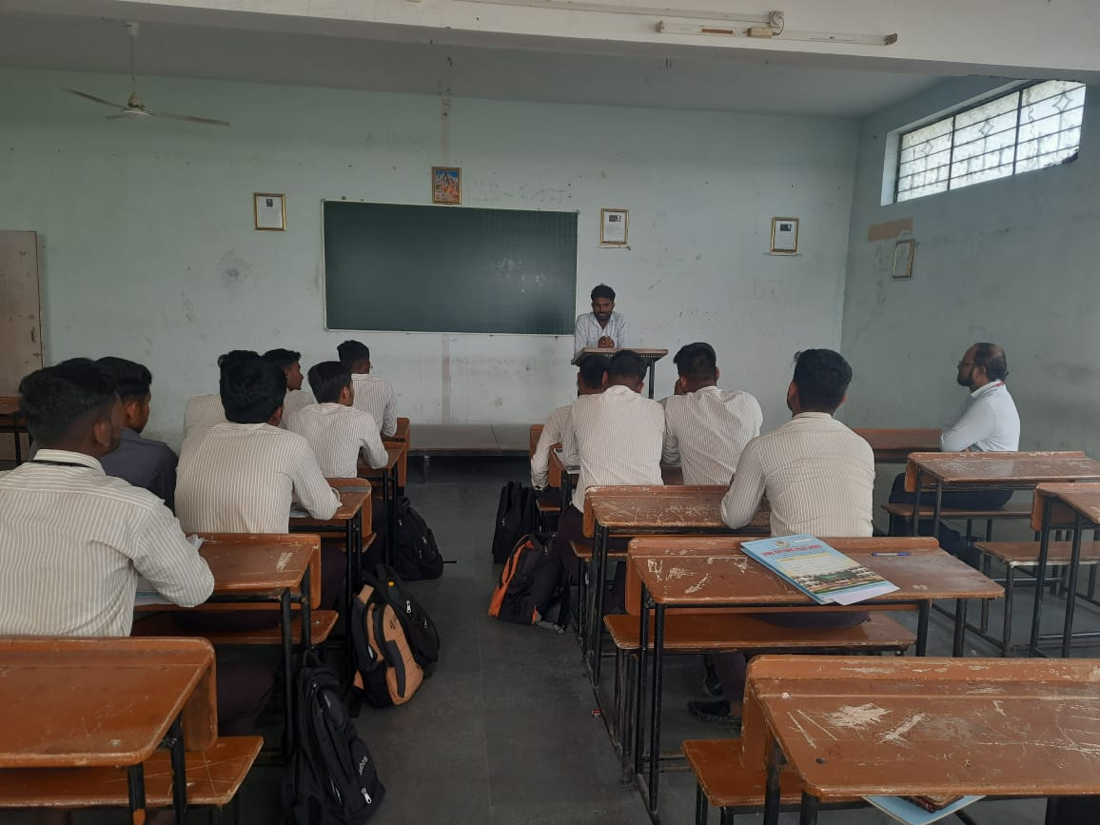
Mr. Dattatray Godase conducted Industrial Expert Lecture on Industry Engineering and Quality Control.
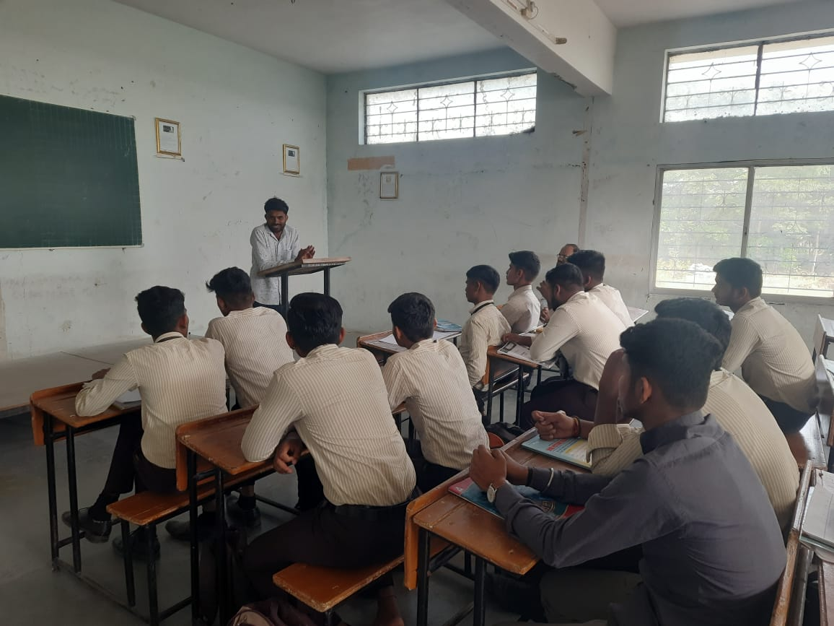
Mr. Godase is interacting with students.
Industrial Expert Lecture on Quality Control Date – 23/10/2023
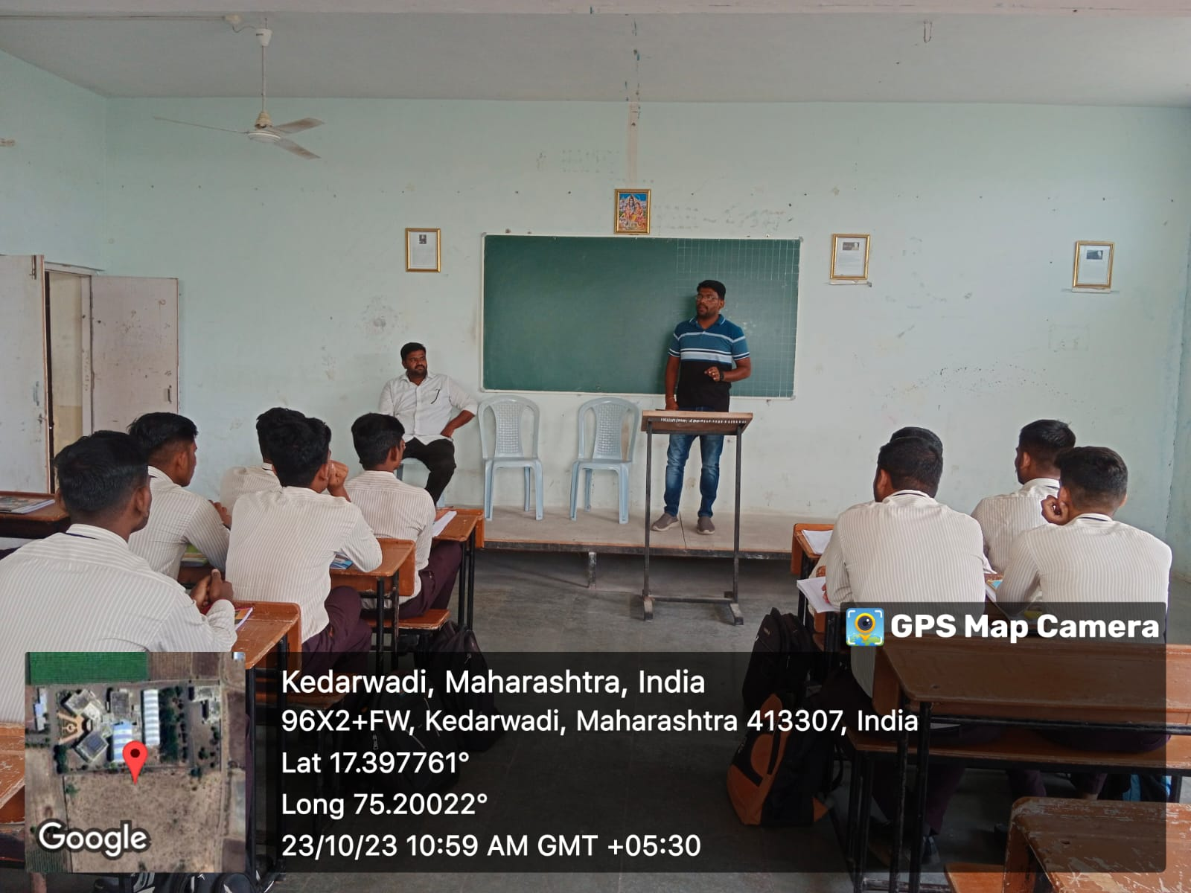
Mr.Sandip Gore conducted Industrial Expert Lecture on Quality Control.

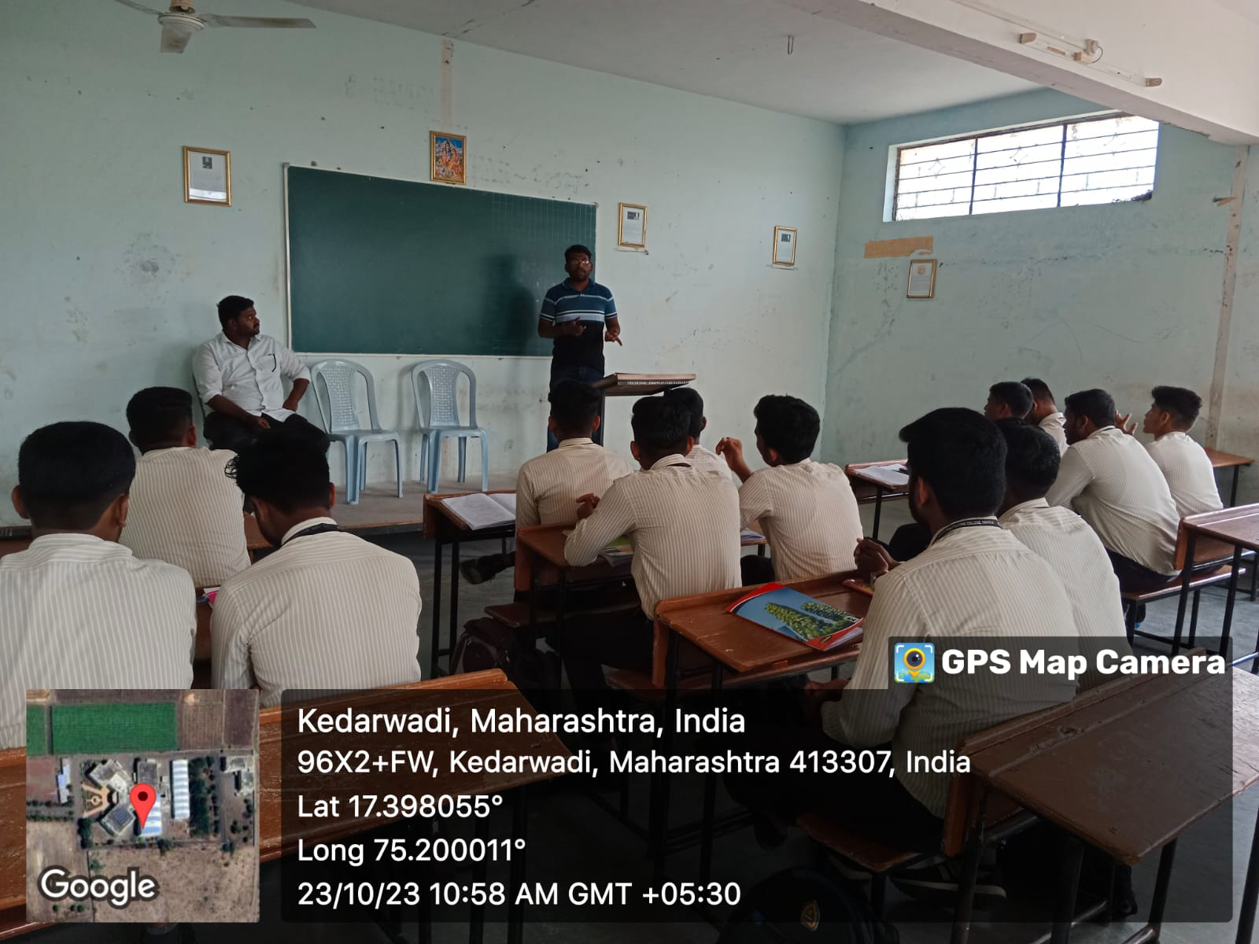

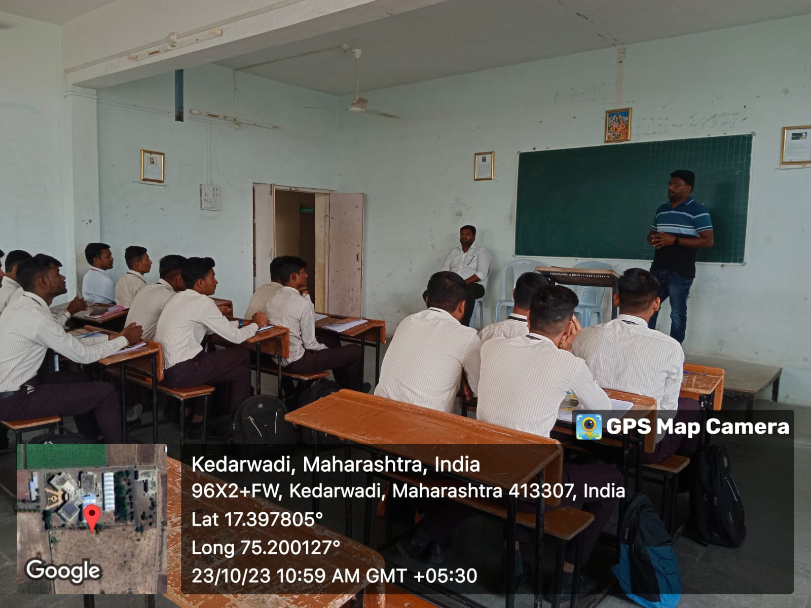

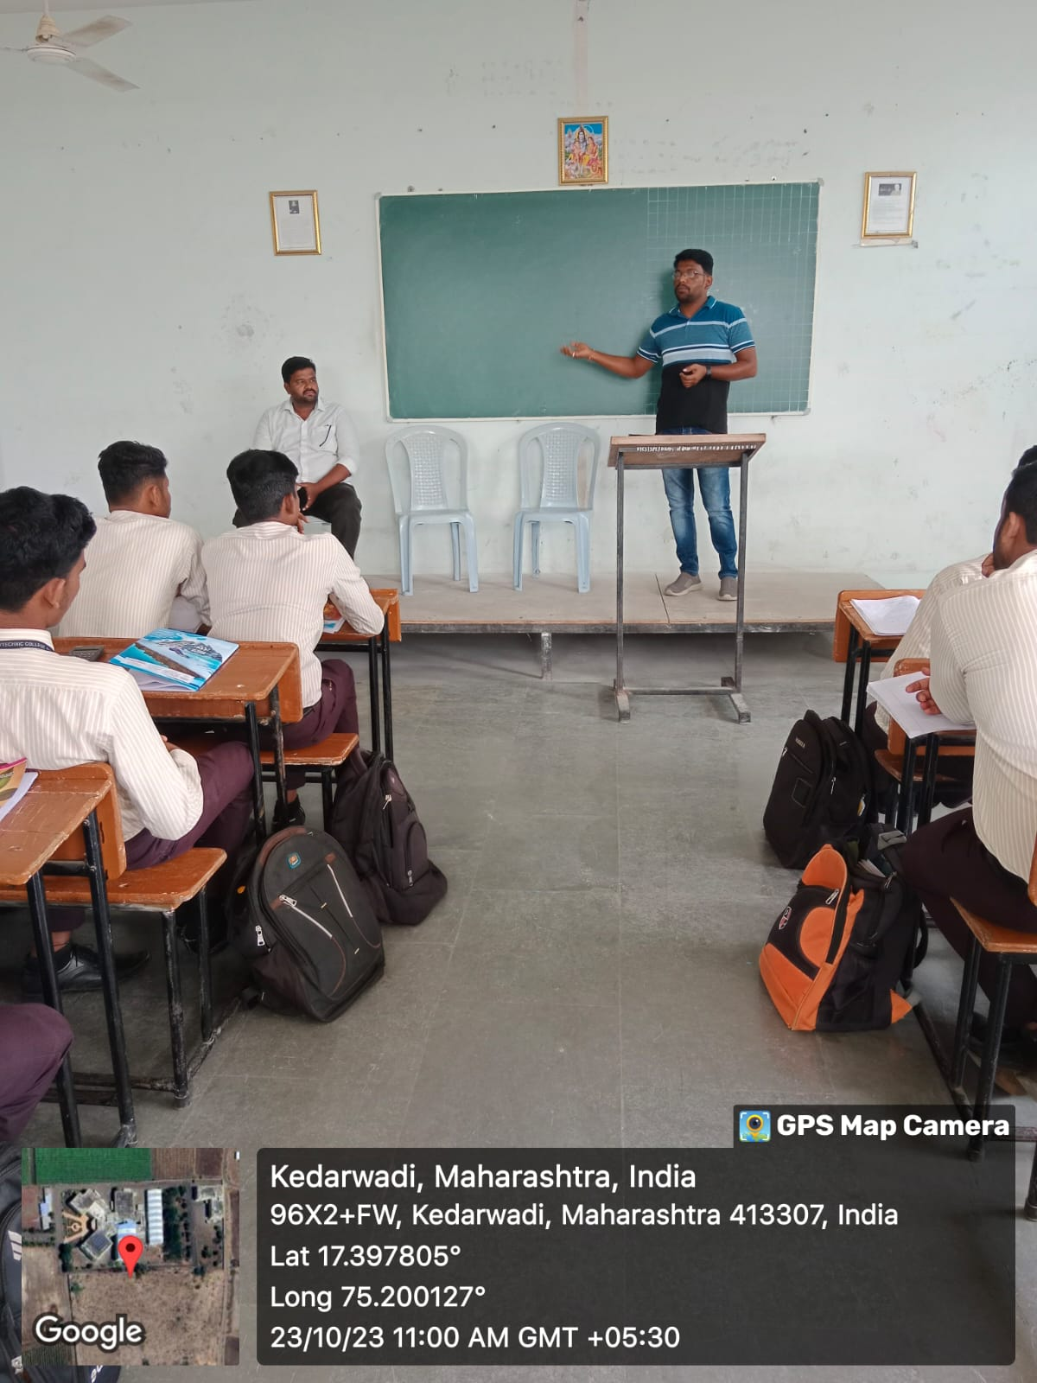
Mr.Sandip Gore is interacting with students.
Guest Lecture on Entrepreneurship Development Date:-02/02/2024
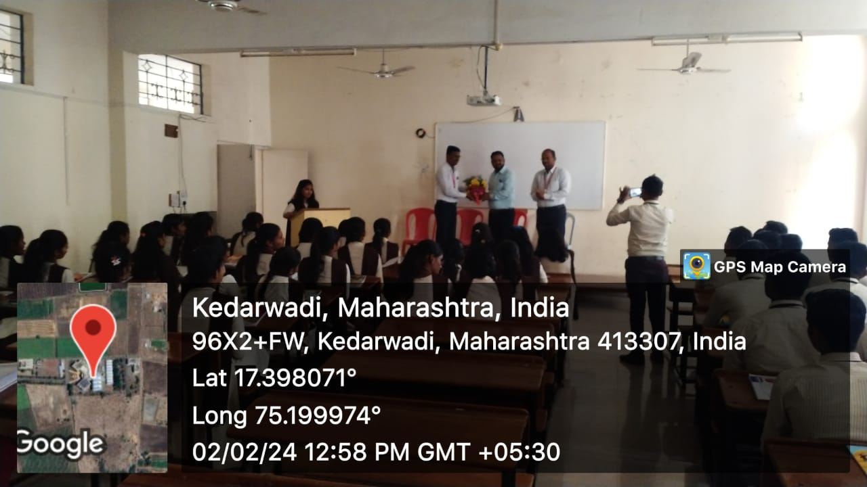
Dr. R. A. Deshmukh (Principal) is Felicitating to the Mr. Somnath Khandagale

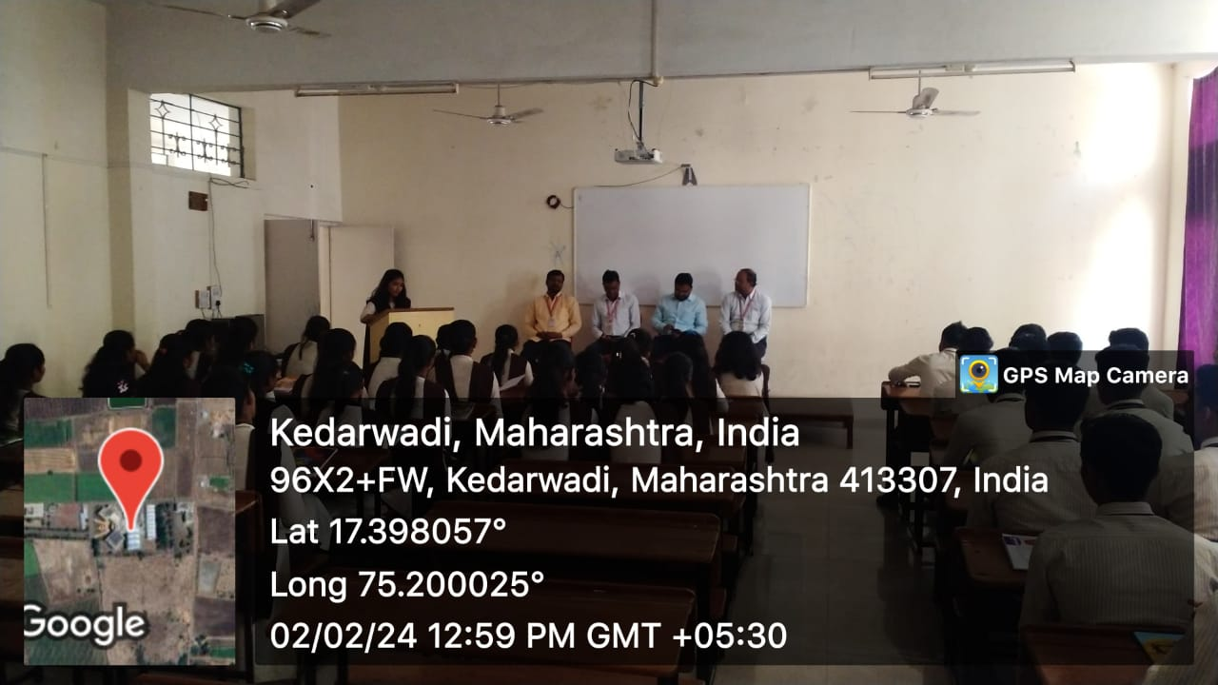
TY Student is introducing Mr. Somnath Khandagale , Chief Guest.

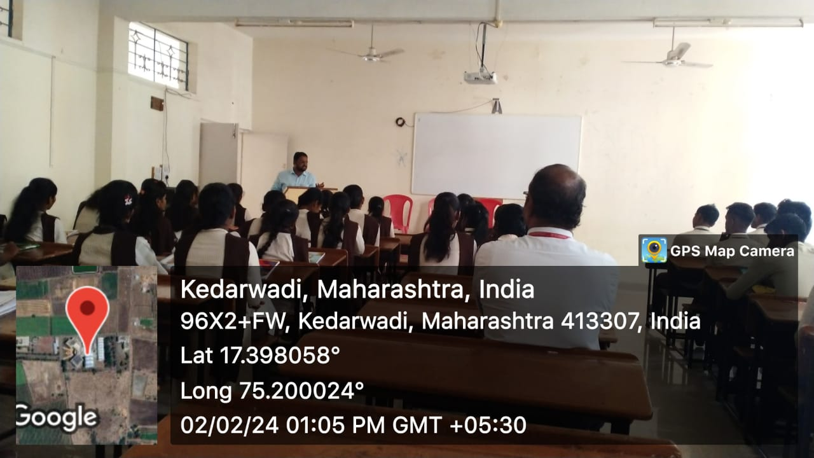
Mr. Khandagale is explaining about the concept of Entrepreneurship.

Guest Lecture on Recent Trends in IC Engines Date:-16/02/2024
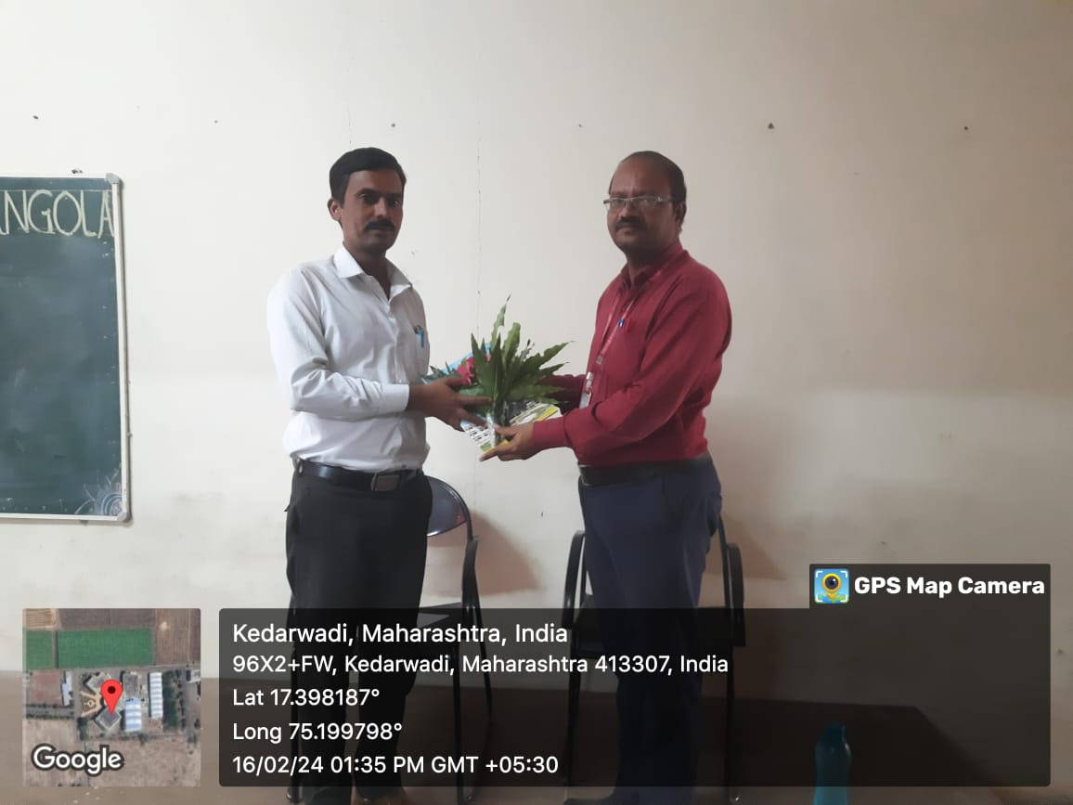
Mr.D.S.Khandare Sir is Felicitating to the Mr. A. M. Markad.
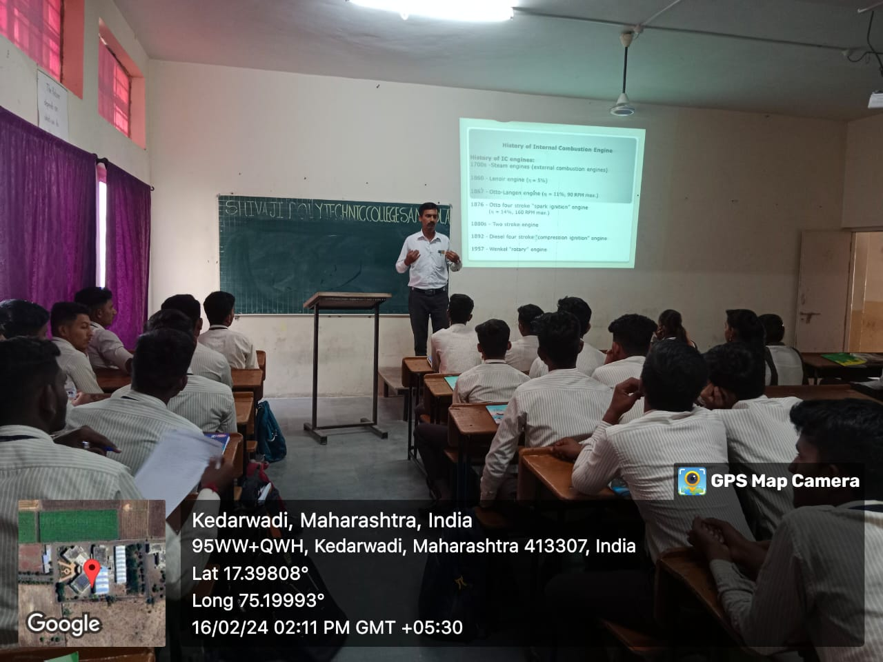
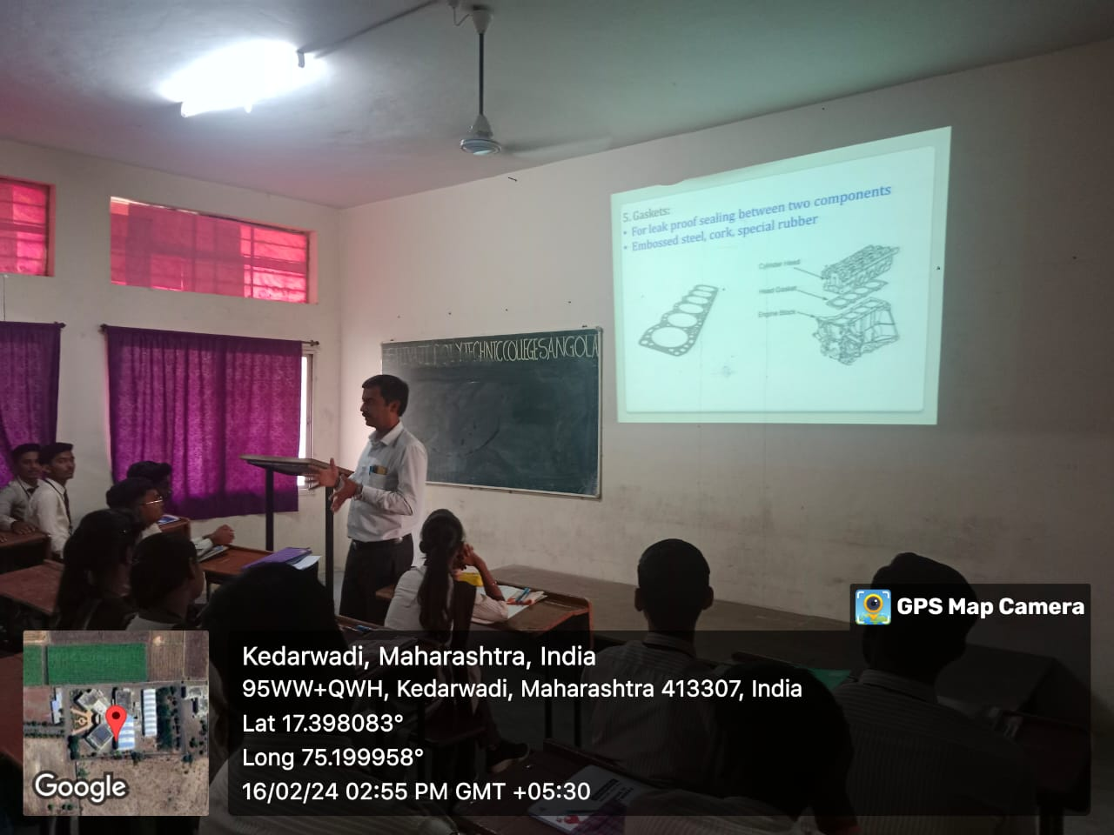
Mr. Markad A.M. is explaining the concept in Recent Trends in IC Engines.
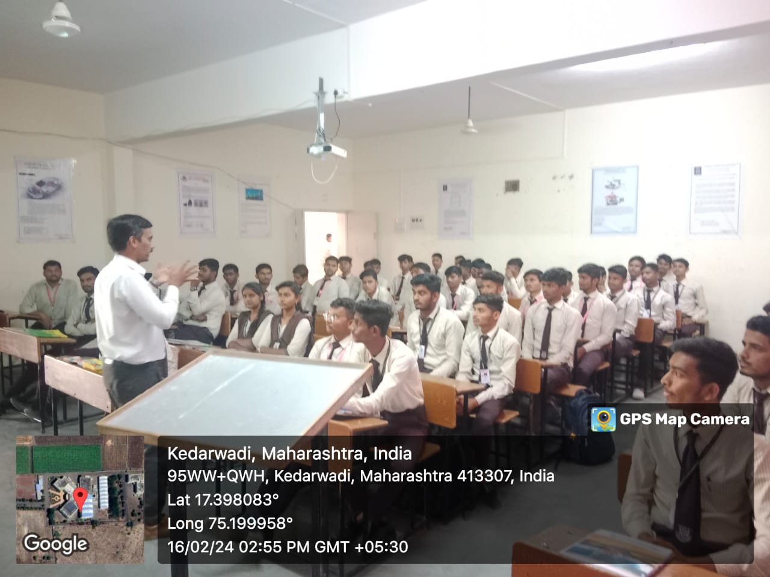
Mr. Markad A.M. is interacting with students.
Guest Lecture on Management Date:-16/02/2024
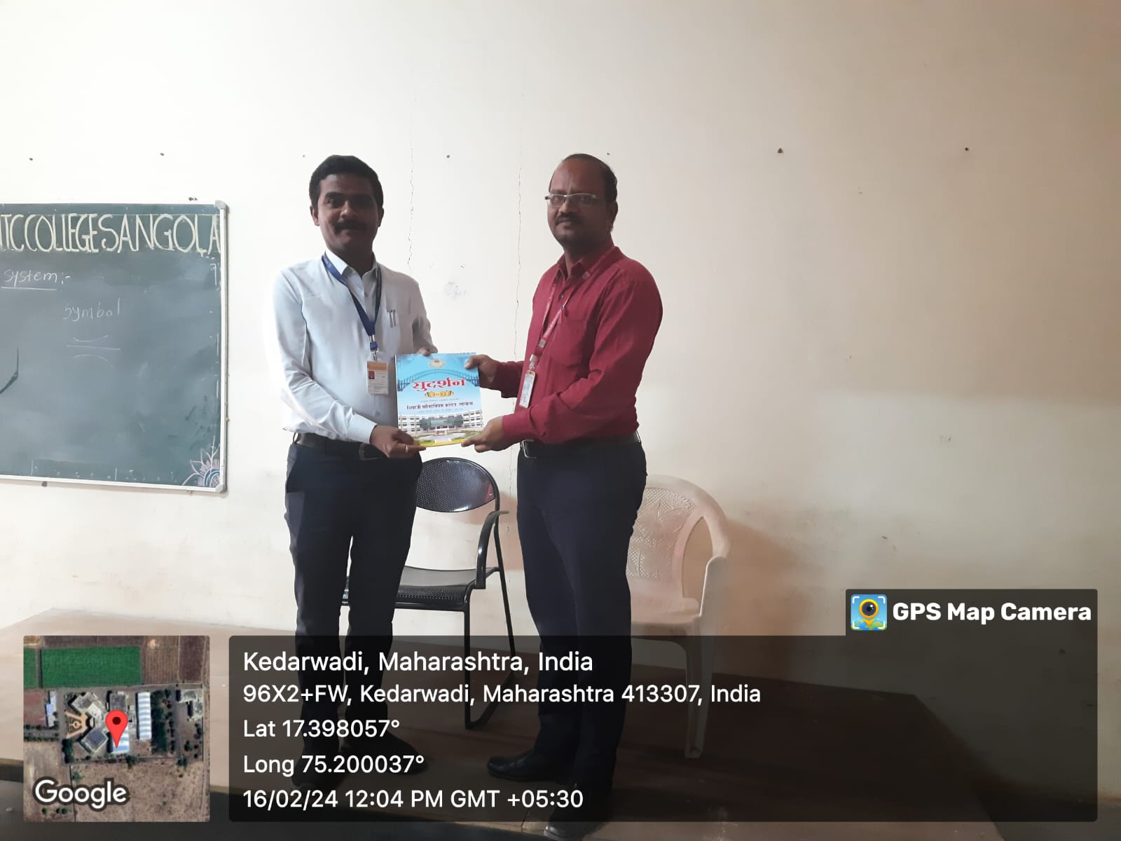
Mr.D.S.Khandare Sir is Felicitating to the Prof. Uttam Anuse.
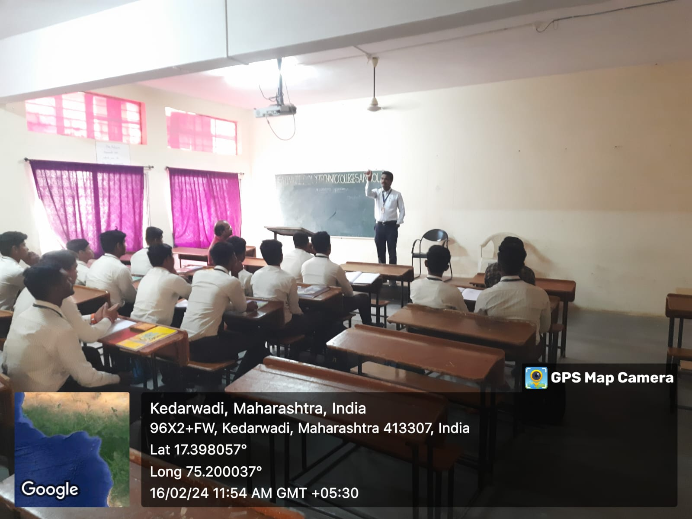
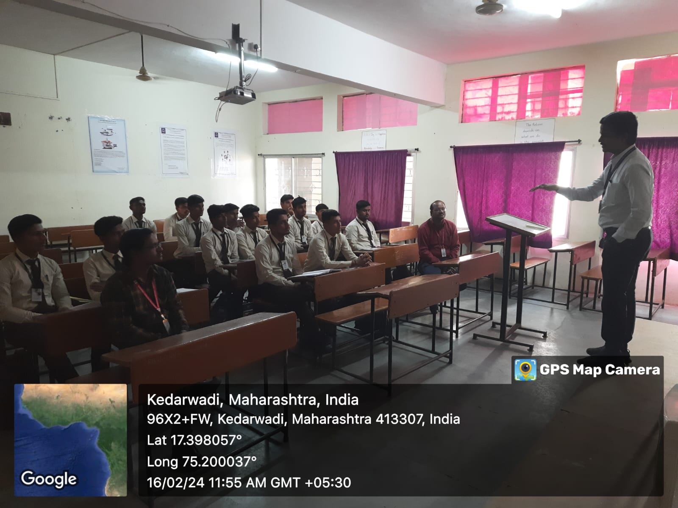
Prof. Uttam Anuse explaining the concept in Management.
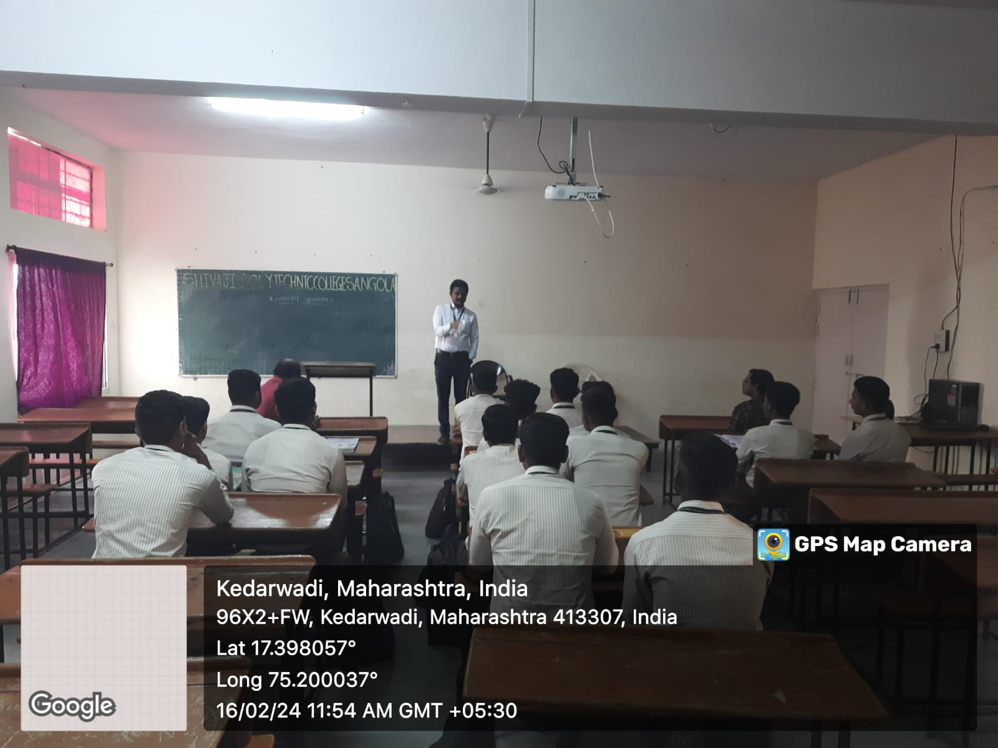
Guest Lecture on 4 Wheeler Maintenance Date:-15/02/2024
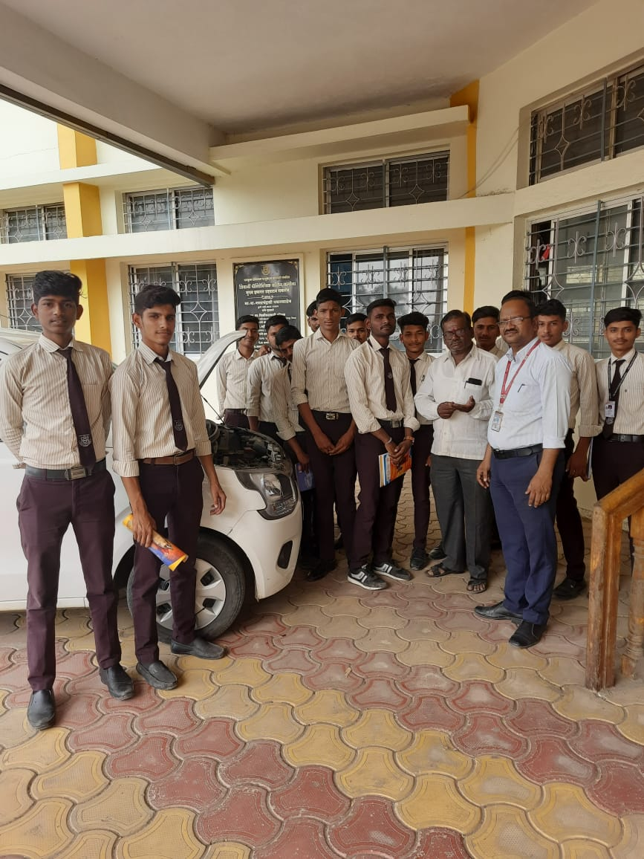
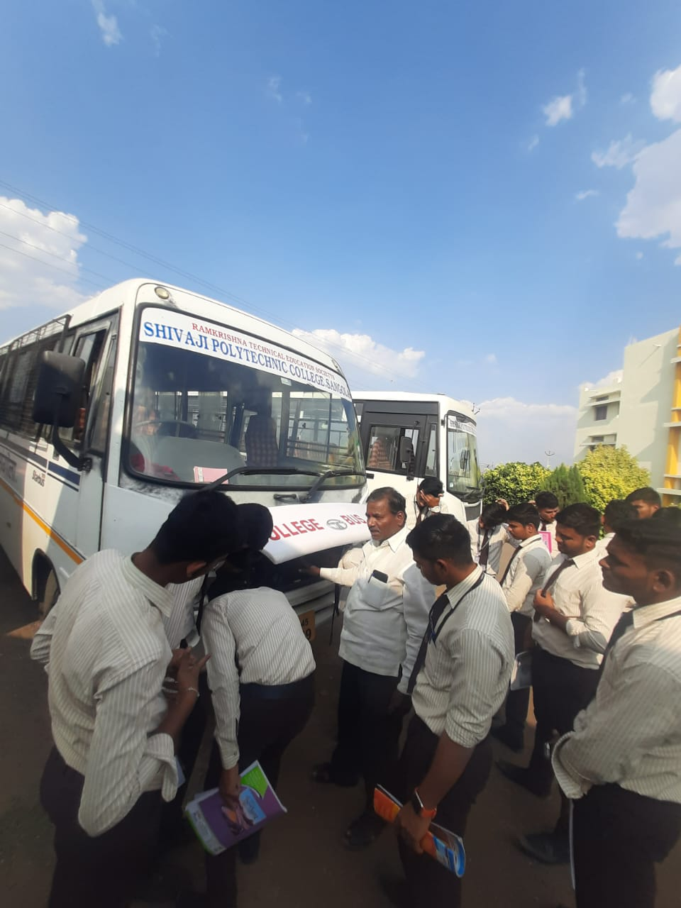
Mr.Khatkale Mohan is interacting with students.
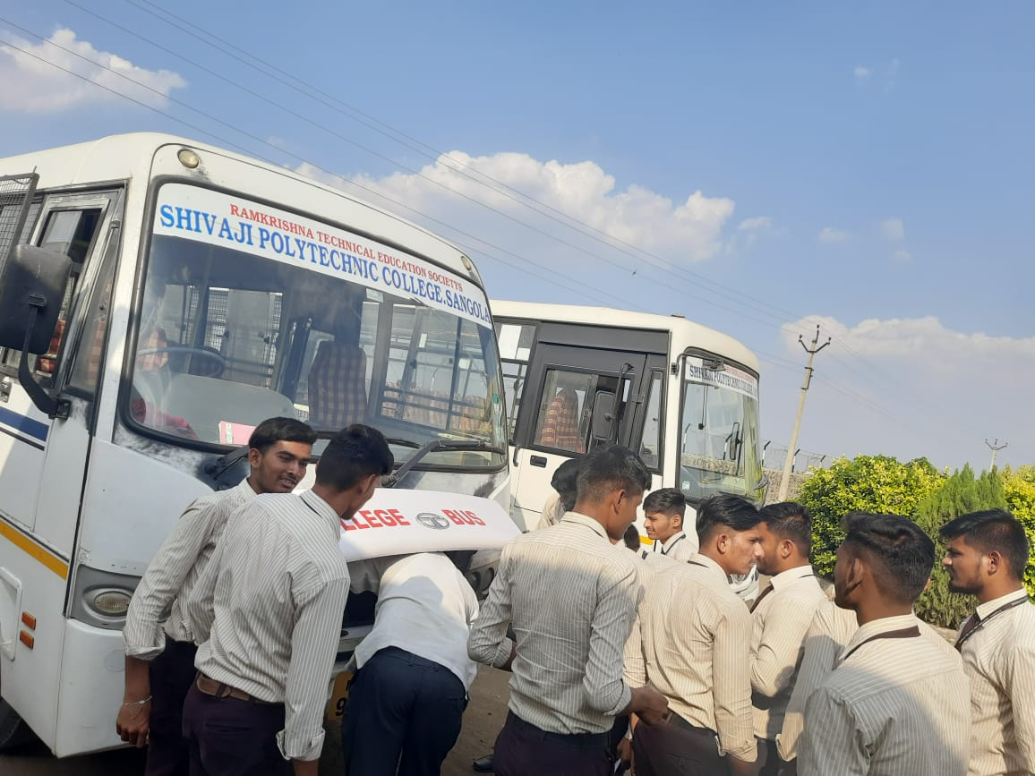

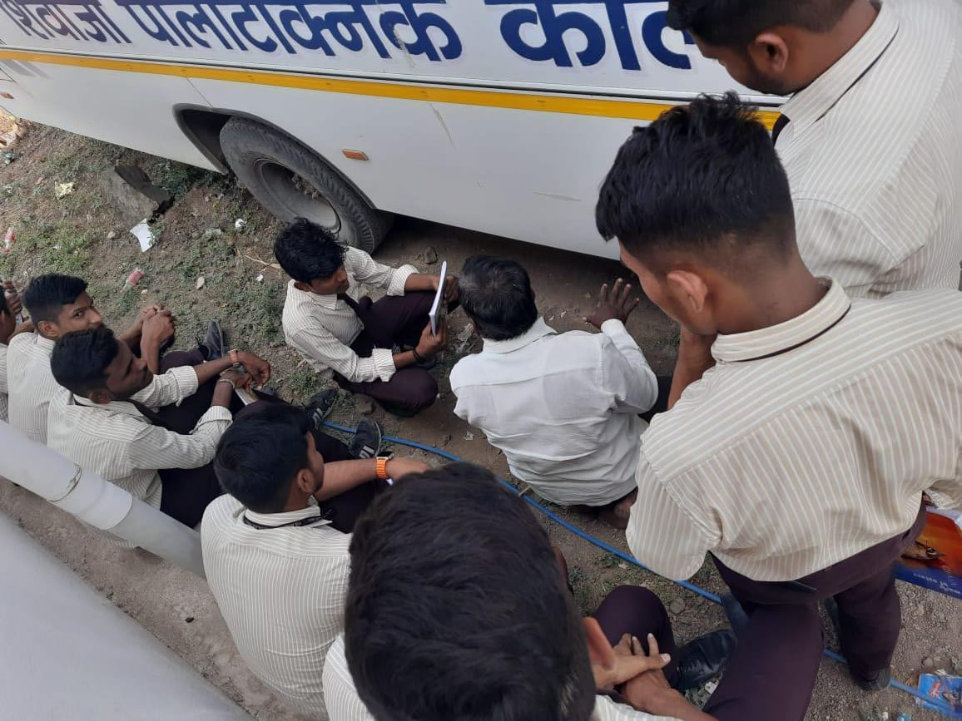
Mr.Khatkale Mohan explaining the concept in 4 Wheeler Maintenance.
Guest Lecture on Personality Development Date:-01/03/2024
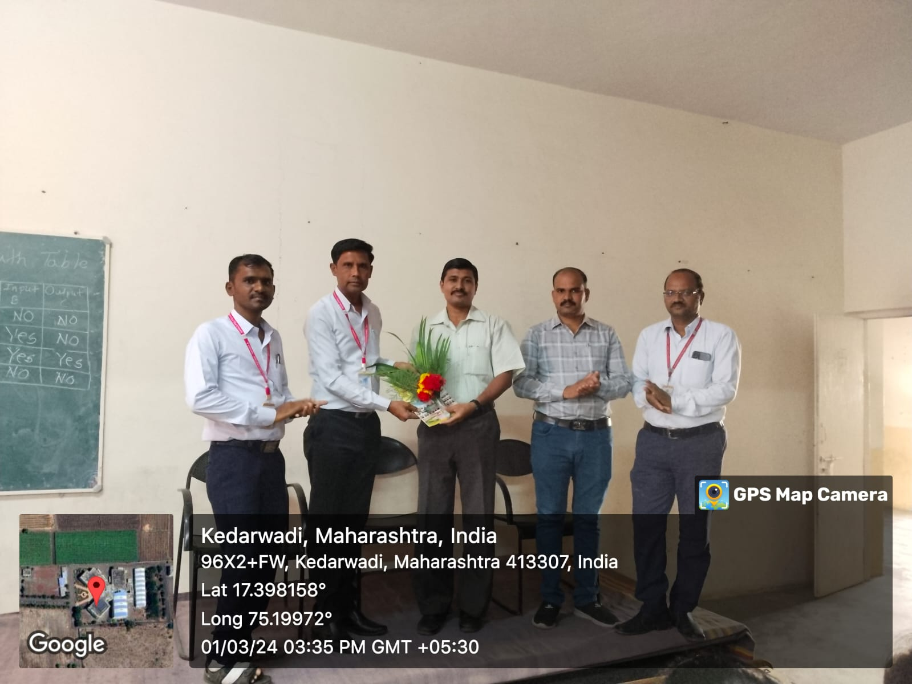
Mr.P.C.Chavan Sir is Felicitating to the Dr.D.P.Ganmote
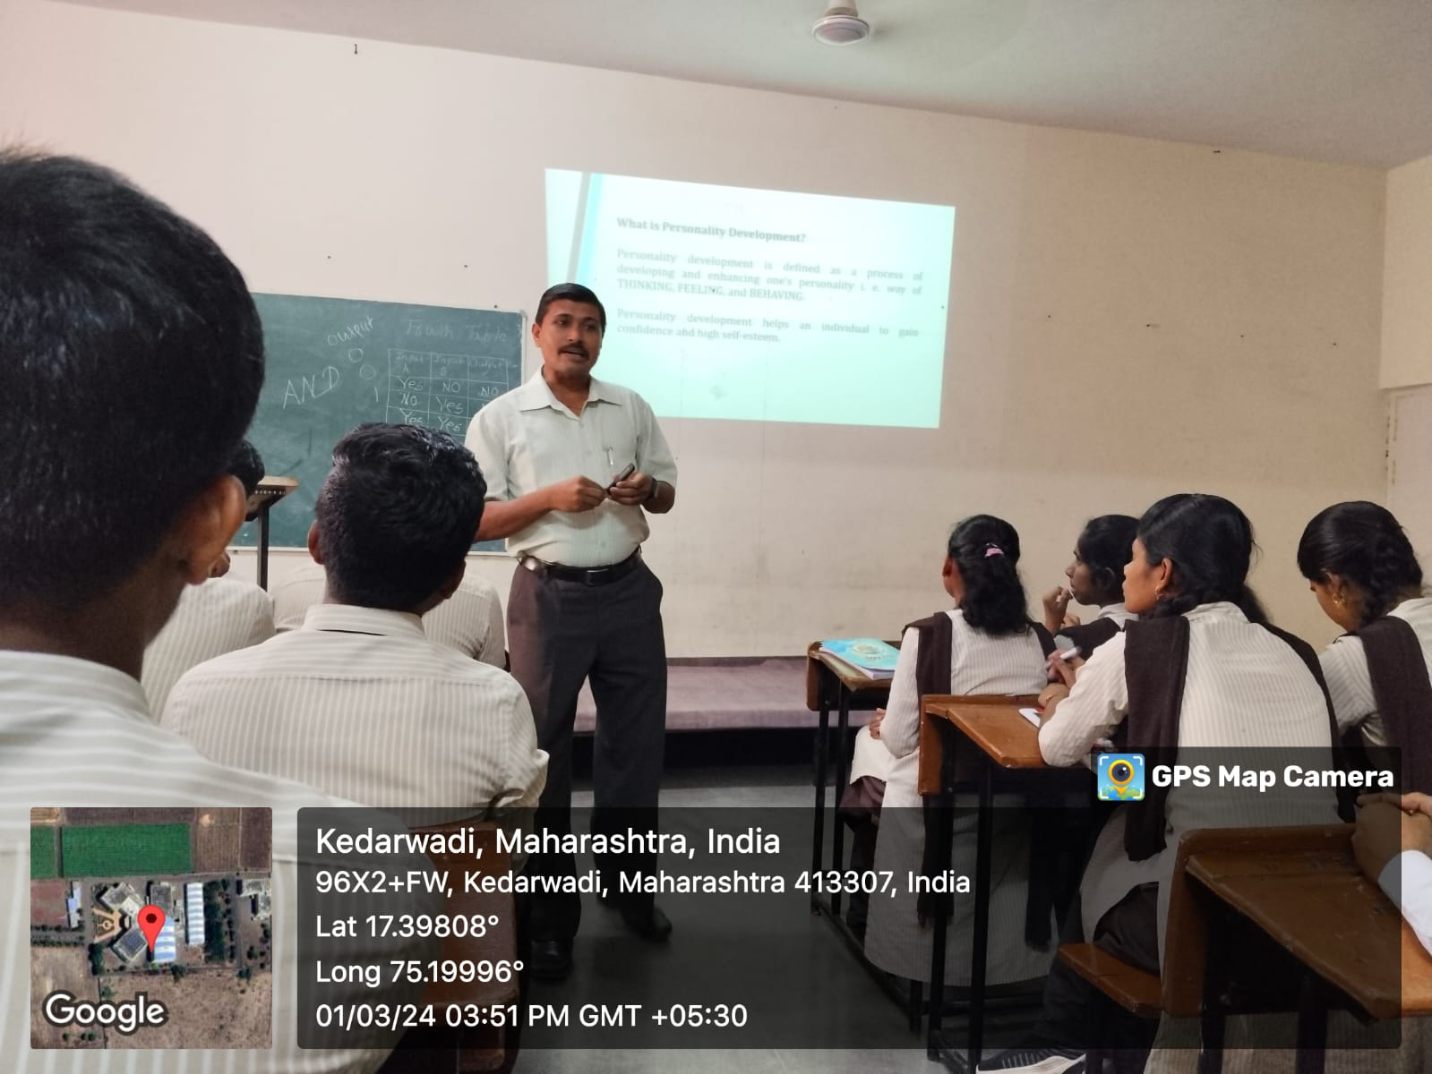

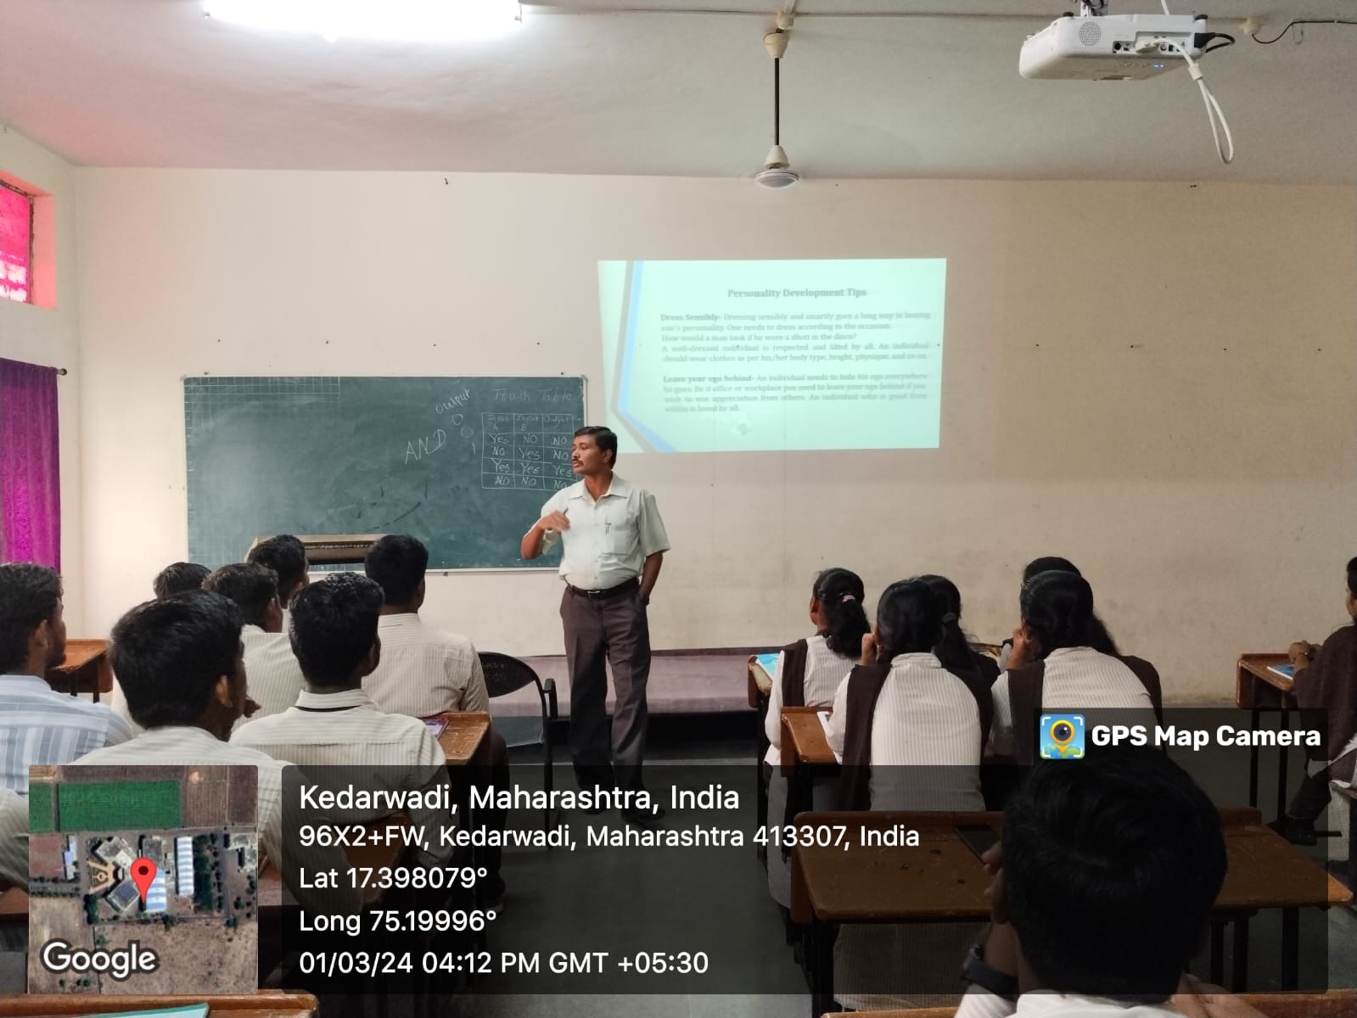
Dr.D.P.Ganmote explaining the concepts in development.
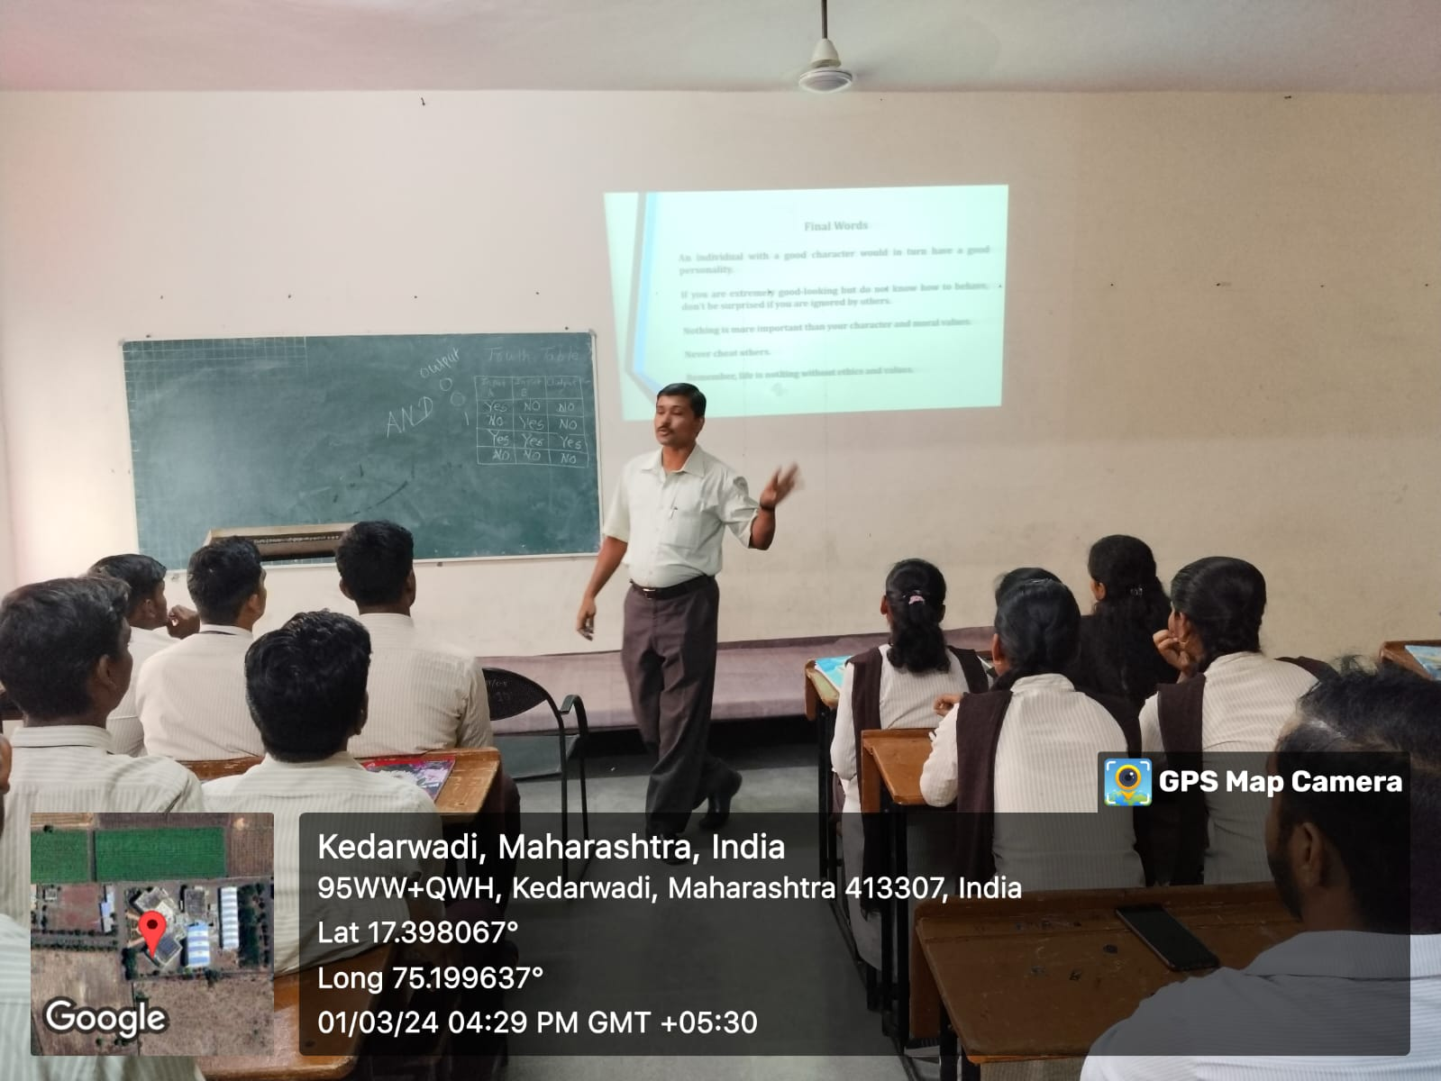 Dr.D.P.Ganmote is interacting with students.
Chief Guest Dr.R.A.Bugad Felicitated by Mr.P.G.Pawar General Science HOD
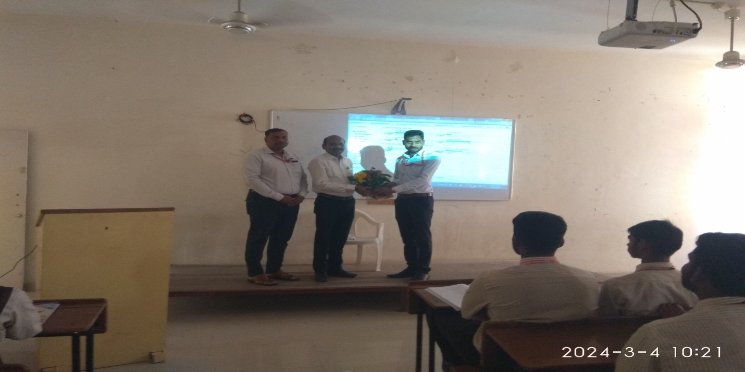

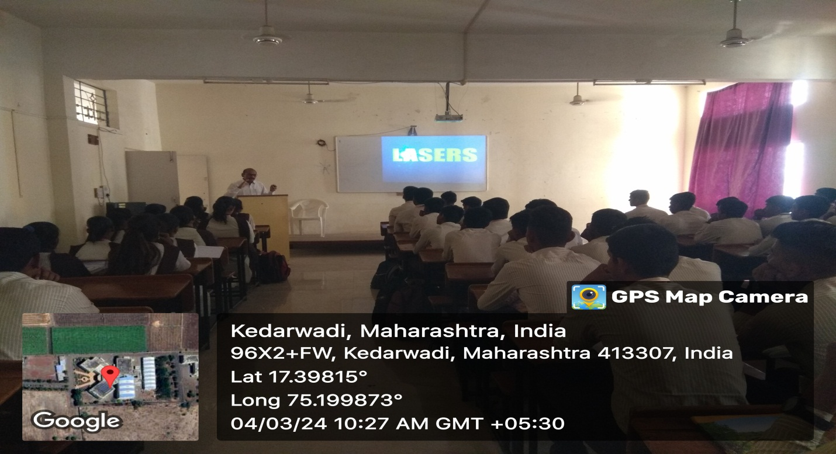
Dr.R.A.Bugad Conducting Guest Lecture on “LASER”

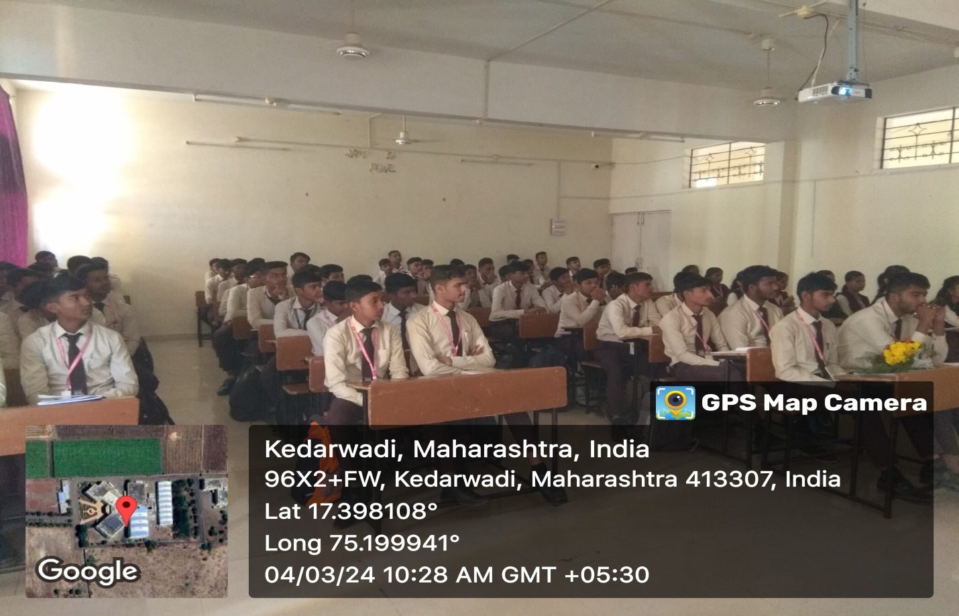
Dr.R.A.Bugad interacting with students.

Chief Guest Dr.P.M.Kharade Felicitated by Mr.P.G.Pawar General Science HOD
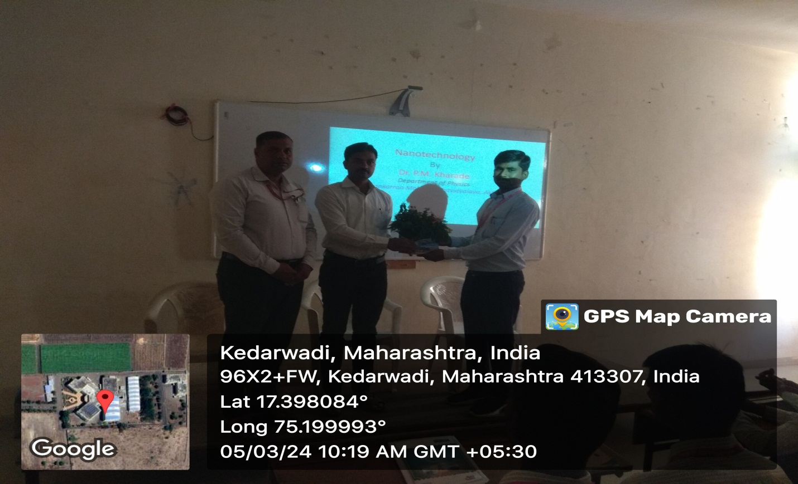

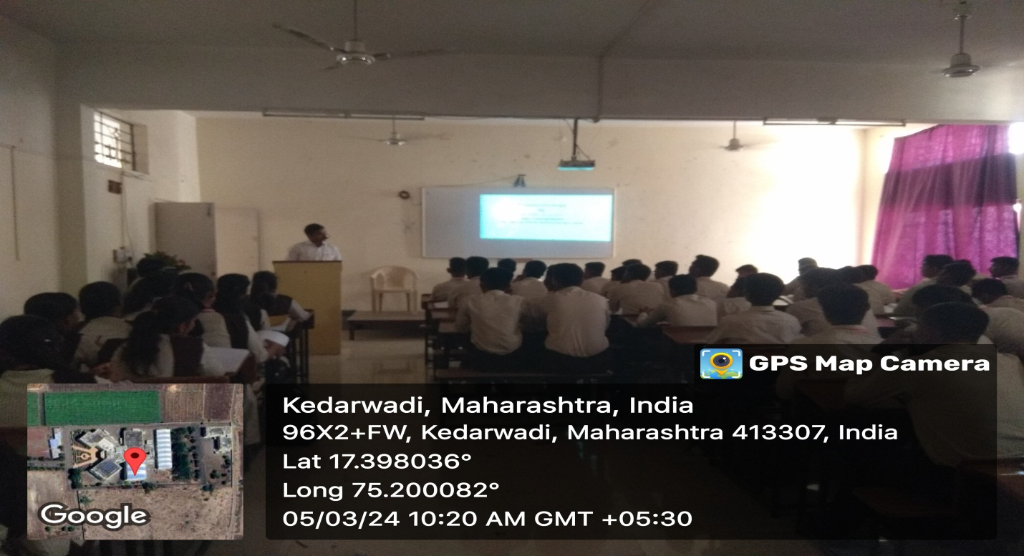Dr.P.M.Kharade explaining the concept in Nanotechnology.
Guest Lecture on Alumini Interaction. Date: - 27/02/2024
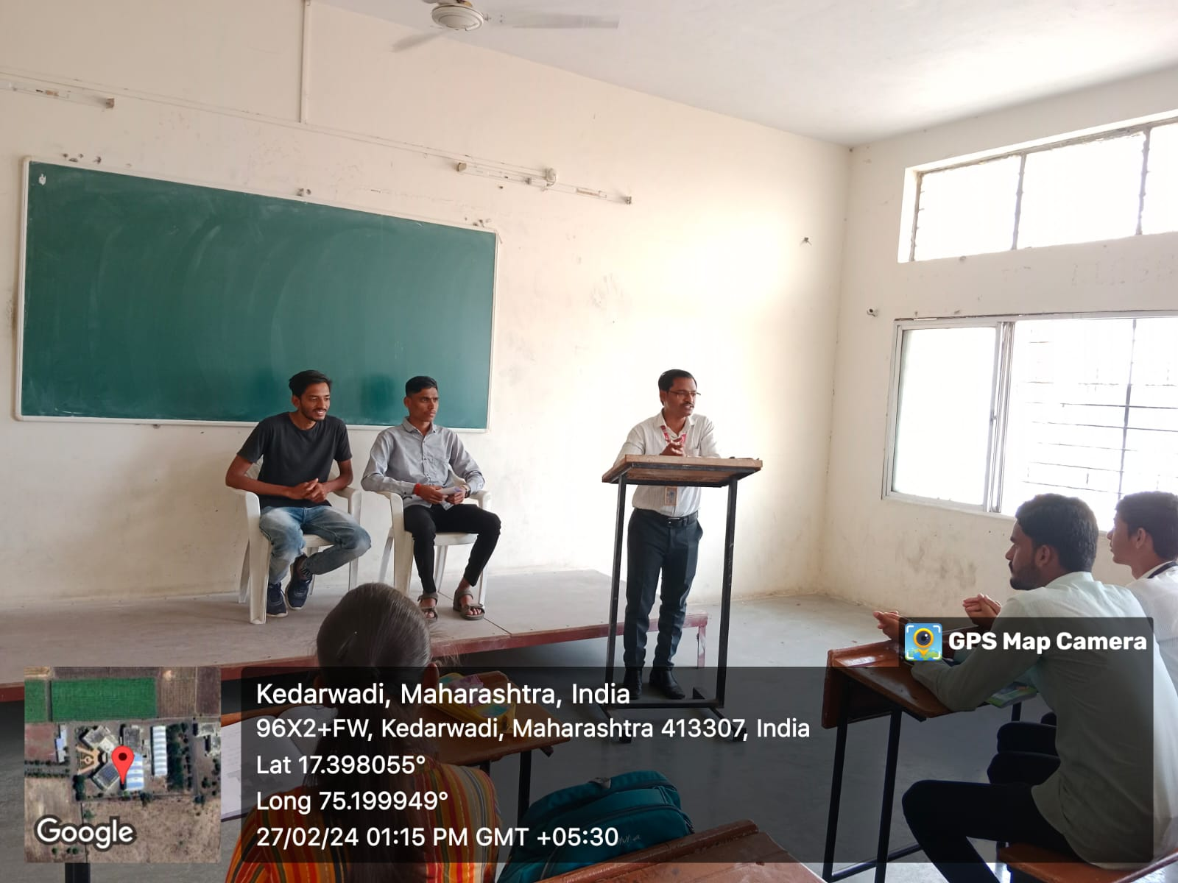
Mr. S.D.Bavache introducing Mr. R.D.Pawar, Chief Guest
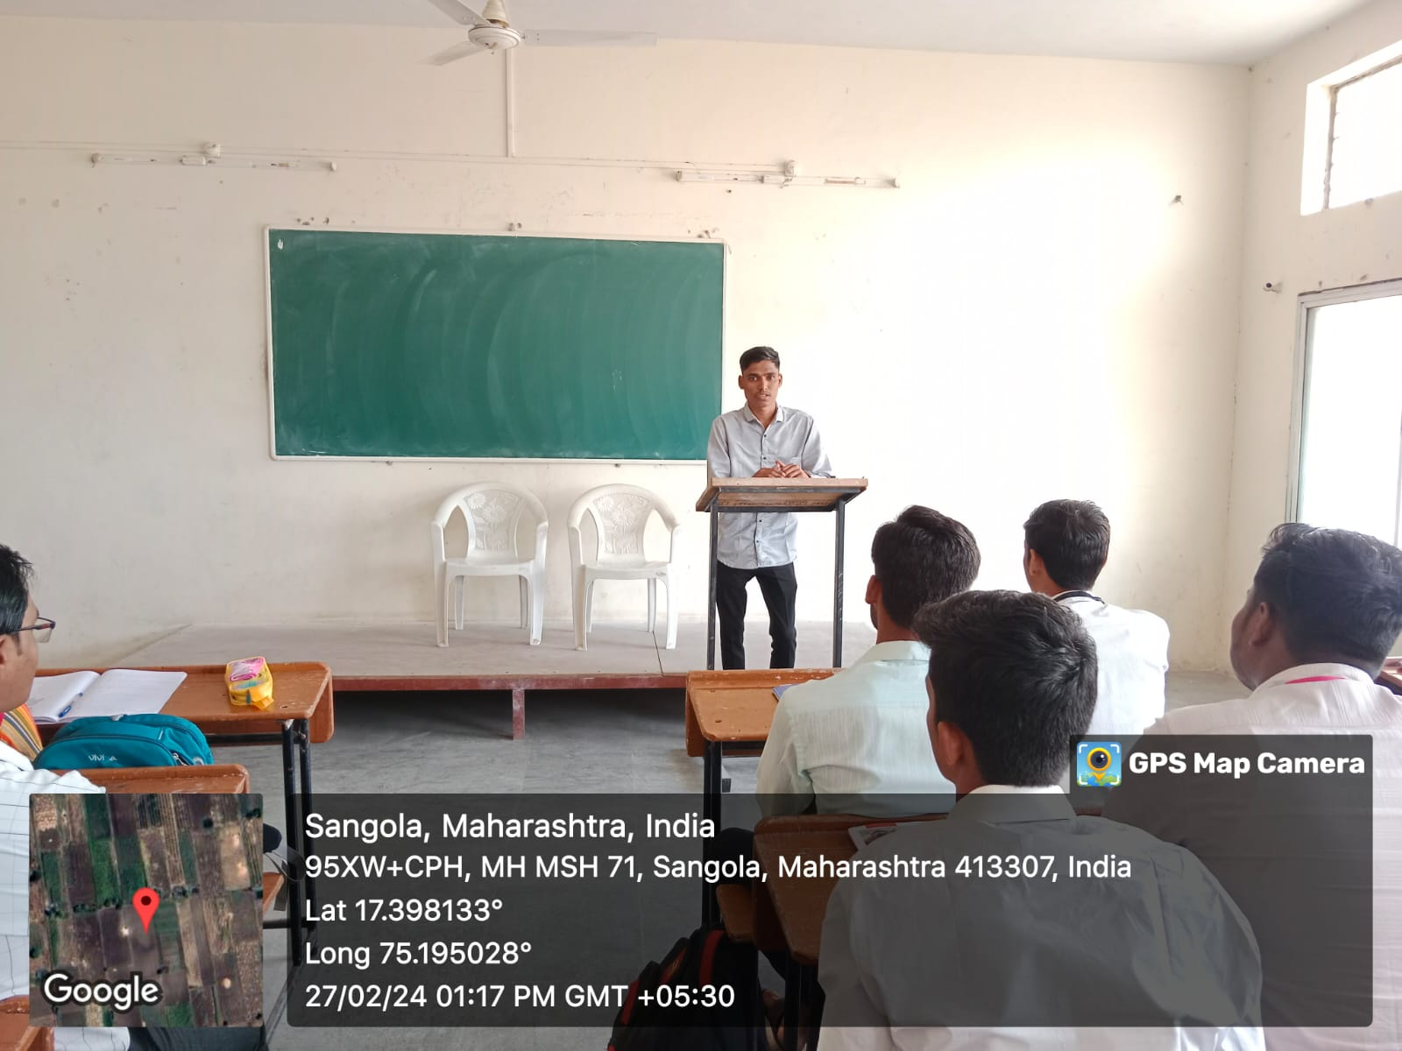
Mr. R.D.Pawar is interacting with students.
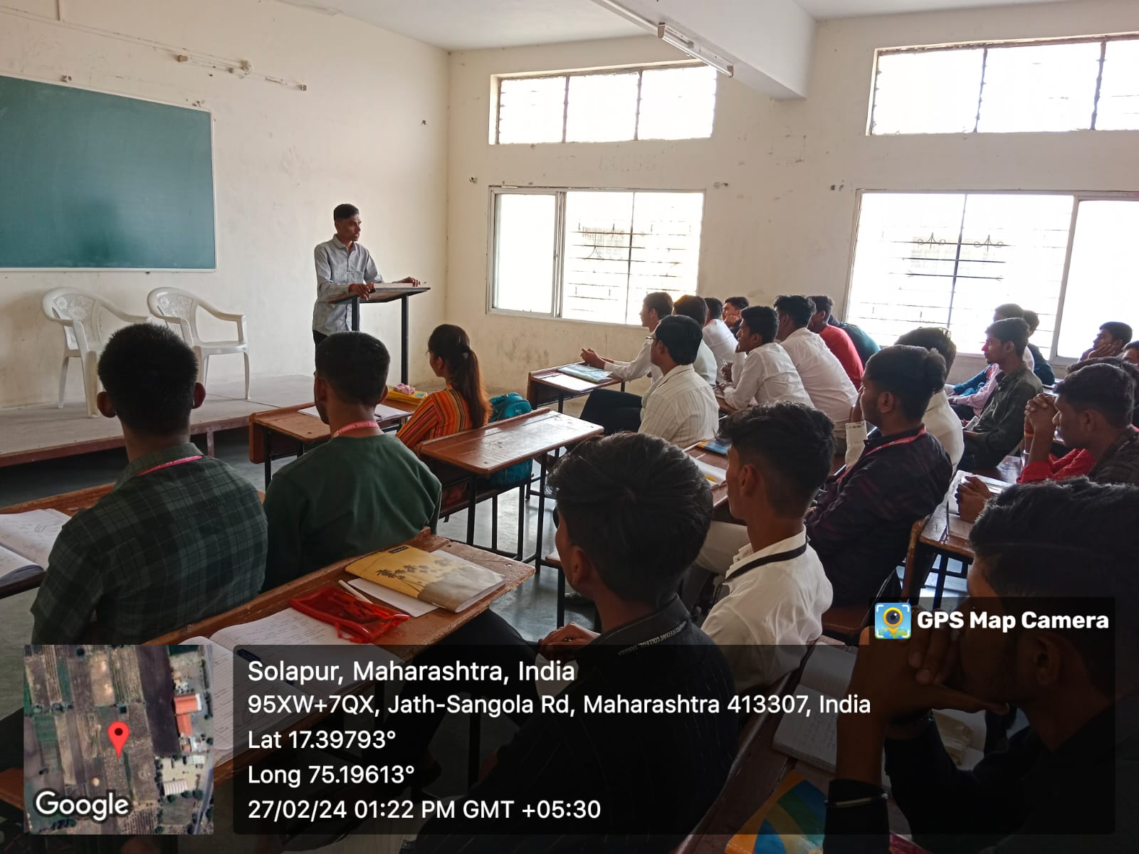
Mr. R.D.Pawar explaining about the training process in industry.
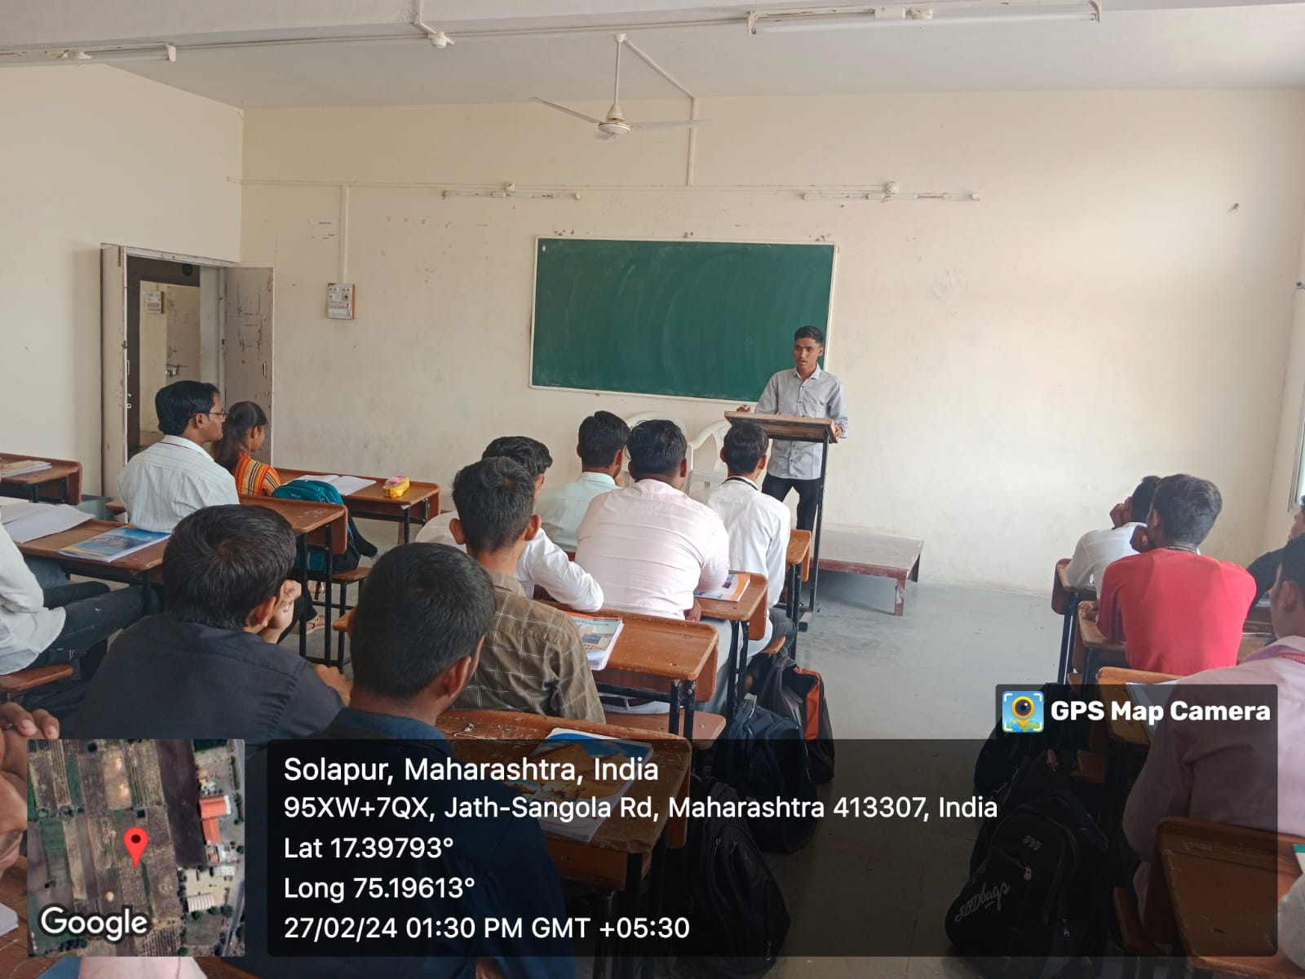
Guest Lecture on Alumini Interaction. Date: - 27/02/2024
Mr. S.D.Bavache introducing Mr. S.S.Raiter, Chief Guest
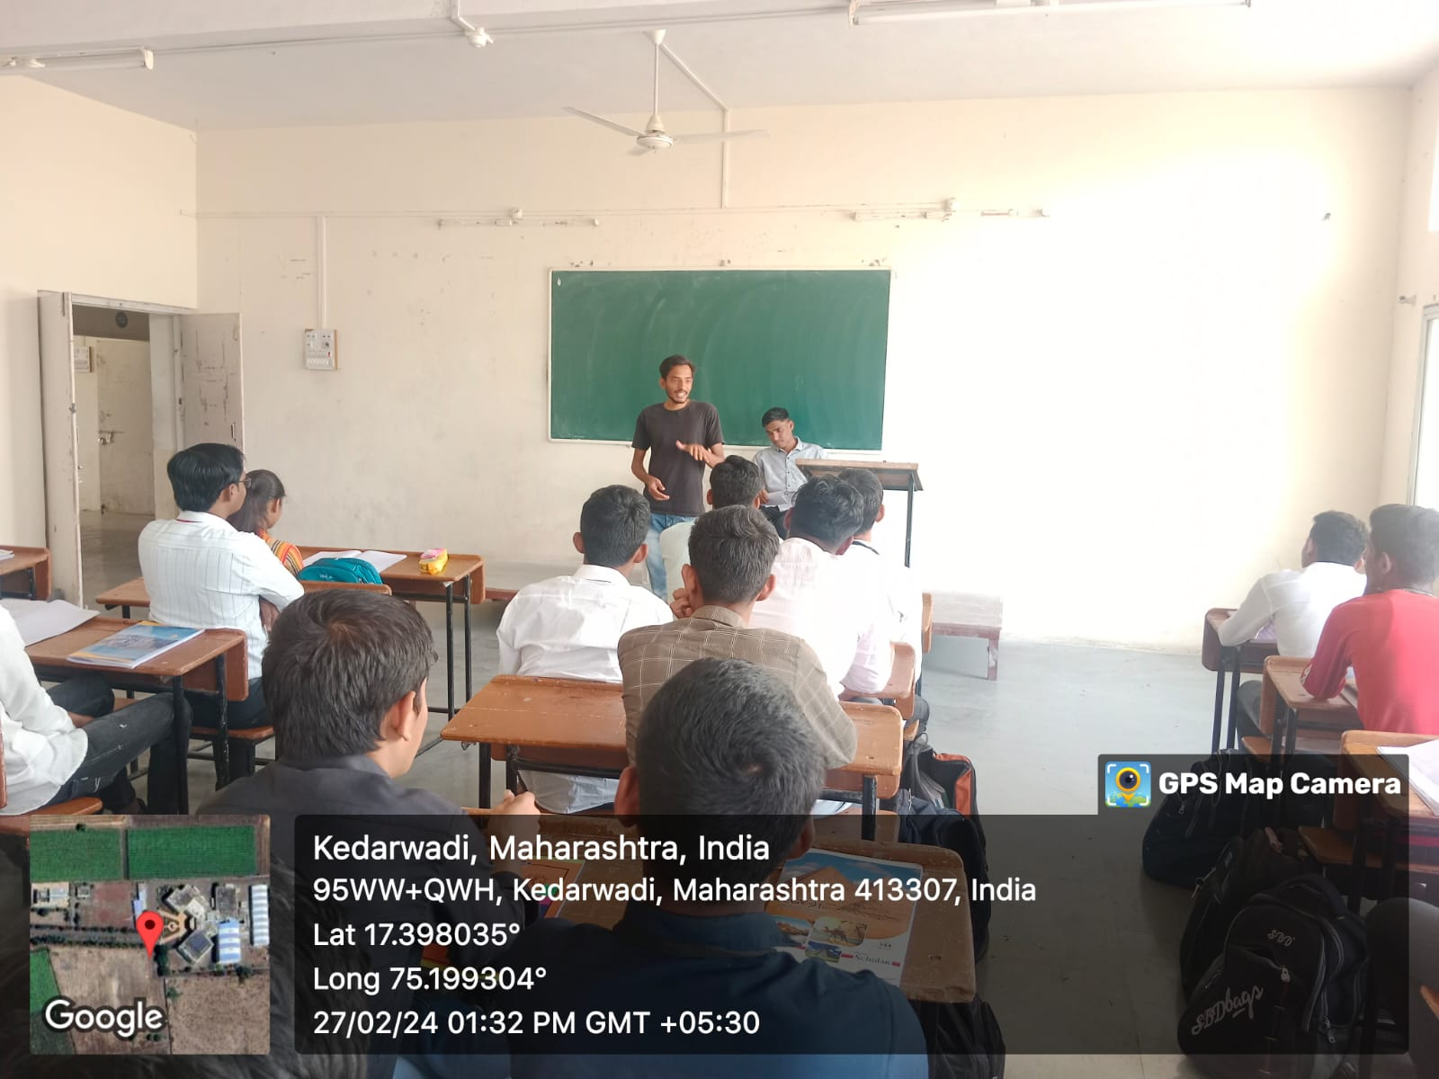
Mr. S.S.Raiter is interacting with students.
