Date:- 12/11/2022
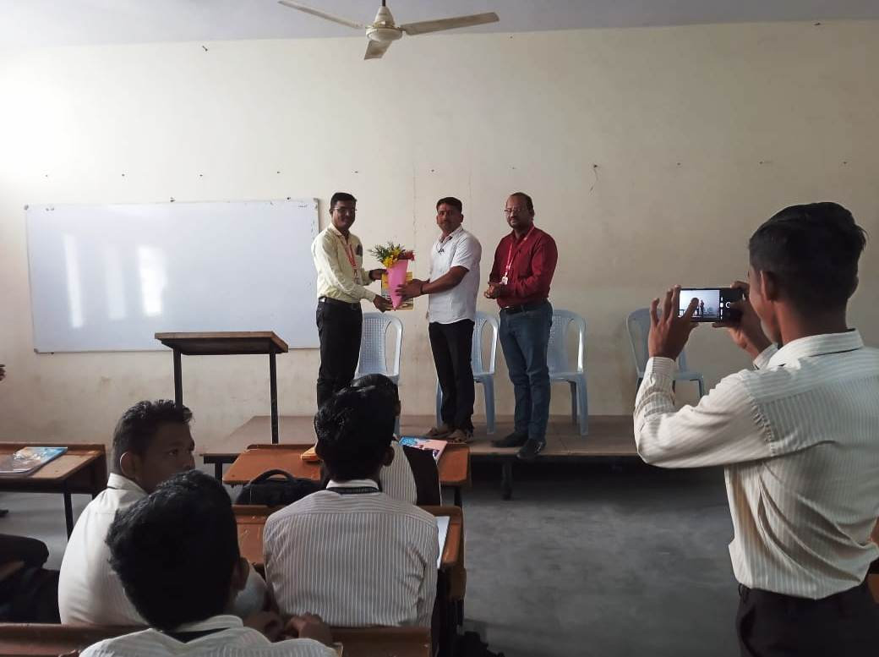
Dr. R. A. Deshmukh (Principal) is Felicitating to the Dr. S. B. Salunkhe. 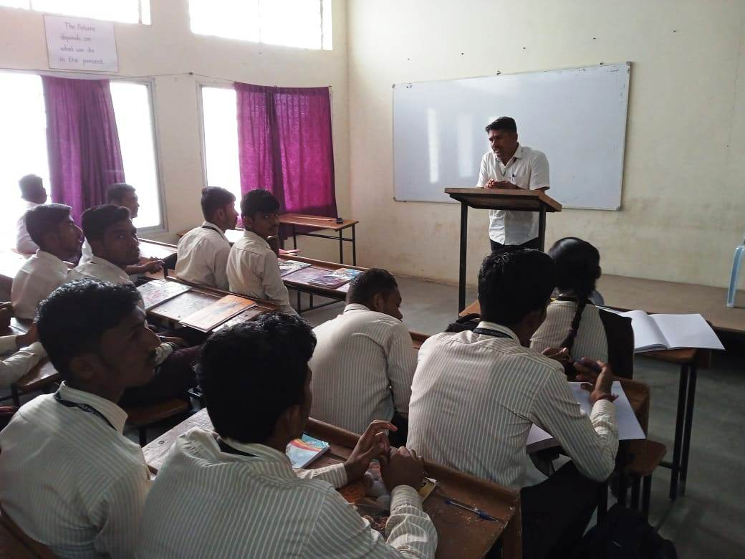
Dr. S. B. Salunkhe is explaining the Refrigeration & Air Conditioning.
Date:- 12/11/2022
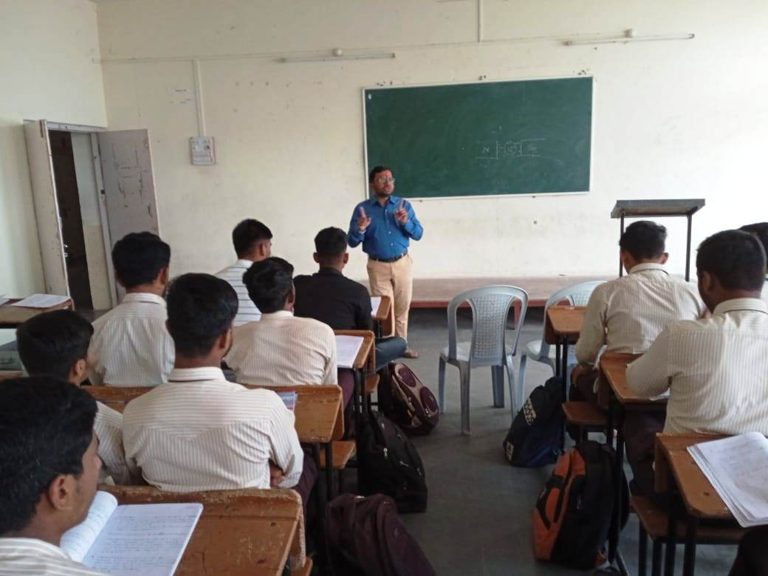
Mr. A. S. Waychal is explaining about Principles of electric and magnetic Circuits.
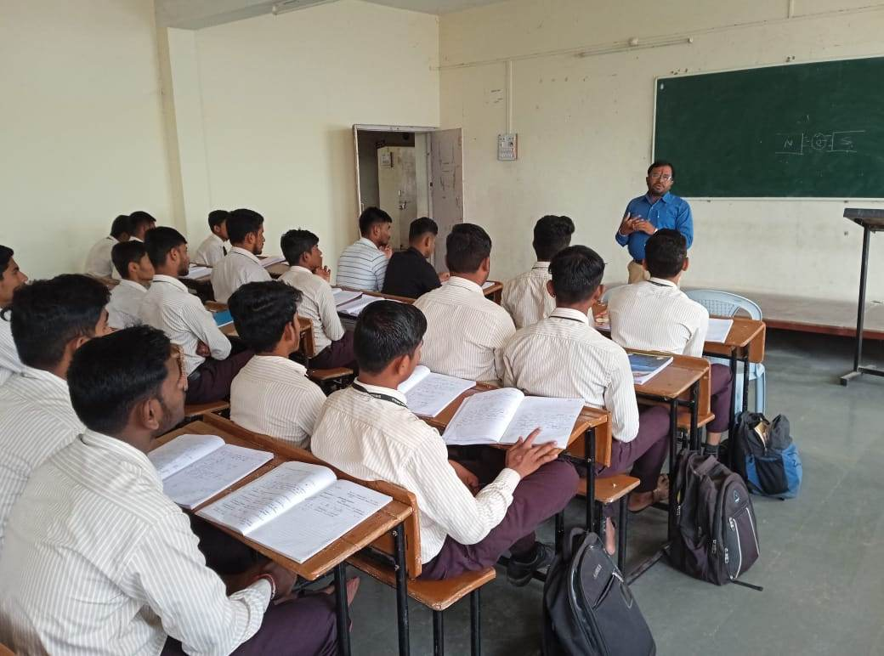
Mr. A. S. Waychal is interacting with students.

Date:- 06/12/2022
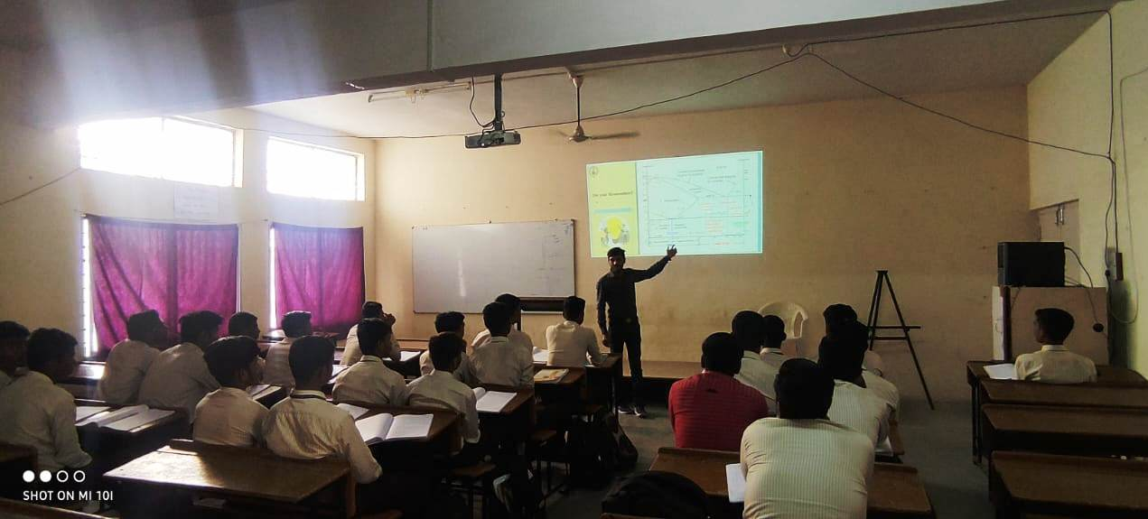
Mr. Y. S. Shete is explaining the Heat treatment process.

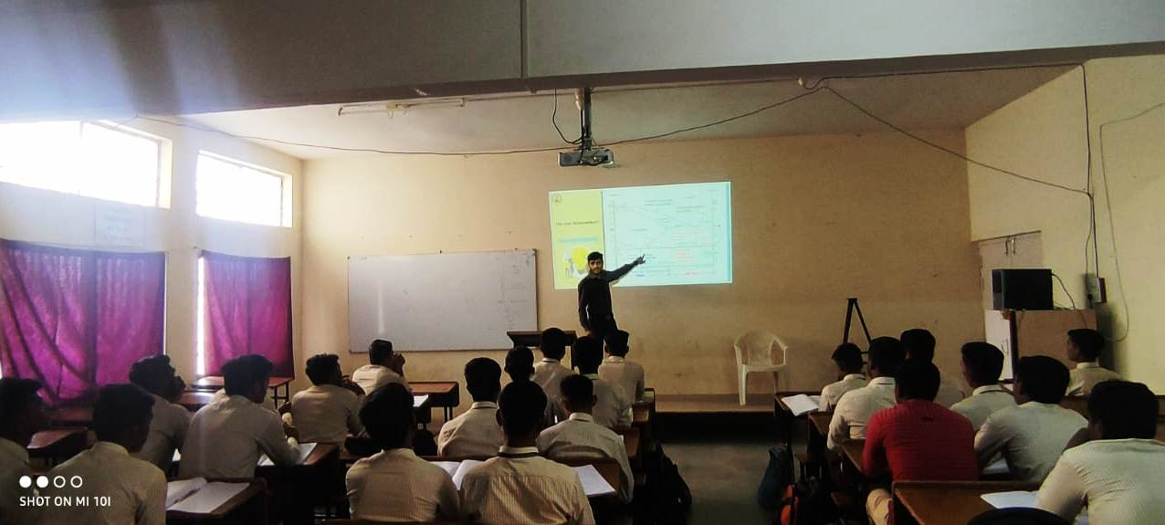
Mr. Y. S. Shete is explaining about the Iron Carbide diagram.

Date:- 10/12/2022
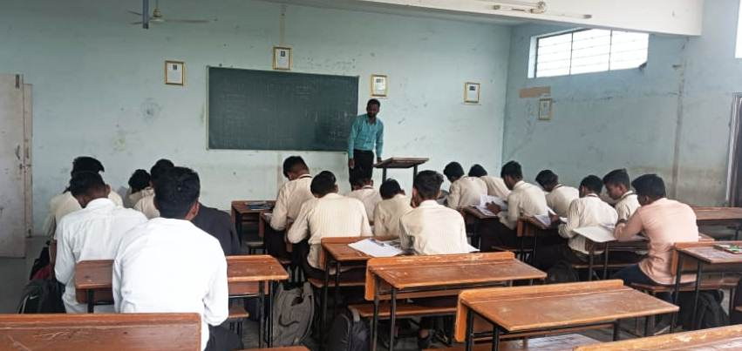
Mr. A. G. Kambale is explaining about the CNC Programming.

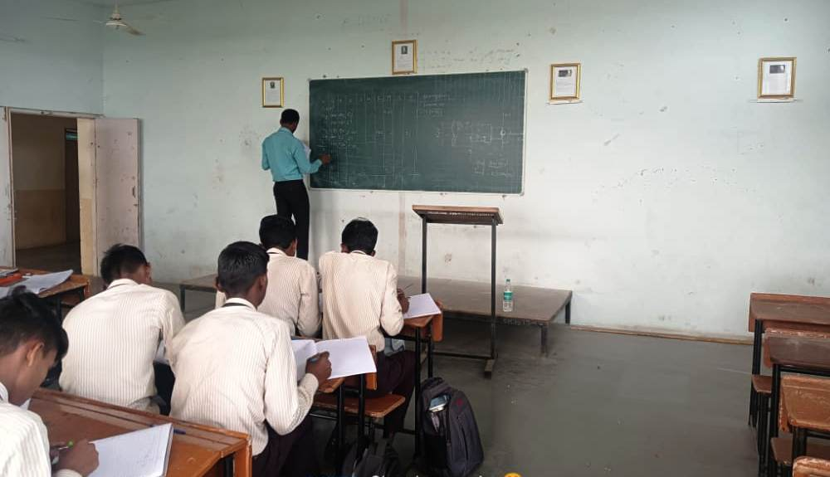
Mr. A. G. Kambale is interacting with students.

Date:- 21/11/2022
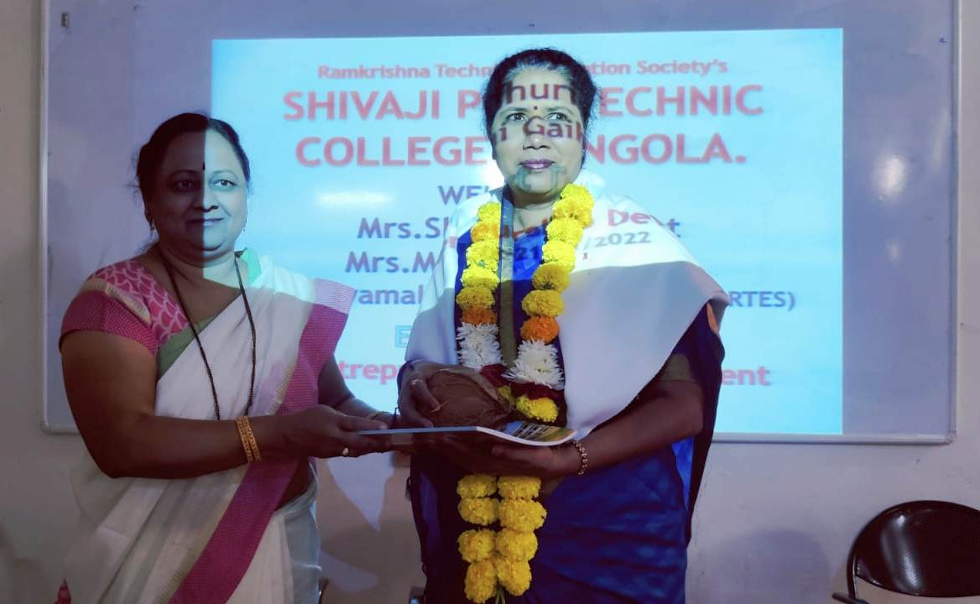
Mrs. Jayamalatai Gaikwad (Director RTES) is Felicitating , Dr. Sharayu Sawant .

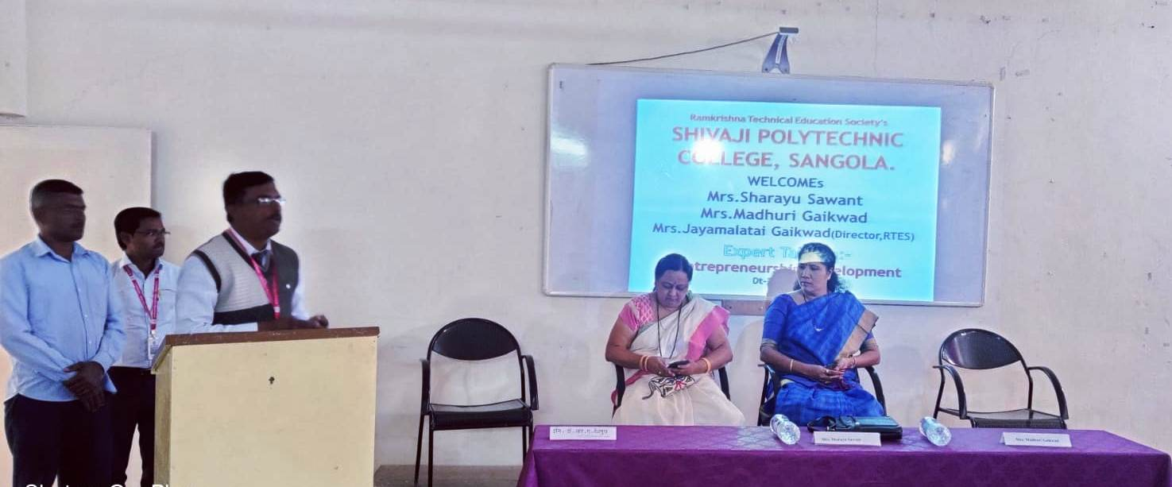
Dr. R. A. Deshmukh (Principal) is introducing Dr. Sharayu Sawant, Chief Guest.

Date:- 21/11/2022

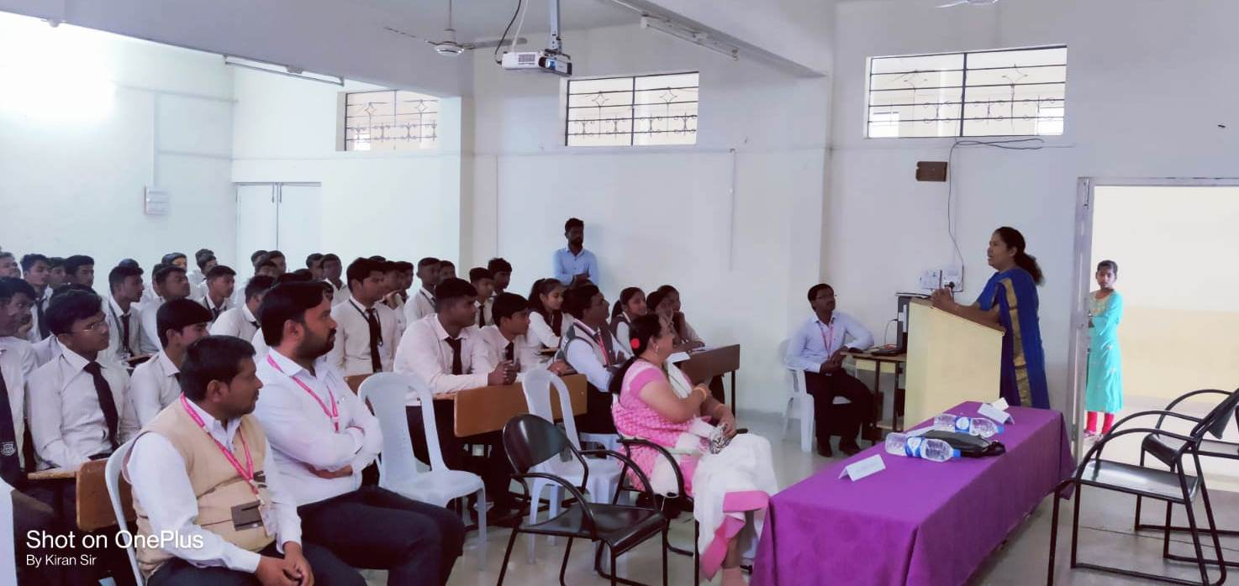
Dr. Sharayu Sawant, Chief Guest is interacting with students about Entrepreneurship Development.

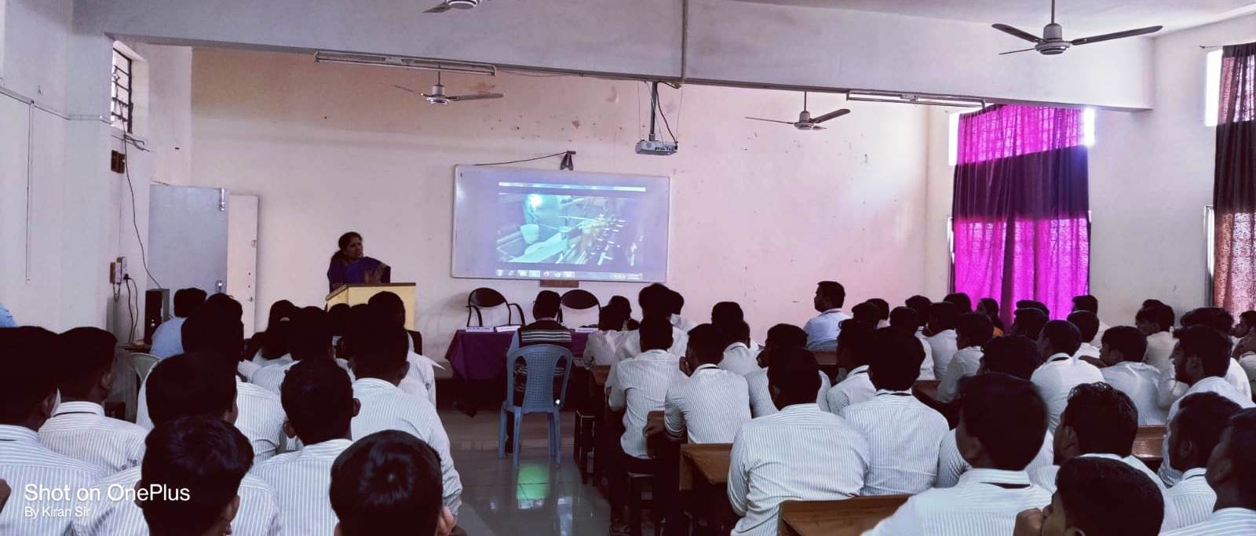
Dr. Sharayu Sawant, Chief Guest is interacting with students.

Date:- 16/03/2023

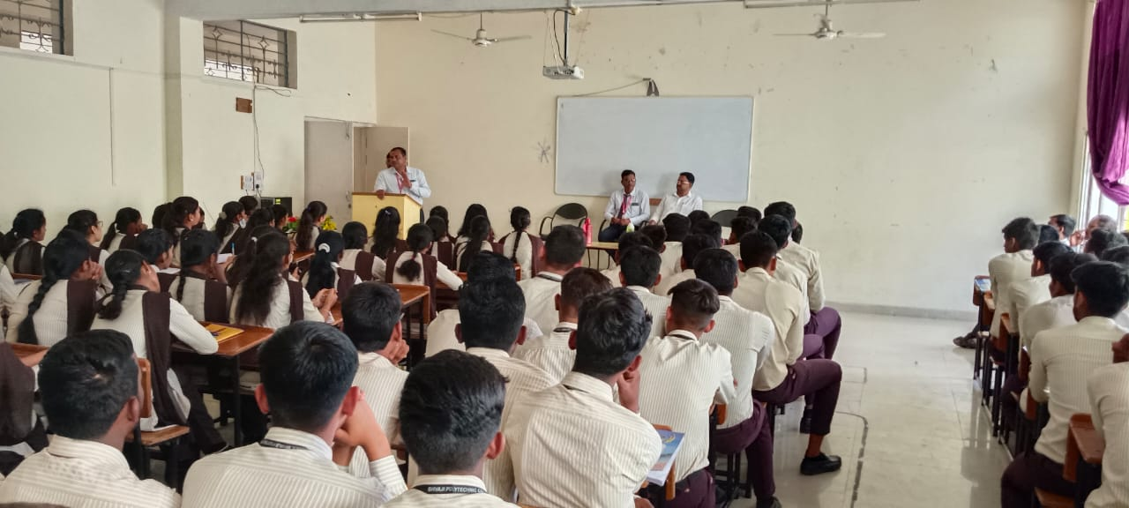
Mr. P. G. Pawar is introducing Er. Somnath Khandagale , Chief Guest

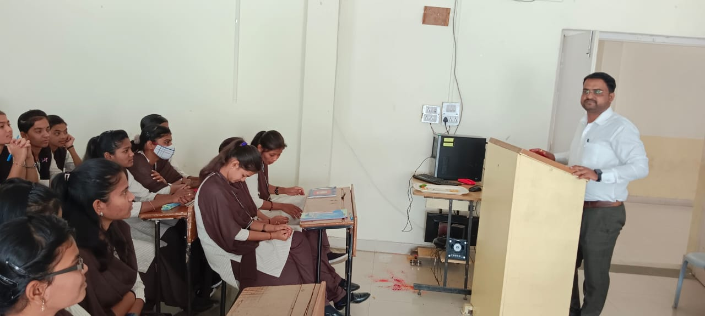
Er. Somnath Khandagale, Chief Guest is interacting with students.

Date:- 14/03/2023
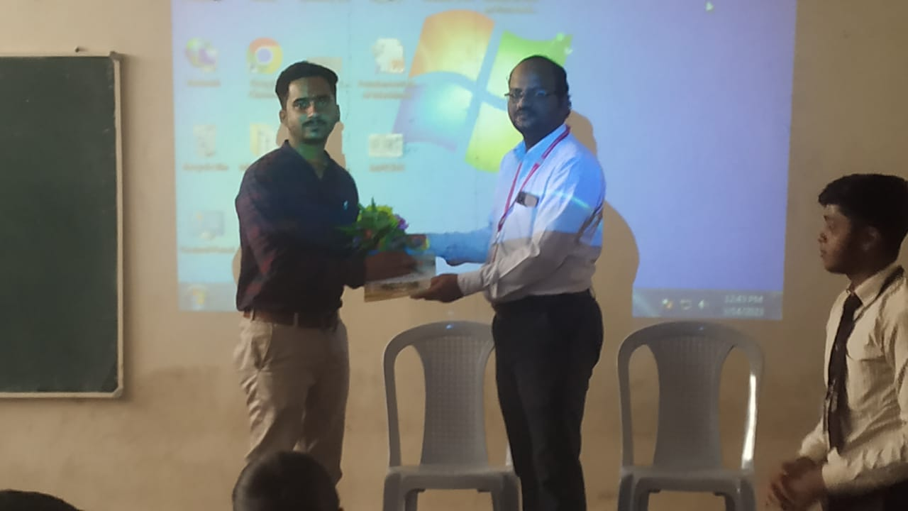
Mr. D. S. Khandare (HOD) is Felicitating, Mr. Parag Deshmukh.

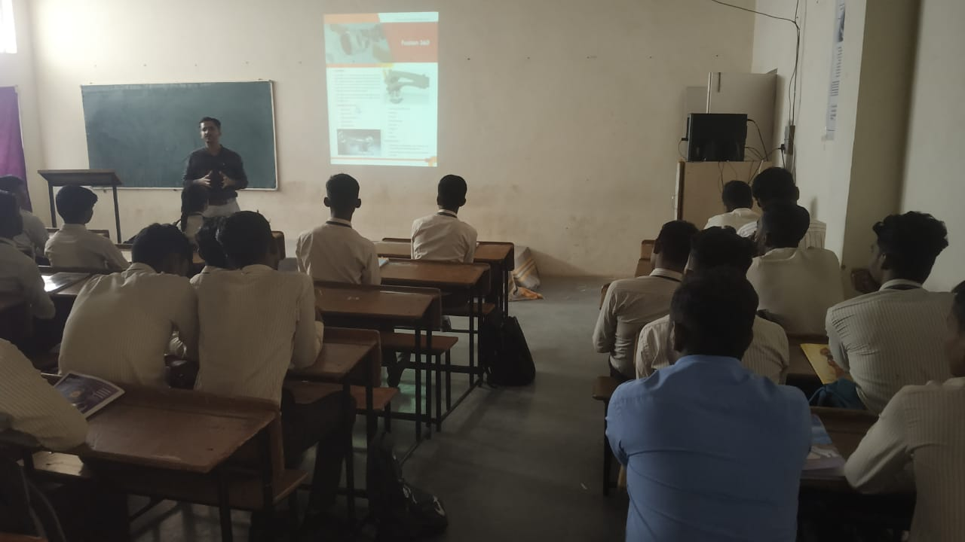
Mr. Parag Deshmukh, Chief Guest is interacting with students about Auto CAD.

Date:- 20/03/2023
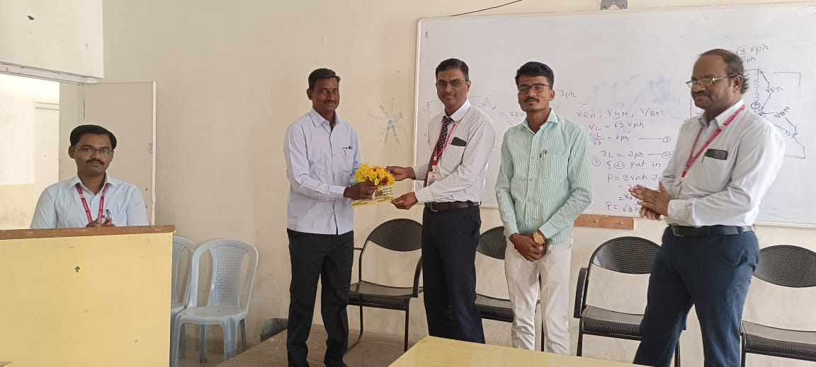
Dr. R. A. Deshmukh (Principal) is Felicitating, Mr. Sambhaji Vasudev Harihar.

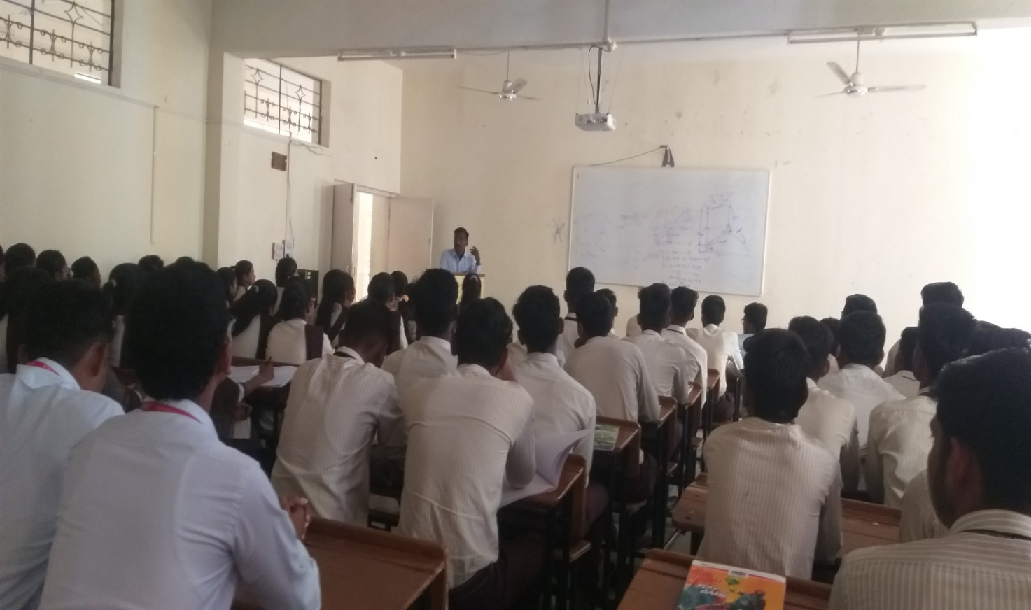
Mr. Sambhaji Vasudev Harihar, Chief Guest is interacting with students about Personality Development.

DATE:- 21/02/2023

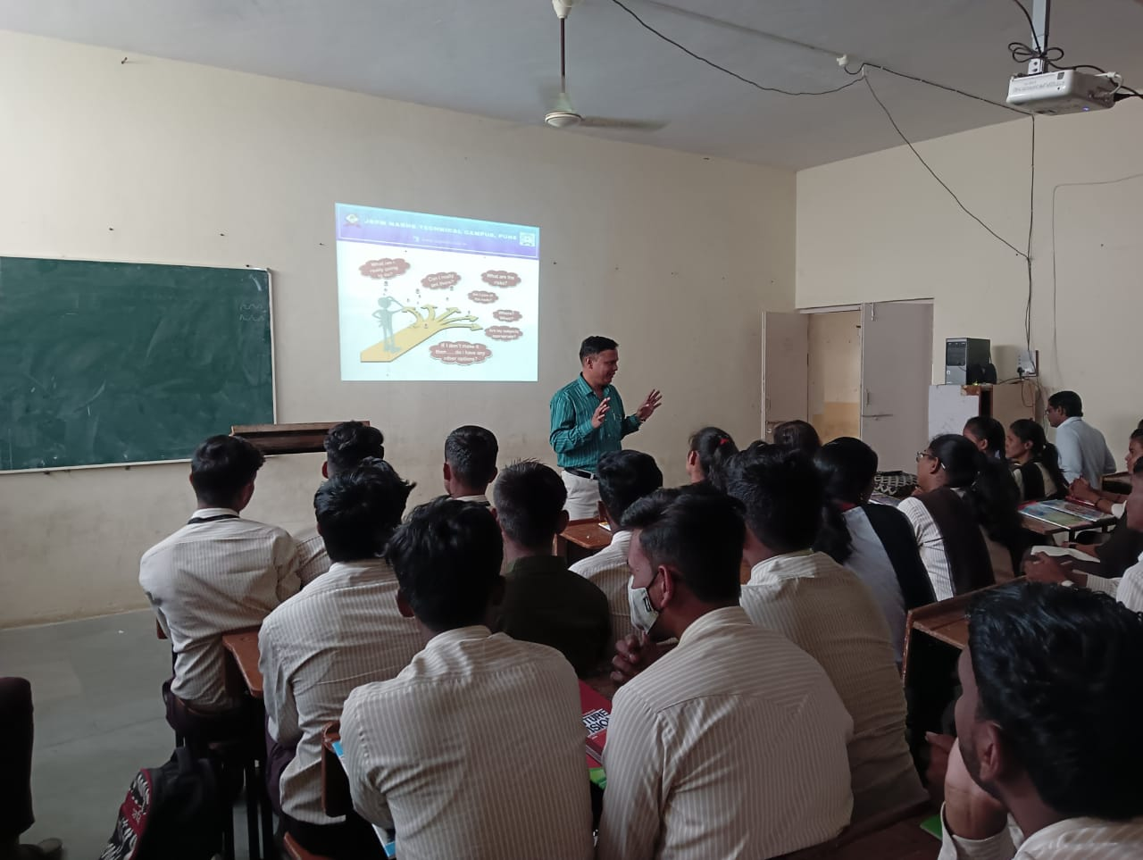

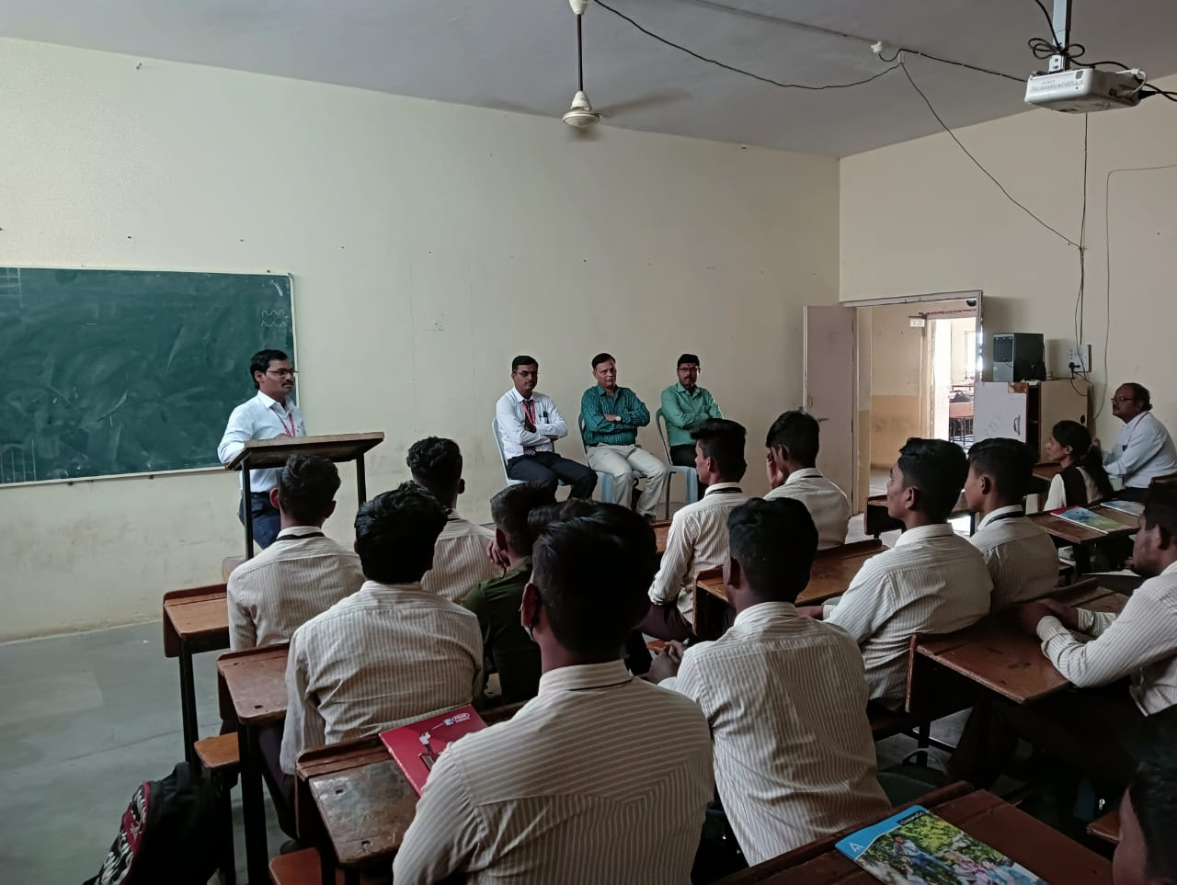

Dr. M. M. Sardeshmukh Conducting a Lecture on Third Year Class on “Personality Development”

Date :- 29/03/2023
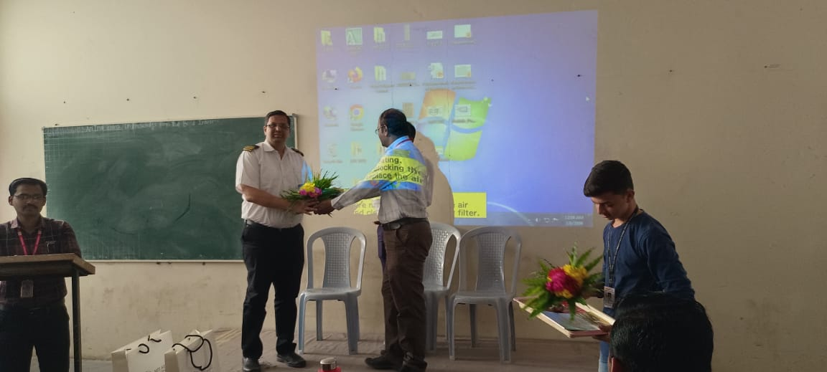

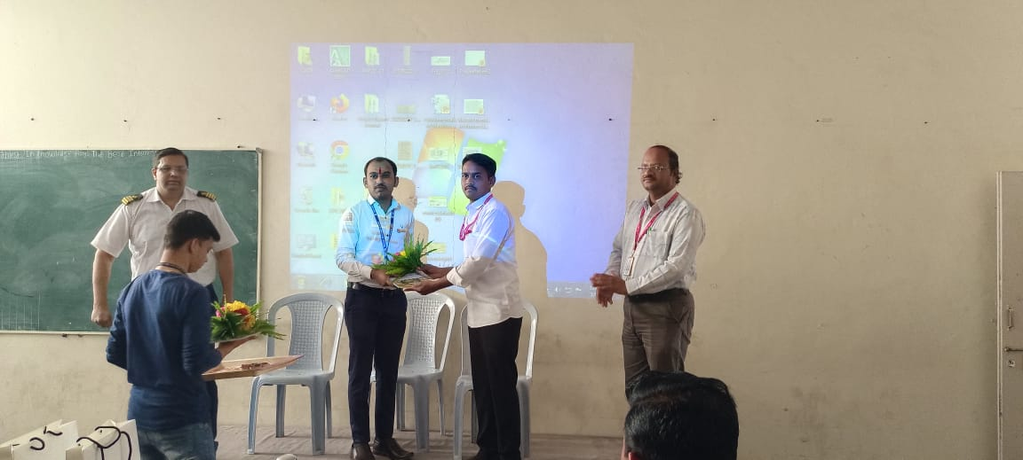
Mr. D. S. Khandare is Felicitating, Mr. Adwait Londhe.

Date :- 04/03/2023
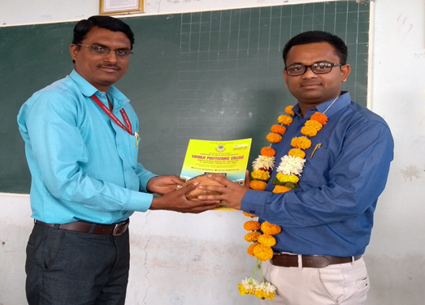
Dr. R. A. Deshmukh (Principal) is Felicitating, Mr. A. M. Markad.

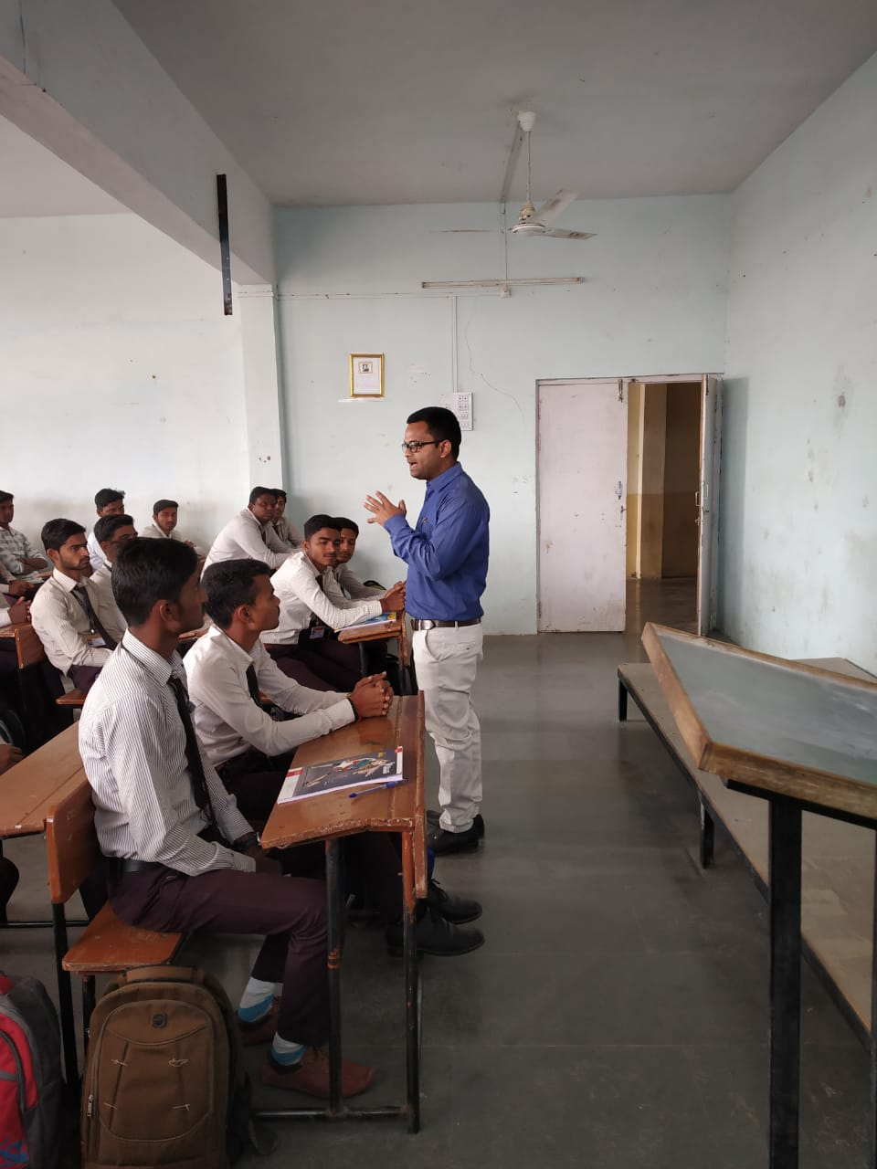
Mr. A. M. Markad, Chief Guest is interacting with students.

Date :- 18/04/2023
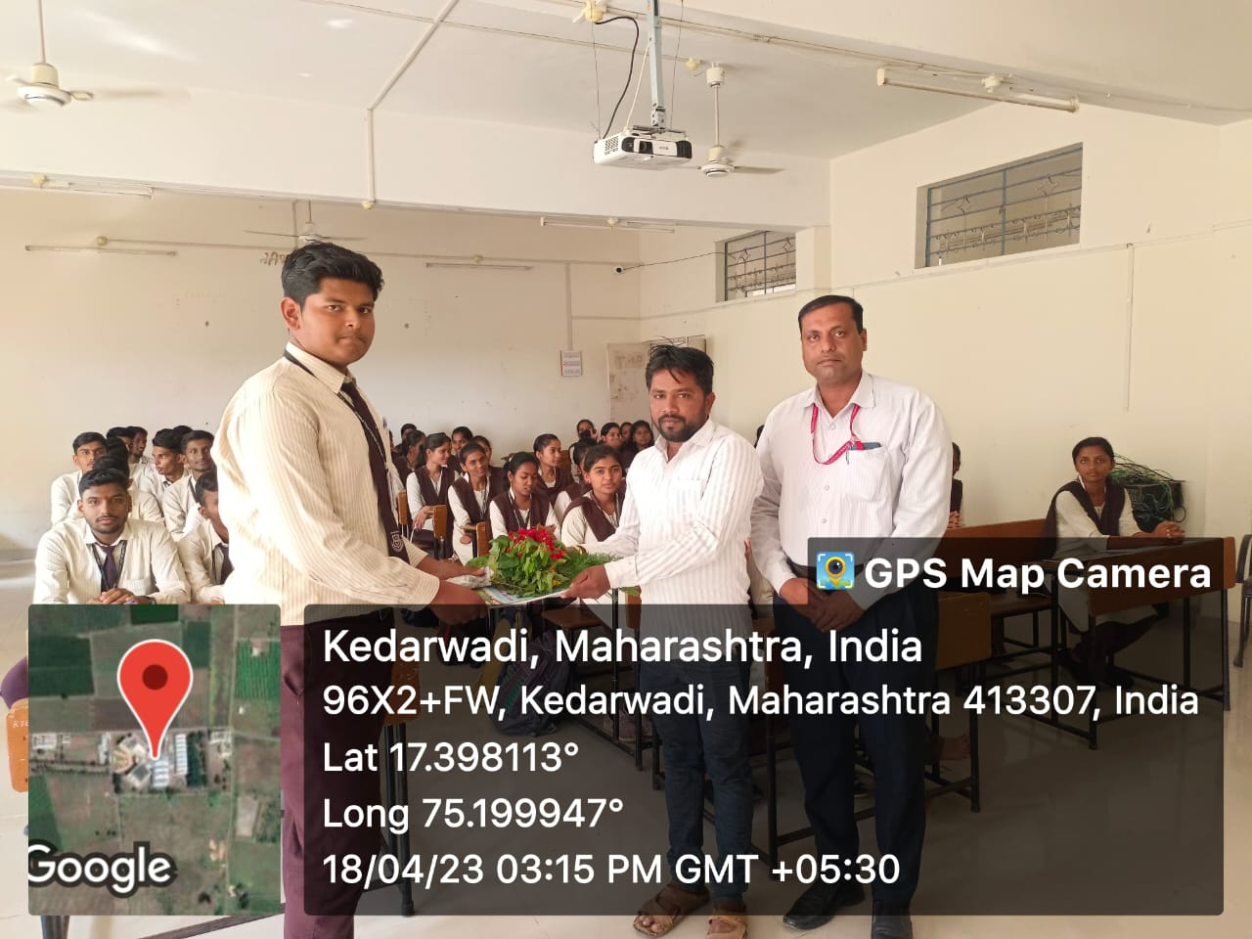
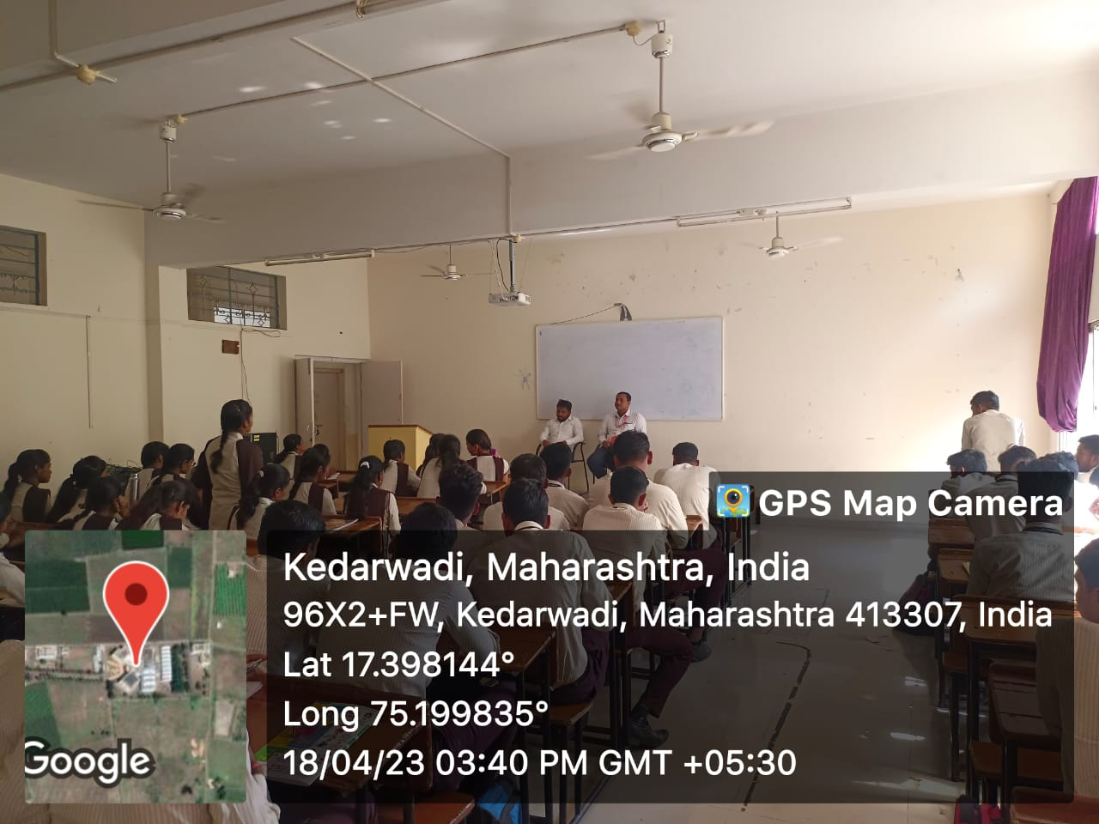Mr. Prashant Dattatray Teli , Chief Guest is interacting with students.

