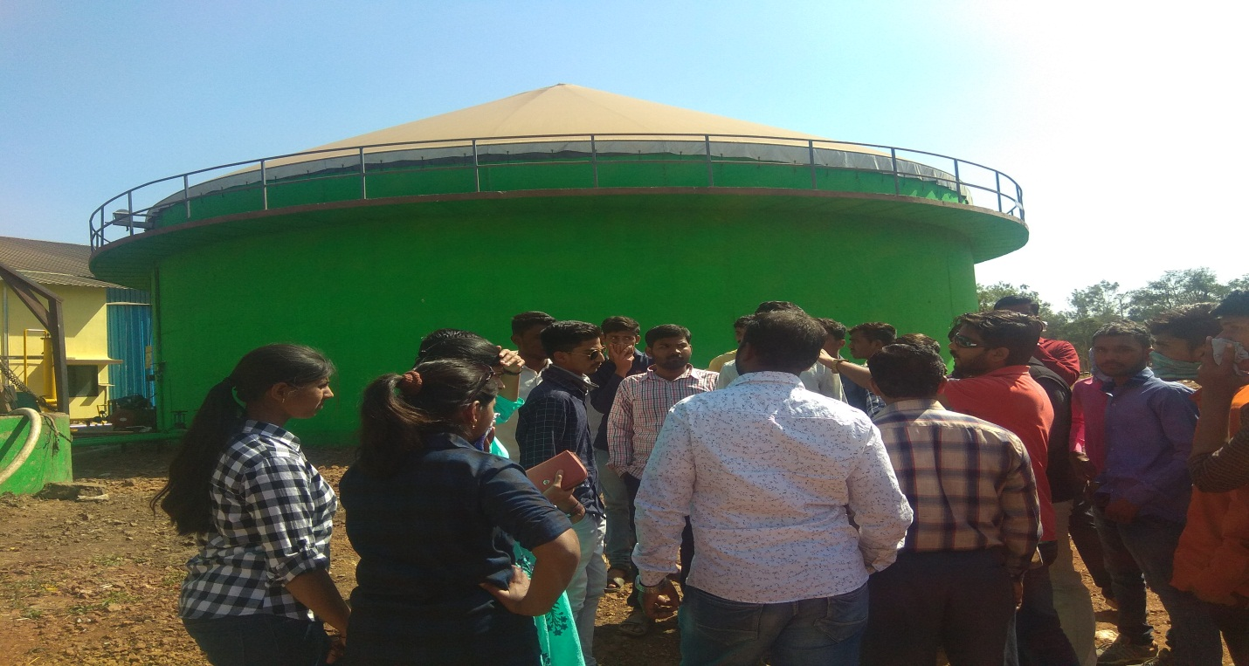

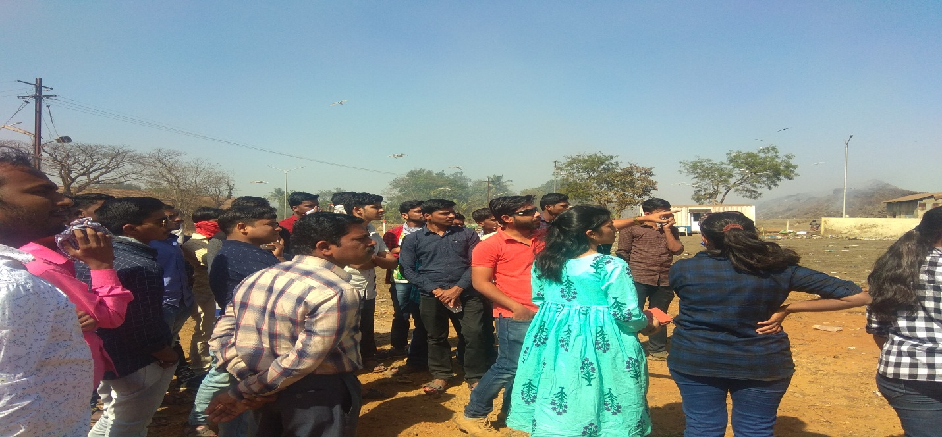

VISIT TO SOLID WASTE DISPOSAL & TREATMENT PLANTS, KOLHAPUR
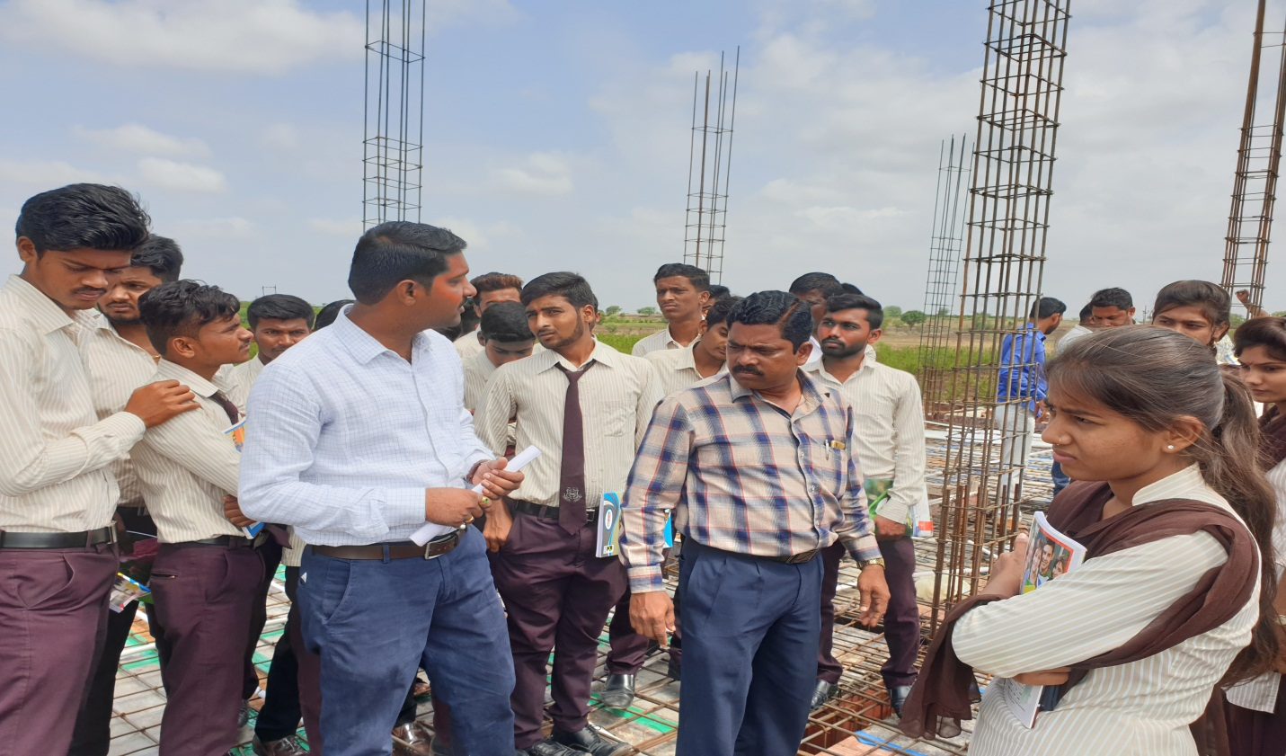

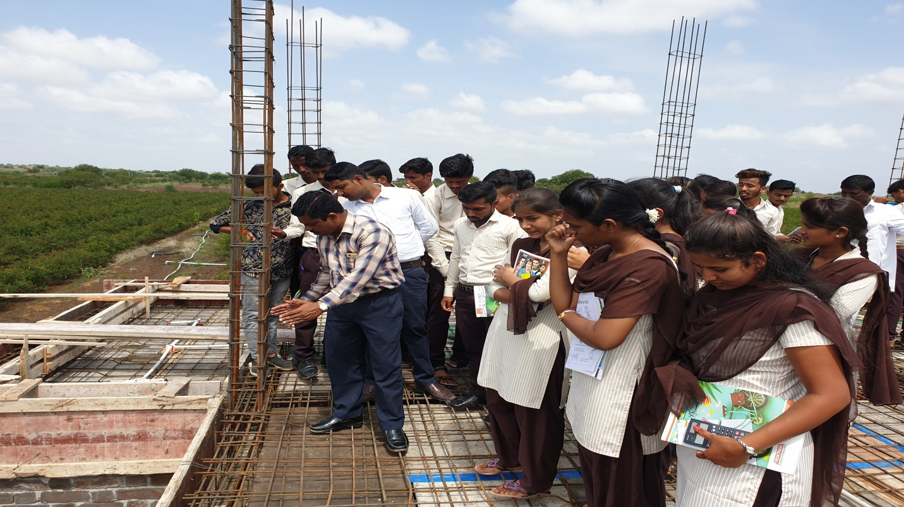
MR. DIGHE S.S EXPLAINING REINFORCEMENT DETAILS OF SLAB AT JAWALA ROAD KADLAS.
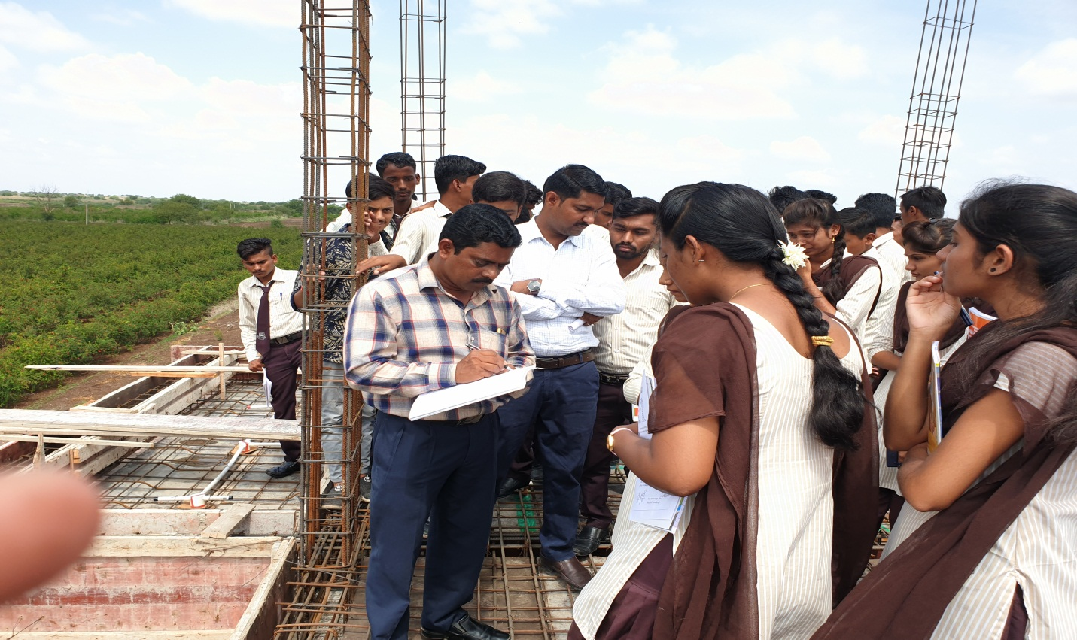

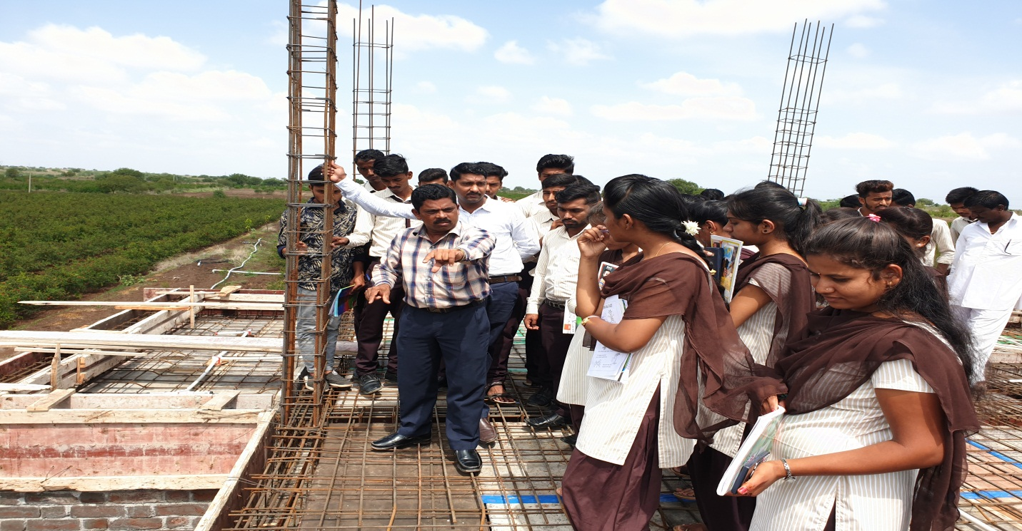
MR. DIGHE S.S EXPLAINING REINFORCEMENT DETAILS OF SLAB AT JAWALA ROAD KADLAS.
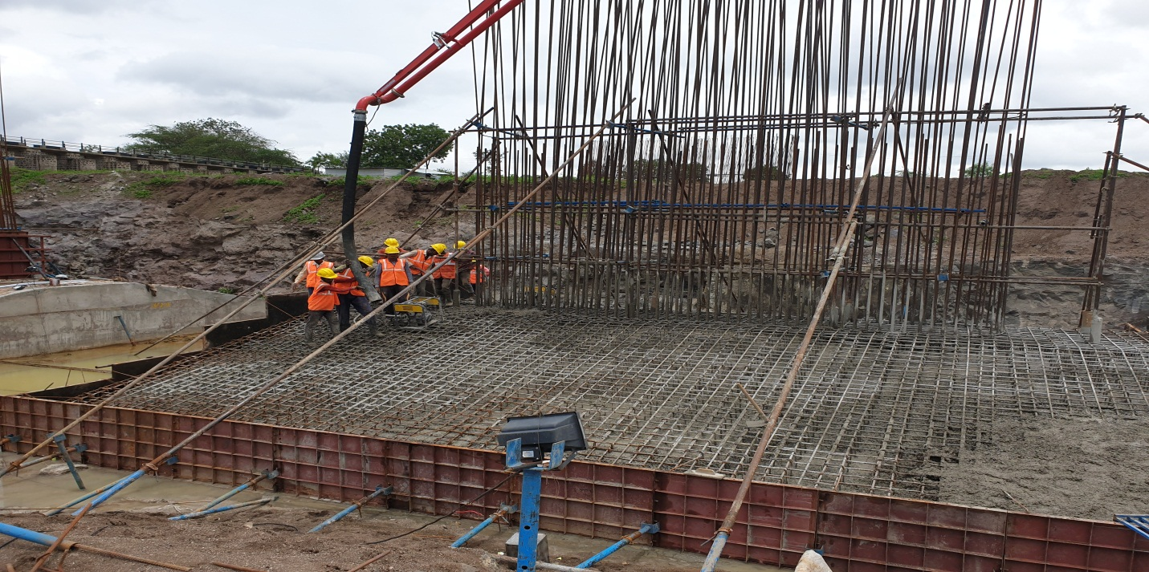

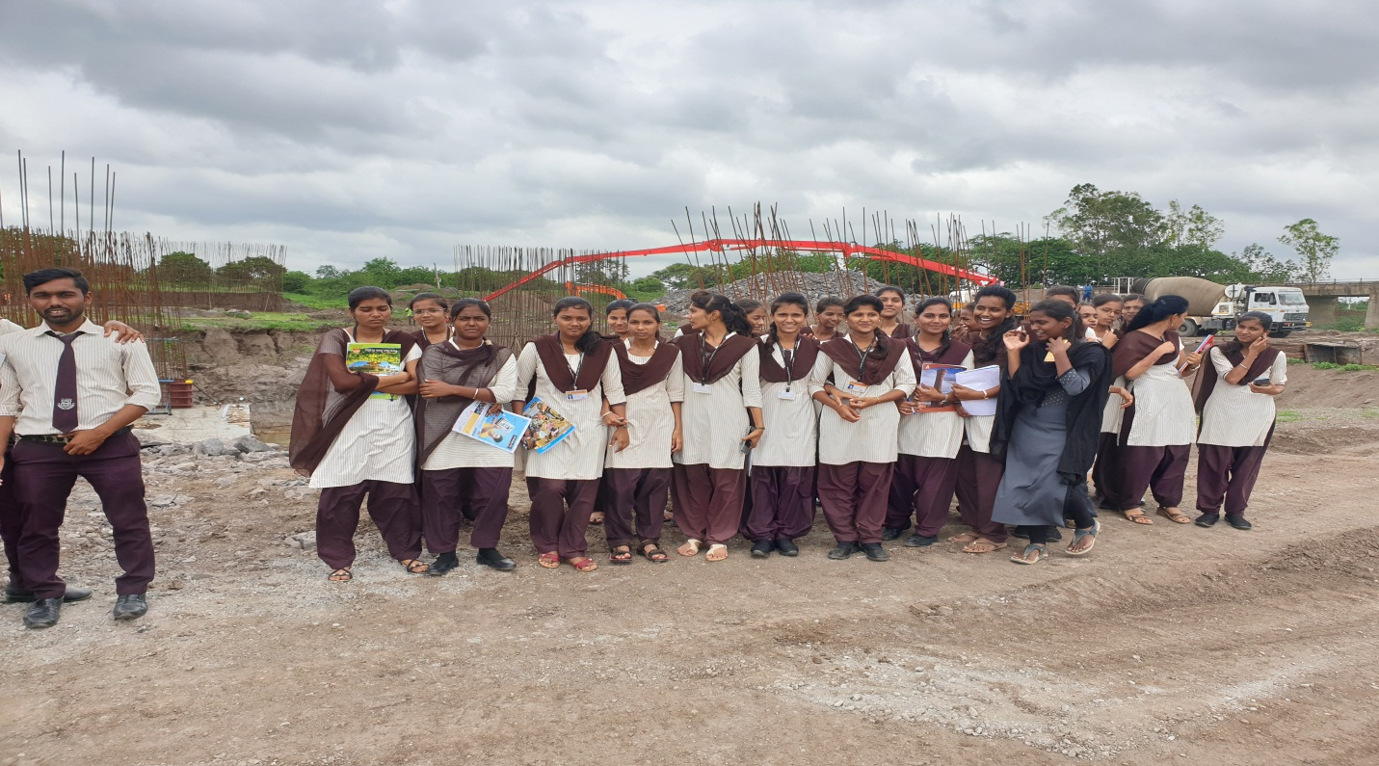
VISIT TO BRIDGE SITE AT WADEGAON, SANGOLA .
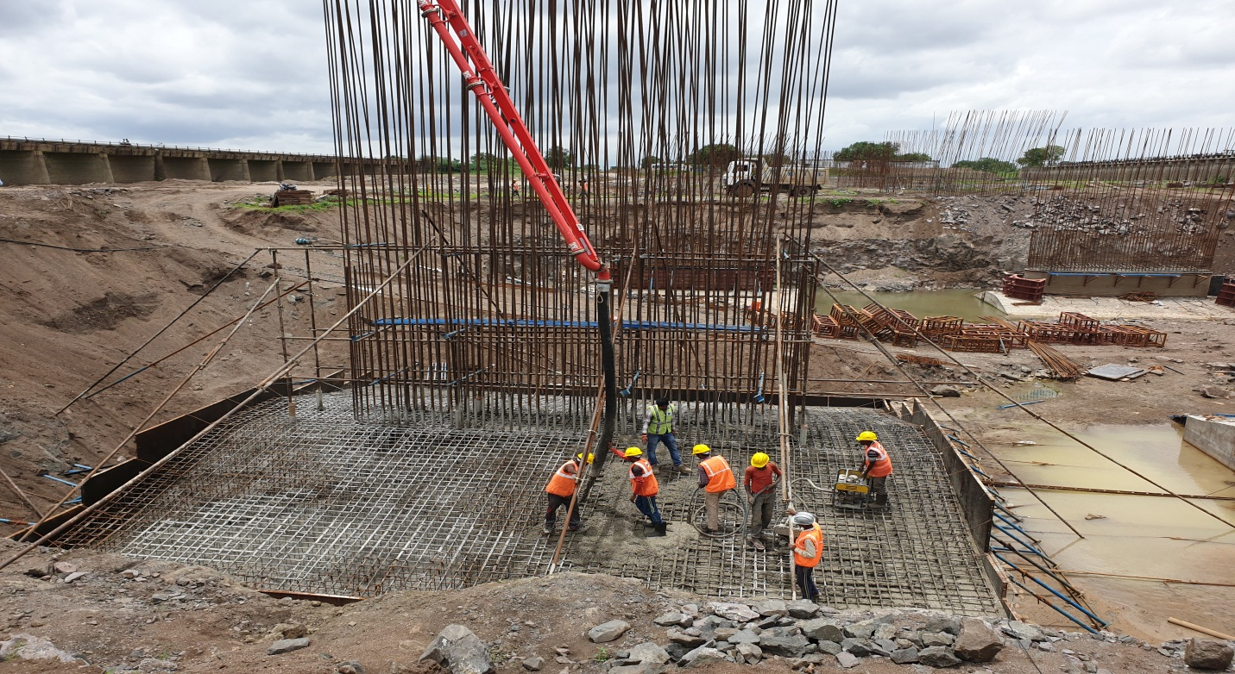

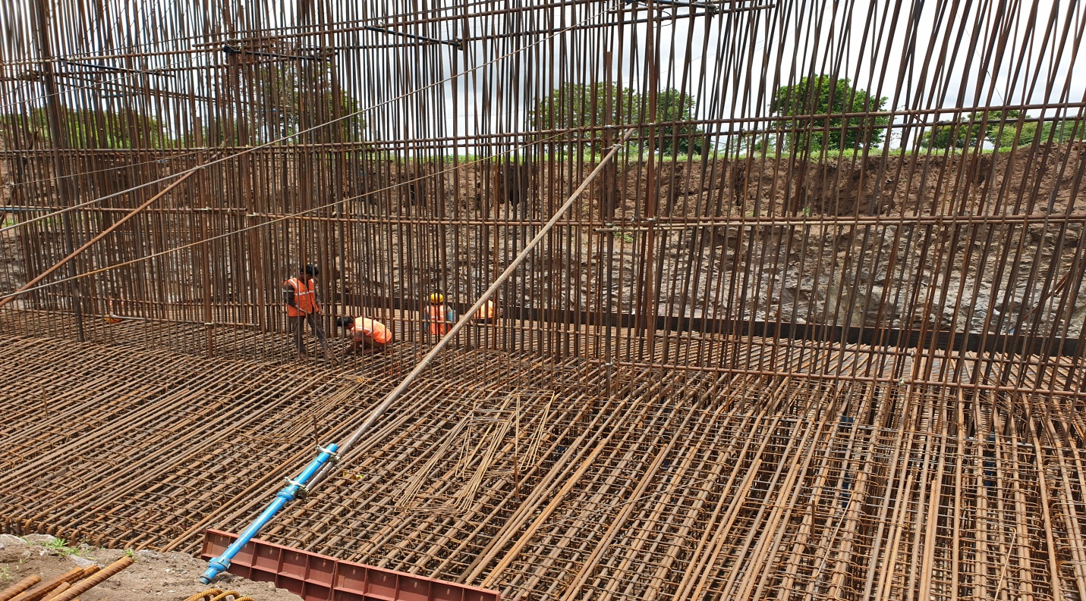
VISIT TO UNDER CONSTRUCTION OF BRIDGE SITE AT WADEGAON, SANGOLA.

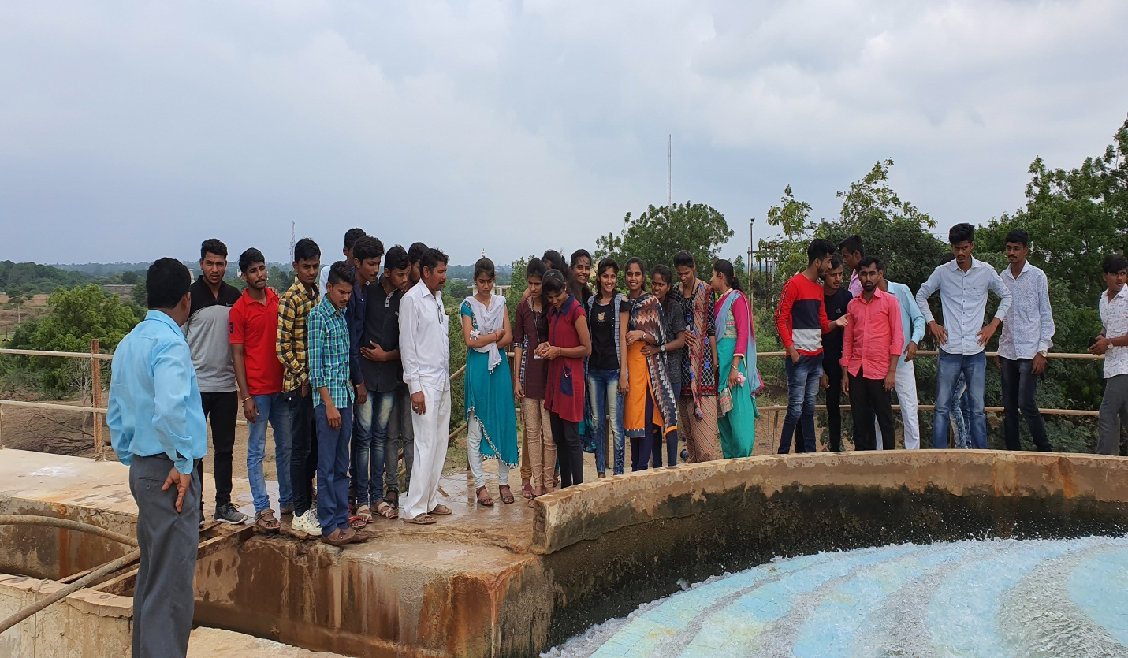

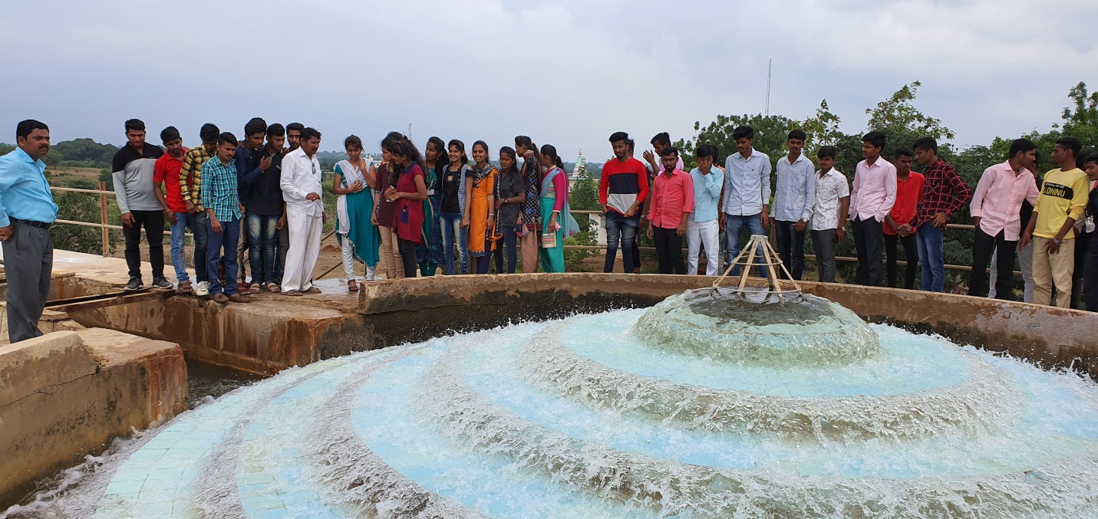
MR. MANE SIR EXPLAINING PROCEDURE OF WATER TREATMENT PLANT AT SHIRBHAVI, SANGOLA.
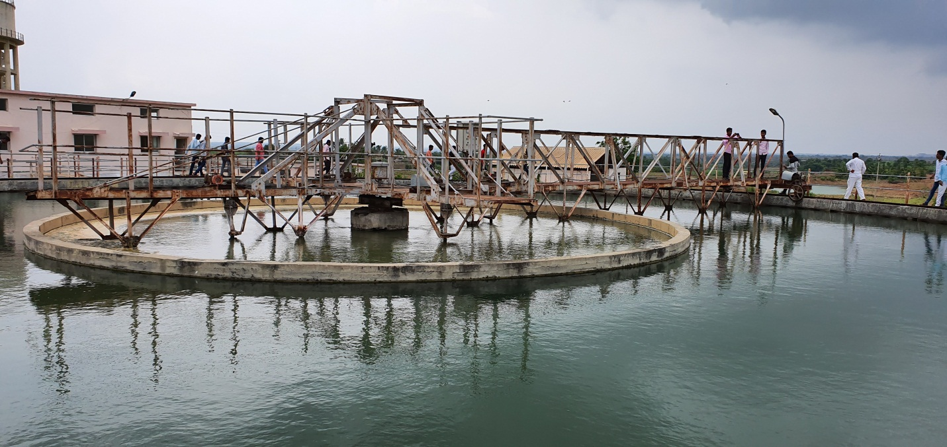

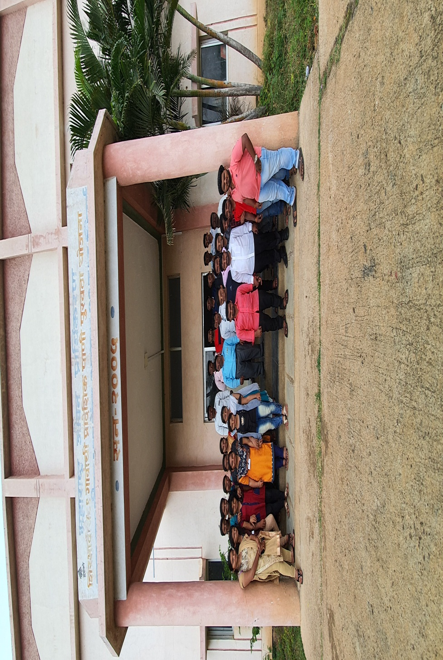
MR. MANE SIR EXPLAINING PROCEDURE OF WATER TREATMENT PLANT AT SHIRBHAVI, SANGOLA.
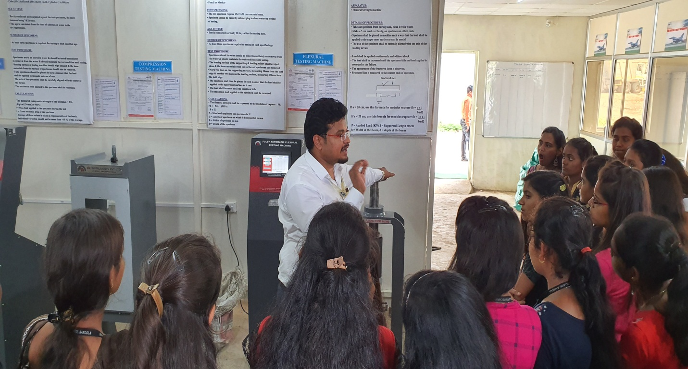

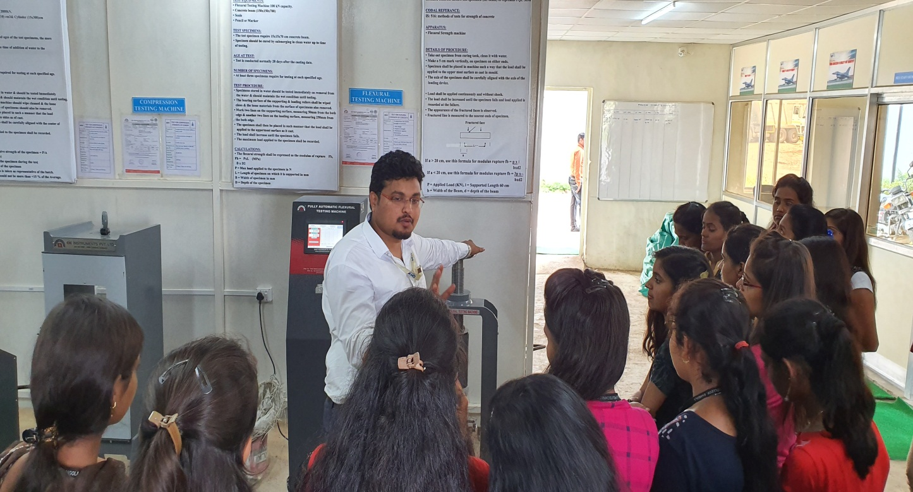
MR. SACHIN PATIL SIR EXPLAINING EXPERIMENTS OF CONCRETE AND GEOTECH TESTING LAB AT LOHEGAON, PUNE
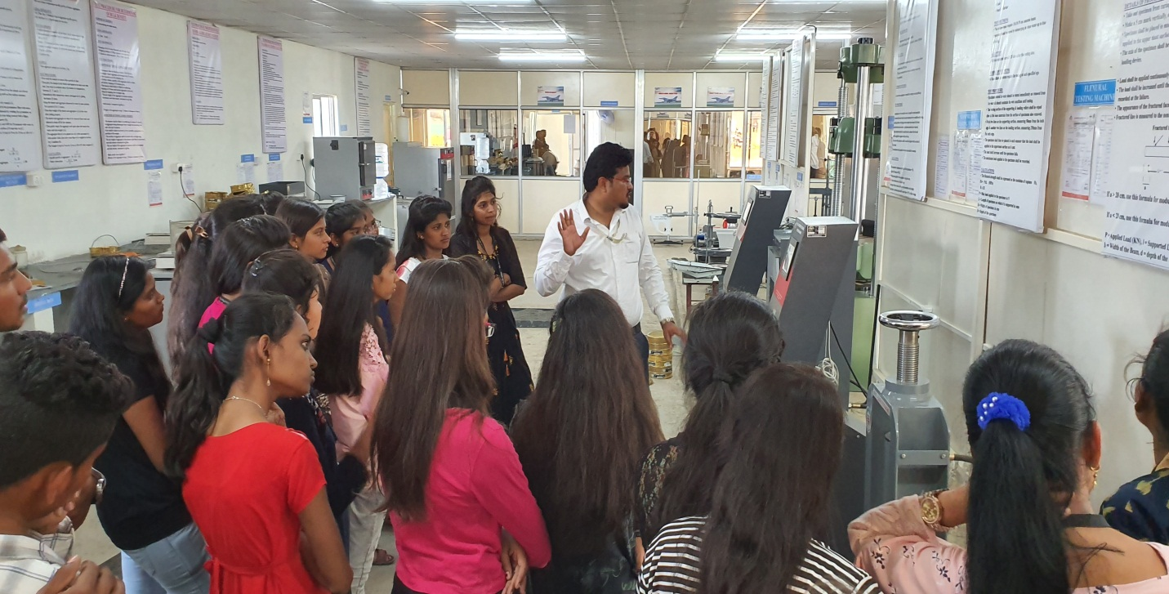

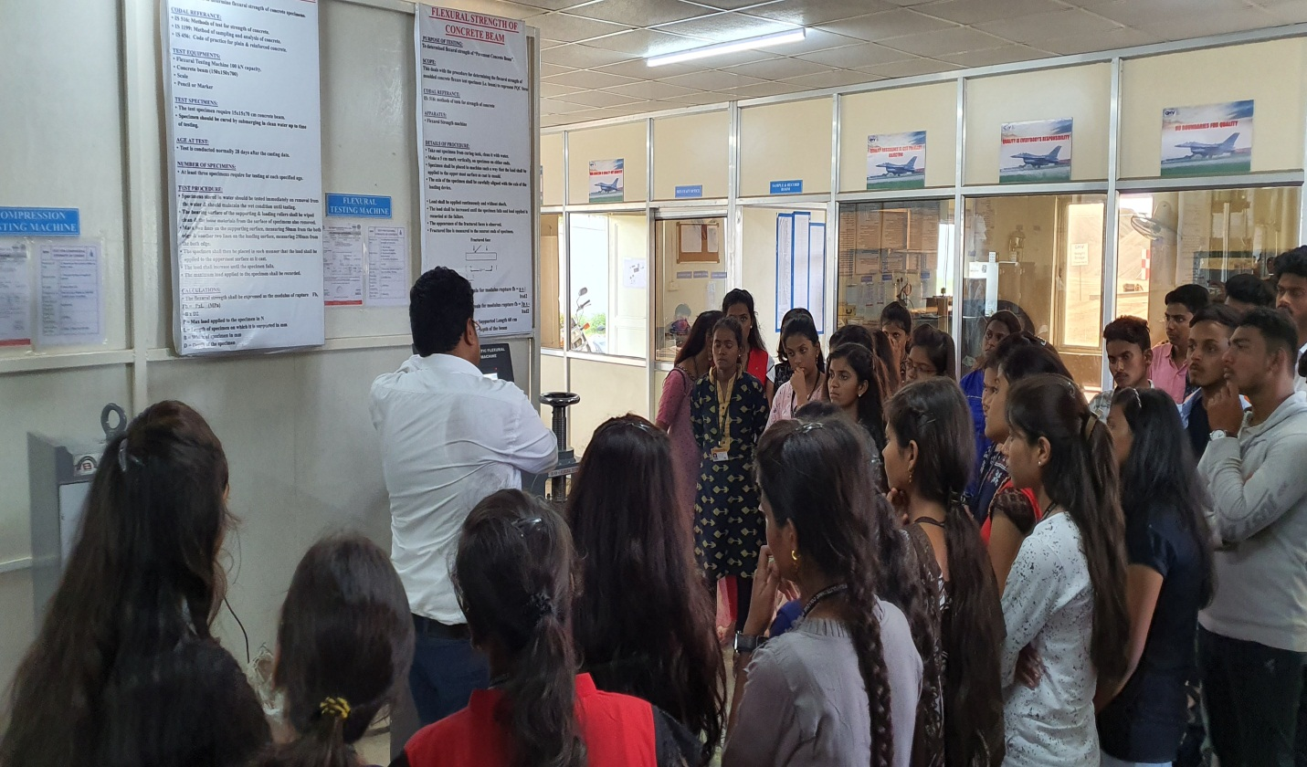
MR. SACHIN PATIL SIR EXPLAINING EXPERIMENTS OF CONCRETE AND GEOTECH TESTING LAB AT LOHEGAON, PUNE
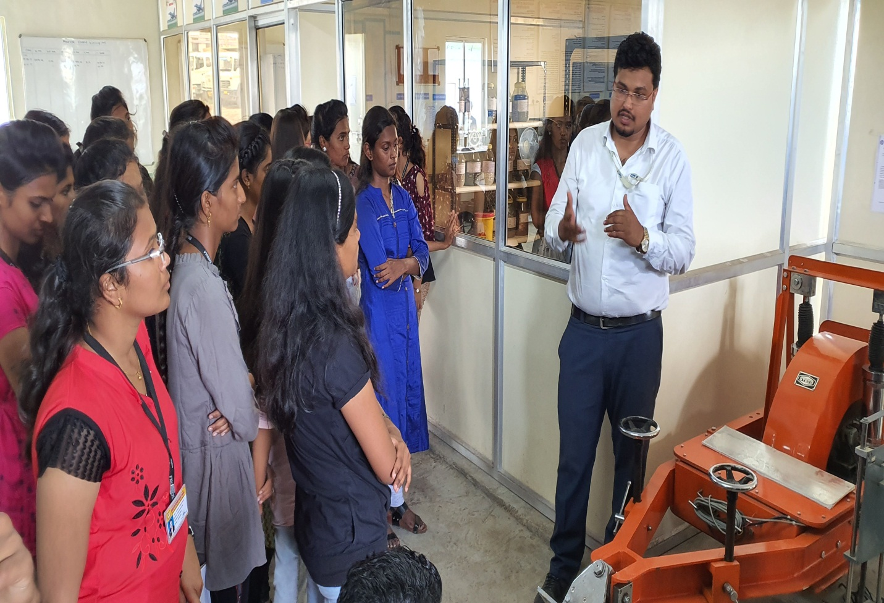
MR. SACHIN PATIL SIR EXPLAINING EXPERIMENTS OF CONCRETE AND GEOTECH TESTING LAB AT LOHEGAON, PUNE

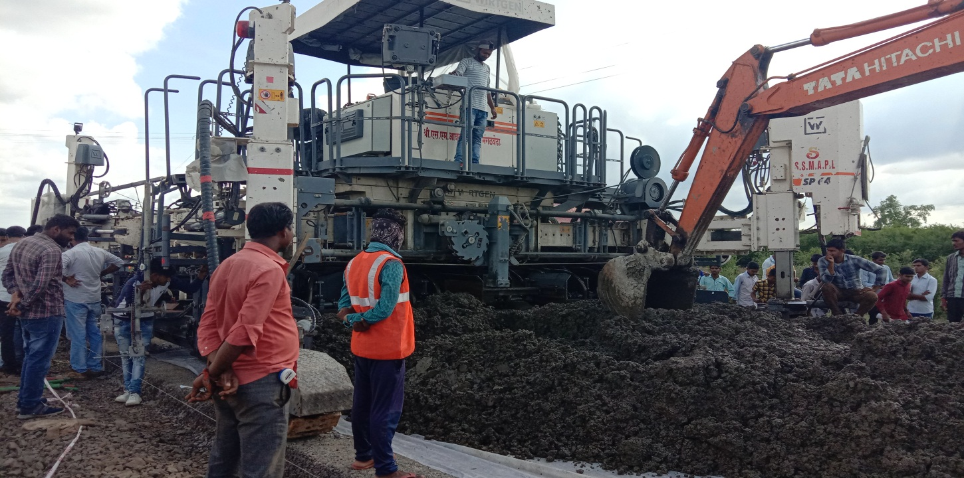

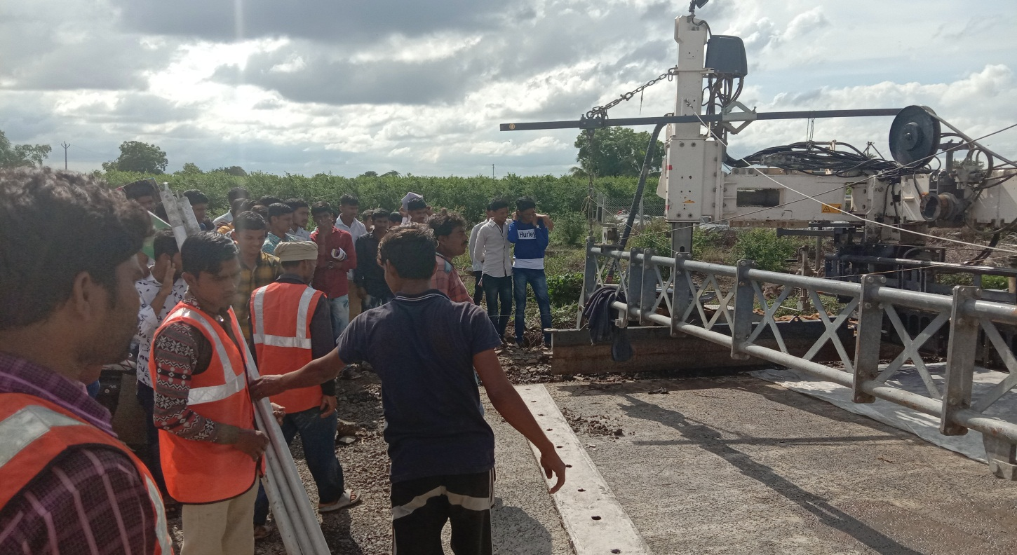
SITE ENGINEER HAS EXPLAINING DETAILS OF CONSTRUCTION OF CEMENT CONCRETE ROAD AT SANGOLA JATH ROAD [SH 71]
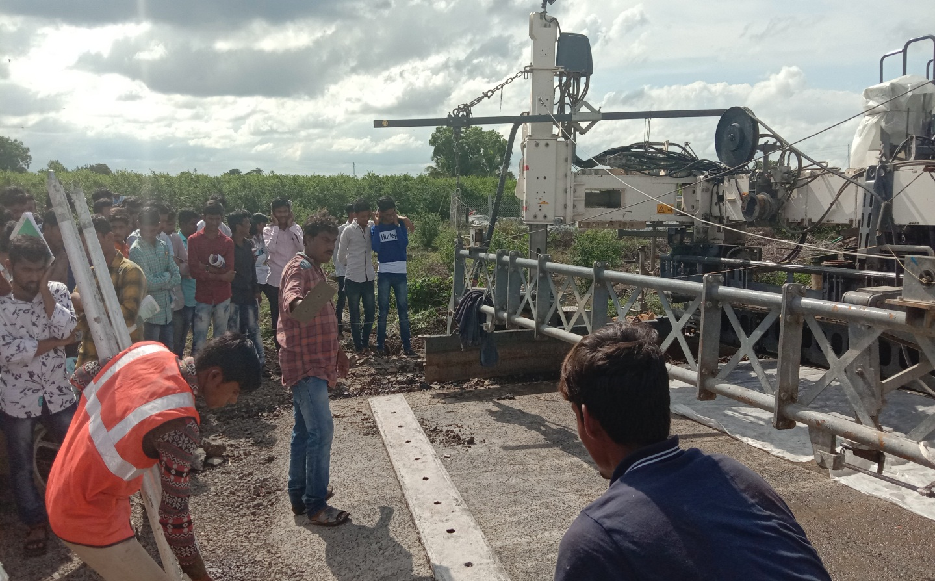

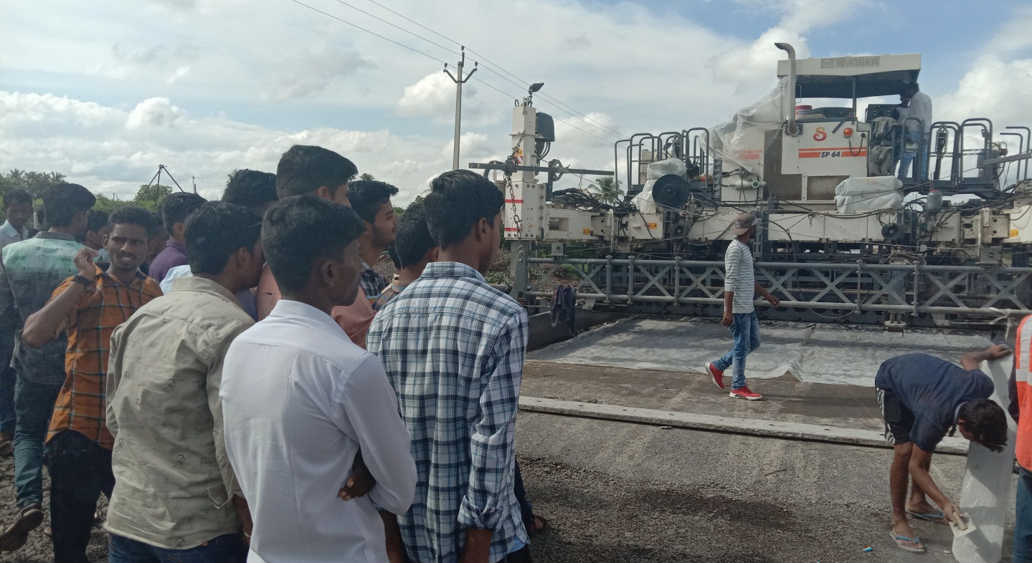
SITE ENGINEER HAS EXPLAINING DETAILS OF CONSTRUCTION OF CEMENT CONCRETE ROAD AT SANGOLA JATH ROAD [SH 71]

