Visit to Mahalaxmi Steel & Patra Depo, Sangola Date: 23/02/2024
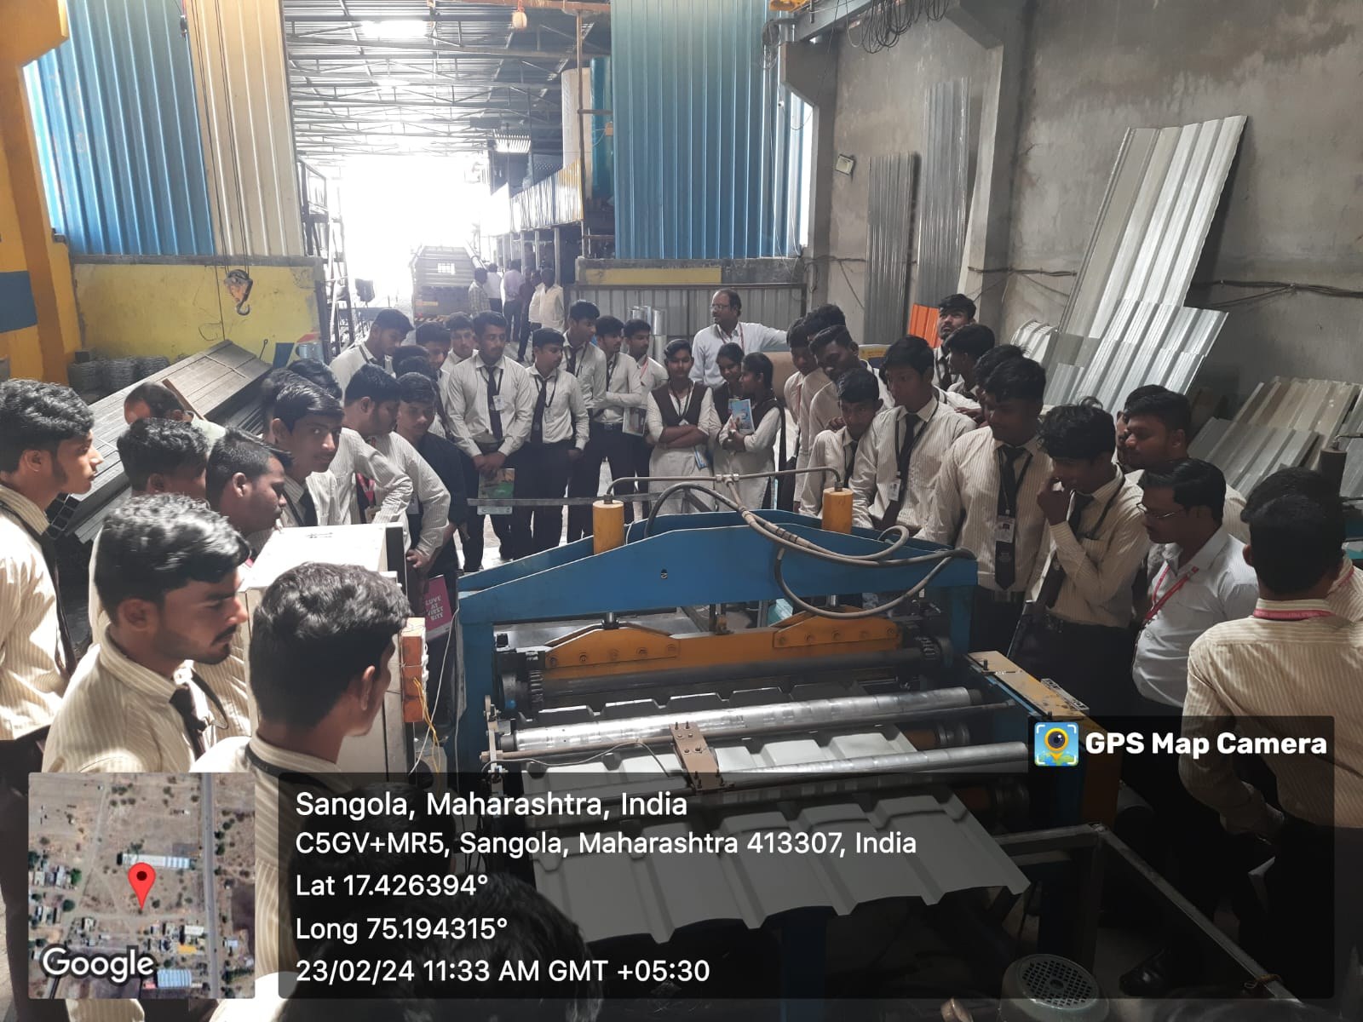
Students are watching the manufacturing process.

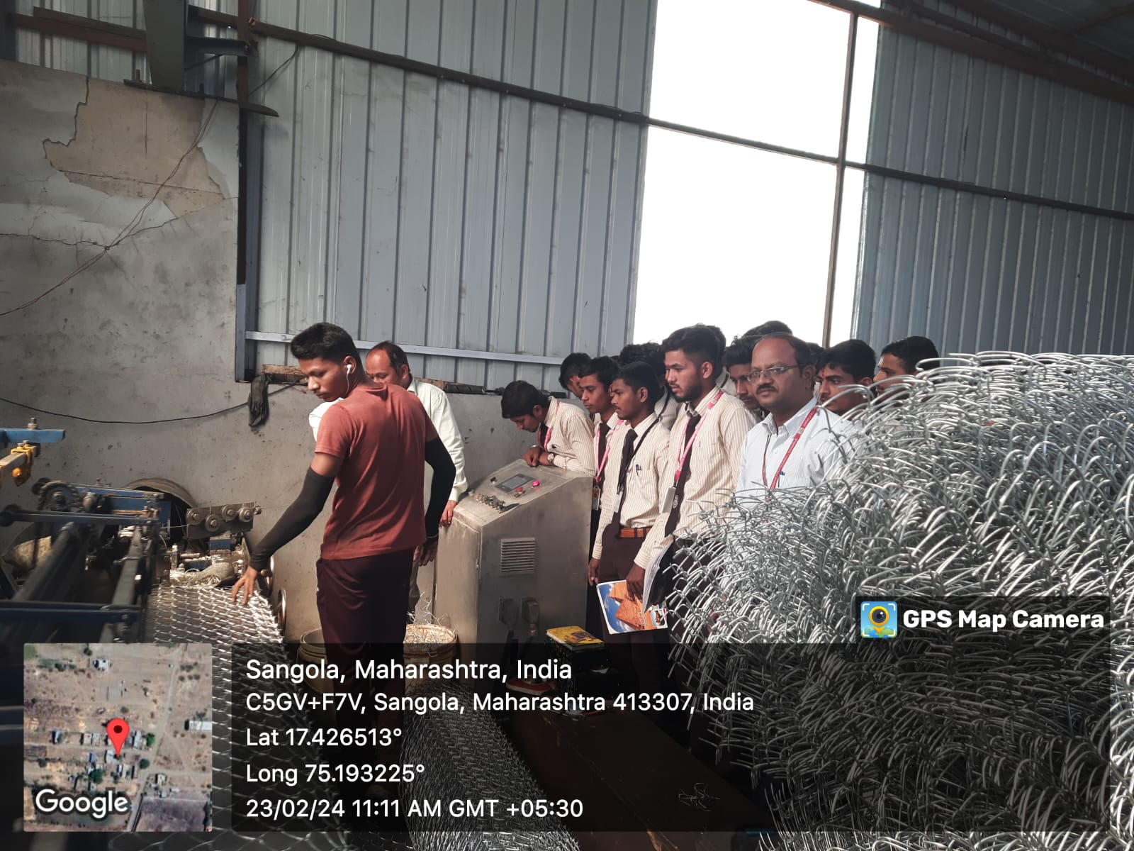
Mr. Yogesh Chowdhari giving information about cutting machine.
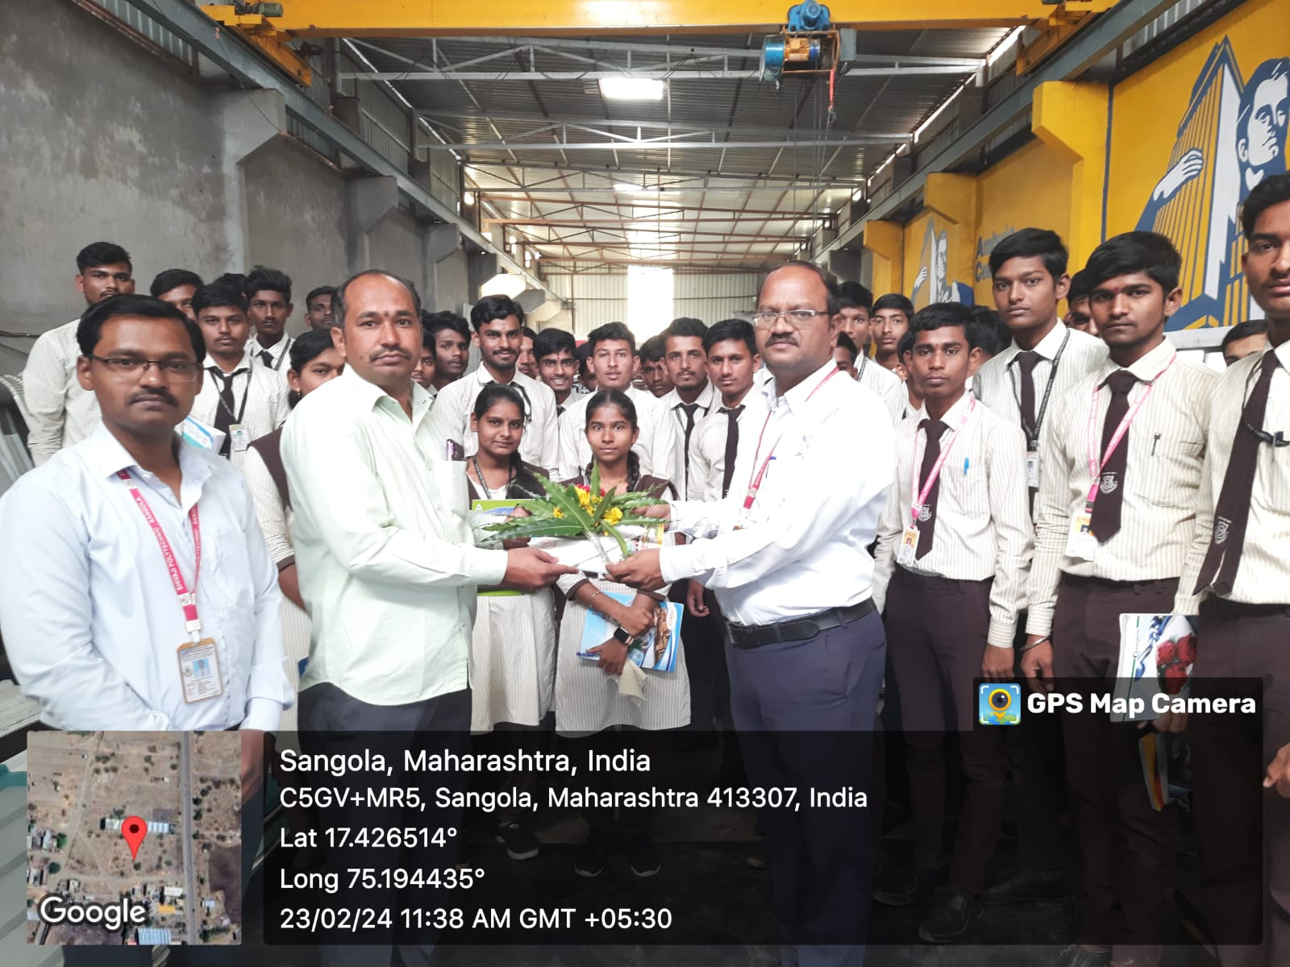
Mr. D.S.Khandare is Felicitating, Mr. Yogesh Chowdhari

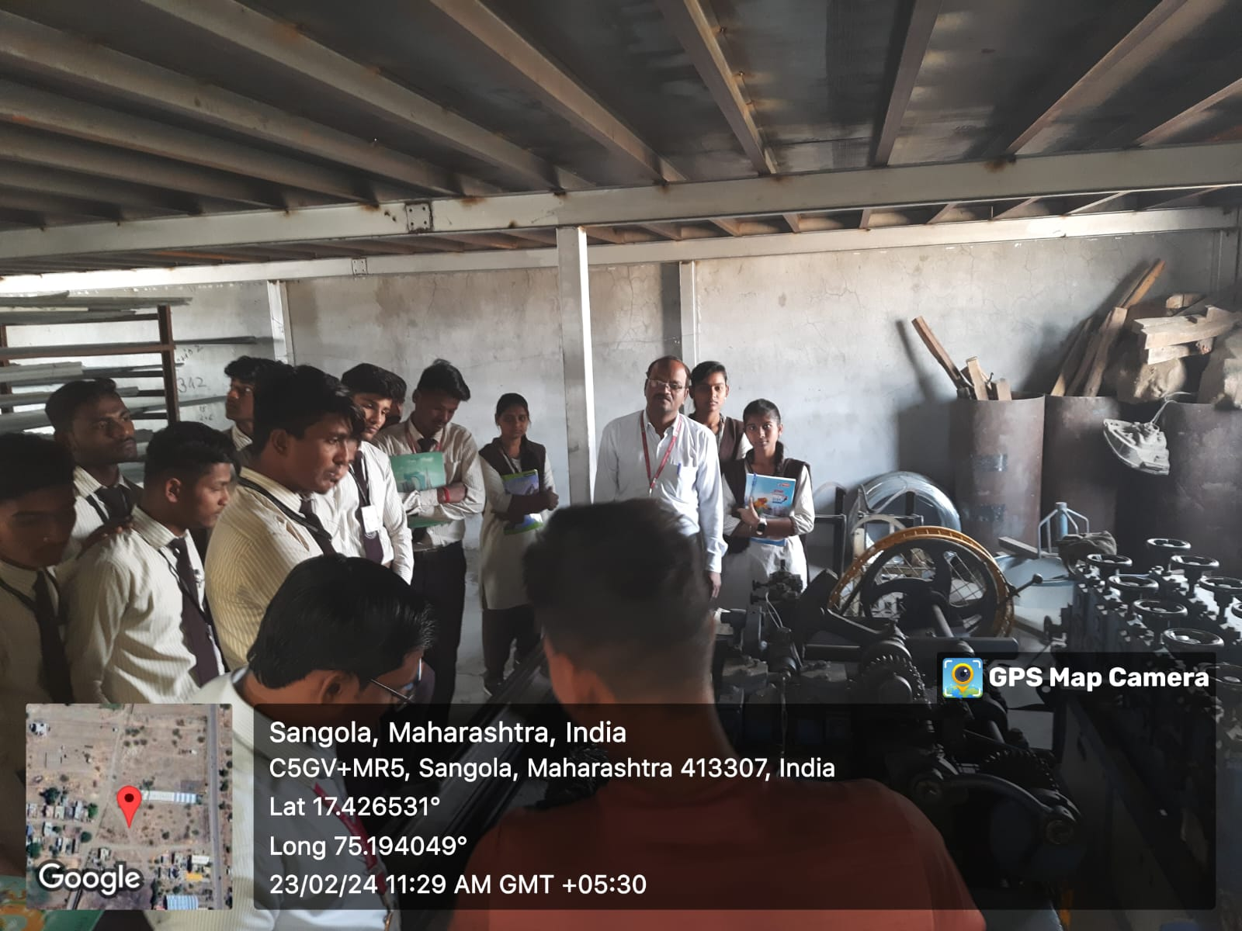
Students are observing different types of machines & Mechanisms
Visit to Siddhivinayak Wheel Alignment, Sangola Date: 23/02/2024

Mr. Sunil Hatkar giving information about Wheel Balancing.
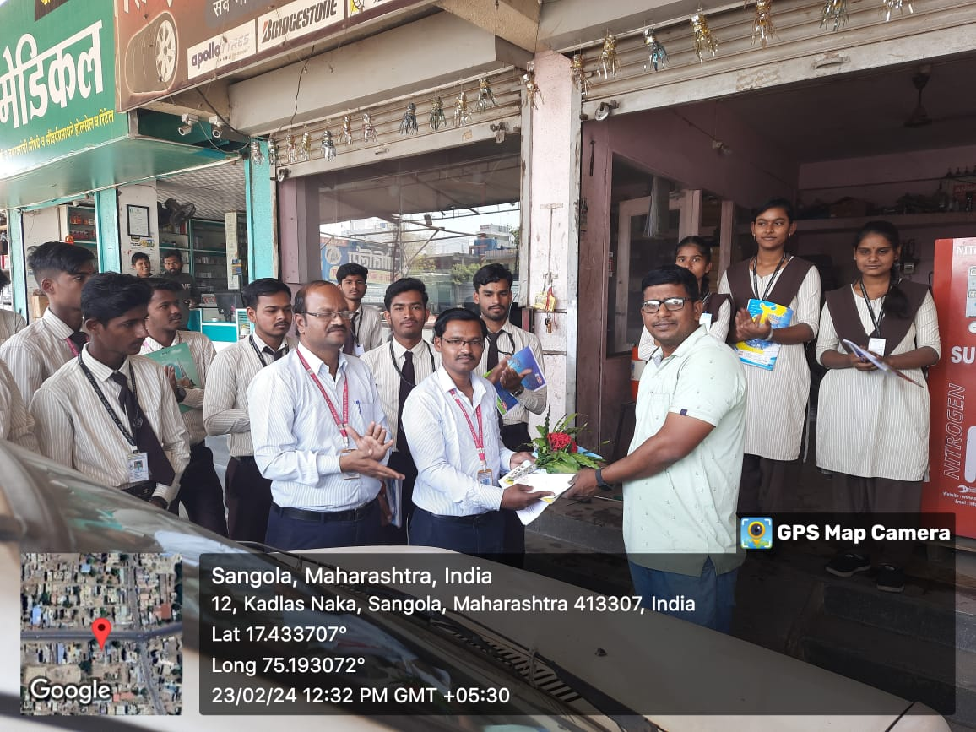
Mr. S. D Bavache is Felicitating, Mr. Sunil Hatkar

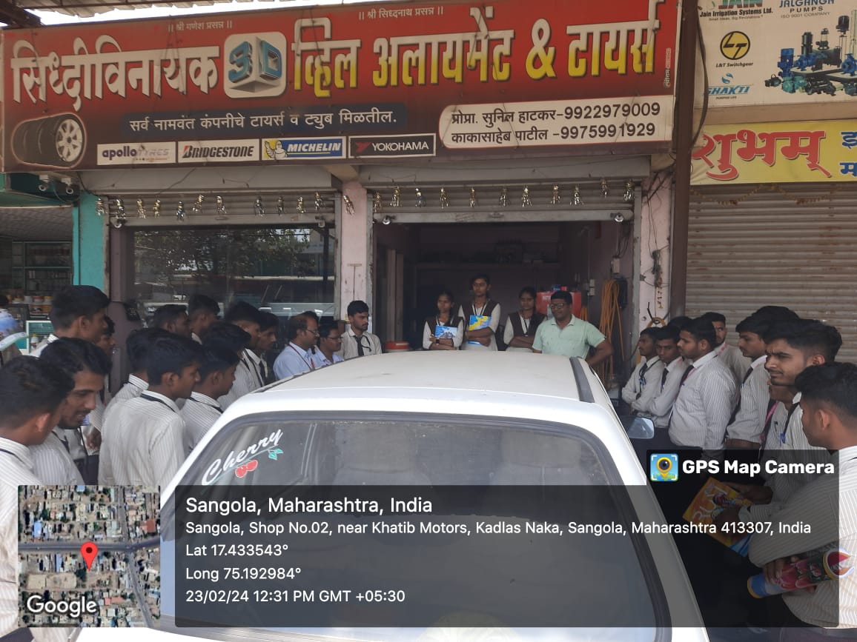
Mr. Sunil Hatkar giving information about Wheel Alignment and Balancing.
Visit to Kohinoor Agro Industries, Kamalapur, Sangola Date: 24/02/2024
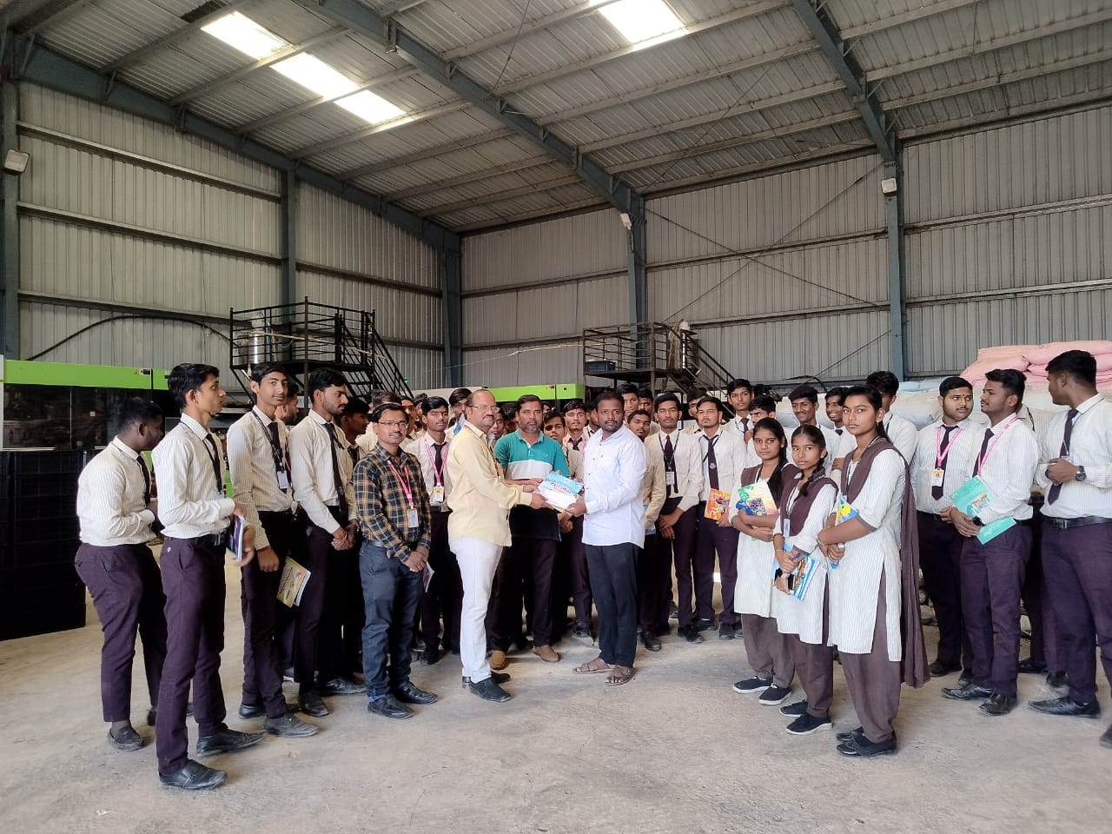
Mr. D.S. Khandare is Felicitating, Mr. Satywan Ghatule

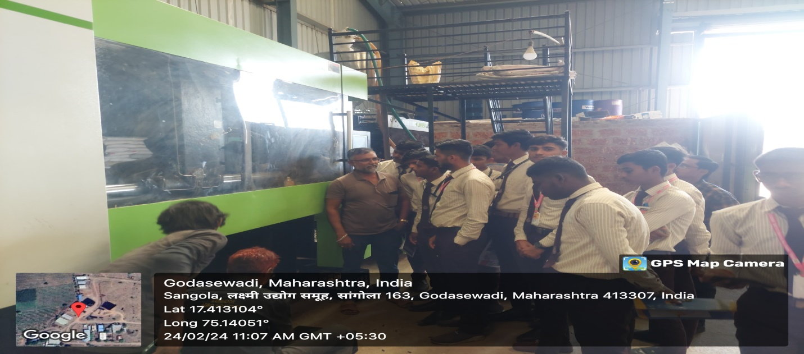
Students taking the information about machine.
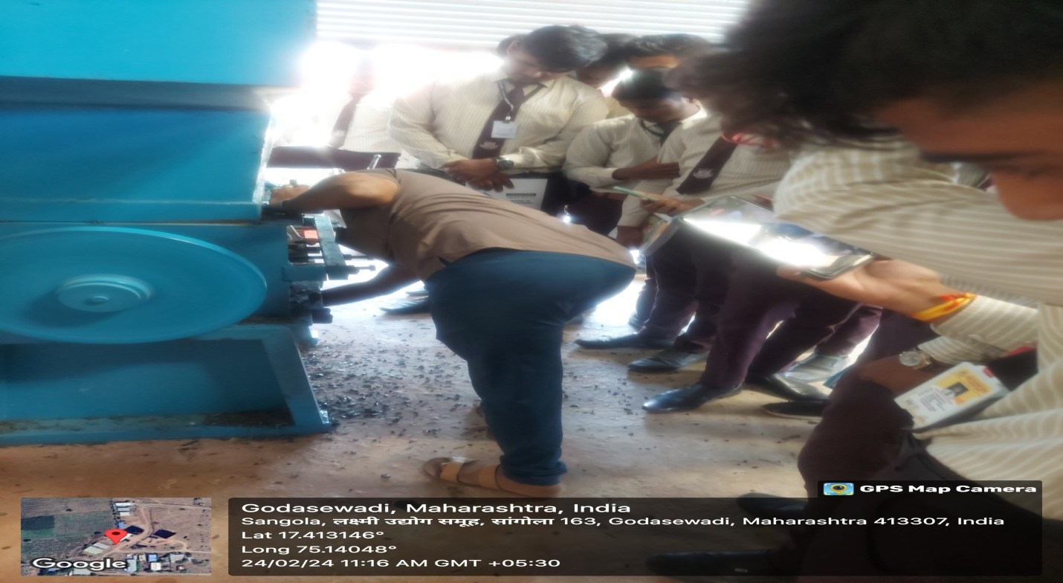

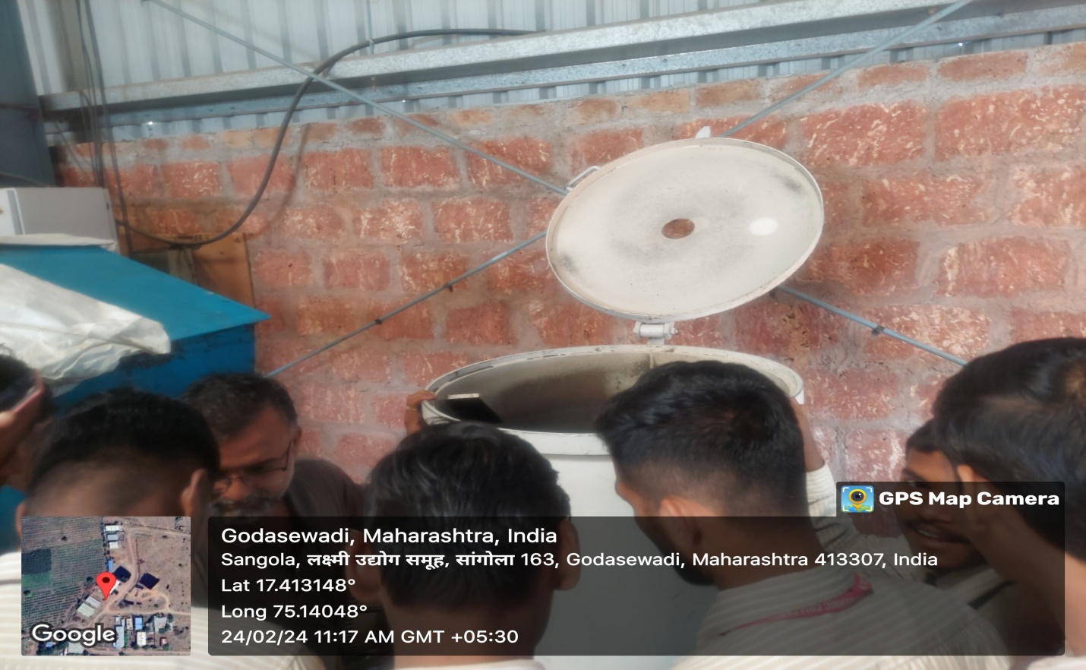

Visit to Sitaram Maharaj Karkhana Pvt. Ltd, Khardi. Date: 04/10/2023
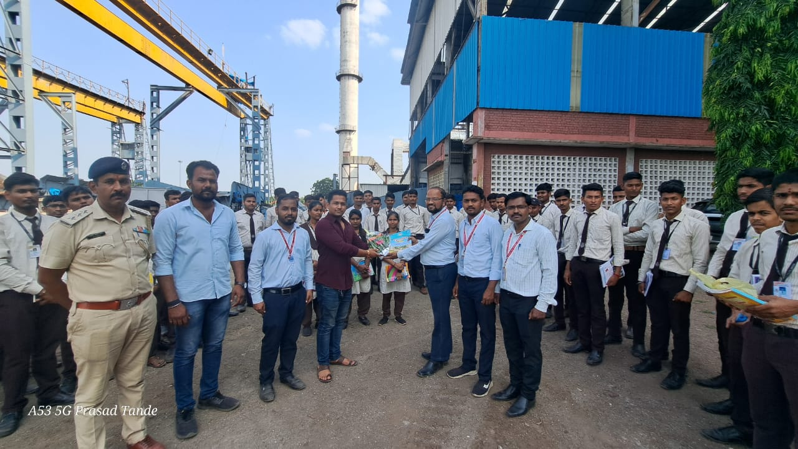
Mr. D.S. Khandare is Felicitating, Mr. Satywan Ghatule

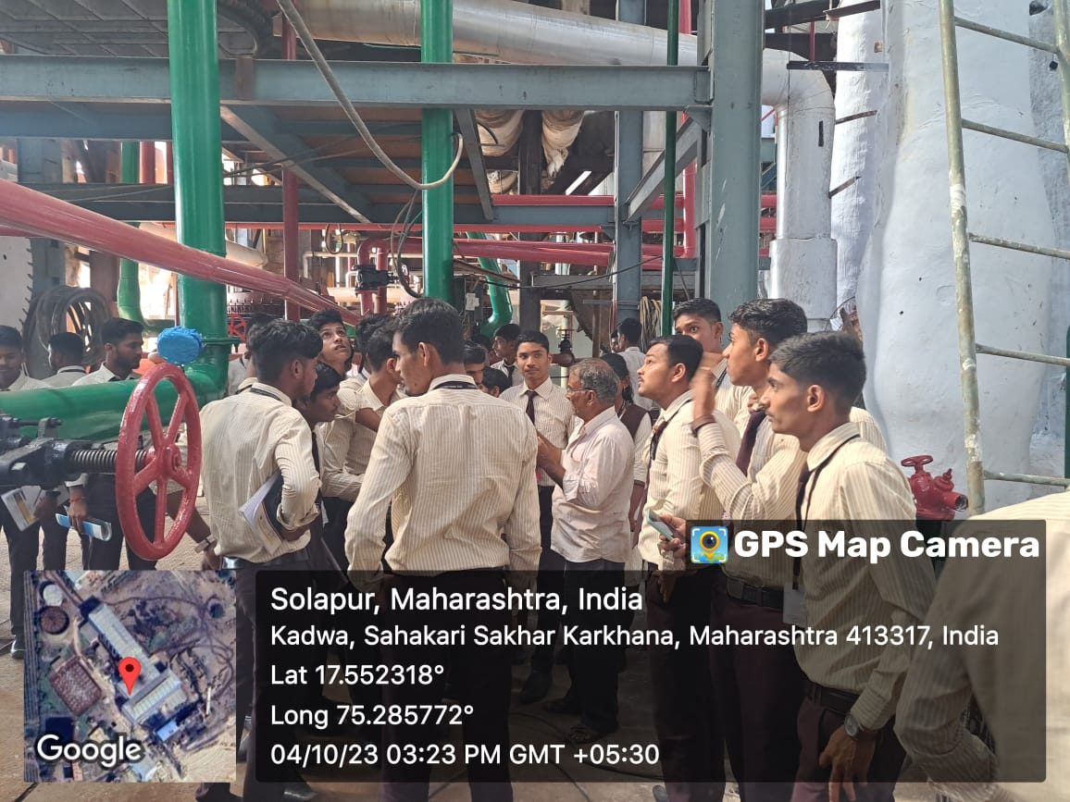
Students taking the information about Sugar Factory
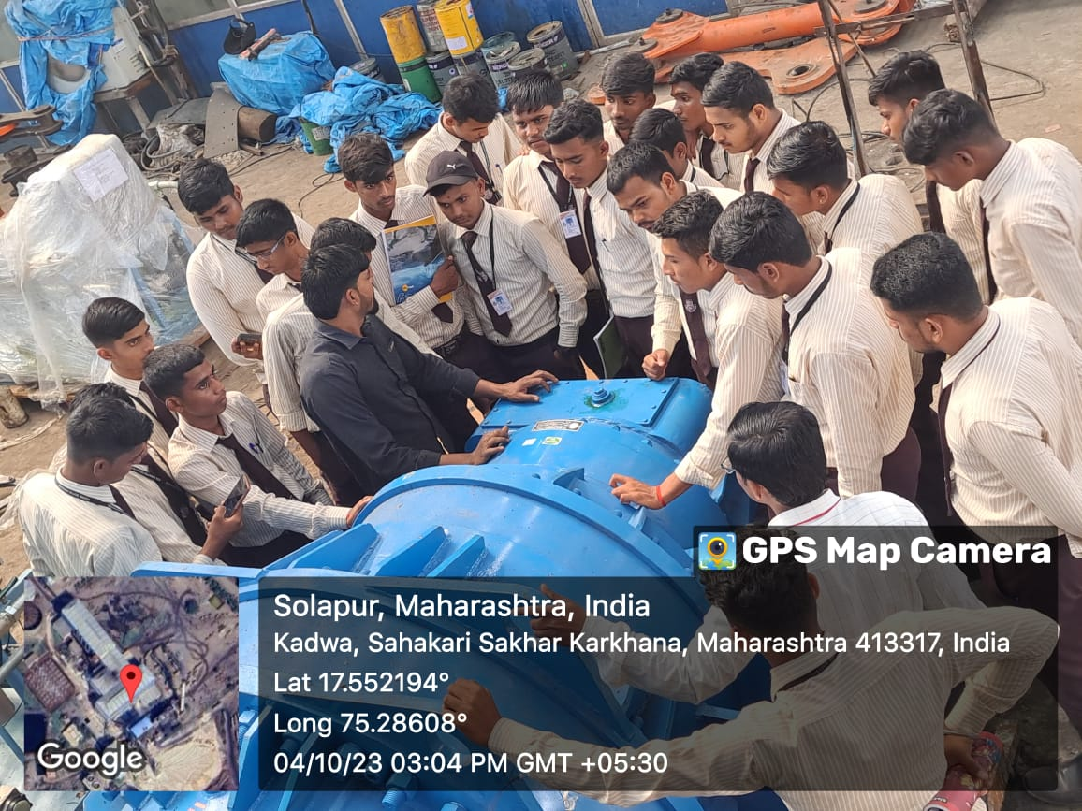
Instructor giving the information about machine
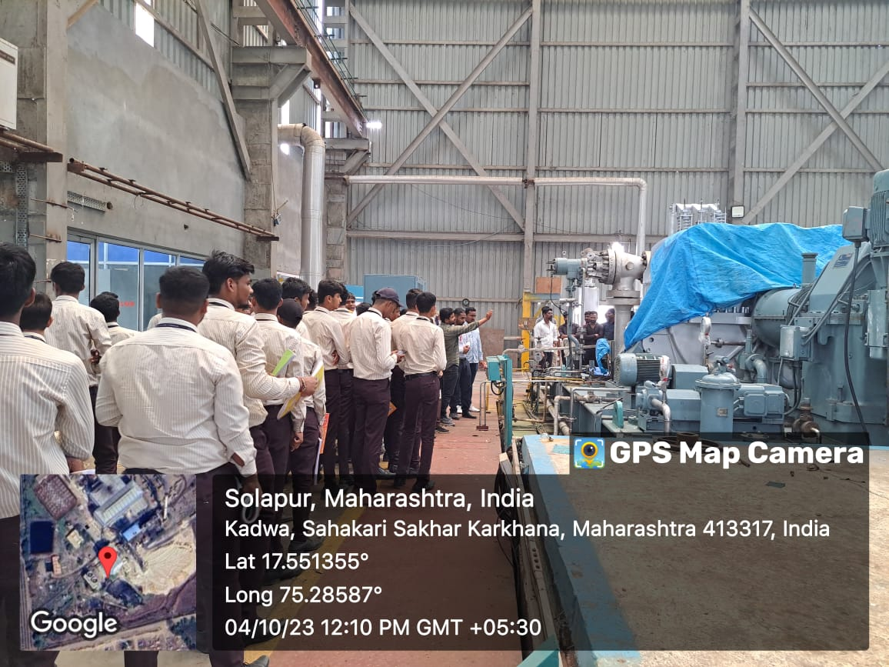
Students taking the information about Sugar Factory

Visit to Dy. RTO Office, Akluj. Date: 11/03/2024
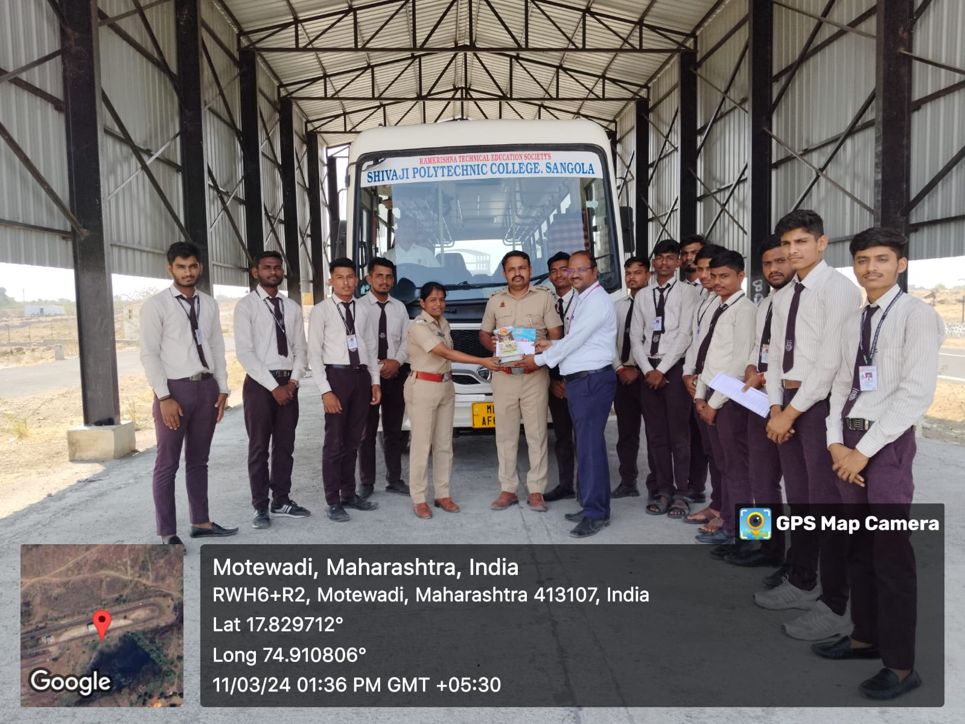
Mr. D.S. Khandare is Felicitating, Mr. RTO. Ganesh Raut.
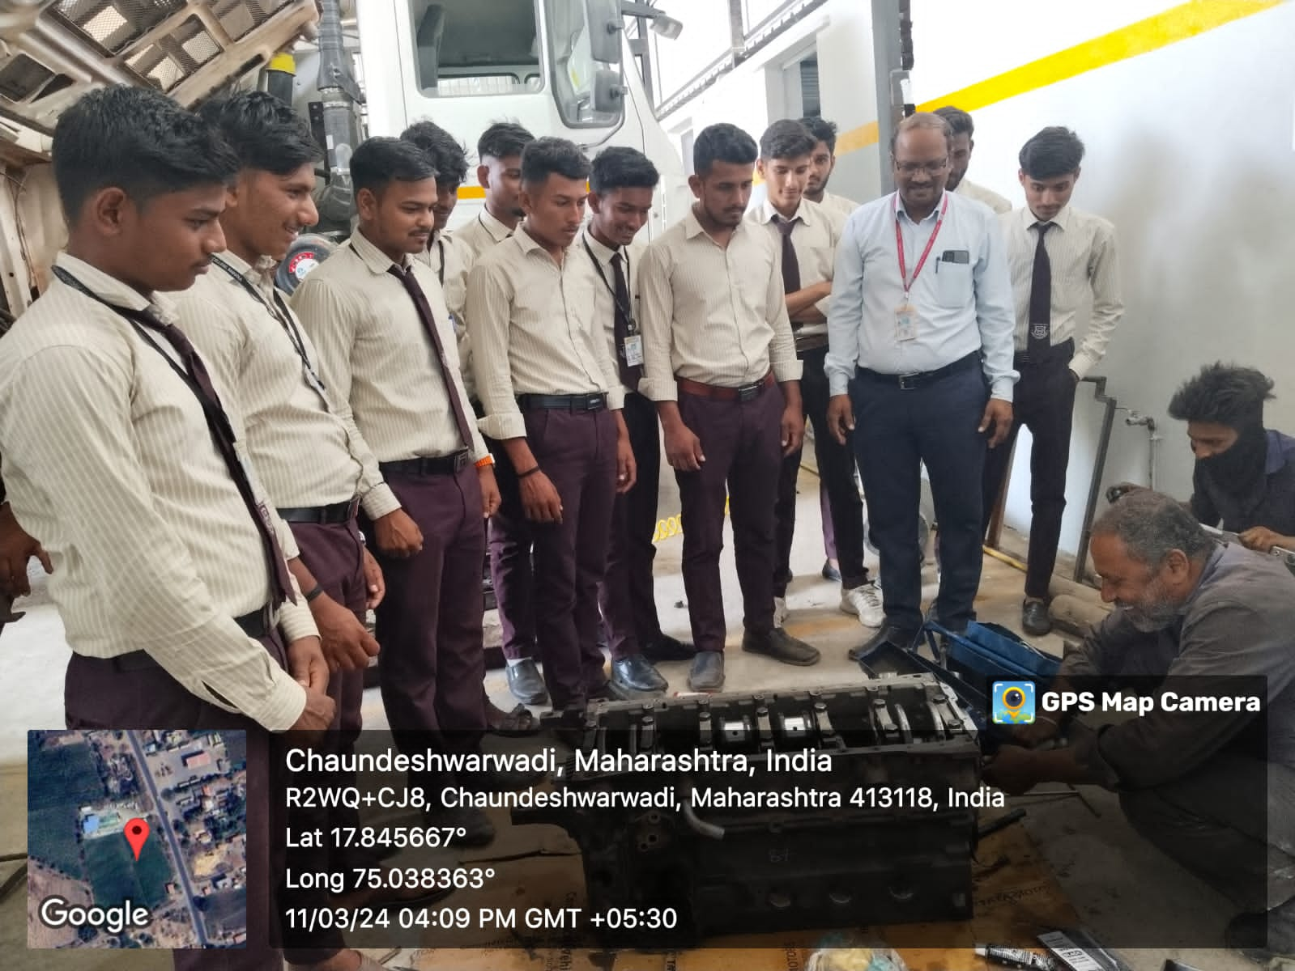
Instructor giving the information about Automobile Parts
Visit to Forming Industries Ltd., Kolhapur. Date: 09/03/2024
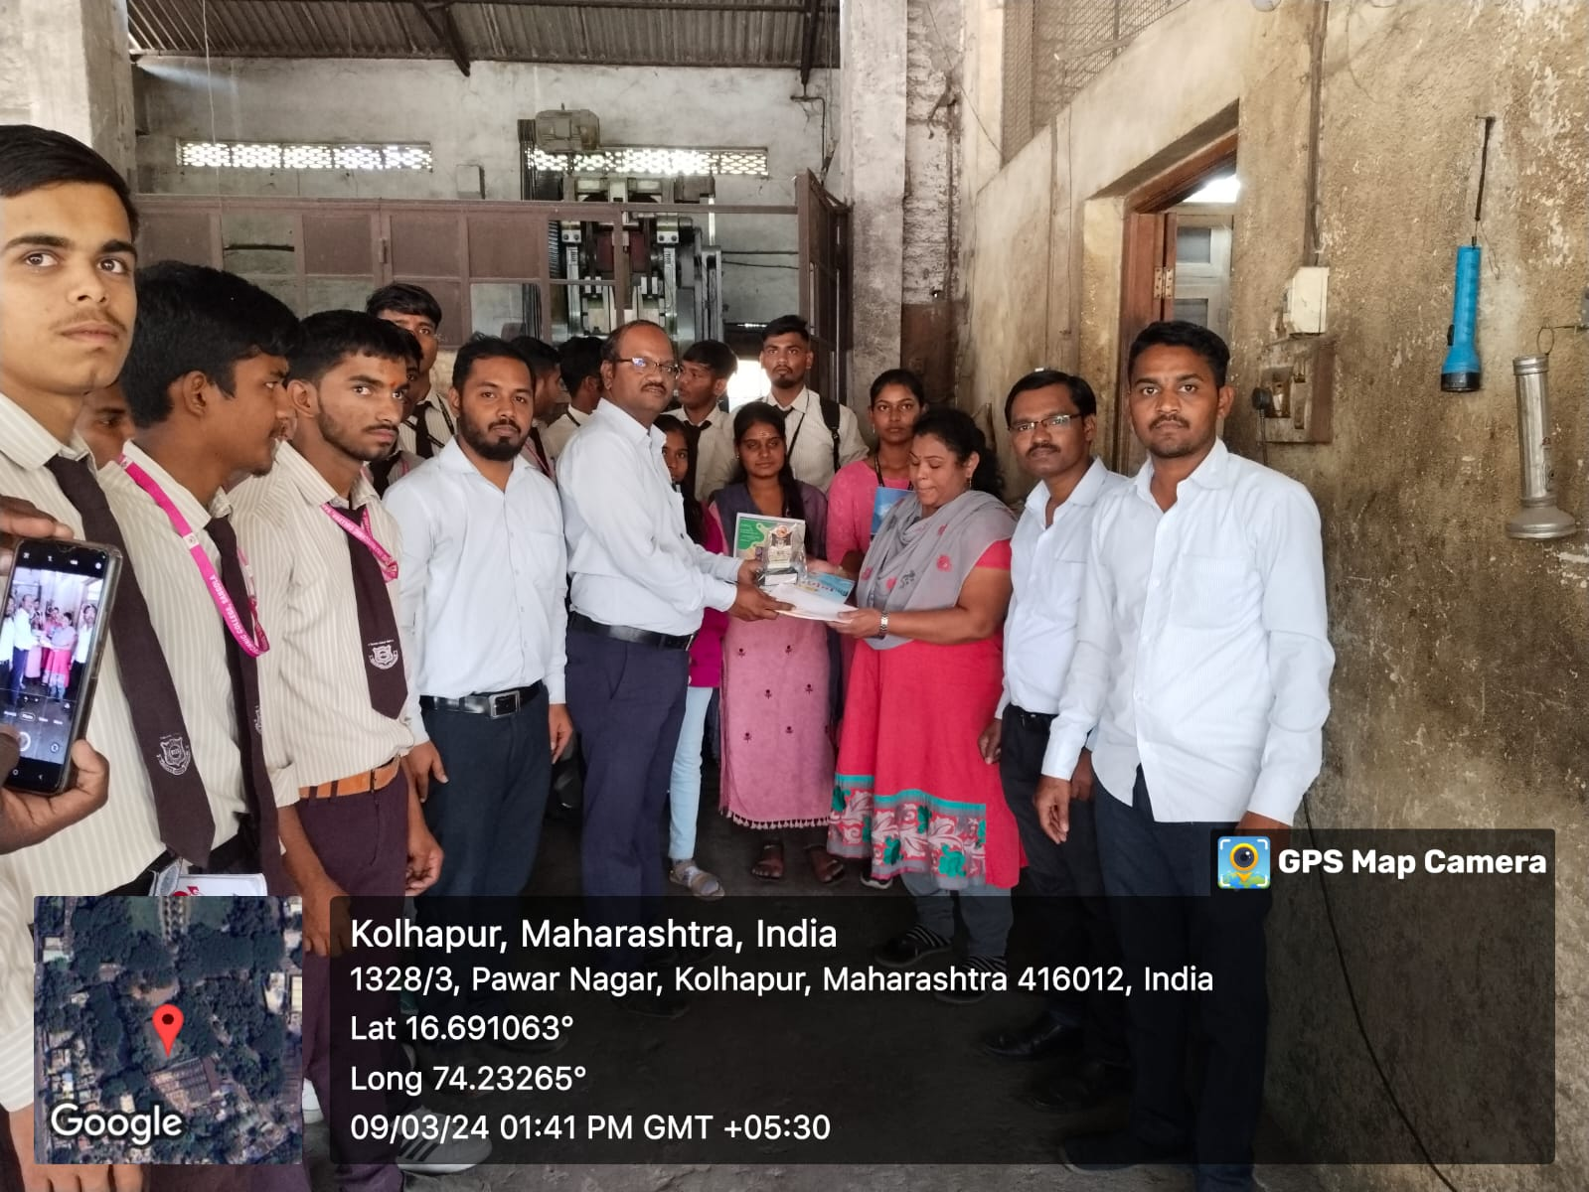
Mr. D.S. Khandare is Felicitating, Mrs. Kavita Vhatkar.
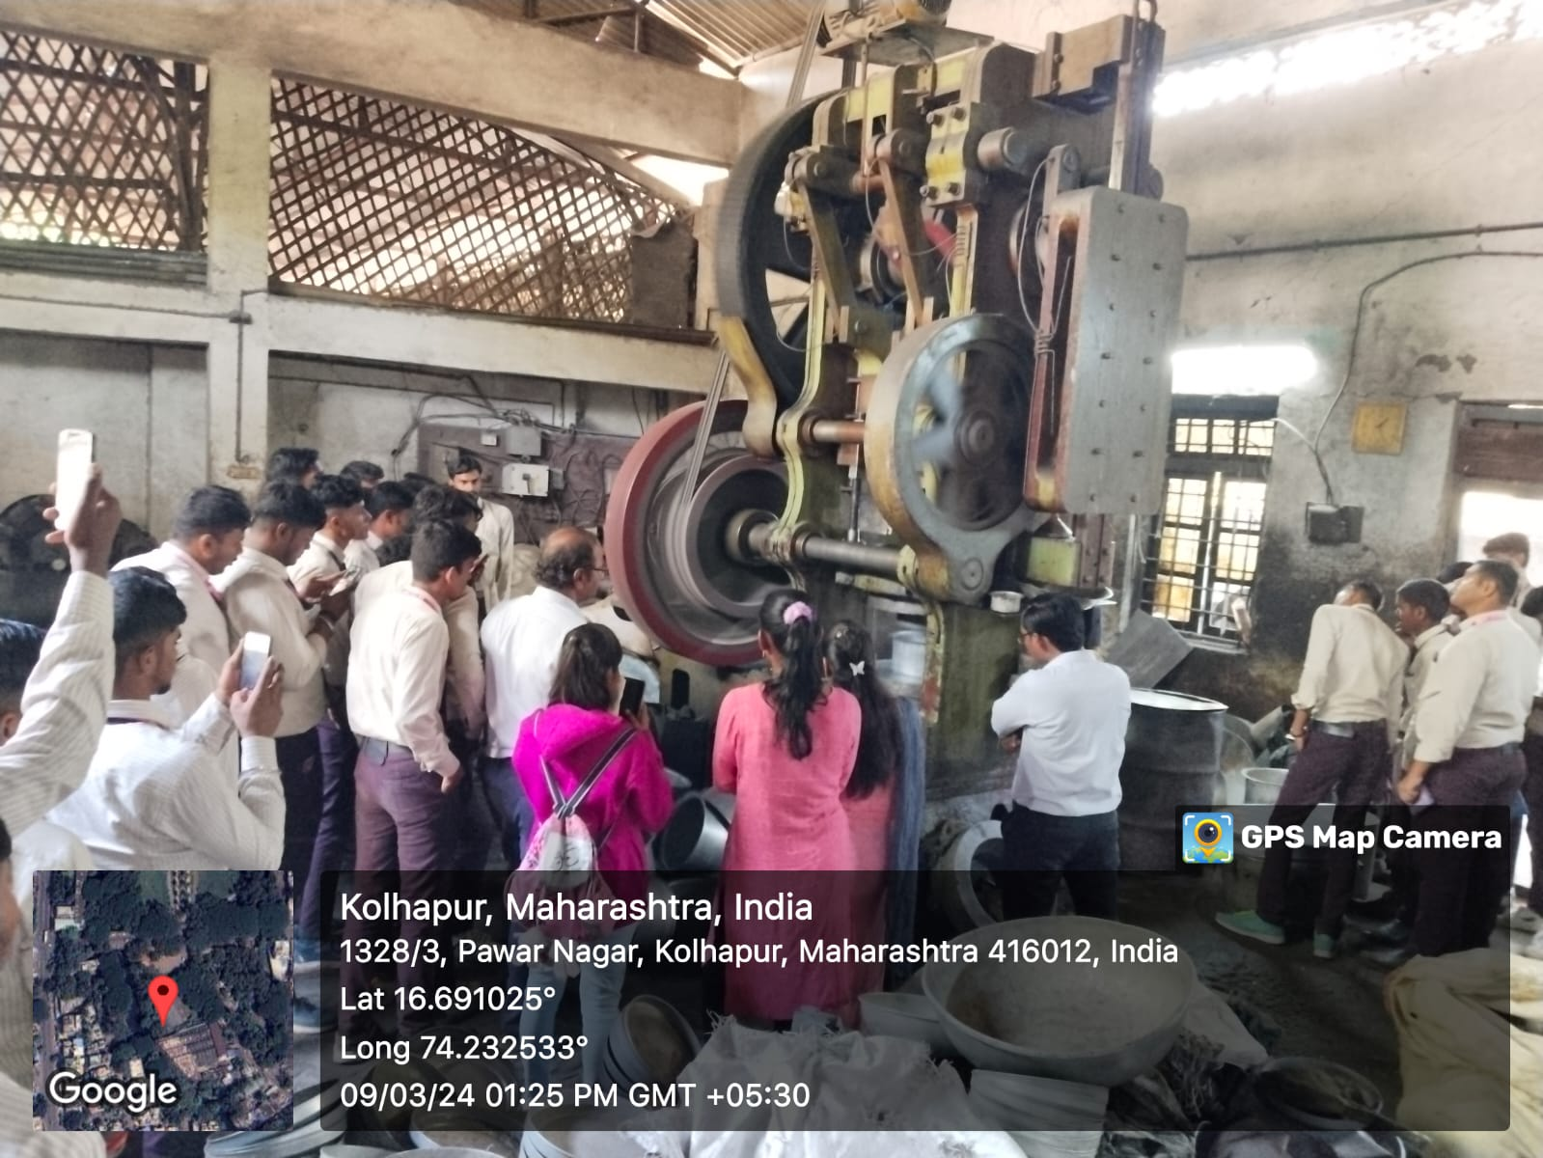
Students taking the information about the Machine & observing the different mechanisms.
Visit to Micro-Metal Industries Ltd., Kolhapur. Date: 09/03/2024
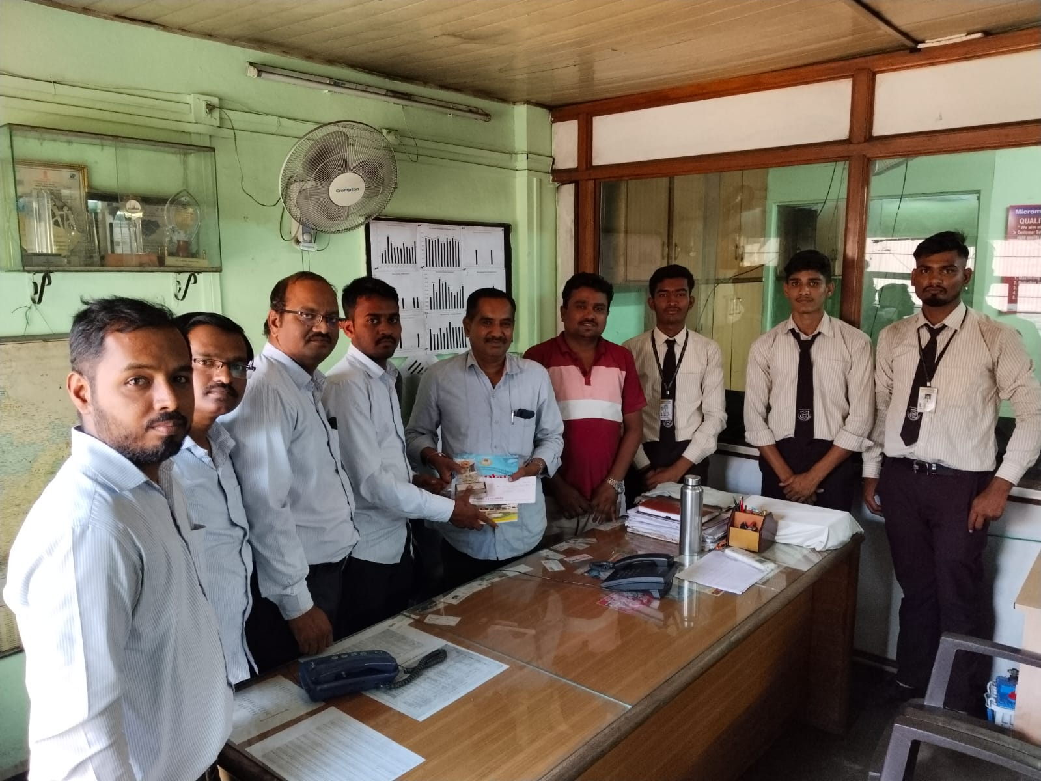
Mr. S. S. Salunkhe is Felicitating, Mr. Vikas Potdar.
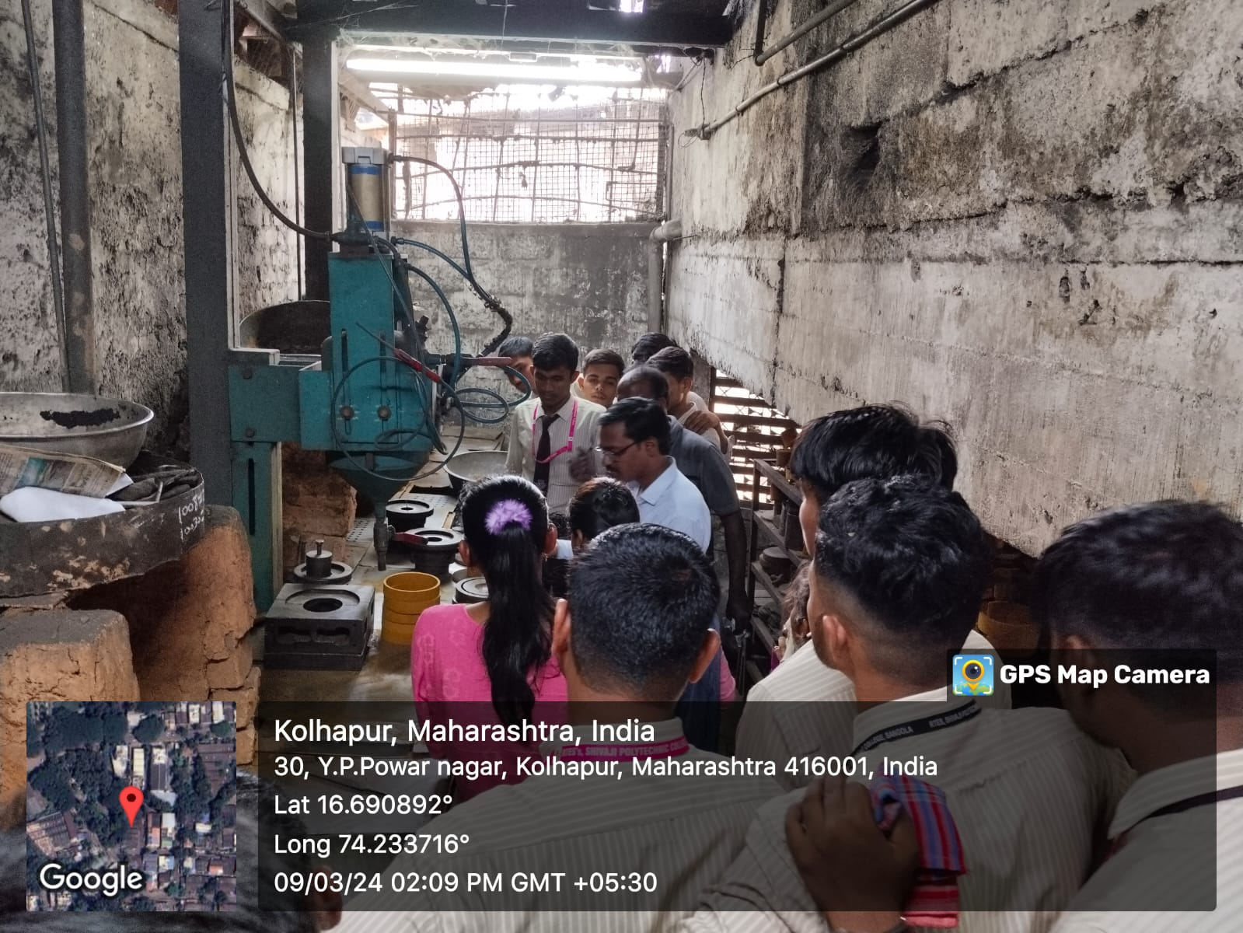
Students taking the information about the Casting Process.

