Guest Lectures
Academic Year - 2022 - 2023
Sr. No. | Topic / Subject | Date | Resource Person | Mode | Students
1 | Opportunities for Civil Engineering Students in Railway Department | 22/09/2022 | Mr. Satyendra Singh | Offline Guest Lecture | SY & TY
2 | Basics of Civil Engineering With Practical Approach (Drawing and Material) | 01/10/2022 | Mr. Milind Ankalgi | Offline Guest Lecture | SY & TY
3 | Design of Steel and RCC Structures’ | 14/11/2022 | Mr. Jitu Batra | Offline Guest Lecture | SY & TY
4 | Personality Development | 20/02/2023 | Dr. M. M. Sardeshmukh | Offline Guest Lecture | SY & TY
5 | Construction Management | 04/03/2023 | Mr. Nitin Gaikwad | Offline Guest Lecture | SY & TY
6 | Civil Engineering Software’s | 14/03/2023 | Mr. Parag Deshmukh | Offline Guest Lecture | SY & TY
7 | Entrepreneurship Development | 16/03/2023 | Mr. Somnath Khandagale | Offline Guest Lecture | SY & TY
8 | Emerging Trends in Civil Engineering | 18/03/2023 | Mr. Vinayak Shinde | Offline Guest Lecture | SY & TY
9 | Personality Development | 20/03/2023 | Dr. Sanbhaji Harihar | Offline Guest Lecture | SY & TY
10 | Railway and Bridge Engineering | 21/03/2023 | Mr. S. G. Gaikwad | Offline Guest Lecture | SY & TY
11 | Theory of Structures | 25/03/2023 | Mr. Jitu Batra | Offline Guest Lecture | SY & TY
12 | Job Opportunities in Civil Engineering | 03/04/2023 | Mr. Vaibhav Ghadage | Offline Guest Lecture | SY & TY

Guest Lecture on ‘Opportunities for Civil Engineering Students in Railway Department’ Date:-22/09/2022

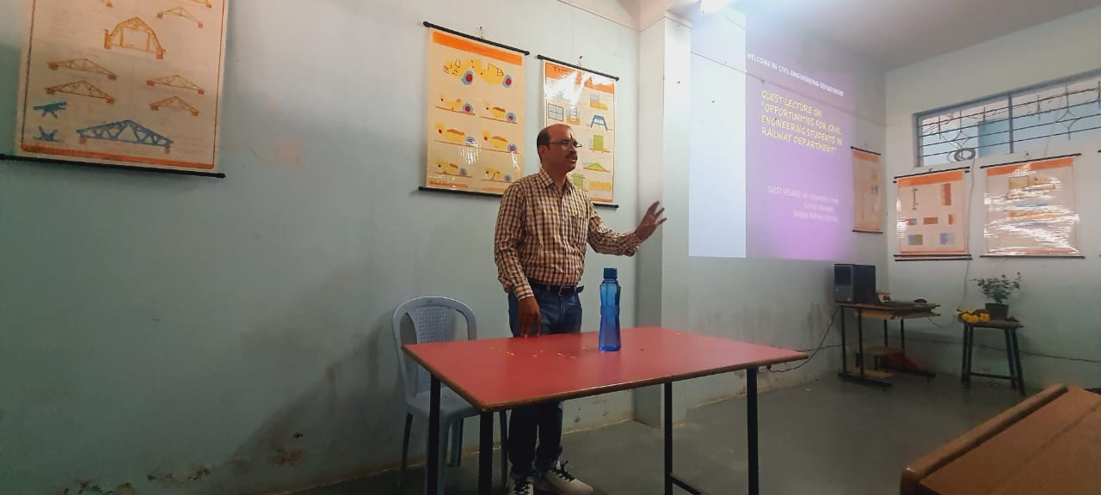

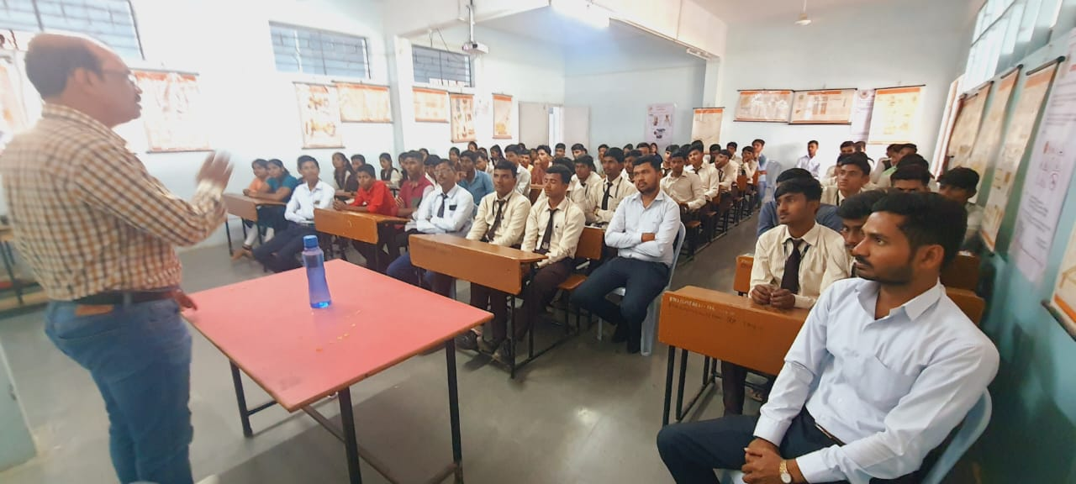
Mr. Satyendra Singh Conducting a Guest Lecture on Second Year & Third Year Class on “Opportunities For Civil Engineering Students In Railway Department”
Guest Lecture on ‘Basics of Civil Engineering With Practical Approach (Drawing and Material)’ Date:-01/10/2022
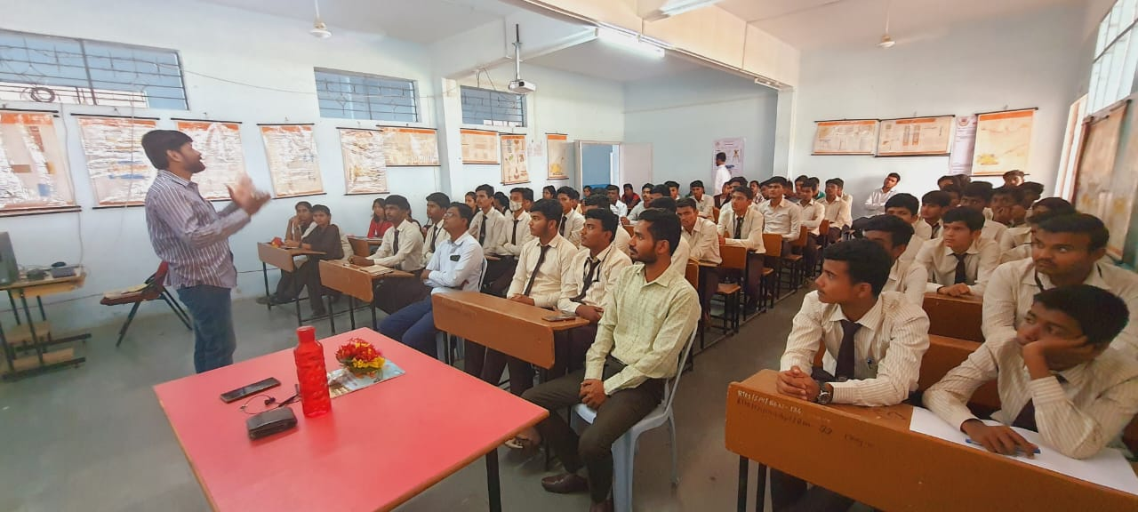

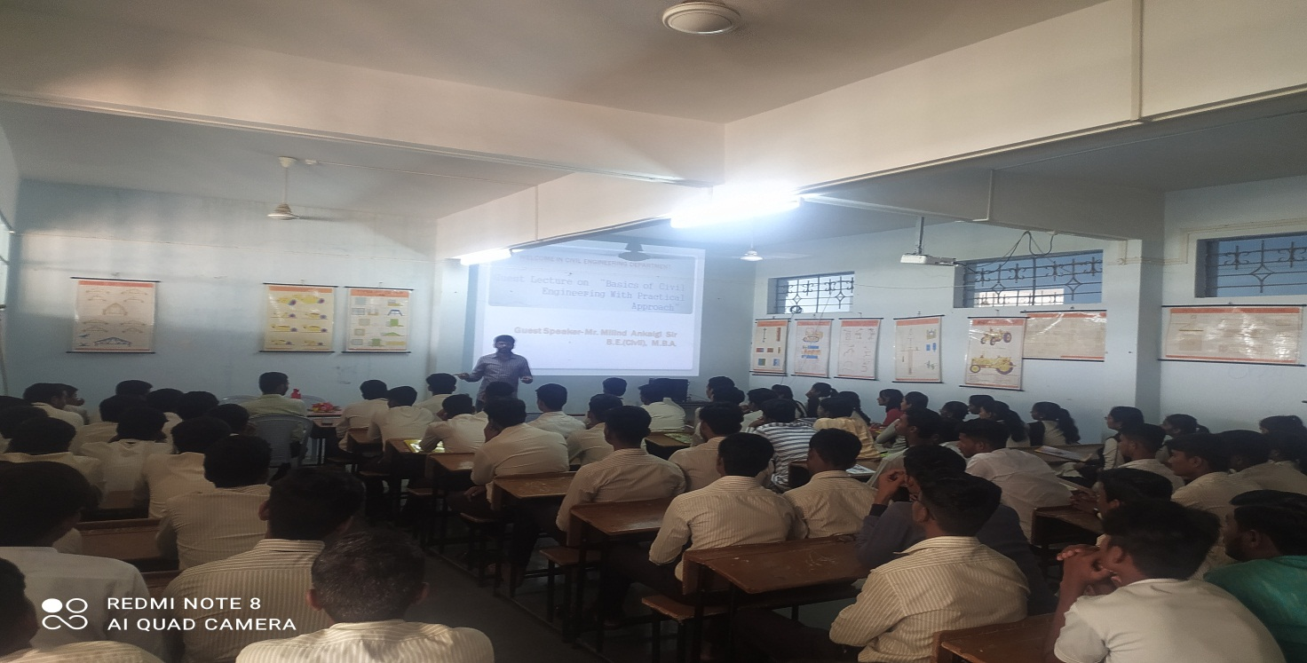
Mr. Milind Ankalgi Conducting a Guest Lecture on Second Year & Third Year Class on “Basics of Civil Engineering With Pratical Approch (Drawing and Material)’’

Guest Lecture on ‘Design of Steel and RCC Structures’ Date:-14/11/2022
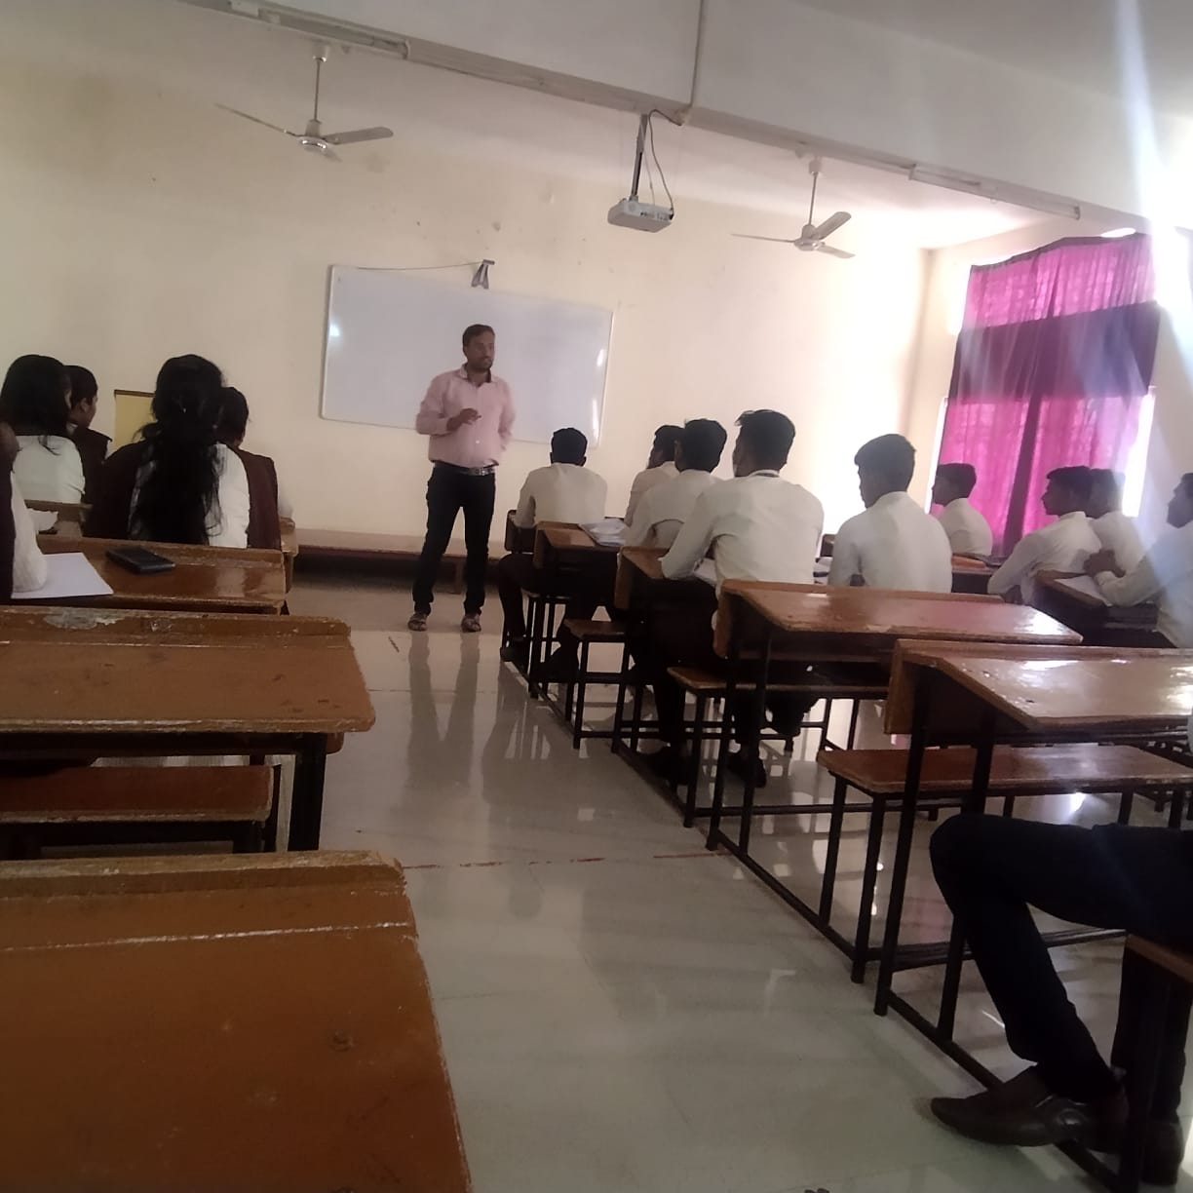

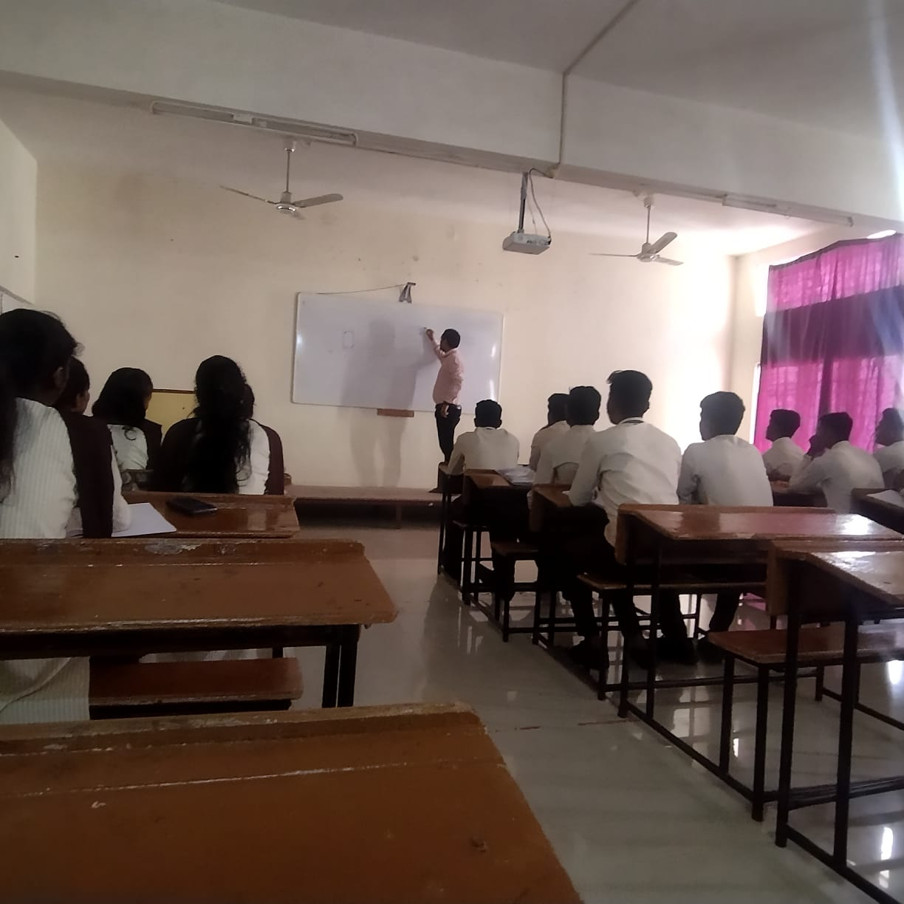
Mr. Jitu Batra Conducting a Guest Lecture on Third Year Class on “Design of Steel and RCC Structures”

Guest Lecture on ‘Personality Development’ Date:- 20/02/2023
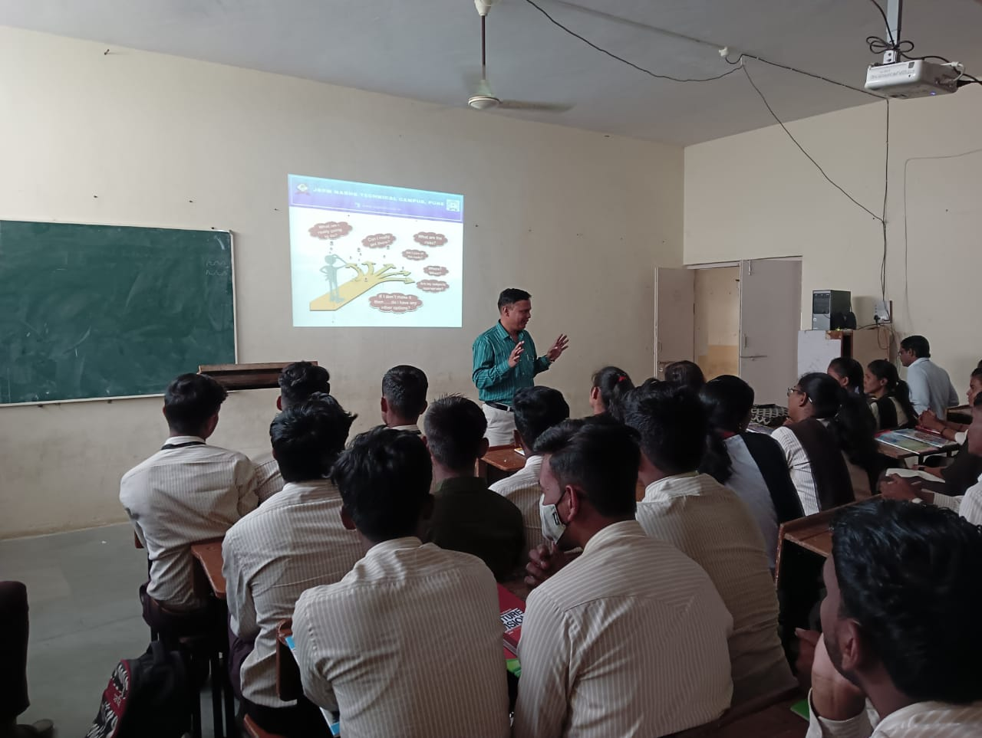

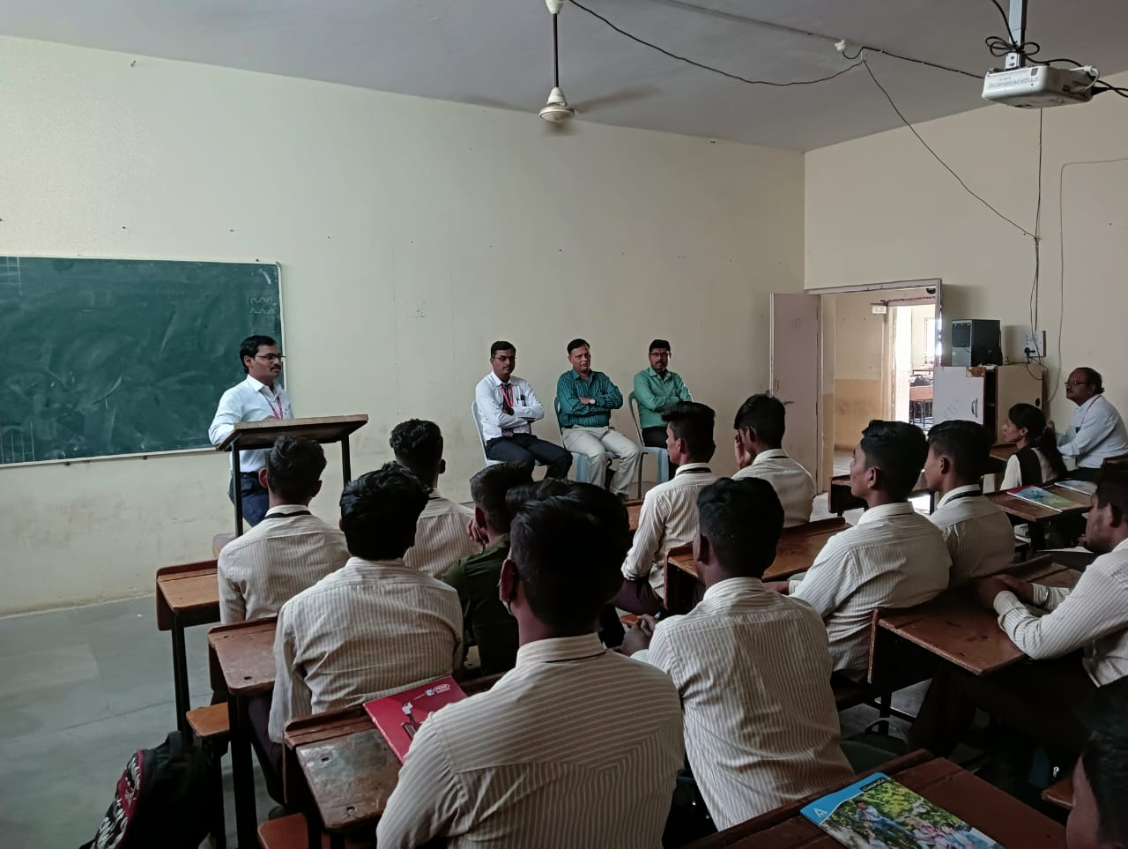

Dr. M. M. Sardeshmukh Conducting a Lecture on Third Year Class on “Personality Development”
Guest Lecture on ‘Construction Management’ Date:- 04/03/2023
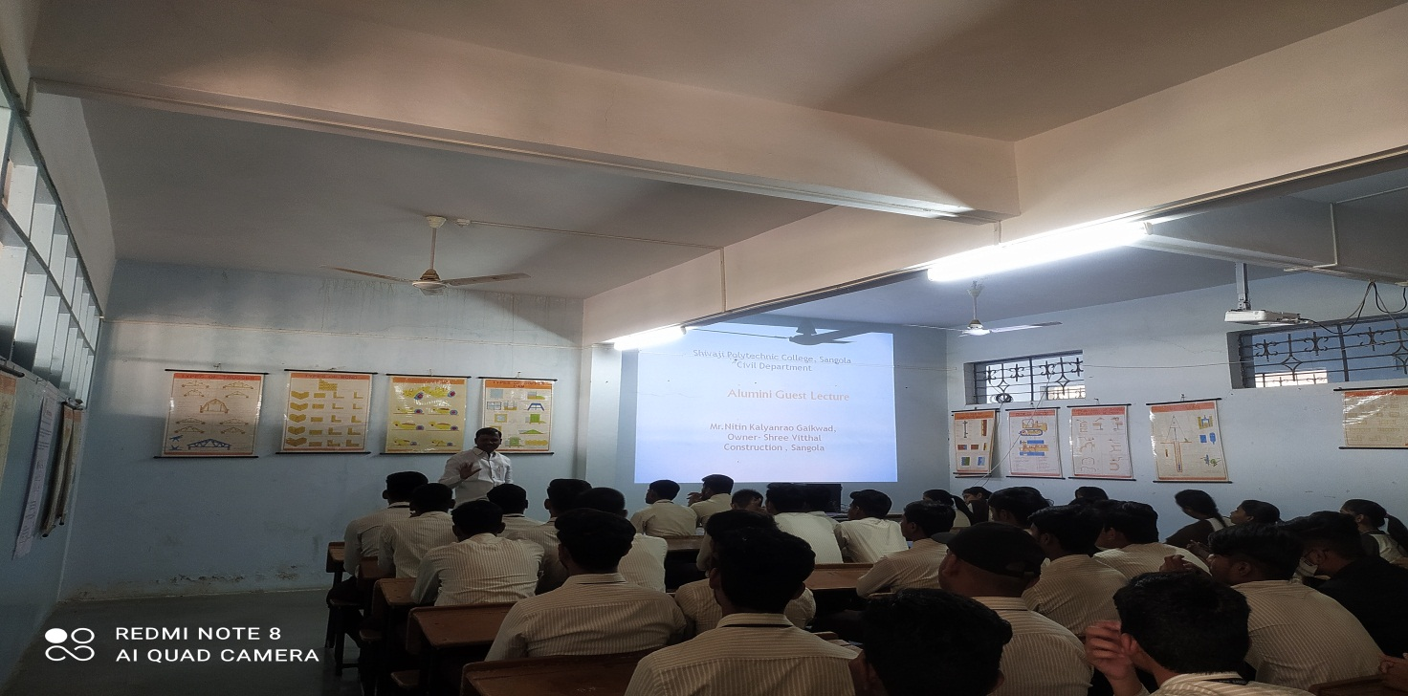

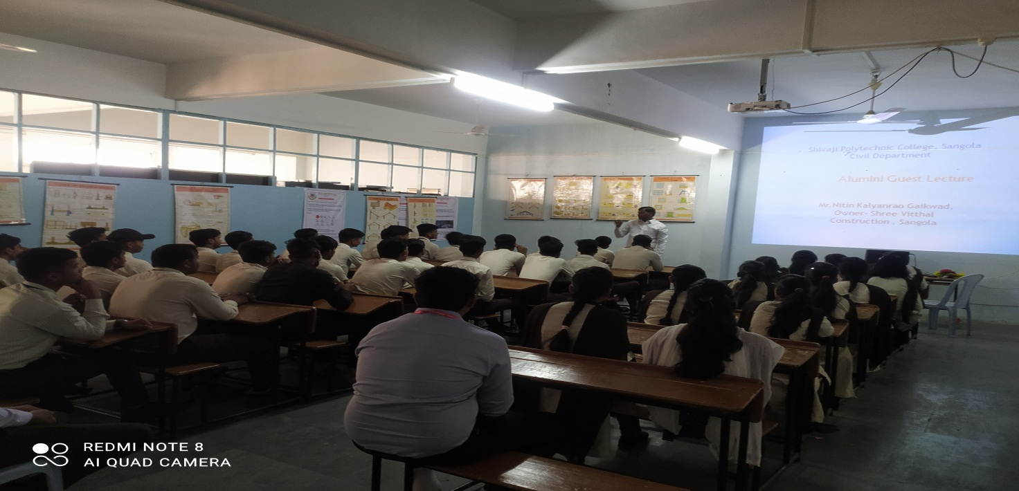

Mr. Nitin Gaikwad Conducting a Guest Lecture on Second & Third Year Class on “Construction Management”

Guest Lecture on ‘Civil Engineering Software’s’ Date:- 14/03/2023
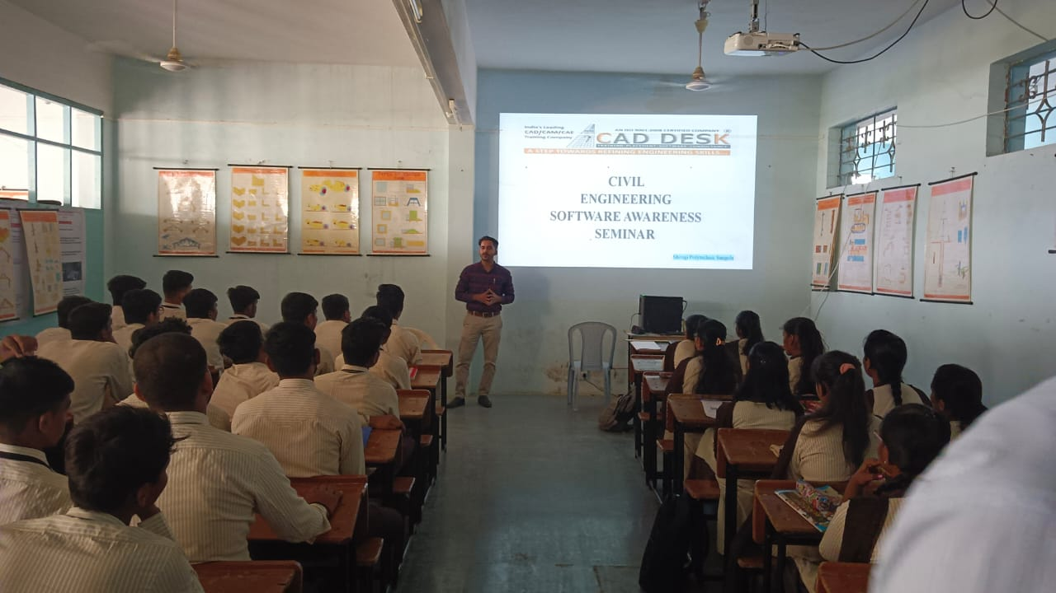

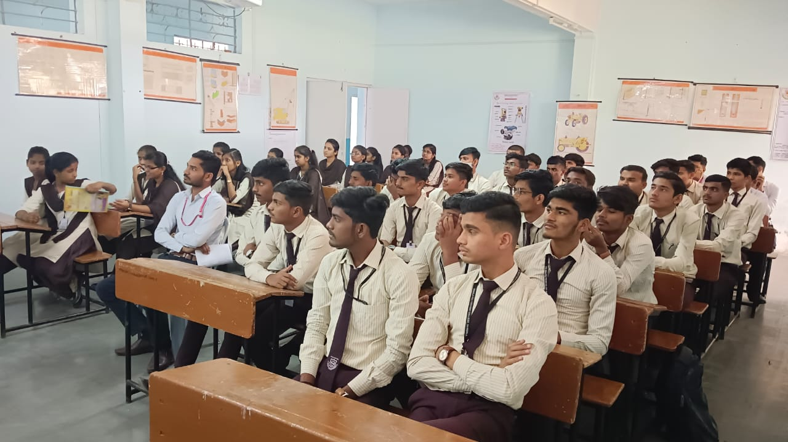

Mr. Parag Deshmukh Conducting a Guest Lecture on Second & Third Year Class on “Civil Engineering Software’s”

Guest Lecture on ‘Entrepreneurship Development’ Date:- 16/03/2023
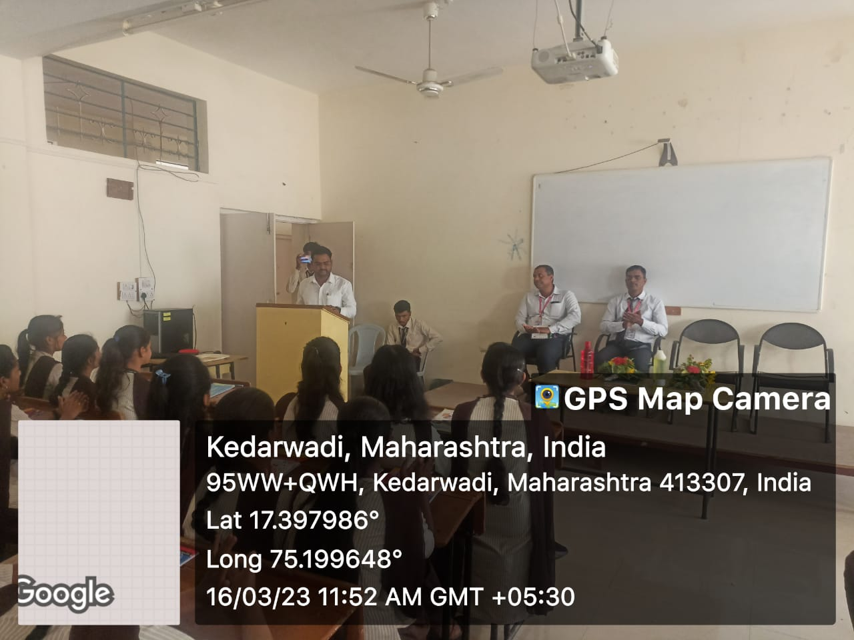

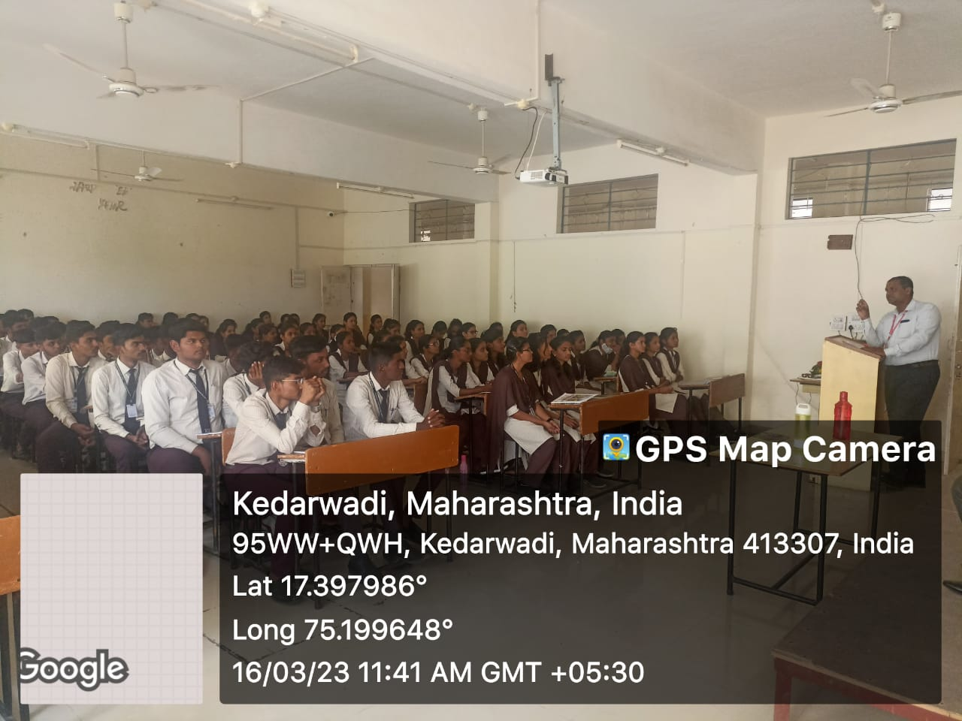

Mr. Somnath Khandagale Conducting a Lecture on Third Year Class on “Entrepreneurship Development”

Guest Lecture on ‘Emerging Trends in Civil Engineering’ Date:- 18/03/2023
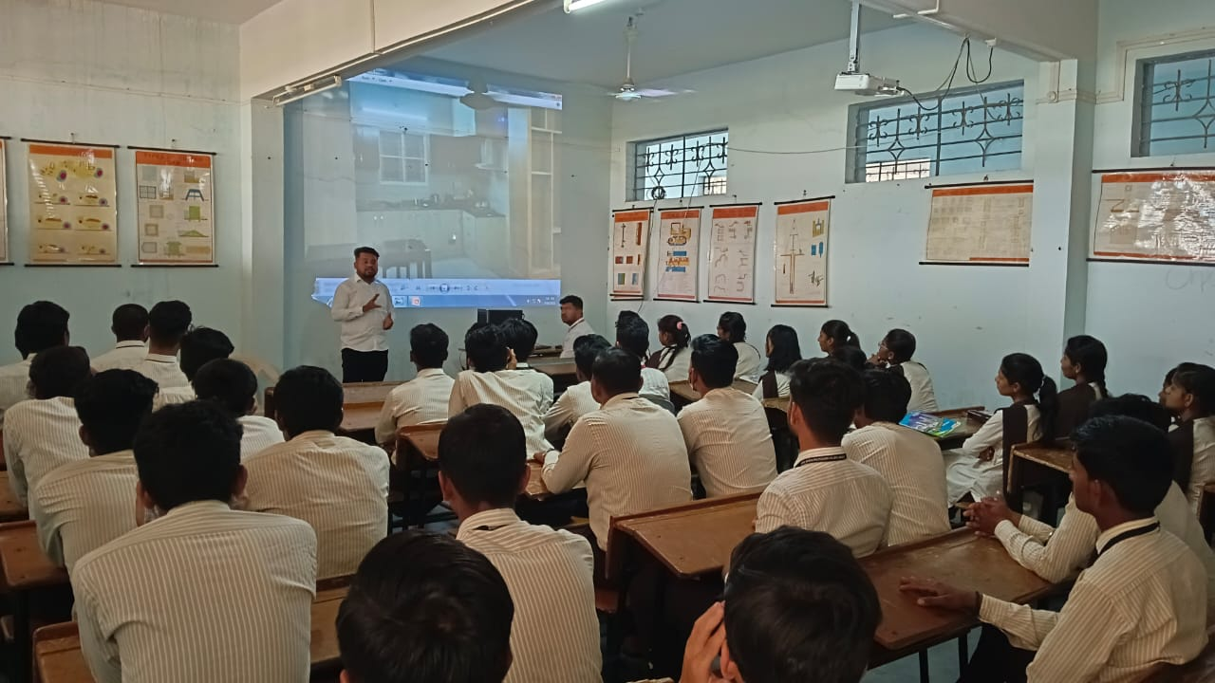

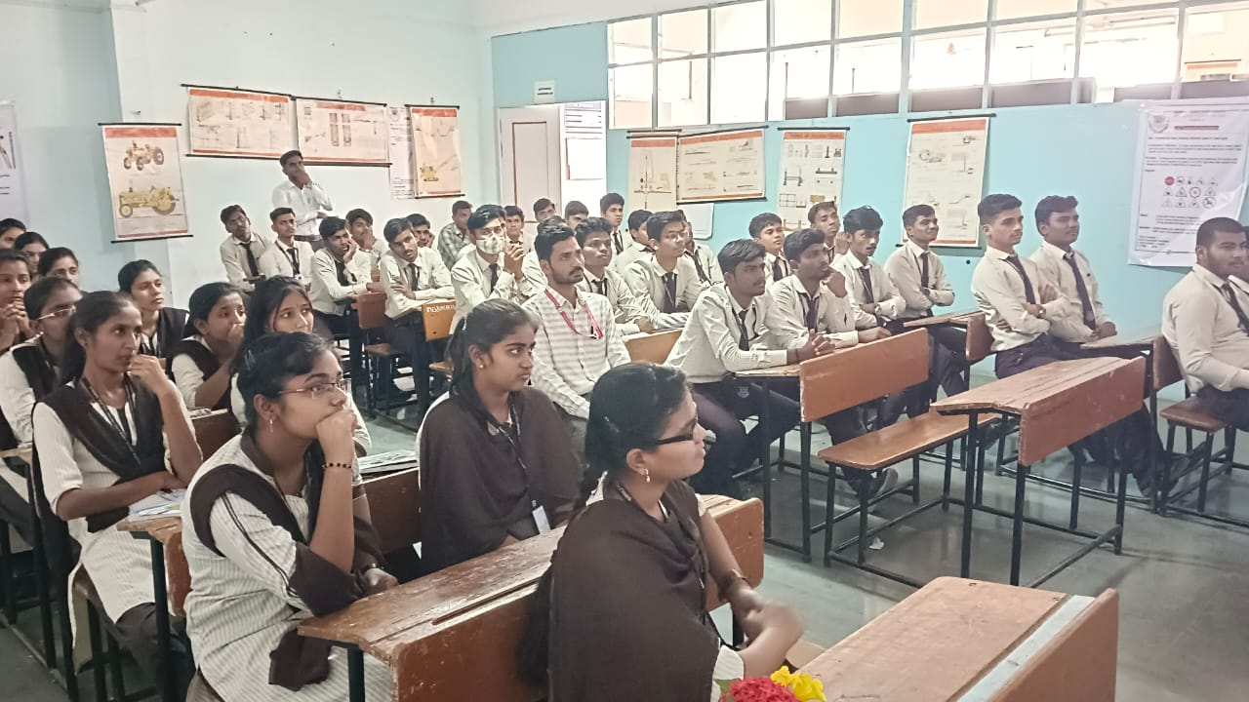
Mr. Vinayak Shinde Conducting a Alumni Lecture on Second & Third Year Class on “Emerging Trends In Civil Engineering”

Guest Lecture on ‘Personality Development’ Date:- 20/03/2023
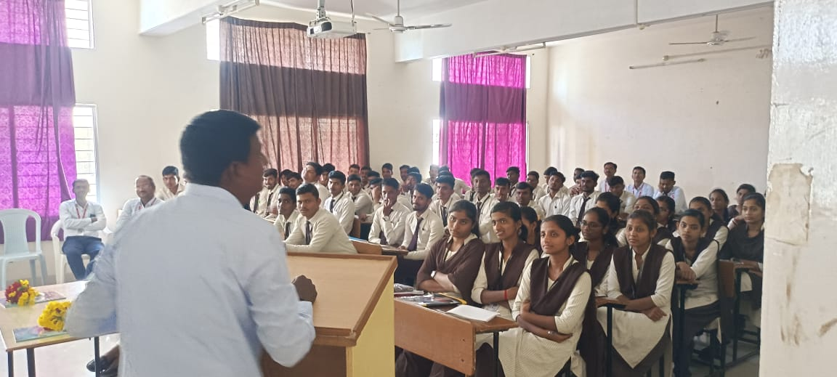

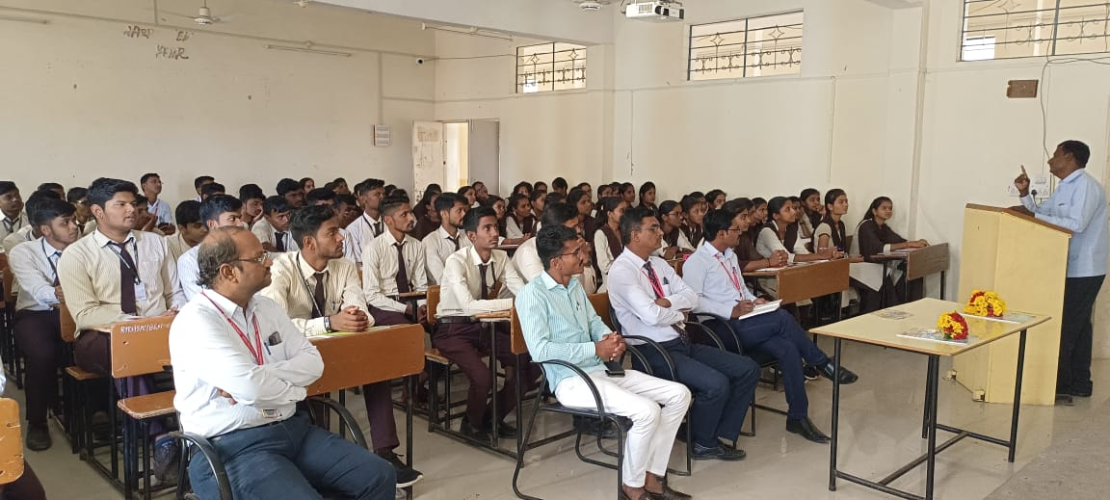

Dr. Sanbhaji Harihar Conducting a Lecture on Third Year Class on “Personality Development”

Guest Lecture on ‘Railway and Bridge Engineering’ Date:- 21/03/2023
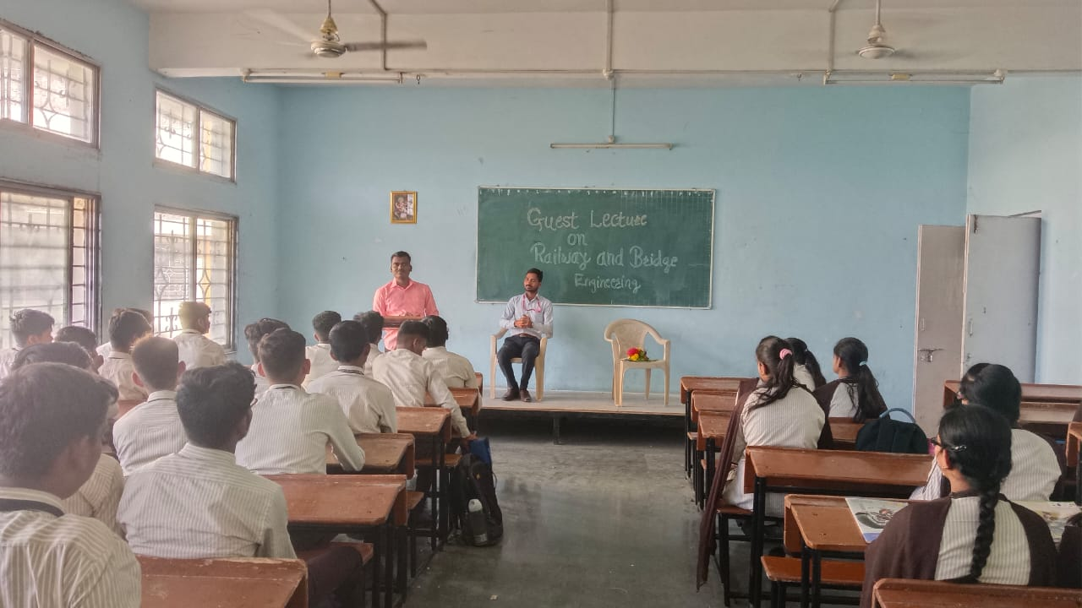

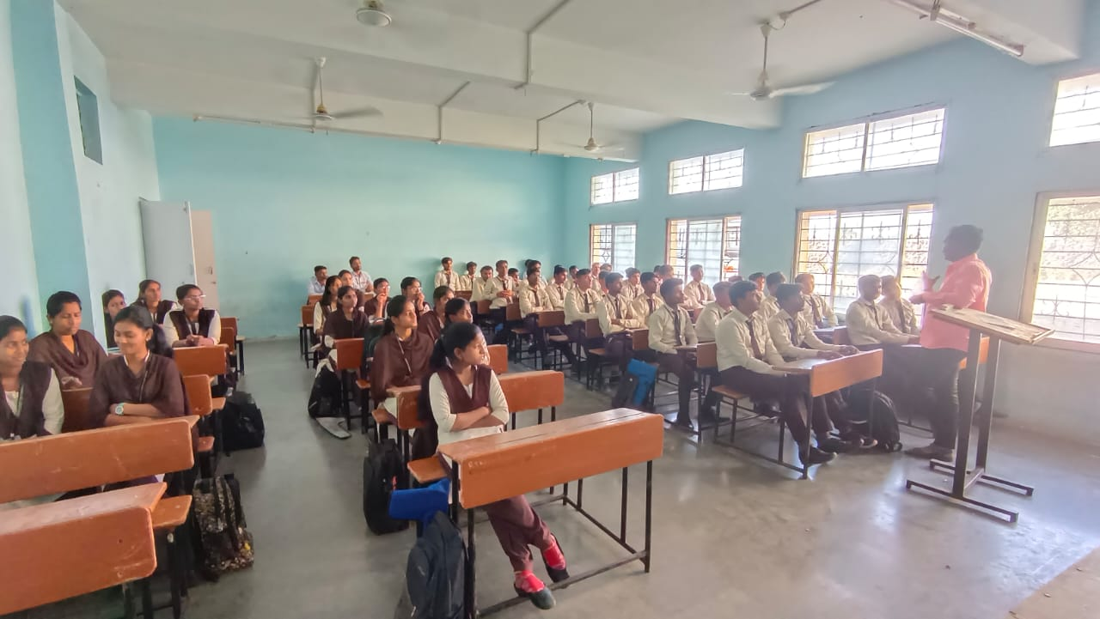

Mr. S. G. Gaikwad Conducting a Guest Lecture on Second Year Class on “Railway and Bridge Engineering”

Guest Lecture on ‘Theory of Structures’ Date:- 25/03/2023
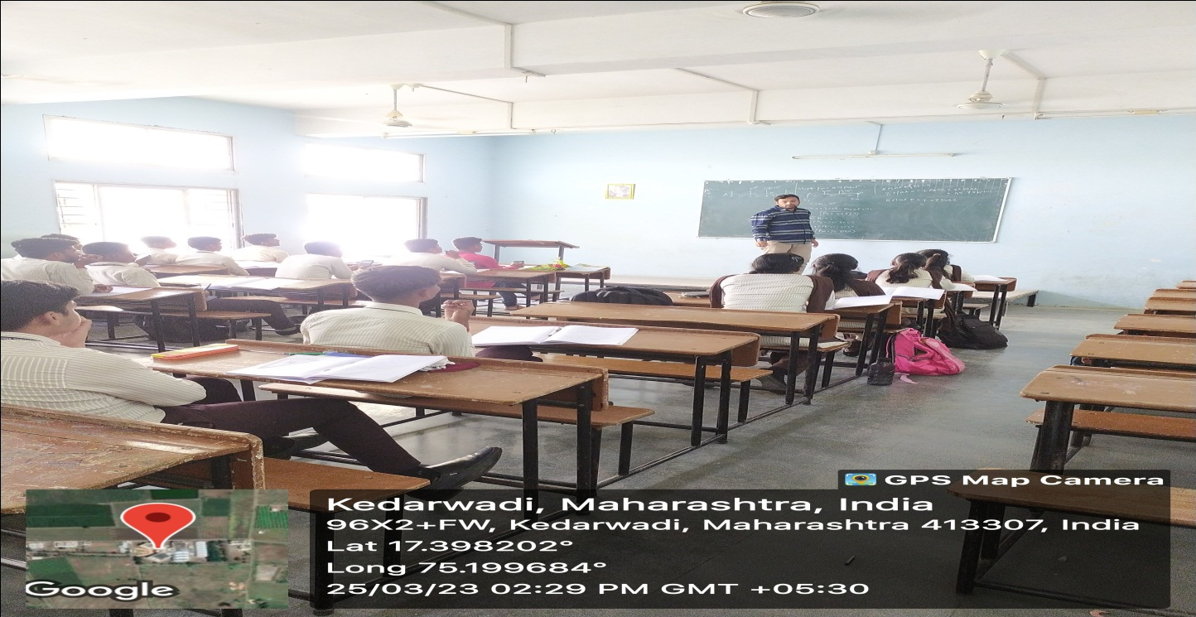
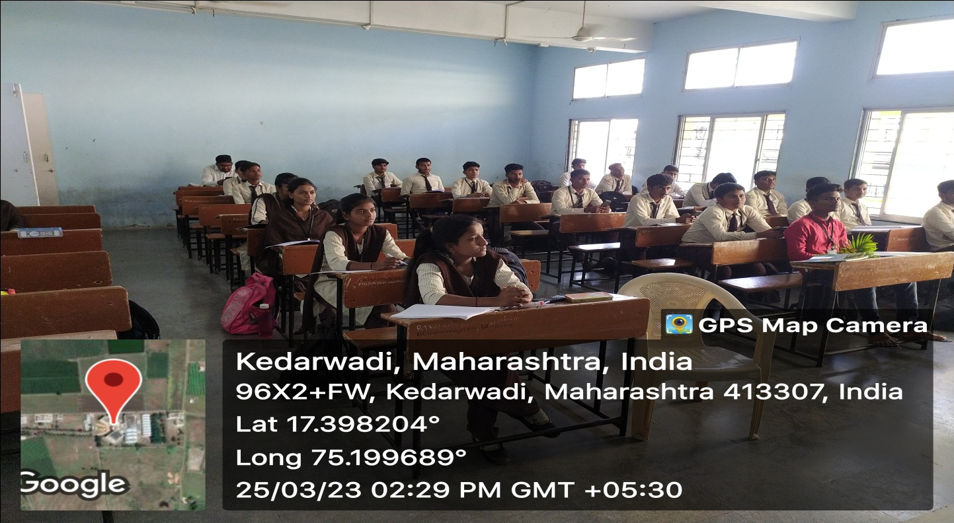
Mr. Jitu Batra Conducting a Guest Lecture on Second Year Class on “Theory of Structures”
Guest Lecture on ‘Job Opportunities in Civil Engineering’ Date:- 03/04/2023
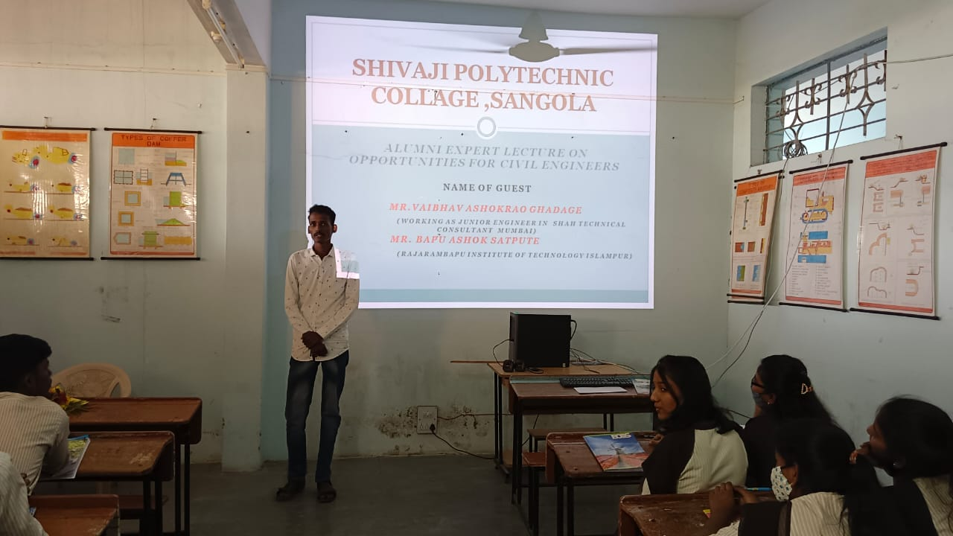

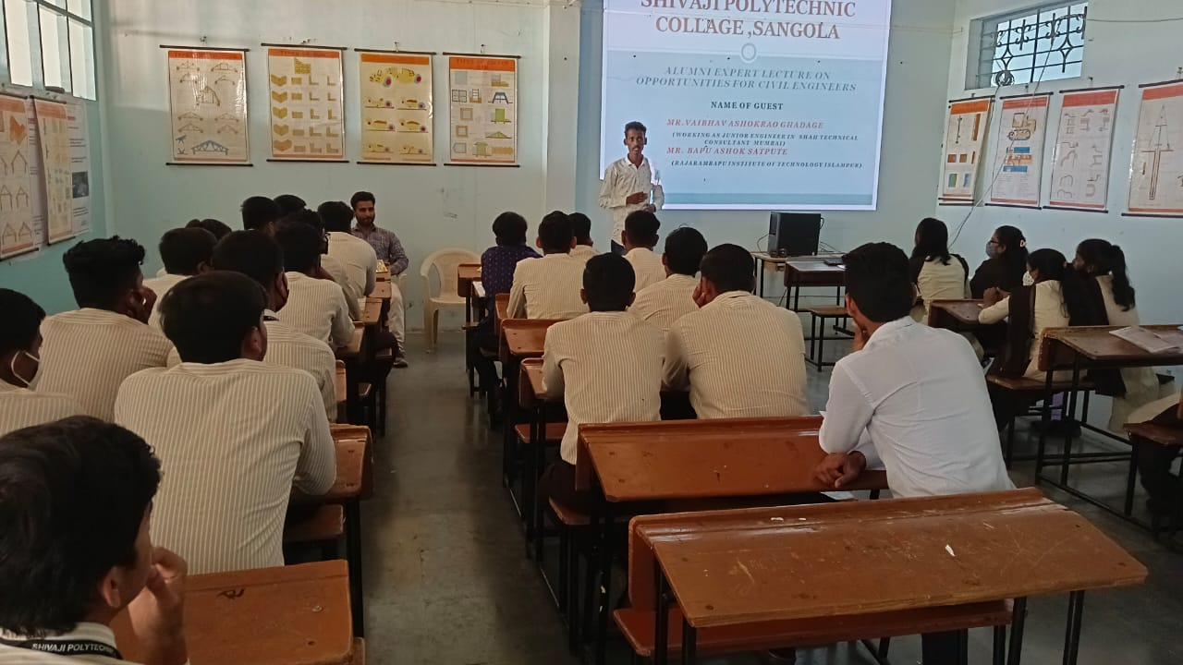
Mr. Vaibhav Ghadage Conducting a Alumni Expert Lecture on Second & Third Year Class on “Job Opportunities in Civil Engineering”

